# Coffee Shop Sales Analysis - SQL Queries

Cleaning and Modifying the data

create database coffee_data;  
  
show databases;  
  
use Coffee_data;  
  
select count(transaction_date) from coffee_shop;  
  
alter table coffee_shop   
change column ï»¿transaction_id transaction_id int;  
  
update coffee_shop   
set transaction_date = str_to_date(transaction_date, '%d-%m-%y');  
  
SET SQL_SAFE_UPDATES = 0;  
  
UPDATE coffee_shop   
SET transaction_date = STR_TO_DATE(transaction_date, '%d-%m-%Y')  
WHERE transaction_id IS NOT NULL;  
  
alter table coffee_shop  
modify column transaction_date DATE;  
  
alter table coffee_shop  
modify column transaction_time time;

describe coffee_shop;

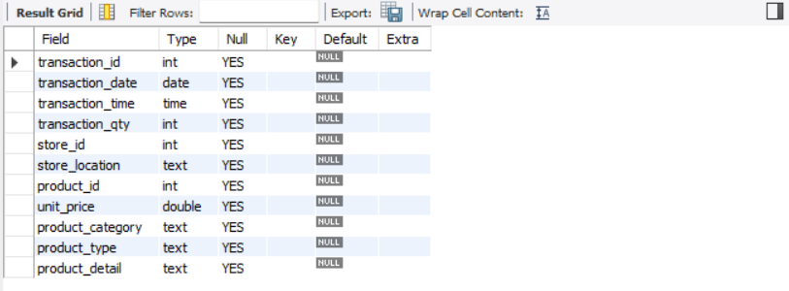

Total Sales Analysis

1. Calculate total Sales for Each Month

select monthname(transaction_date) as Month,   
round(sum(transaction_qty*unit_price),3) as Total_sales  
from coffee_shop  
group by Month;

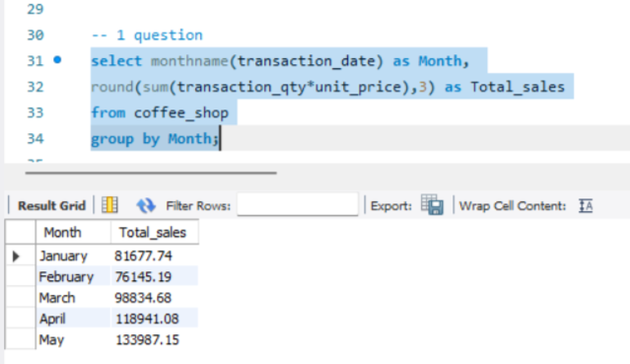  
2. Calculate total Sales for selected month

select sum(transaction_qty*unit_price) as Total_sales  
from coffee_shop  
where month(transaction_date)=5;

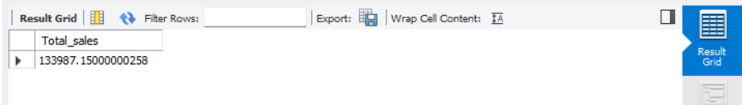

3) Determine Month on Month Decrease or Increase in Sales

with a as (select monthname(transaction_date) as Month,  
month(transaction_date) as month_num,   
round(sum(transaction_qty*unit_price),3) as Total_sales  
from coffee_shop  
group by Month, month_num)  
  
select concat(month, " to ", lead(month) OVER (order by month_num )) as Month_name,   
abs(round(total_sales-lead(total_sales) OVER (order by month_num), 3)) as month_to_month,  
case   
 when total_sales-lead(total_sales) OVER (order by month_num)>0 then "Decrease"  
 else  
 "Increase"  
end as Profit_grapgh,  
abs(round(((total_sales-lead(total_sales) OVER (order by month_num))/  
total_sales)*100, 3)) as Percentage  
from a   
limit 4;

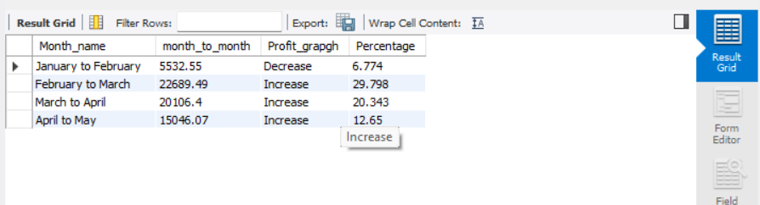

-- Total Orders Analysis

1) Calculate the total orders of each month

select monthname(transaction_date) as Month_name,   
count(transaction_id) as Total_orders   
from coffee_shop  
group by Month_name;

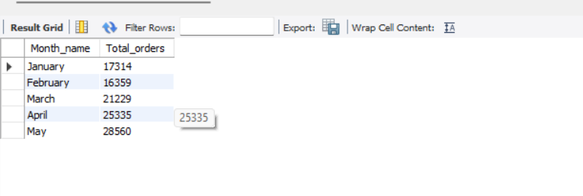  
  
2) Month to month decrease or increase of total order

with a as (select monthname(transaction_date) as Month_name,   
month(transaction_date) as Month_num,  
count(transaction_id) as Total_orders   
from coffee_shop  
group by Month_name, Month_num)  
  
select   
concat(Month_name, " To ", lead(month_name) over (order by month_num))   
as Month_TO_Month,  
abs(total_orders-lead(total_orders) Over (order by month_num)) as total_orders_Vary,  
  
Case  
When (total_orders-lead(total_orders) Over (order by month_num)) < 0   
then "Increased"  
else  
"Decreased"  
end as Graph,  
abs(round(((total_orders-lead(total_orders) Over (order by month_num))/total_orders)*100,3))  
as Percentage  
from a  
limit 4;

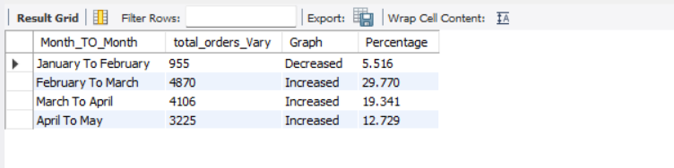  
  
-- Total Quantity Analysis

1) Total quantity sold per each month

select monthname(transaction_date) as Month_Name,  
sum(transaction_qty) as total_quantity  
from Coffee_shop  
group by Month_name;

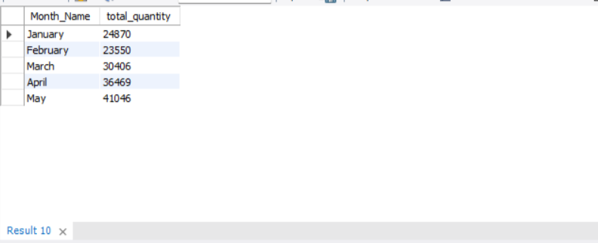  
  
2) Month on Month increase and decrease in total quantity

With Tab as (select monthname(transaction_date) as Month_Name,  
month(transaction_date) as Month_num,  
sum(transaction_qty) as total_qt  
from Coffee_shop  
group by Month_name, month_num)  
  
select   
concat(Month_name, " To ", lead(month_name) over (order by month_num))   
as Month_TO_Month,  
abs(total_qt-lead(total_qt) Over (order by month_num)) as total_orders_Vary,  
  
Case  
When (total_qt-lead(total_qt) Over (order by month_num)) < 0   
then "Increased"  
else  
"Decreased"  
end as Graph,  
abs(round(((total_qt-lead(total_qt) Over (order by month_num))/total_qt)*100,3))  
as Percentage  
from tab  
limit 4;

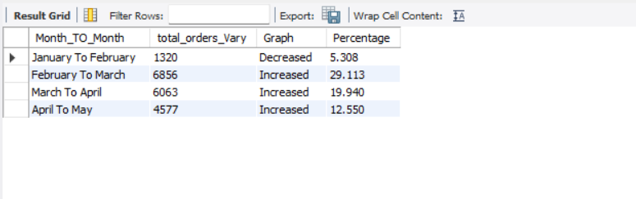

Chart Requirements   
**1) Detailed metrics for specific day**

select concat((round(sum(unit_price* transaction_qty),3))/1000,"k") as total_sales,  
concat(count(transaction_id)/1000,"k") as total_orders,  
concat(sum(transaction_qty)/1000,"k") as total_quantity  
from coffee_shop  
where transaction_date='2023-01-01';

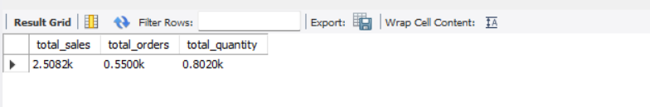  
**2) Sales data with respect weekdays and weekend**

select   
case  
 when dayname(transaction_date) in ("Sunday", "Saturday") then "Weekends"  
 else   
 "Weekdays"  
 end as Day_type,  
 round(sum(transaction_qty*unit_price),3) as sales  
 from coffee_shop  
 where month(transaction_date)=5  
 group by Day_type;

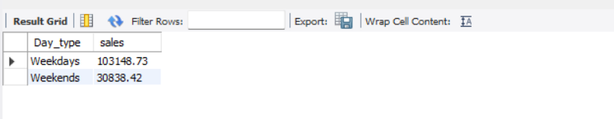

**3) Sales analysis by store locations**

select store_location,   
concat(round((sum(transaction_qty*unit_price)/1000),2),"k") as sales  
from coffee_shop  
group by store_location;

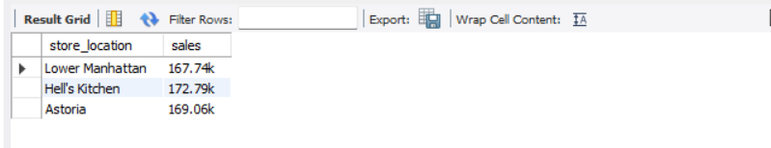

**4) Average Daily sales of selected month**

select avg(total_sales) as Average_sales  
from   
(select sum(transaction_qty*unit_price) as total_sales  
from Coffee_shop  
Where month(transaction_date)=5  
group by transaction_date) as Internal ;

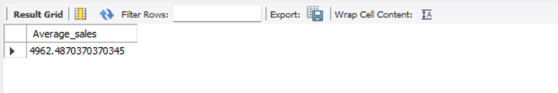  
  
**5) Sales Analysis by Product Category**

select product_category, round(sum(transaction_qty*unit_price)) as total_sales  
from coffee_shop  
group by product_category;

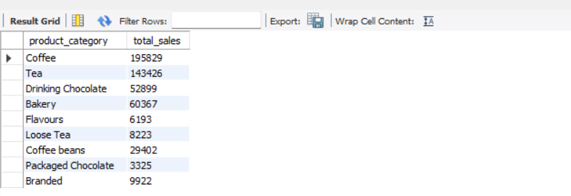  
  
**6) Top 10 products by sales volume**

select product_type, round(sum(transaction_qty*unit_price)) as total_sales  
from coffee_shop  
group by product_type  
order by total_sales desc   
limit 10;

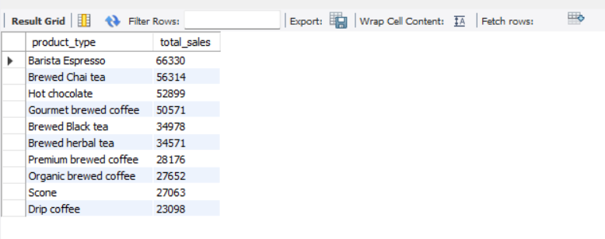  
  
**7) Sales analysis by days and hour**  
select   
Hour(transaction_time) as Hour,  
round(sum(transaction_qty*unit_price),2) as Sales,  
sum(transaction_qty) as Total_quantity,  
count(transaction_id) as Total_Orders  
from coffee_shop  
where day(transaction_date)=3 and  
month(transaction_date)=3  
group by Hour;

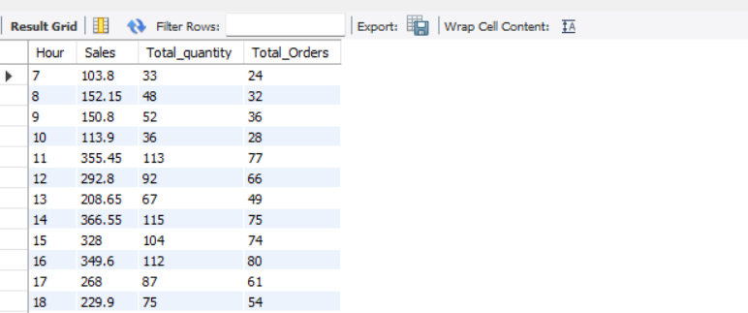  
  
select   
dayname(transaction_date) as day,  
hour(transaction_time) as Hour,  
round(sum(transaction_qty*unit_price),2) as Sales,  
sum(transaction_qty) as Total_quantity,  
count(transaction_id) as Total_Orders  
from coffee_shop  
where day(transaction_date)=3 and  
month(transaction_date)=3  
group by day, hour;

