**Solr SetUp Document**

**Step1**:Download the Solr from the below link

<http://mirror.olnevhost.net/pub/apache/lucene/solr/6.6.0/>

**Step2:** extract the solr zip.

**Step3**:Go to the bin folder through command prompt

**Step4:** then type solr start

D:\solr\solr-6.6.0 (1)\solr-6.6.0\bin>solr start

Waiting up to 30 to see Solr running on port 8983

**Started Solr server on port 8983. Happy searching!**

**Step5:** Go to the browser type this URL: <http://localhost:8983>

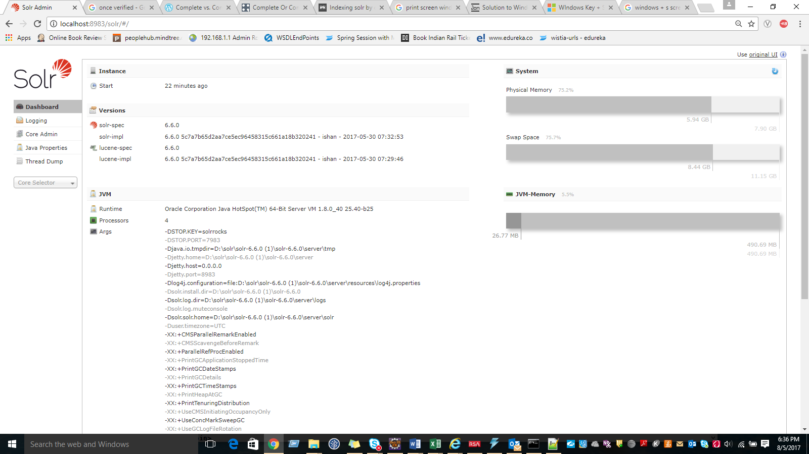

**Step6**: Again go to command prompt then type the below command to create core

**D:\solr\solr-6.6.0 (1)\solr-6.6.0\bin>solr create -c MyApp**

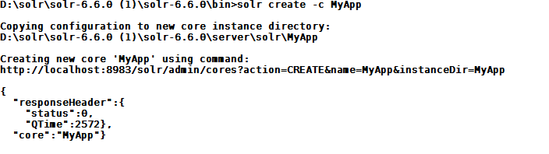

**Step7:** Core project **MyApp** is created inside the solr (D:\solr\solr-6.6.0 (1)\solr-6.6.0\server\solr)folder .

**Step8:** For connecting solr to database we need to download the database connector jar for example For MySql we need to down load mysql-connector-java-5.1.42-bin.jar and place in to the **dist** (D:\solr\solr-6.6.0 (1)\solr-6.6.0\dist)folder.

**Step9:** Add these below configuration under the **<config>** tag of solrconfig.xml

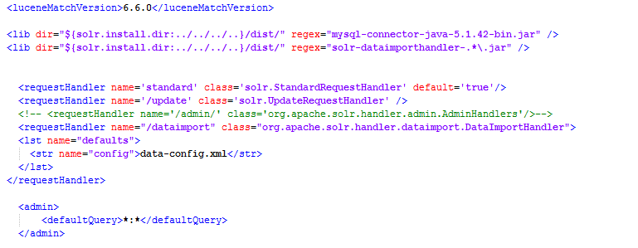

**Step9:**Create **data-config.xml** , define the connection related settings of database and also set the queries according to your schema. Refer the below screen shot for more information then place in to conf(D:\solr\solr-6.6.0 (1)\solr-6.6.0\server\solr\MyApp\conf) folder.

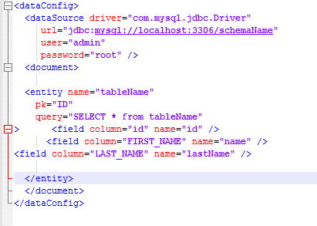.

**Step10:** Restart the solr server using the below command



**Step11:go to the browser type** [**http://localhost:8983/solr/#/**](http://localhost:8983/solr/#/)

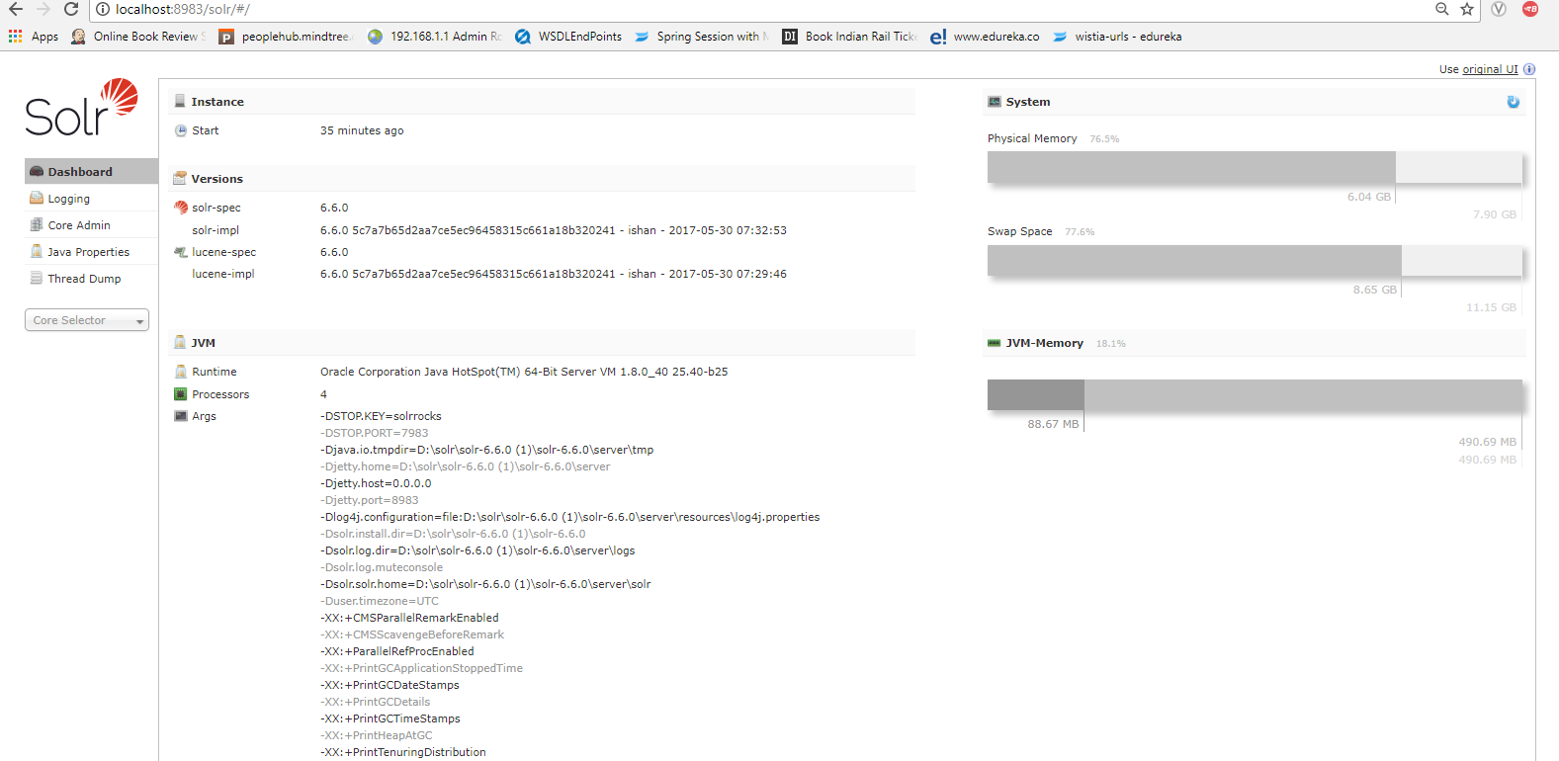

Go to the core selector then select your core application for example(MyApp)

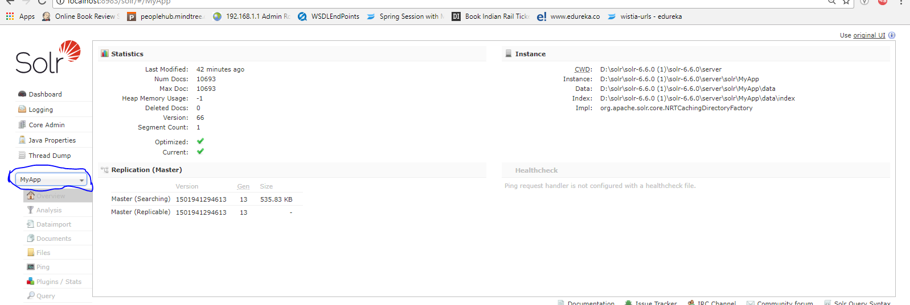

Go to the datImport Section then select the Entity then click the Execute button then click the refresh button to see the dataimport result as you see the below screen print.

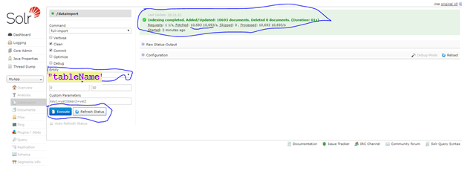

Then go to Scema Section then Add Filed into the search Criteria

**Example:**name field =Name(column name Mentioned data config.xml file)

Field Type: String (Choose data type) then click Add Field

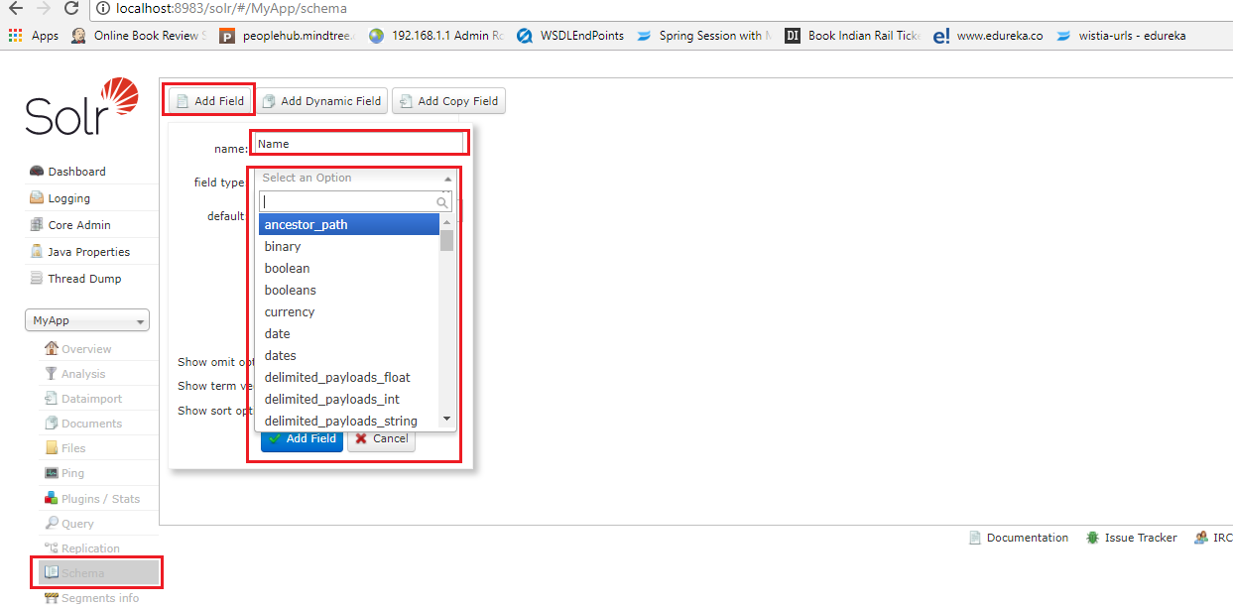

**Step12**: Go to Query Section then click the Execute Query button

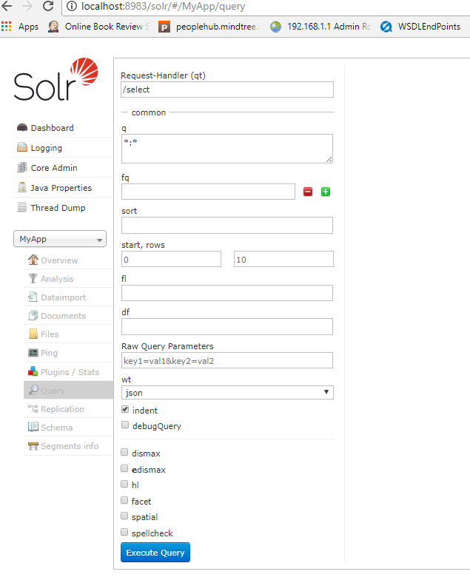

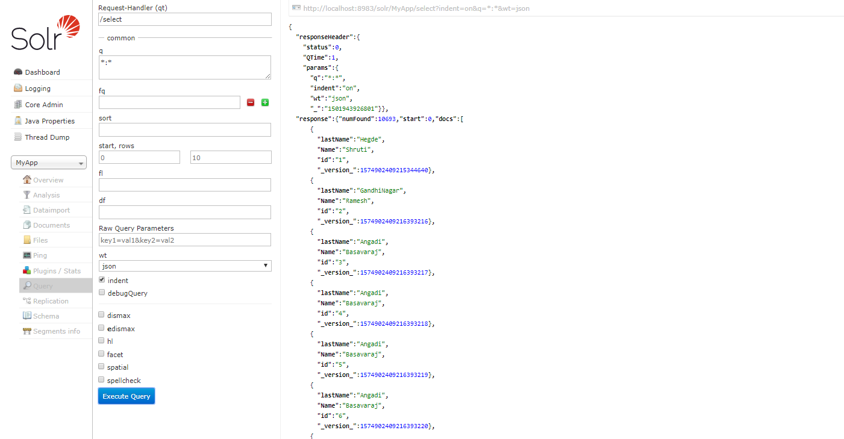

**Even you can search by search criteria like name or lastName.**

