1. Our job as a automation eng?--🡪 convert manual test cases in to automation scripts
2. In a project, 1 AE or >1 AE?--> Multiple AE
3. Should each eng write script , on their own way? No
4. Batch execution?
5. All AE in a team , they should dev Automation script: in same format?- consistency
6. lead /architect – decide the format- Automation Framework
7. Based on the format(design) AFW is called with dif name?
   1. Robot FW
   2. Hybrid
   3. Modular
   4. Data Driven
   5. POM
   6. Keyword driven
   7. BDD
   8. Jasmin
8. AFW selection
   1. Exp on multiple automation project
   2. Project
   3. POC (proof of concept)- Automate some sample test cases – check
9. AFW stages
   1. Design ---------------------architect
   2. Implementation------ All AE (MTC-ATS)
   3. Execution-------Automatically – when we get new build AFW executed automatically

Design

Folder Structure

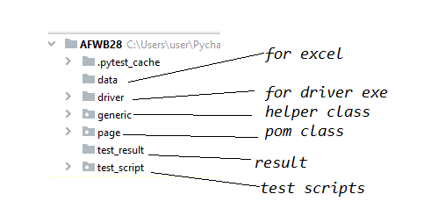

BasetTest

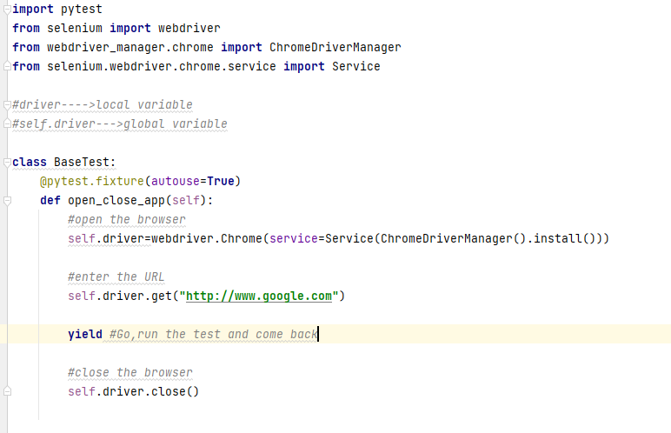

Sample Test Script

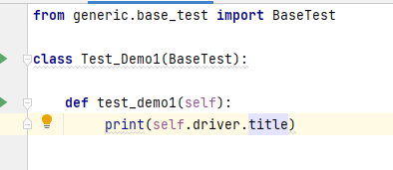

Run from terminal



Out put:

