**MY SQL QUERIES**

**COFFEE SHOP SALES PROJECT**

**CONVERT DATE (transaction_date) COLUMN TO PROPER DATE FORMAT**

**update coffee**

**set transaction_date = str_to_date(transaction_date, "%d-%m-%Y");**

**ALTER DATE (transaction_date) COLUMN TO DATE DATA TYPE**

**Alter table coffee**

**modify column transaction_date date;**

**CONVERT TIME (transaction_time) COLUMN TO PROPER DATE FORMAT**

**update coffee**

**set transaction_time = str_to_date(transaction_time, "%H:%i:%s");**

**ALTER TIME (transaction_time) COLUMN TO DATE DATA TYPE**

**Alter table coffee**

**modify column transaction_time time;**

**DATA TYPES OF DIFFERENT COLUMNS**

**describe coffee;**

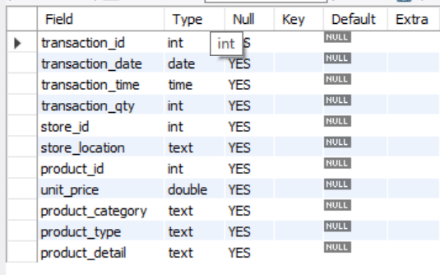

**CHANGE COLUMN NAME `ï»¿transaction_id` to transaction_id**

**ALTER TABLE coffee**

**CHANGE COLUMN `¿transaction_id` transaction_id INT;**

**TOTAL SALES**

**select sum(transaction_qty * unit_price) as total_sales from coffee;**

**TOTAL SALES KPI - MOM DIFFERENCE AND MOM GROWTH**

**select**

**month(transaction_date) as month, --- no of months**

**round(sum(transaction_qty * unit_price)) as total_sales, -- total sales column**

**(sum(unit_price * transaction_qty) - lag(sum(unit_price * transaction_qty) , 1) -- previous month sales difference**

**over (order by month(transaction_date))) / lag(sum(unit_price * transaction_qty) , 1) -- division by pm sales**

**over (order by month(transaction_date)) * 100 as MoM_Increase_percentage -- percentage**

**from coffee**

**where month(transaction_date) in (1,4,5,6)**

**group by month(transaction_date)**

**order by month(transaction_date);**

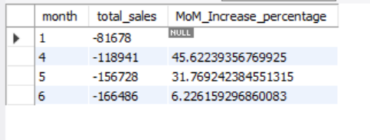

**TOTAL ORDERS**

**select month(transaction_date), count(transaction_id) as Total_orders**

**from coffee**

**where month(transaction_date)**

**group by month(transaction_date);**

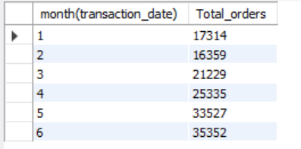

**TOTAL ORDERS KPI - MOM DIFFERENCE AND MOM GROWTH**

**select**

**month(transaction_date) as month,**

**count(transaction_id) as total_orders,**

**(count(transaction_id) - lag(count(transaction_id),1)**

**over(order by month(transaction_date))) / lag(count(transaction_id),1)**

**over(order by month(transaction_date)) * 100 as MoM_increase_percentage**

**from coffee**

**where month(transaction_date)**

**group by month(transaction_date)**

**order by month(transaction_date);**

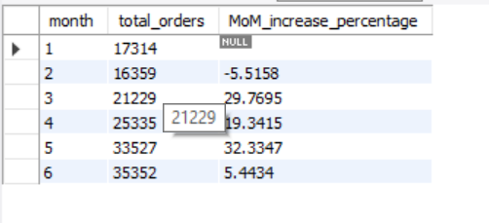

**TOTAL QUANTITY SOLD**

**select month(transaction_date) as month, sum(transaction_qty) as Total_quantity from coffee**

**where month(transaction_date)**

**group by month(transaction_date);**

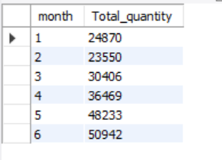

**TOTAL QUANTITY SOLD KPI - MOM DIFFERENCE AND MOM GROWTH**

**select**

**month(transaction_date) as month,**

**sum(transaction_qty) as total_Qty,**

**(sum(transaction_qty) - lag(sum(transaction_qty),1)**

**over(order by month(transaction_date))) / lag(count(transaction_id),1)**

**over(order by month(transaction_date)) * 100 as MoM_increase_percentage**

**from coffee**

**where month(transaction_date)**

**group by month(transaction_date)**

**order by month(transaction_date);**

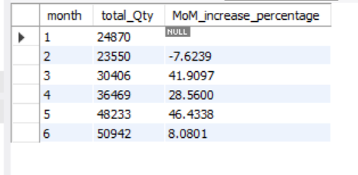

**CALENDAR TABLE – DAILY SALES, QUANTITY and TOTAL ORDERS**

select transaction_date,

count(transaction_id) as Total_order,

sum(transaction_qty) as total_qty,

round(sum(unit_price * transaction_qty),1) as Total_sales

from coffee

where transaction_date= '2023-01-01';

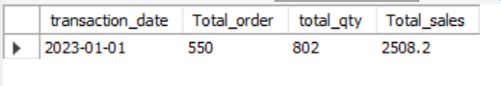

**SALES TREND OVER PERIOD**

**DAILY SALES FOR MONTH SELECTED**

**select**

**day(transaction_date) as day_of_month,**

**sum(transaction_qty * unit_price) as total_sales**

**from coffee**

**where month(transaction_date)= 5**

**group by day(transaction_date)**

**order by day(transaction_date) asc;**

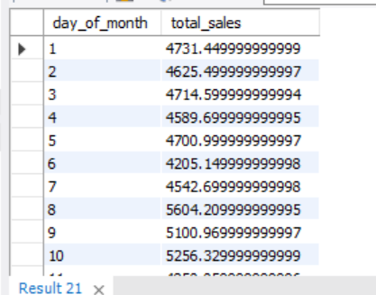

***COMPARING DAILY SALES WITH AVERAGE SALES – IF GREATER THAN “ABOVE AVERAGE” and LESSER THAN “BELOW AVERAGE”***

SELECT

day_of_month,

CASE

WHEN total_sales > avg_sales THEN 'Above Average'

WHEN total_sales < avg_sales THEN 'Below Average'

ELSE 'Average'

END AS sales_status,

total_sales

FROM (

SELECT

DAY(transaction_date) AS day_of_month,

SUM(unit_price * transaction_qty) AS total_sales,

AVG(SUM(unit_price * transaction_qty)) OVER () AS avg_sales

FROM

coffee_shop_sales

WHERE

MONTH(transaction_date) = 5 -- Filter for May

GROUP BY

DAY(transaction_date)

) AS sales_data

ORDER BY

day_of_month;

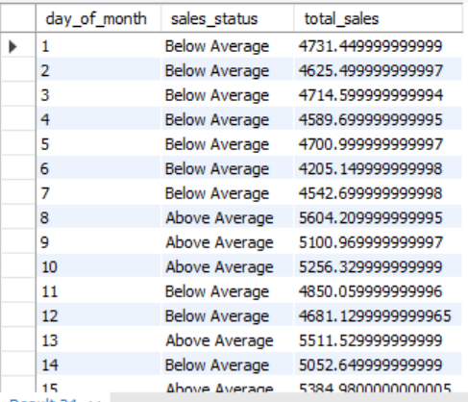

**SALES BY WEEKDAY / WEEKEND:**

**-- weekdays - Monday - Friday**

**-- weekends -- Saturday and Sunday -- Sun = 1 Saturday= 7**

select

case when dayofweek(transaction_date) in (1,7) then 'weekends'

else 'weekdays'

end as daytype,

sum(transaction_qty * unit_price) as total_sales

from coffee

where month(transaction_date) = 5

group by

case when dayofweek(transaction_date) in (1,7) then 'weekends'

else 'weekdays' end;

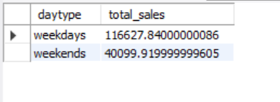

**SALES BY STORE LOCATION**

**select**

**store_location,**

**sum(transaction_qty * unit_price) as total_sales**

**from coffee**

**where month(transaction_date)= 2**

**group by store_location**

**order by total_sales desc;**

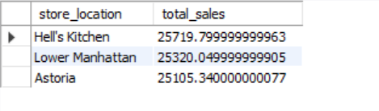

**SALES BY PRODUCT CATEGORY**

select product_category,

sum(transaction_qty * unit_price) as total_sales from coffee

WHERE MONTH(transaction_date) = 5

group by product_category

ORDER BY SUM(unit_price * transaction_qty) DESC;

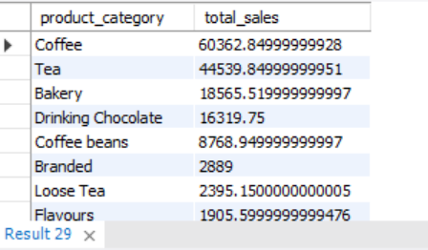

**SALES BY PRODUCTS (TOP 10)**

SELECT product_type,

SUM(unit_price * transaction_qty) as Total_Sales

FROM coffee_shop_sales

WHERE MONTH(transaction_date) = 5

GROUP BY product_type

ORDER BY SUM(unit_price * transaction_qty) DESC

LIMIT 10

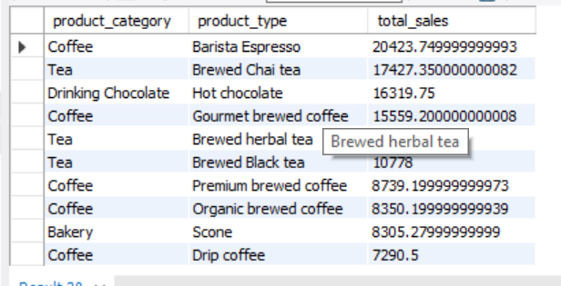

**SALES BY DAY | HOUR**

SELECT

ROUND(SUM(unit_price * transaction_qty)) AS Total_Sales,

SUM(transaction_qty) AS Total_Quantity,

COUNT(*) AS Total_Orders

FROM

coffee_shop_sales

WHERE

DAYOFWEEK(transaction_date) = 3 -- Filter for Tuesday (1 is Sunday, 2 is Monday, ..., 7 is Saturday)

AND HOUR(transaction_time) = 8 -- Filter for hour number 8

AND MONTH(transaction_date) = 5; -- Filter for May (month number 5)

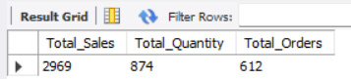

***TO GET SALES FOR ALL HOURS FOR MONTH OF MAY***

SELECT

CASE

WHEN DAYOFWEEK(transaction_date) = 2 THEN 'Monday'

WHEN DAYOFWEEK(transaction_date) = 3 THEN 'Tuesday'

WHEN DAYOFWEEK(transaction_date) = 4 THEN 'Wednesday'

WHEN DAYOFWEEK(transaction_date) = 5 THEN 'Thursday'

WHEN DAYOFWEEK(transaction_date) = 6 THEN 'Friday'

WHEN DAYOFWEEK(transaction_date) = 7 THEN 'Saturday'

ELSE 'Sunday'

END AS Day_of_Week,

ROUND(SUM(unit_price * transaction_qty)) AS Total_Sales

FROM

coffee_shop_sales

WHERE

MONTH(transaction_date) = 5 -- Filter for May (month number 5)

GROUP BY

CASE

WHEN DAYOFWEEK(transaction_date) = 2 THEN 'Monday'

WHEN DAYOFWEEK(transaction_date) = 3 THEN 'Tuesday'

WHEN DAYOFWEEK(transaction_date) = 4 THEN 'Wednesday'

WHEN DAYOFWEEK(transaction_date) = 5 THEN 'Thursday'

WHEN DAYOFWEEK(transaction_date) = 6 THEN 'Friday'

WHEN DAYOFWEEK(transaction_date) = 7 THEN 'Saturday'

ELSE 'Sunday'

END;

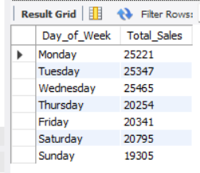

***TO GET SALES FOR ALL HOURS FOR MONTH OF MAY***

SELECT

HOUR(transaction_time) AS Hour_of_Day,

ROUND(SUM(unit_price * transaction_qty)) AS Total_Sales

FROM

coffee_shop_sales

WHERE

MONTH(transaction_date) = 5 -- Filter for May (month number 5)

GROUP BY

HOUR(transaction_time)

ORDER BY

HOUR(transaction_time);

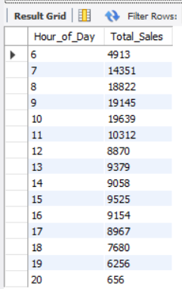

**Thank You**