INDEX

## [Introduction into Git](https://www.vogella.com/tutorials/Git/article.html#introduction-into-git)

### [What is Git?](https://www.vogella.com/tutorials/Git/article.html#gitterminlogy)

*Git* is currently the most popular implementation of a distributed version control system.

Git originates from the Linux kernel development and was founded in 2005 by Linus Torvalds. Nowadays it is used by many popular open source projects, e.g., the Android or the Eclipse developer teams, as well as many commercial organizations.

The core of Git was originally written in the programming language *C*, but Git has also been re-implemented in other languages, e.g., Java, Ruby and Python.

**What is GitHub?**

Git Hub is a Collaboration platform. It is built on top of git. It allows you to keep both local and remote copies of your project. A project which you can publish it among your team members as they can use it and update it from there itself.

## Git Installation

Now let us start by installing "Git ".

**Step 1)** Launch the Browser and navigate to URL- https://git-scm.com/

**Step 2)** Download the latest stable release.

**Step 3)** Click on downloads for windows once the file is downloaded we can begin with our installation.

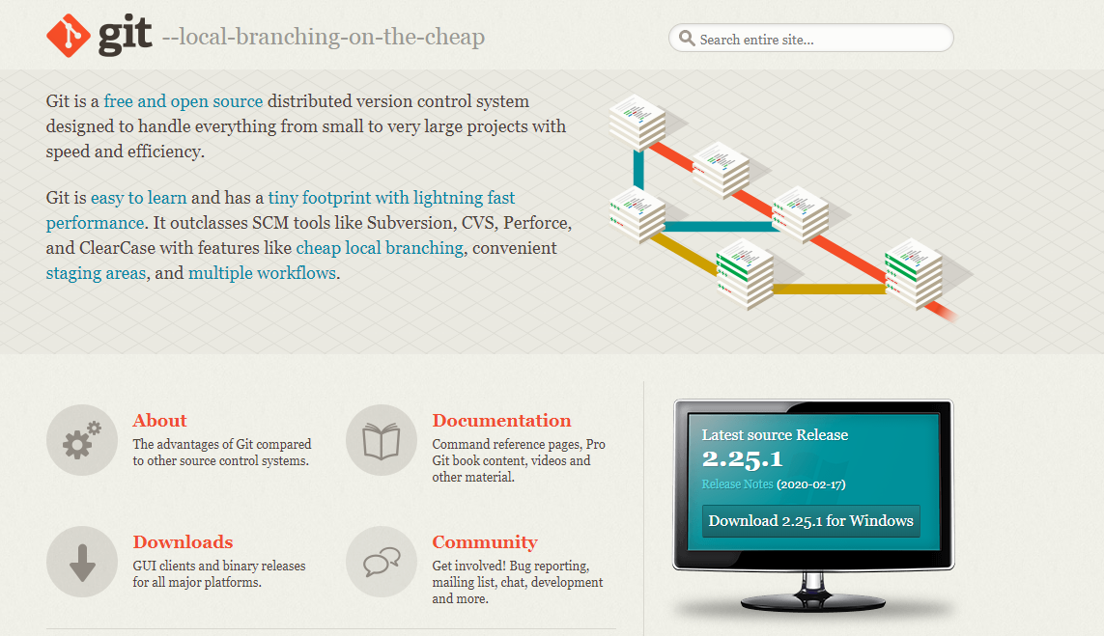

**Step 4)** Go to the download location or icon and run the installer.

**Step 5)** Click through welcome and General Public license.

**Step 6)** Click on "next" button in git setup wizard

[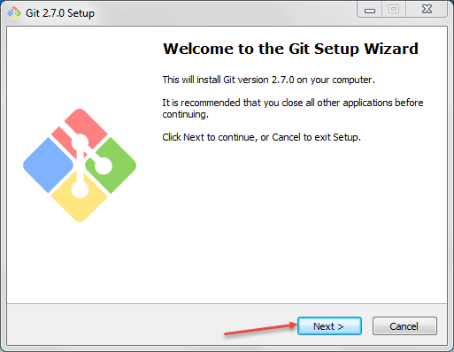](https://www.guru99.com/images/cassandra/021216_0757_Seleniumwit2.png)

**Step 7)**Read the GNU General Public License and click on next

[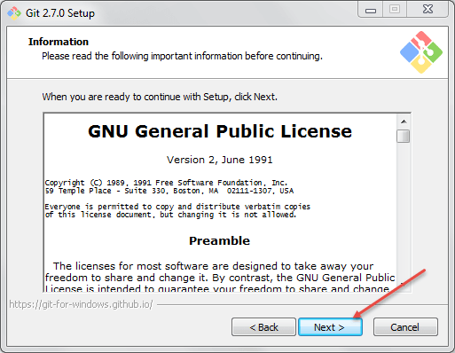](https://www.guru99.com/images/cassandra/021216_0757_Seleniumwit3.png)

Another window will pop up,

**Step 8)** In this step,

1. Select the Directory where  where you want to install "Git Binaries" and
2. Click on next button

[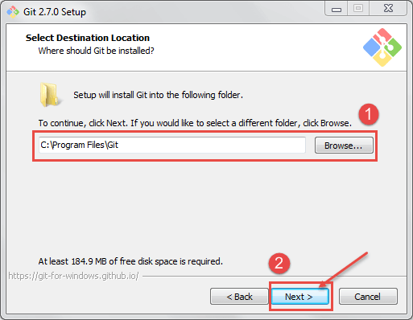](https://www.guru99.com/images/cassandra/021216_0757_Seleniumwit4.png)

**Step 9)** Select the component which you want to install and click on next

[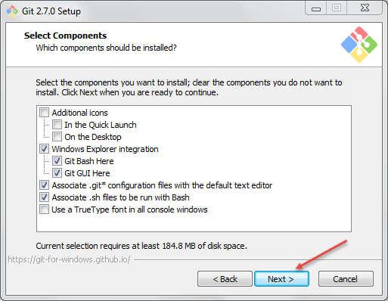](https://www.guru99.com/images/cassandra/021216_0757_Seleniumwit5.png)

**Step 10)** If you want to create a start menu folder for Git, leave the setting default and click on next.

[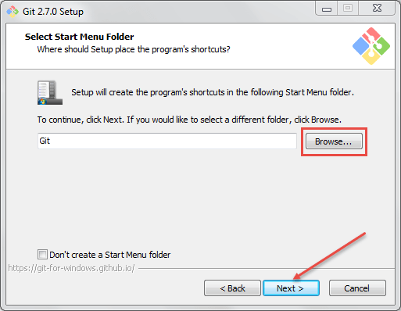](https://www.guru99.com/images/cassandra/021216_0757_Seleniumwit6.png)

**Step 11)** In this step,

1. Select Use Git from the Windows Command Prompt to run Git from the command line and
2. Click on next.

[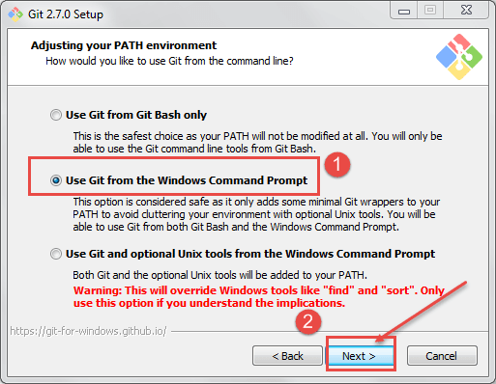](https://www.guru99.com/images/cassandra/021216_0757_Seleniumwit7.png)

Leave the default setting and click on next to install.

**Step 12)**In this step,

1. Select Use Open SSH It will help us to execute the command from the command line, and it will set the environmental path.
2. Click on next button.

[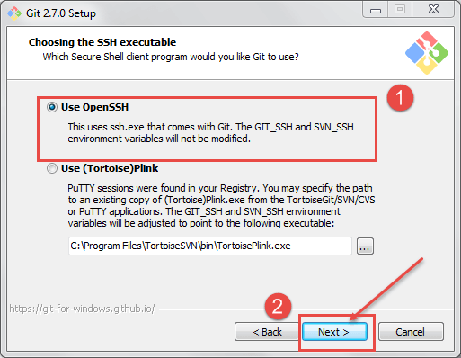](https://www.guru99.com/images/cassandra/021216_0757_Seleniumwit8.png)

**Step 13)**In this step,

1. Select "Checkout windows-style, commit Unix-style line ending".(how the git hub should treat line endings in text files).
2. Click on next button.

[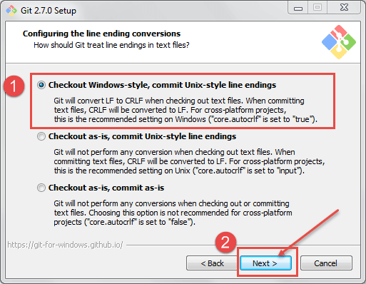](https://www.guru99.com/images/cassandra/021216_0757_Seleniumwit9.png)

**Step 14)**In this step,

1. Select Use MinTTY is the default terminal of MSys2 for Git Bash
2. Click on next button

[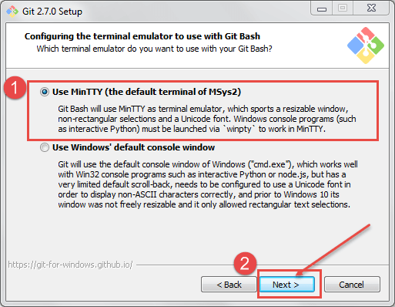](https://www.guru99.com/images/cassandra/021216_0757_Seleniumwit10.png)

[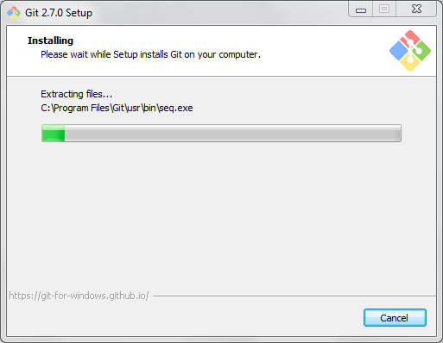](https://www.guru99.com/images/cassandra/021216_0757_Seleniumwit11.png)

Once git is installed successfully, you can access the git.

Open Command prompt and type "git" and hit "Enter" If you see below screen means it is installed successfully

[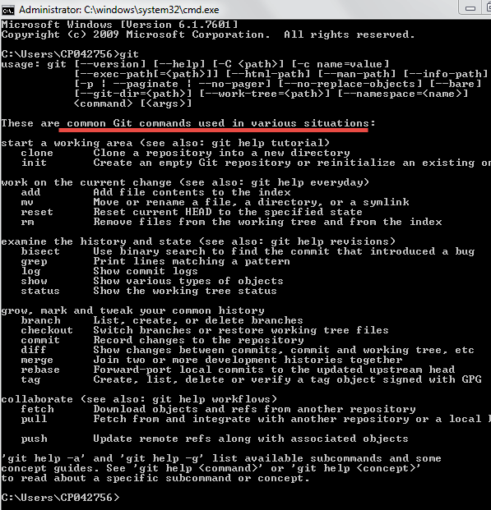](https://www.guru99.com/images/cassandra/021216_0757_Seleniumwit12.png)

## Building a repository on Git

**Step 1)** Navigate to Git Hub URI: <https://github.com/> sign up for git hub

**Step 2)** Once you have been successfully signed up then click on create new repository

[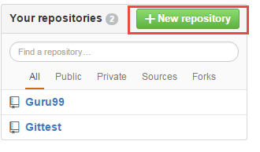](https://www.guru99.com/images/cassandra/021216_0757_Seleniumwit24.png)

**Step 3)** In this step,

1. Enter the name of the repository and
2. click on create repository[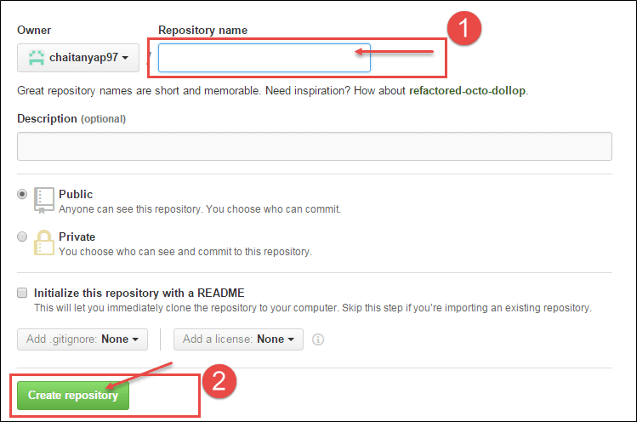](https://www.guru99.com/images/cassandra/021216_0757_Seleniumwit25.png)