**Francisco, Angelica I.**

**Mizona , Jhanna D.**

**BSTM-2D**

**INTRODUCTION**

Information Technology (IT) is the lifeblood of tourism and hospitality industry. As the lifeblood, this means it plays a very important role in the provision of sevices to the end-users or clients. IT connects the customers, travel industry, and other suppliers. It became essential for the efficient and timely processing of services offered to the customers.

Customer behavior analysis provides valuable insights into satisfaction levels, loyalty, and churn patterns. Also, the level of the organization, applications of information technology are transforming traditional approaches to communication and coordination.

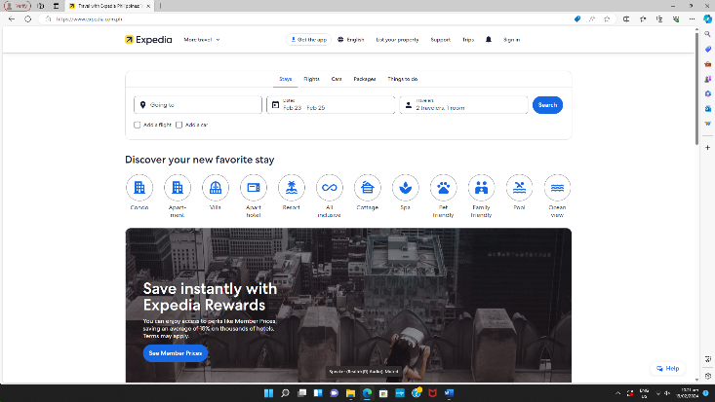

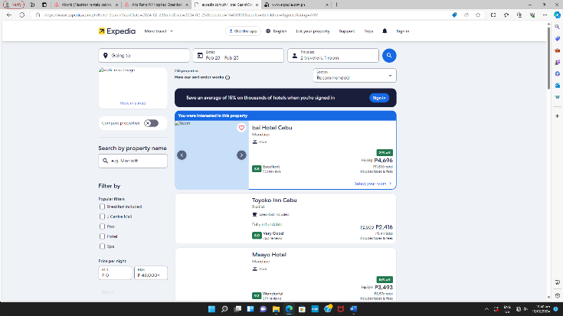

Expedia offers services which are car rentals, ticketing flights, staycation and packages which are convenient to all. Also on Expedia you can book cheap flights to match your needs. Select from thousands of flight- airlines, one-way or return, departure and arrival.

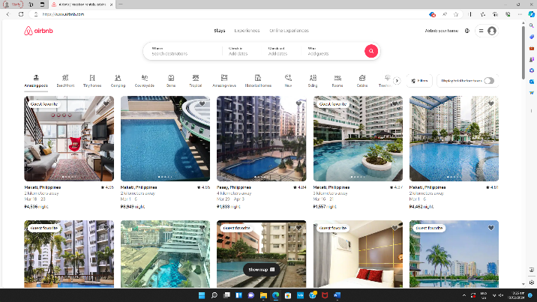

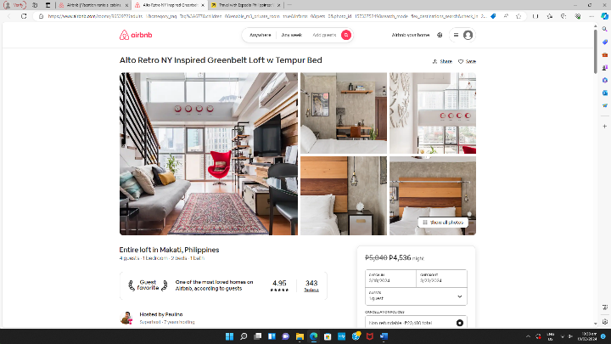

Air bnb has more to offer like 4-61 Airbnb Categories showing amazing pools, beachfront, tiny homes, islands, boats, barns, tropical, amazing views, historical homes, skiing, rooms, cabins, treehouses, camping, arctic, bread and breakfast, farms, vineyards, caves, surfing, golfing, hanoks, houseboats, windmills, and beach. That has lot to offer unlike Expedia.

As of January 16, 2024 the cost per person; Small Airbnb (fits 2 adults). $125: Large Airbnb (fits 6 adults). $60,: Hotel room (fits 2 adults). $89.

<https://www.nerdwallet.com/article/travel/airbnb-pricing-statistics>

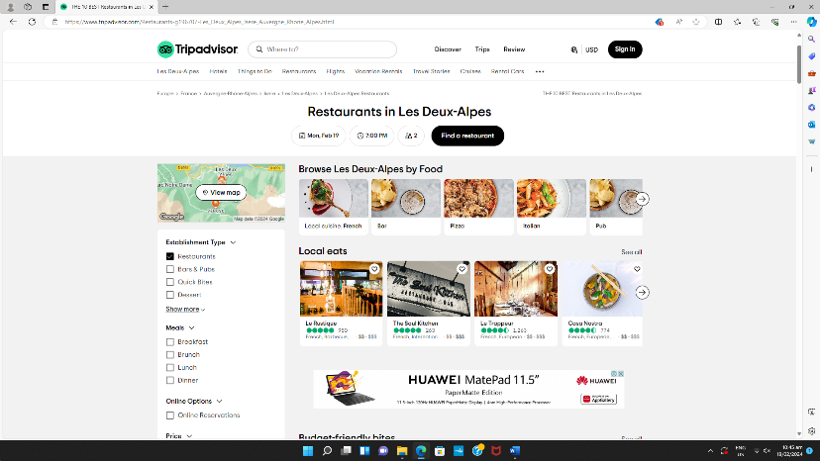

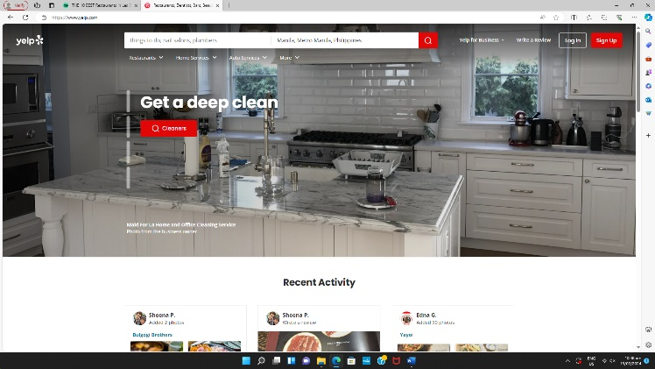

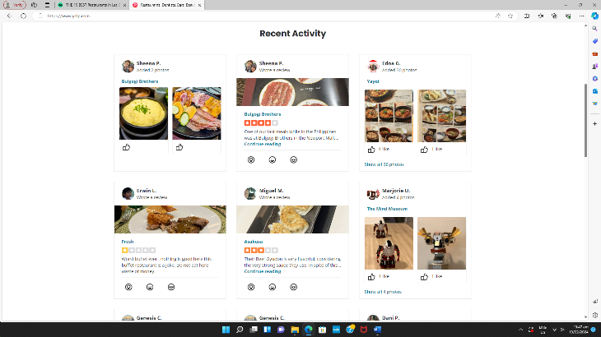

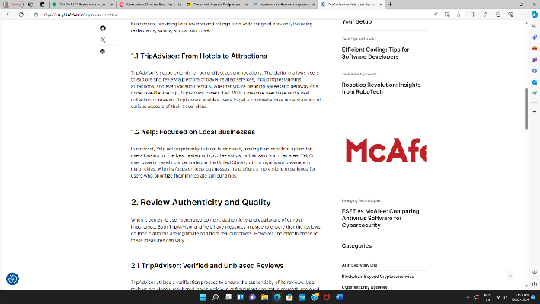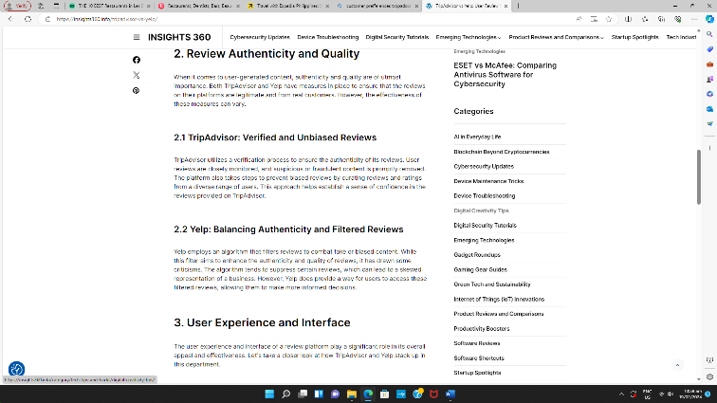Based on TripAdvisor and Yelp. They offers restaurants and serves local foods. Lots of restaurants to offer and each cuisine serves different kind of dish which people liked. TripAdvisor are much foods to offer than Yelp.