“Attesting too Soon”- When MAS changes the date of service to a future date.
Someidy tries to resolve this by emailing tripinvresolution@medanswering.com to inform them that the trip was already completed, and they would respond with new invoice numbers. Error is that they are using the same invoice for different days.
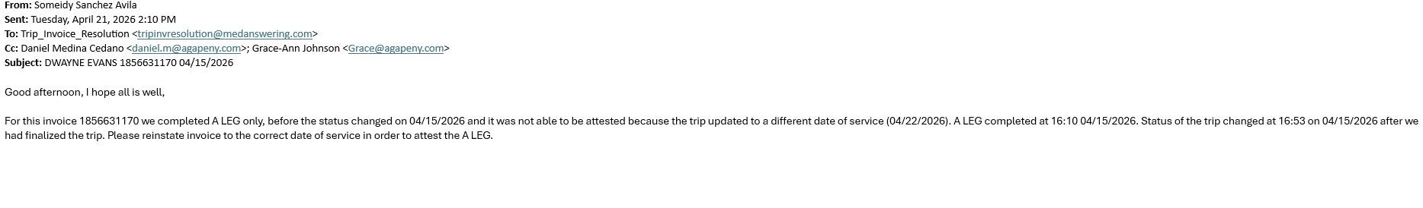
“Ineligible Enrollee” These reflect in Limosys as Cancelled Trips.
MAS These are resolved by going to MAS and submitting a “Correction Request” once the window pops up, Someidy selects the “Other” option and there she would tell them that the trip was already completed by us prior to it being cancelled.
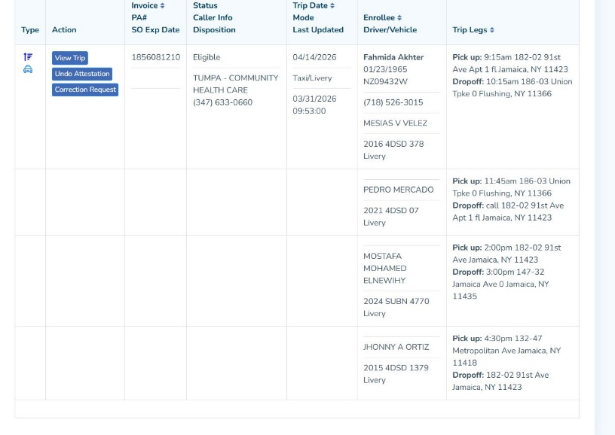
Sample of what she have written:
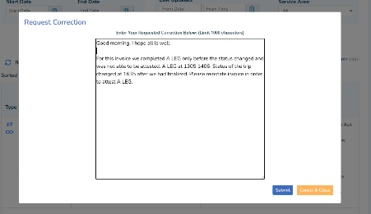
“Invoice Number not in System” – This also happens when MAS cancels after the trip was completed and another invoice has to be assigned. Since this invoice is not available for correction on MAS we would have to email tripinvresolution@medanswering.com for them to send over a new invoice number via email and this number will be used to attest for this trip on MAS portal.
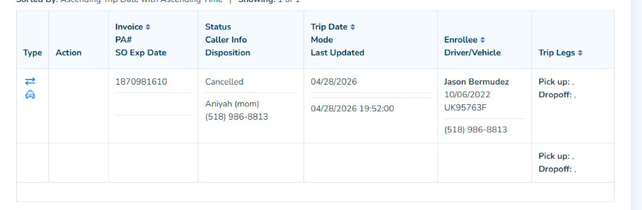

Error- Driver not Usable for this Trip: MAS does not accept attestations from this error and therefore no action can be taken on the portal.

