

Customer Order Processing System

CS3462 Project



group 09

Akhil Jain (40051215)

Hadrien Luttiau (40056002)

Contents

Introduction 3

Business requirements 3

System functional specifications 4

Query 1 4

Query 2 4

Query 3 4

Query 4 4

Query 5 4

Query 6 4

Query 7 5

Query 8 5

Query 9 5

Query 10 5

Query 11 5

Query 12 5

Query 13 6

Extended Entity Relationship Model 7

Data Flow Diagrams 8

Report 1 8

Report 2 8

Report 3 8

Report 4 9

Report 5 9

Report 6 9

Report 7 10

Report 8 10

Report 9 10

Report 10 11

Report 11 11

Report 12 11

Report 13 12

Relational schema 13

General 13

Detailed 13

Relational database normal form specification 16

Test cases of the developed database system 17

SQL programs listing 18

Query 1 18

Query 2 18

Query 3 18

Query 4 18

Query 5 19

Query 6 19

Query 7 19

Query 8 19

Query 9 19

Query 10 19

Query 11 19

Query 12 20

Query 13 20

ScreenCAM Demonstration CD 21

# Introduction

This project is to design and implement a database system for a customer order processing system in a company using a relational database Server. We have used an MS SQL based relational DBMS to implement a web based server to manage the data.

# Business requirements

The target of our relational database system is an enterprise that consists of a number of stores located in different cities and states. Each state has many cities, and a headquarter address coordinating all of its stores in the state. The location of the stores is also recorded. Each store is located in one city, and there can be many stores in the city. The enterprise’s goal is to meet all of the customer’s requirements from stores located in the customer’s city. If the requirement cannot be met, the company will turn to the other cities where the item can be found if there is any. Each store holds a variety of items in various quantity. Each item can be held in different stores. In addition, the enterprise keeps the information of the customers. The city location of the customer, together with the data of the customer’s first order, is stored by the existing system.

There are two kinds of customers: Employee and Regular, exclusively. There are also two kinds of customers on the market: Walk-in and e-commerce, inclusively. Each customer lives in one city only, and the enterprise will try to satisfy the customer’s order items by the present stock in the city where the customer lives. The order of each customer can be for any quantity of any number of items, and each order is uniquely identified by an order number. The same item can be in different orders.

Some processing information is important for the enterprise. For example, the total quantity of item stored in each city. After every time an item is taken, the company needs to know the total quantities of the item in all the stores in a city.

The retail store ordering system must produce the following reports:

1. Find all the stores along with city, state, phone, description, size, weight and unit price that hold a particular item of stock.
2. Find all the orders along with customer id and order date that can be fulfilled by a given store.
3. Find all stores along with city name and phone that hold items ordered by a given customer.
4. Find the headquarter address along with city and state of all stores that hold stocks of an item above a particular level.
5. For each customer order, show the items ordered along with description, store id and city name and the stores that hold the items.
6. Find the city and the state in which a given customer lives.
7. Find the stock level of a particular item in all stores in a particular city.
8. Find the items, quantity ordered, customer and city of an order.
9. Find a list of employee customers with name and discount rate.
10. Find a list of non-employee customers with name and post address.
11. Find a list of all customers sorted by sales volume in ascending order.
12. Find a list of walk-in customer sorted by name.
13. Find a list of ecommerce customer sorted by email address.

# System functional specifications

## Query 1

Find all the stores along with city, state, phone, description, size, weight and unit price that hold a particular item of stock.

**Input:** Item_id

**Process:** A query that accepts input and generates an output report

**Output:** A report consists of Item_id, Store_id, City_name, State, Phone, Description, Size, Weight and Unit_price

## Query 2

Find all the orders along with customer id and order date that can be fulfilled by a given store.

**Input:** Store_id

**Process:** A query that accepts input and generates an output report

**Output:** A report consists of Order_no, Customer_id and Order_date

## Query 3

Find all stores along with city name and phone that hold items ordered by a given customer.

**Input:** Customer_id

**Process:** A query that accepts input and generates an output report

**Output:** A report consists of Store_id, City_name and Phone

## Query 4

Find the headquarter address along with city and state of all stores that hold stocks of an item above a particular level.

**Input:** Item_id, Quantity_held

**Process:** A query accepts input and generates an output report

**Output:** A report consists of City_name, State and Headquarter_addr

## Query 5

For each customer order, show the items ordered along with description, store id and city name and the stores that hold the items.

**Input:** N/A

**Process:** A query that generates an output report

**Output:** A report consists of Item_id, Description, Store_id and City_name associated with each order_no.

## Query 6

Find the city and the state in which a given customer lives.

**Input:** Customer_id

**Process:** A query that accepts input and generates an output report

**Output:** A report consists of City_name and State

## Query 7

Find the stock level of a particular item in all stores in a particular city.

**Input:** Item_id, City_name

**Process:** A query that accepts input and generates an output report

**Output:** A report consists of stock level of the selected item in the selected city

## Query 8

Find the items, quantity ordered, customer and city of an order.

**Input:** Order_no

**Process:** A query that accepts input and generates an output report

**Output:** A report consists of Item_id, Description, Quantity_ordered, Customer_id and City_name

## Query 9

Find a list of employee customers with name and discount rate.

**Input:** N/A

**Process:** A query that generates an output report

**Output:** A report consists of Employee_customer_name and Employee_discount_rate

## Query 10

Find a list of non-employee customers with name and post address.

**Input:** N/A

**Process:** A query that generates an output report

**Output:** A report consists of Regular_customer_name and Regular_customer_address

## Query 11

Find a list of all customers sorted by sales volume in ascending order.

**Input:** N/A

**Process:** A query that generates an output report

**Output:** A report consists of Customer Name and his Sales Volume

## Query 12

Find a list of walk-in customer sorted by name.

**Input:** N/A

**Process:** A query that generates an output report

**Output:** A report consists of Walkin_customer_name

## Query 13

Find a list of ecommerce customer sorted by email address.

**Input:** N/A

**Process:** A query that generates an output report

**Output:** A report consists of Ecommerce_customer_name

# Extended Entity Relationship Model

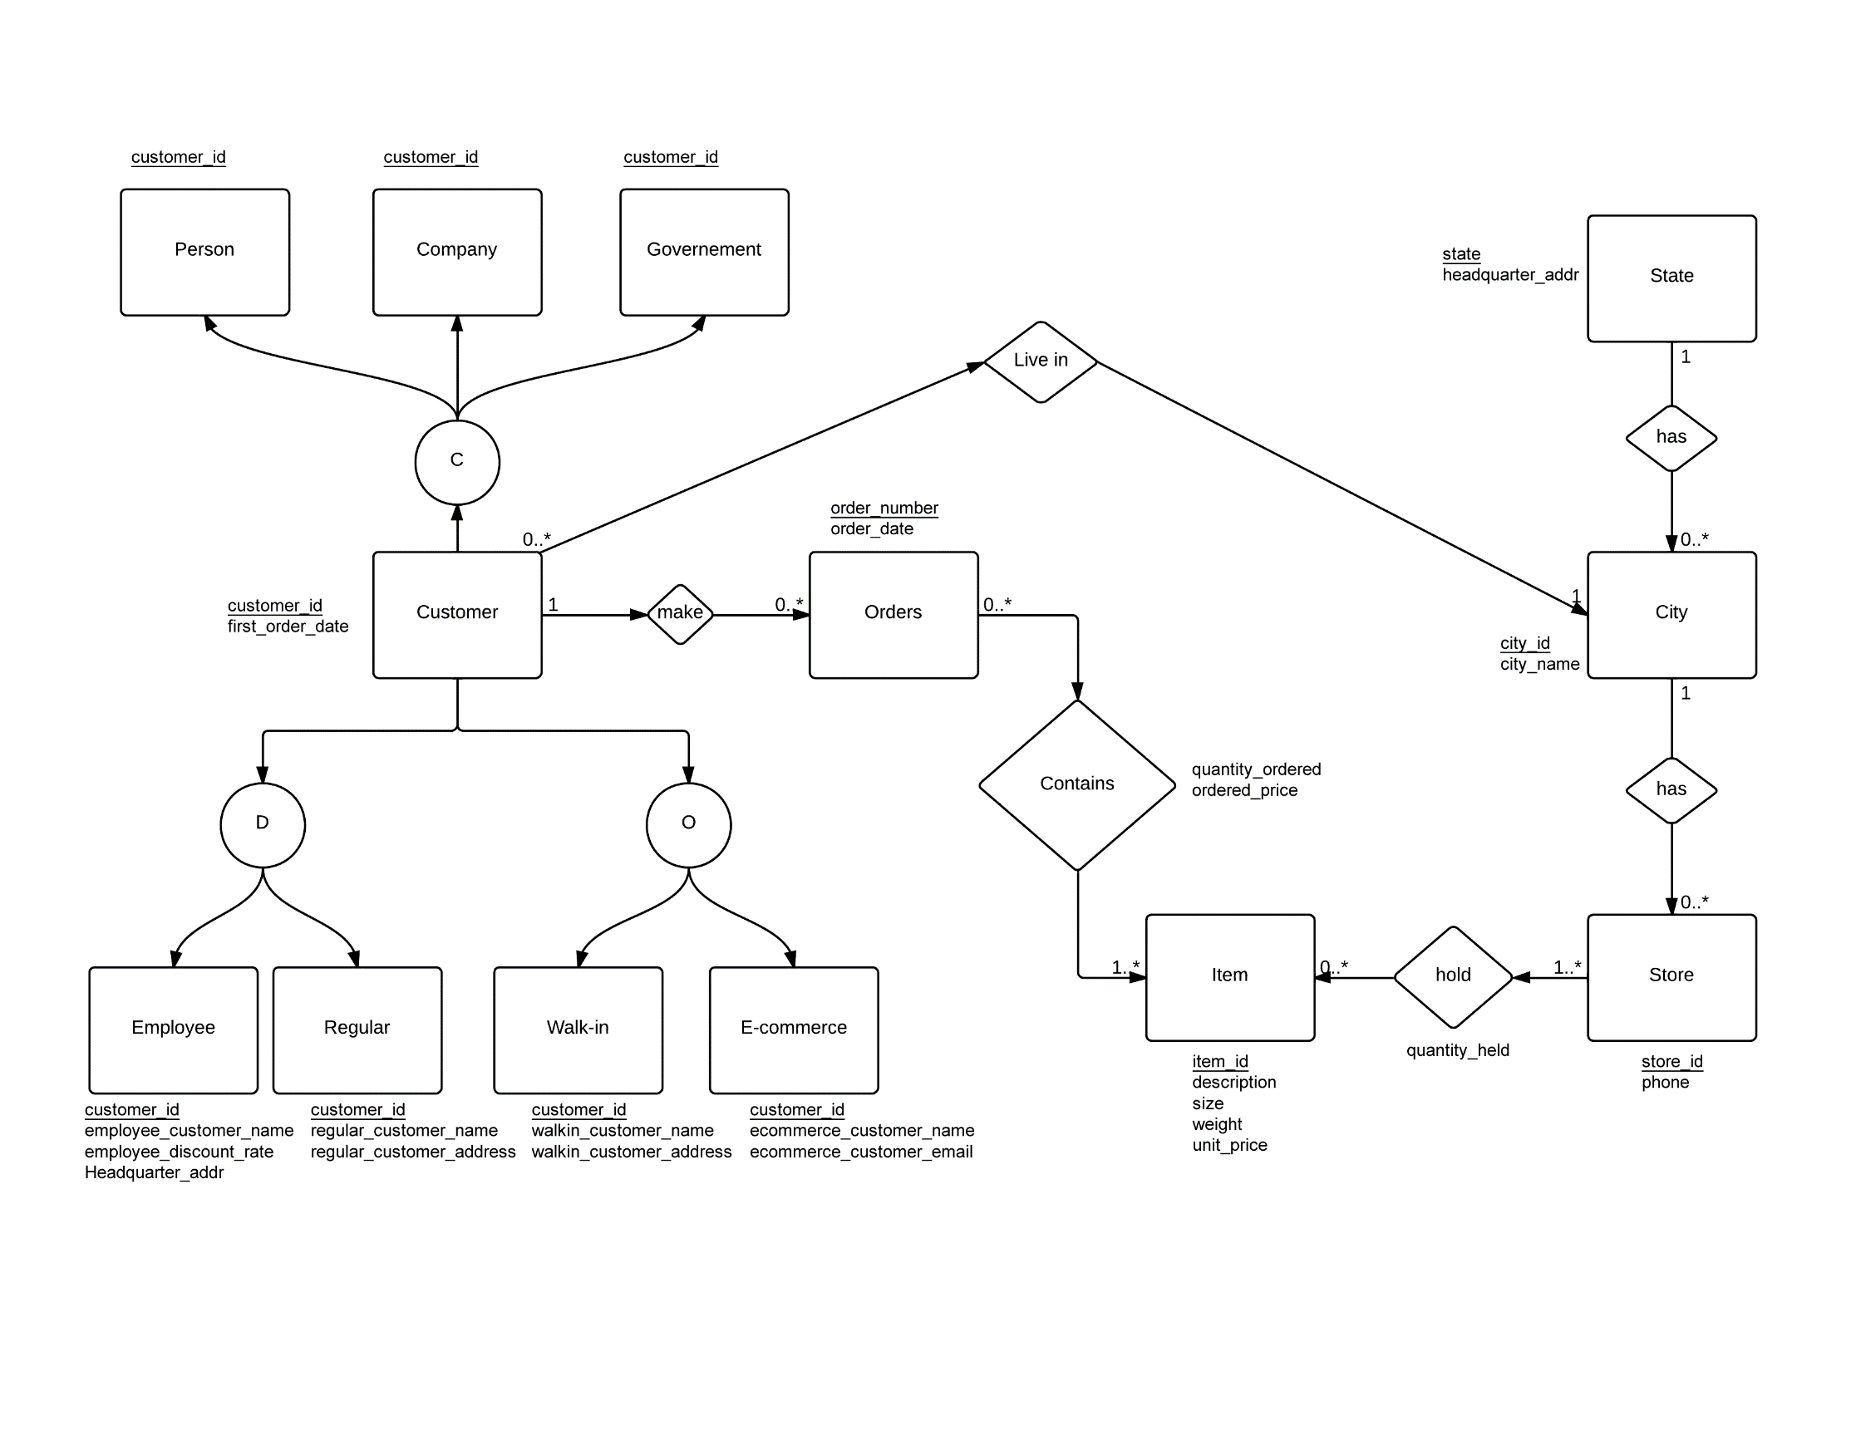

# Data Flow Diagrams

## Report 1

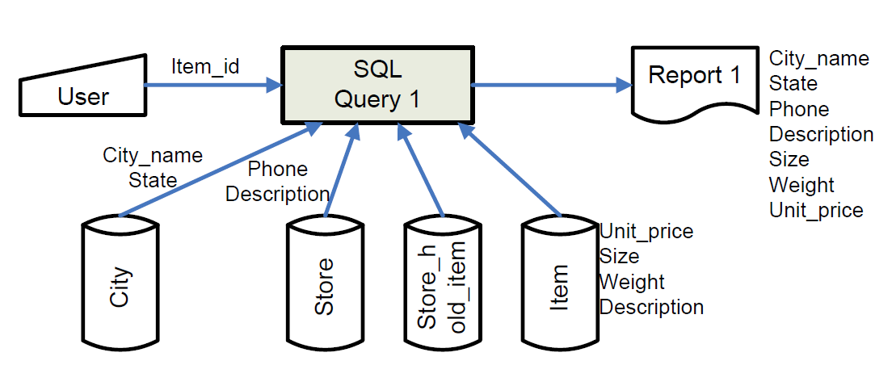

## Report 2

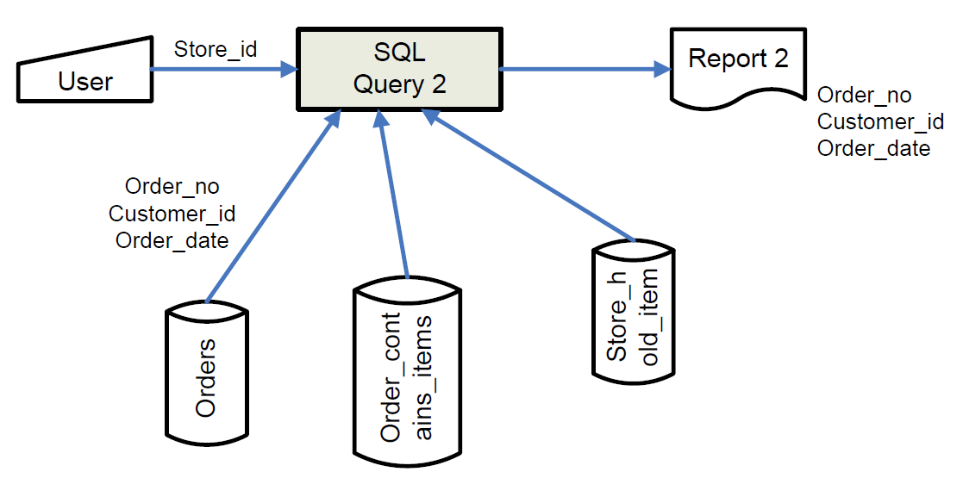

Report 3

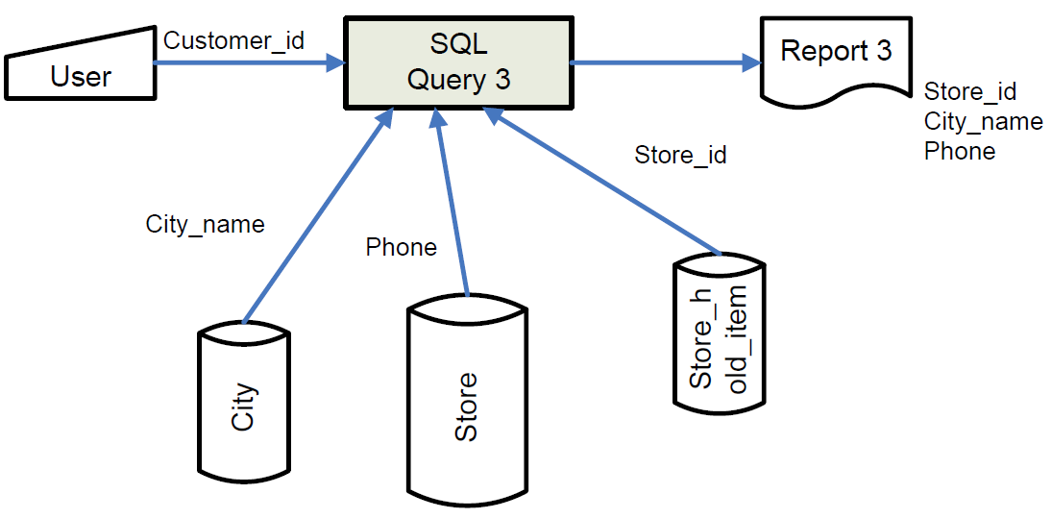

Report 4

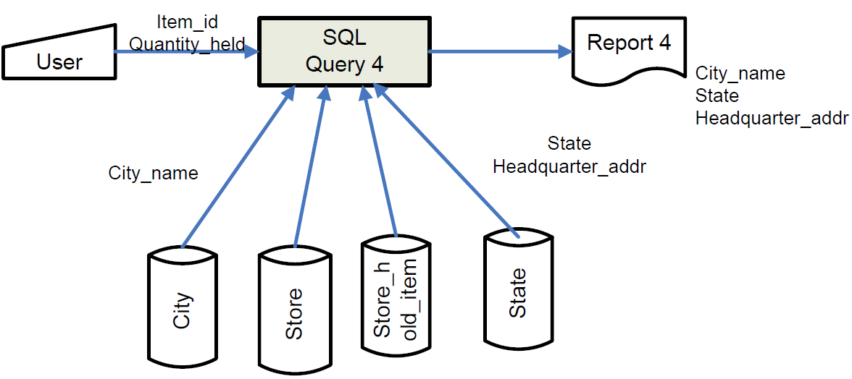

Report 5

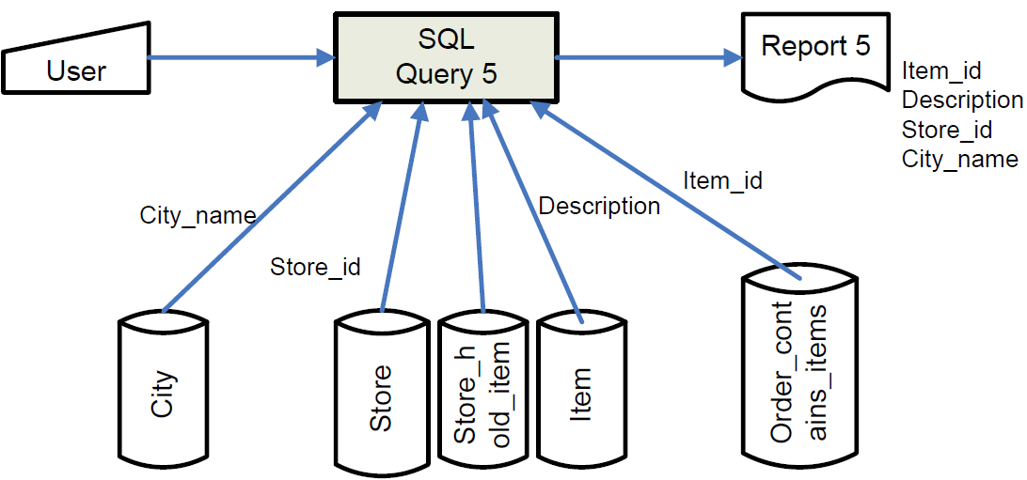

Report 6

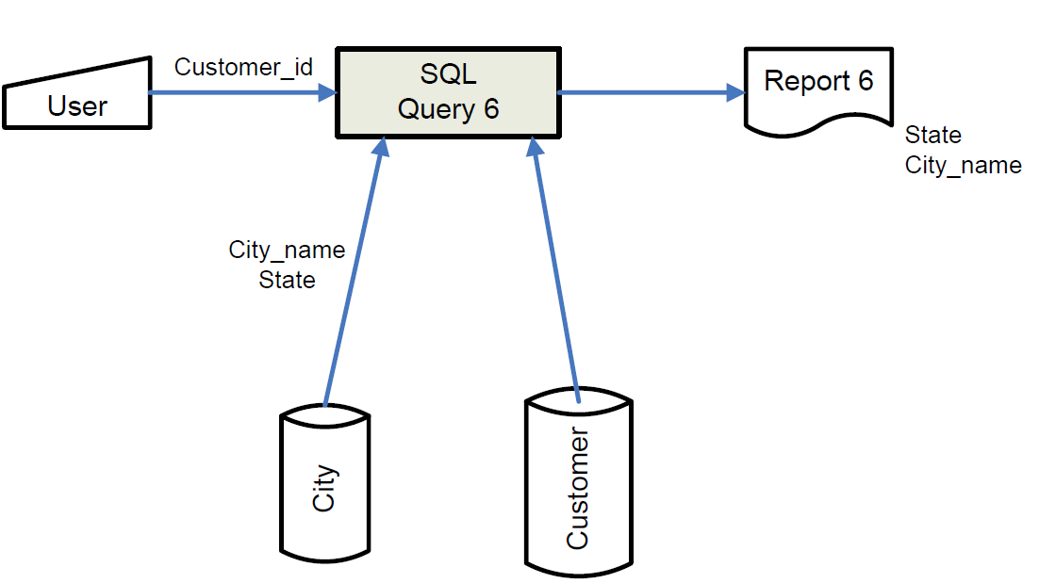

Report 7

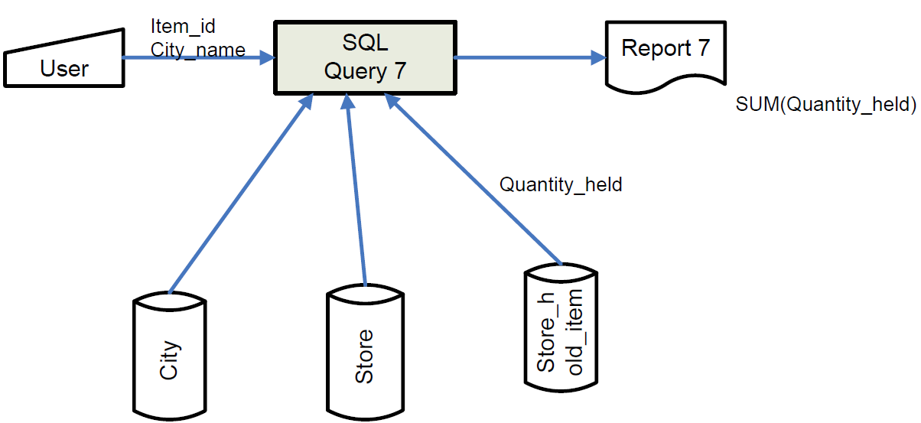

Report 8

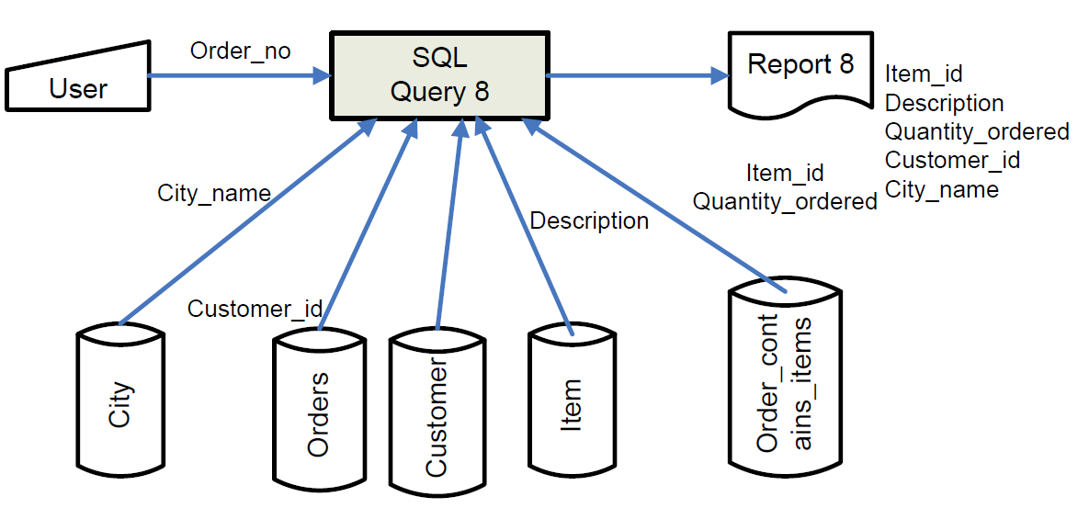

Report 9

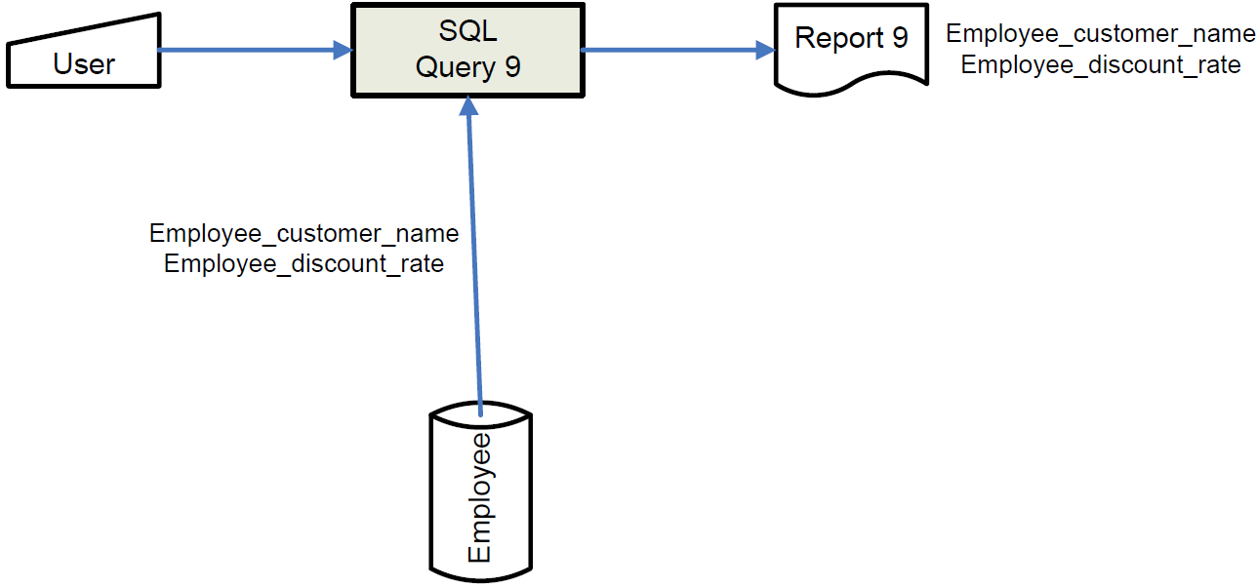

Report 10

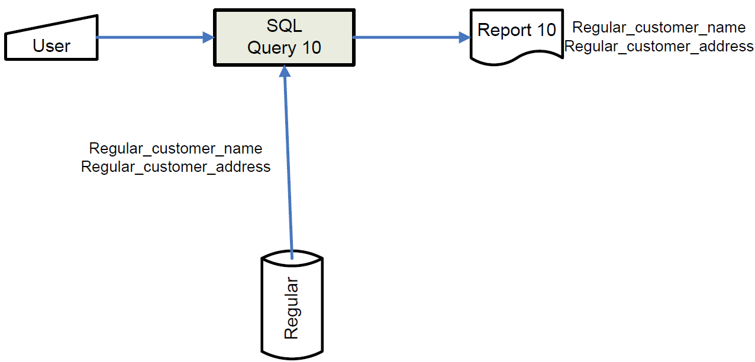

Report 11

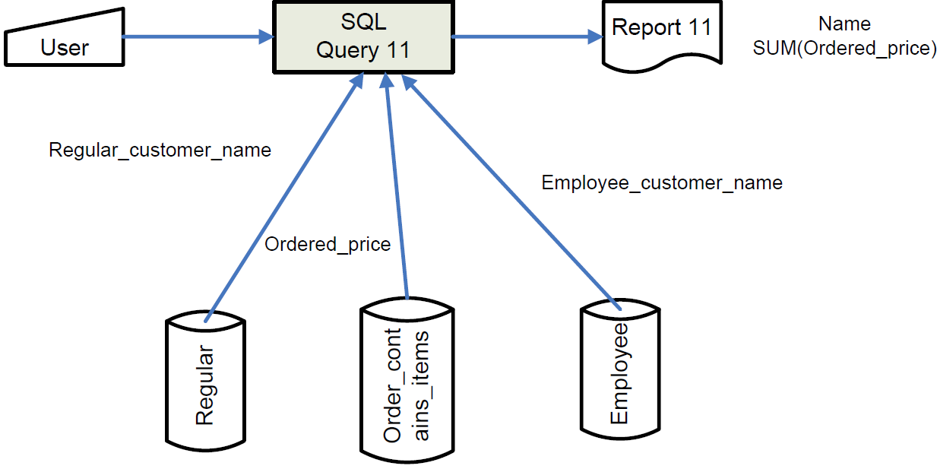

Report 12

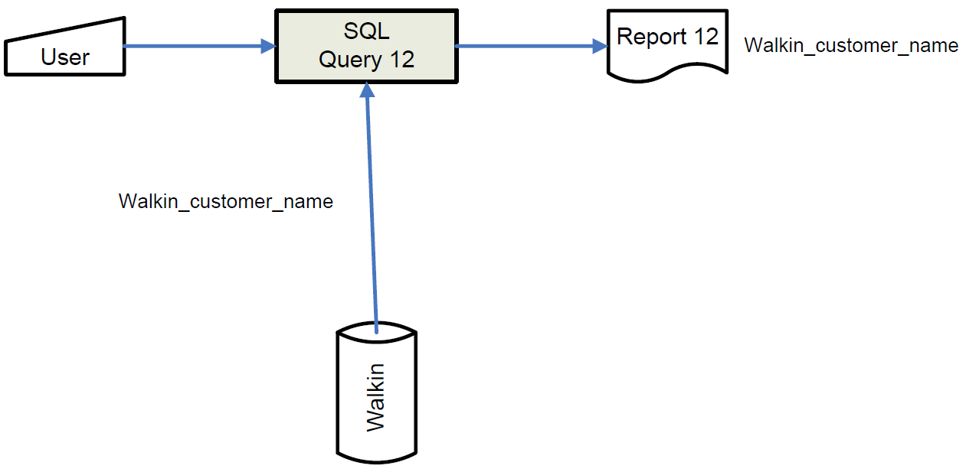

Report 13

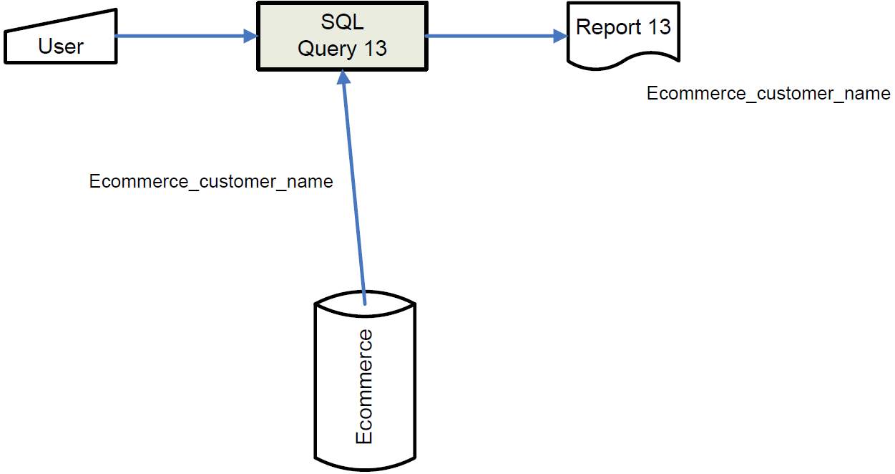

# Relational schema

## General

Relation State (State, Headquarter_addr);

Relation City (City_id, City_name,*State);

Relation Store (Store_id,*City_id, Phone);

Relation Item (Item_id, Description, Size, Weight, Unit_price);

Relation Store_hold_Item (*Store_id, *Item_id, Quantity_held);

Relation Customer (Customer_id, First_order_date, *City_id);

Relation Order (Order_no, Order_date, *Customer_id);

Relation Order_contains_items (*Item_id, *Order_no, Quantity_ordered, Ordered_price);

Relation Person (Customer_id);

Relation Company (Customer_id);

Relation Government (Customer_id);

Relation Employee (*Customer_id, Employee_customer_name, Employee_discount_rate, Headquarter_addr);

Relation Regular (*Customer_id, Regular_customer_name, Regular_customer_address);

Relation WalkIn (*Customer_id, Walkin_customer_name, Walkin_customer_address);

Relation ECommerce (*Customer_id, Ecommerce_customer_name, Ecommerce_customer_email)

## Detailed

CREATE TABLE State (

State CHAR(20),

Headquarter_addr CHAR(4),

PRIMARY KEY(State)

);

CREATE TABLE City (

City_id CHAR(4),

City_name CHAR(15),

State CHAR(15),

PRIMARY KEY(City_id),

FOREIGN KEY(State) REFERENCES States(State)

);

CREATE TABLE Store (

Store_id CHAR(4),

City_id CHAR(4),

Phone CHAR(8),

PRIMARY KEY(Store_id),

FOREIGN KEY(City_id) REFERENCES City(City_id)

);

CREATE TABLE Item (

Item_id CHAR(4),

Description CHAR(40),

Size CHAR(40),

Weight REAL,

Unit_price REAL,

PRIMARY KEY(Item_id)

);

CREATE TABLE Store_hold_Item (

Store_id CHAR(4),

Item_id CHAR(4),

Quantity_held INT,

PRIMARY KEY(Store_id, Item_id),

FOREIGN KEY(Store_id) REFERENCES Store(Store_id),

FOREIGN KEY (Item_id) REFERENCES Item(Item_id)

);

CREATE TABLE Customer (

Customer_id CHAR(4),

First_order_date DATE,

City_id CHAR(4),

PRIMARY KEY(Customer_id),

FOREIGN KEY(City_id) REFERENCES City(City_id)

);

CREATE TABLE Order (

Order_no CHAR(4),

Order_date DATE,

Customer_id CHAR(4),

PRIMARY KEY(Order_no),

FOREIGN KEY(Customer_id) REFERENCES Customer(Customer_id)

);

CREATE TABLE Order_contains_items (

Item_id CHAR(4),

Order_no INT,

Quantity_ordered INT,

Ordered_price REAL,

PRIMARY KEY(Item_id, Order_no),

FOREIGN KEY(Order_no) REFERENCES Order(Order_no),

FOREIGN KEY(Item_id) REFERENCES Item(Item_id)

);

CREATE TABLE Person (

Customer_id CHAR(4),

PRIMARY KEY(Customer_id)

);

CREATE TABLE Company (

Customer_id CHAR(4),

PRIMARY KEY(Customer_id)

);

CREATE TABLE Government (

Customer_id CHAR(4),

PRIMARY KEY(Customer_id)

);

CREATE TABLE Employee (

Customer_id CHAR(4),

Employee_customer_name CHAR(15),

Employee_discount_rate FLOAT,

Headquarter_addr CHAR(4),

PRIMARY KEY(Customer_id)

FOREIGN KEY(Customer_id) REFERENCES Customer(Customer_id)

);

CREATE TABLE Regular (

Customer_id CHAR(4),

Regular_customer_name CHAR(15),

Regular_customer_address CHAR(80),

PRIMARY KEY(Customer_id)

FOREIGN KEY(Customer_id) REFERENCES Customer(Customer_id)

);

CREATE TABLE WalkIn (

Customer_id CHAR(4),

Walkin_customer_name CHAR(15),

Walkin_customer_address CHAR(80),

PRIMARY KEY(Customer_id)

FOREIGN KEY(Customer_id) REFERENCES Customer(Customer_id)

);

CREATE TABLE ECommerce (

Customer_id CHAR(4),

Ecommerce_customer_name CHAR(15),

Ecommerce_customer_email CHAR(80),

PRIMARY KEY(Customer_id)

FOREIGN KEY(Customer_id) REFERENCES Customer(Customer_id)

);

# Relational database normal form specification

**First Normal form (1NF):** The domain of each attribute contains only atomic values, and the value of each attribute contains only a single value from that domain.

**Second Normal form (2NF):** No non-prime attribute in the table is functionally dependent on a proper subset of any candidate key.

**Third Normal form (3NF):** Every non-prime attribute is non-transitively dependent on every candidate key in the table. The attributes that do not contribute to the description of the primary key are removed from the table. In other words, no transitive dependency is allowed.

**Boyce Codd Normal form (BCNF):** Every non-trivial functional dependency in the table is a dependency on a superkey.

**Fourth Normal form (4NF):** Every non-trivial multivalued dependency in the table is a dependency on a superkey.

**Fifth Normal form (5NF):** Every non-trivial join dependency in the table is implied by the superkeys of the table.

In keeping with these definitions, we can say that the relations in the developed database are normalised as follows:

|  |  |  |
| --- | --- | --- |
| Sr. No. | Relation | Normal Form |
| 1 | State | 5NF |
| 2 | City | 3NF |
| 3 | Store | 3NF |
| 4 | Item | 5NF |
| 5 | Store_hold_item | 3NF |
| 6 | Customer | 5NF |
| 7 | Order | 3NF |
| 8 | Order_contains_items | 3NF |
| 9 | Person | 5NF |
| 10 | Company | 5NF |
| 11 | Government | 5NF |
| 12 | Employee | 5NF |
| 13 | Regular | 5NF |
| 14 | Walkin | 5NF |
| 15 | Ecommerce | 5NF |

# Test cases of the developed database system

# SQL programs listing

## Query 1

SELECT item.item_id as a, store.store_id as b, city.city_id as c, city.city_name as d, city.state as e, store.phone as f, item.description as g,item.size as h, item.weight as i, item.unit_price as j

FROM city, store, item, store_hold_item

WHERE city.city_id = store.city_id

AND store.store_id = store_hold_item.store_id

AND store_hold_item.item_id = item.item_id

AND item.item_id =<user_input>

ORDER BY store.store_id;

## Query 2

SELECT Orders.order_no as order, Orders.Customer_id as id, Orders.order_date as orderdate

FROM orders, Order_contains_items, Store_hold_Item

WHERE Store_hold_Item.store_id=<user_input>

AND Order_contains_items.order_no=orders.order_no

AND NOT EXISTS (

SELECT *

FROM Order_contains_items, Store_hold_Item

WHERE Order_contains_items.quantity_ordered>Store_hold_Item.quantity_held

AND Store_hold_Item.store_id='"+a+"'

AND Order_contains_items.order_no=orders.order_no

);

## Query 3

SELECT Store_hold_Item.item_id as items, Store_hold_Item.store_id as stores, city.city_name as city, store.phone as phone

FROM Store_hold_Item, store, city

WHERE (

Store_hold_Item.item_id

IN (

SELECT Order_contains_items.item_id

FROM Order_contains_items

WHERE Order_contains_items.order_no = Orders.order_no

AND Orders.Customer_id =<user_input>

)

)

AND Store_hold_Item.store_id=store.store_id

AND store.city_id=city.city_id;

## Query 4

SELECT city.city_name as city, state.state as state, state.headquarter_addr as hq

FROM city, state, Store_hold_Item, store

WHERE Store_hold_Item.item_id=<user_input>

AND Store_hold_Item.quantity_held><user_input>

AND Store_hold_Item.store_id=store.store_id

AND store.city_id=city.city_id

AND city.state=state.state;

## Query 5

SELECT Order_contains_items.item_id as id, item.description as des, store.store_id as store, city.city_name as city

FROM Order_contains_items, item, store, city, Store_hold_Item

WHERE Order_contains_items.order_no=<cycle_through_orders>

AND Order_contains_items.item_id=item.item_id

AND Store_hold_Item.item_id=item.item_id

AND Store_hold_Item.store_id=store.store_id

AND store.city_id=city.city_id;

## Query 6

SELECT city.city_name as city, city.state as state

FROM city, customer

WHERE Customer.Customer_id=<user_input>

AND Customer.city_id=city.city_id;

## Query 7

SELECT SUM(Store_hold_Item.quantity_held) as stock, city.city_name as city, item.item_id as id, item.description as des

FROM Store_hold_Item, city, store

WHERE Store_hold_Item.item_id=<user_input>

AND store.store_id=Store_hold_Item.store_id

AND city.city_id=store.city_id

AND city.city_name=<user_input>;

## Query 8

SELECT Order_contains_items.item_id as item, item.description as des, Order_contains_items.quantity_ordered as qo, Orders.Customer_id as customer, city.city_name as city

FROM orders, item, Order_contains_items, customer, city

WHERE Order_contains_items.order_no=<user_input>

AND Order_contains_items.order_no=orders.order_no

AND item.item_id=Order_contains_items.item_id

AND Orders.Customer_id=Customer.Customer_id

AND Customer.city_id=city.city_name;

## Query 9

SELECT employee.Employee_customer_name as name, employee.Employee_discount_rate as dis

FROM employee

ORDER BY employee.Customer_id;

## Query 10

SELECT regular.Regular_customer_name as name, regular.Regular_customer_address as address

FROM regular

ORDER BY regular.Customer_id;

## Query 11

SELECT Regular.Regular_customer_name as name, SUM(Order_contains_items.ordered_price) as sales

FROM regular, Order_contains_items

WHERE regular.Customer_id=orders.Customer_id

AND Order_contains_items.order_no=orders.order_no

UNION

SELECT Employee.Employee_customer_name as name, SUM(Order_contains_items.ordered_price) as sales

FROM employee, Order_contains_items

WHERE employee.Customer_id=orders.Customer_id

AND Order_contains_items.order_no=orders.order_no

ORDER BY sales;

## Query 12

SELECT walkin.Walkin_customer_name as name

FROM walkin

ORDER BY walkin.Walkin_customer_name;

## Query 13

SELECT ecommerce.Ecommerce_customer_name as name, ecommerce.Ecommerce_customer_email as email

FROM ecommerce

ORDER BY ecommerce.Ecommerce_customer_email;

# ScreenCAM Demonstration CD