CA#1

B11209013 大氣一 甘祐銓

1. Data source: 46810-2018072100.edt.txt

The data is from SCSMITX 2018 sounding data.

1. 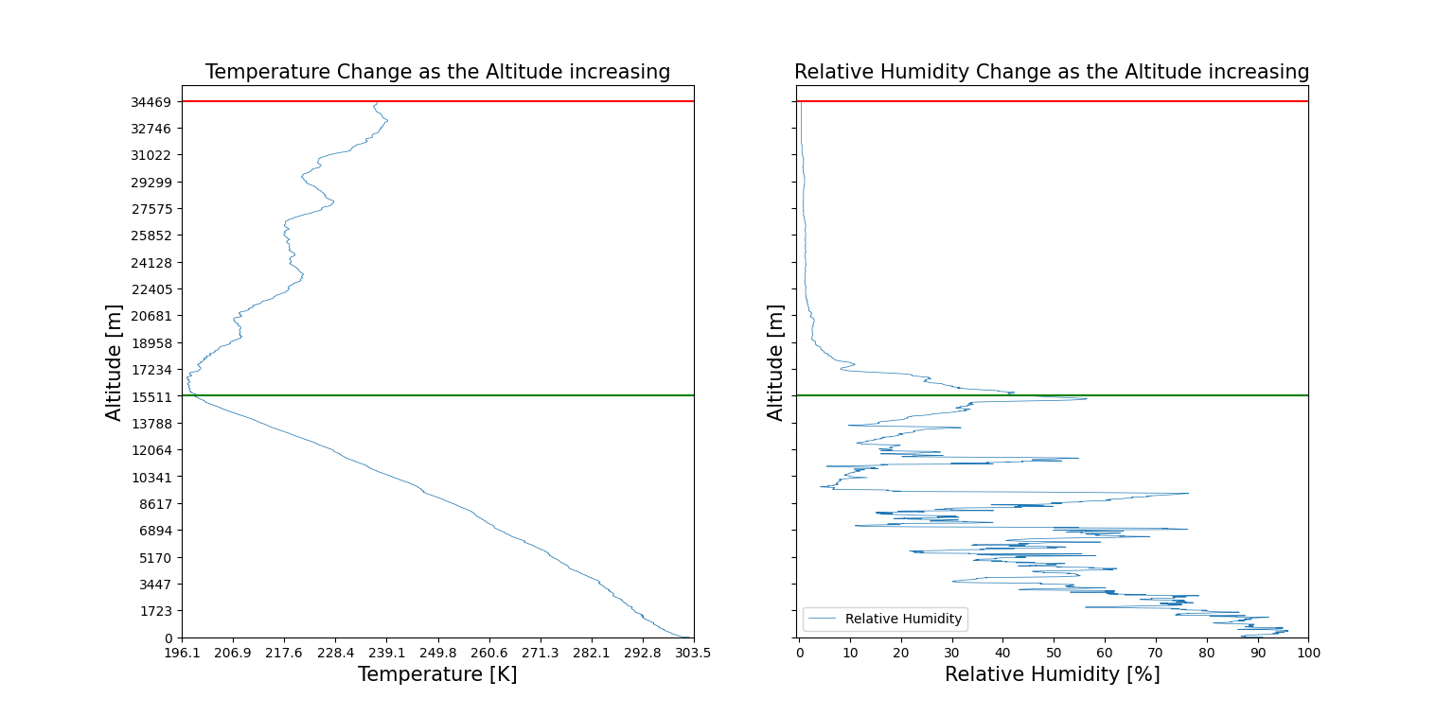Comparison of temperature and relative humidity in altitude coordinate

Graph interpretation:

The red line in both graphs is the upper limit of weather balloon.

The green line is the altitude of 15512 m, where the temperature changing tendency changed.

Comparison of the two graphs:

The temperature is constantly decreasing as the altitude increasing below 15512 m. Between 0~3500 m, the lase rate is about -5.7K/km. Between 3500~tropopause, the lapse rate is about -7.08K/km. At the same time, the relative humidity can’t be described in a simple way. However, the relative humidity changing tendency is also decreasing as the altitude increasing. This can show that the percentage of water vaper in the atmosphere is decreasing as the altitude increasing because saturating vapor pressure is positively related to temperature.

In stratosphere, there is 4 inverse layers.

When the altitude is higher than 15512 m, the tendency of temperature seems to become increasing as the altitude increasing. Thus, the saturating vapor pressure increasing, but the relative humidity becomes lower. This may show that the volume of water vapor higher than 15512 m is stable, or to say, the volume is small. As the temperature increasing, the relative humidity decreases rapidly.

Thus, we can roughly regard 15512 m is the approximate tropopause.

1. 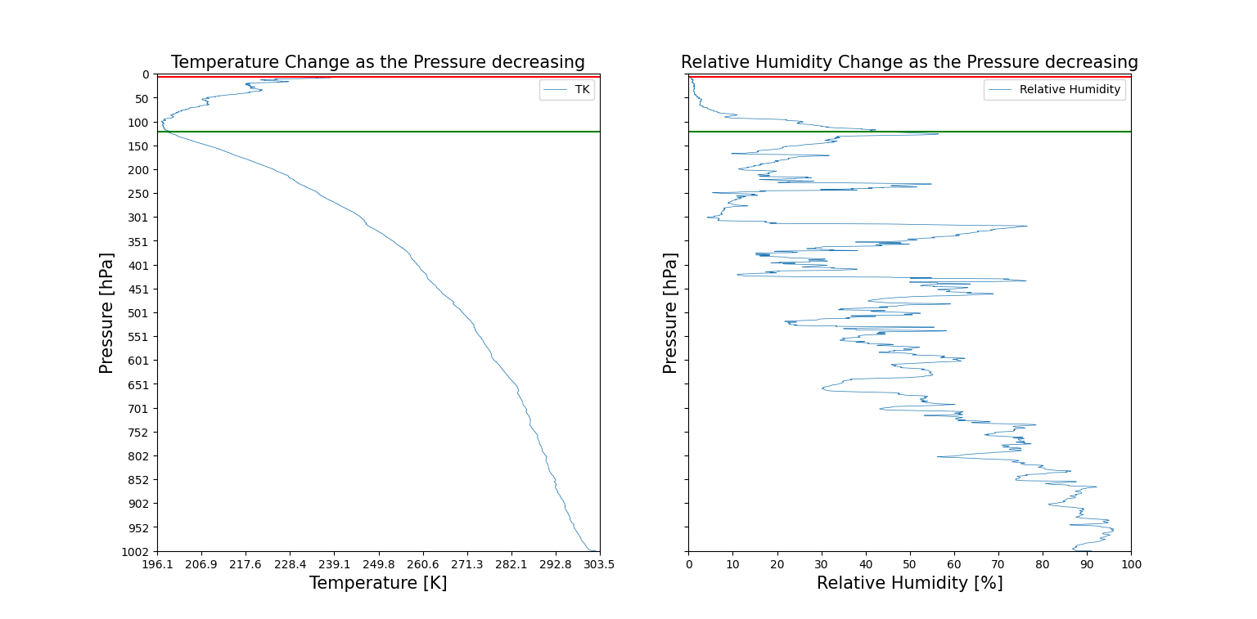Comparison of temperature and relative humidity in pressure coordinate

Graph interpretation:

The red line in both graphs is the upper limit of weather balloon.

The green line is the pressure of 122.2 hPa, where the temperature changing tendency changed, corresponding the altitude of 15512 m.

Comparison of the two graphs:

The temperature is constantly decreasing as the pressure decreasing before the value reach 122.2 hPa. Meanwhile, the relative humidity can’t be described in a simple way. However, the relative humidity changing tendency is also decreasing as the pressure decreasing. This can show that the percentage of water vaper in the atmosphere is decreasing as the altitude increasing because saturating vapor pressure is positively related to temperature.

When the pressure is lower than 122.2 hPa, the tendency of temperature seems to become increasing as the pressure decreasing. Thus, the saturating vapor pressure increasing, but the relative humidity becomes lower. This may show that the volume of water vapor higher than 122.2 hPa is stable, or to say, the volume is small.

Compare with altitude coordinate, pressure coordinate can highlight the difference between quantities in the troposphere because the troposphere including about 90% mass of the whole air column.

1. 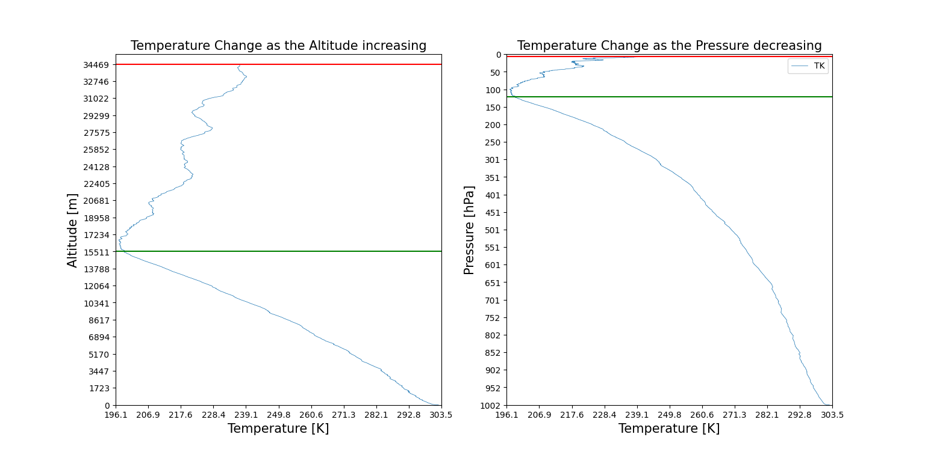Comparison of temperature in altitude and pressure coordinate

For the altitude coordinate, the troposphere altitude thickness occurs 45% of the whole altitude of weather balloon. However, the troposphere pressure thickness occurs 87.8% of the whole pressure of weather balloon. In another word, the 87.8% of the air mass, in the whole air column, is limited in troposphere.

1. 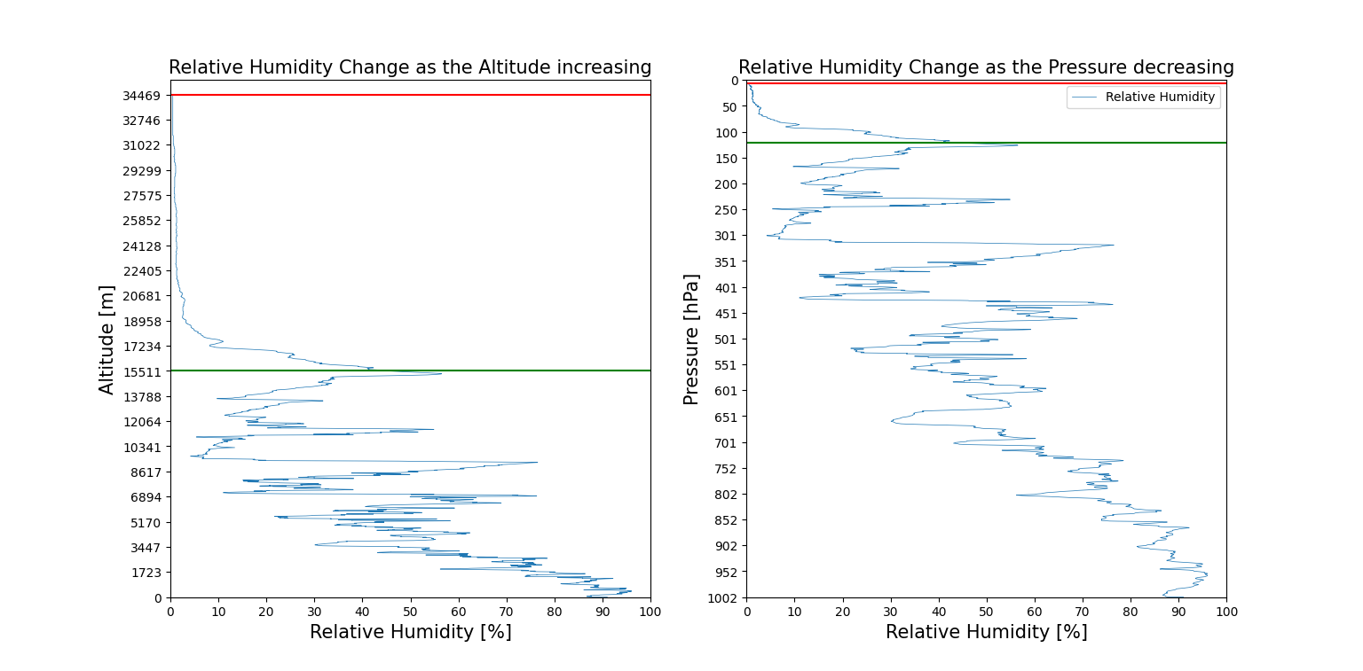Comparison of relative humidity in altitude and pressure coordinate

For the altitude coordinate, the troposphere altitude thickness occurs 45% of the whole altitude of weather balloon. However, the troposphere pressure thickness occurs 87.8% of the whole pressure of weather balloon. In another word, the 87.8% of the air mass, in the whole air column, is limited in troposphere.