CA#2

B11209013 Department of Atmospheric Sciences 甘祐銓

1. Following Class Activity 1, use the soundings to calculate the vertical profiles of the specific humidity and virtual temperature. Plot the vertical profiles of virtual temperature, specific humidity, and temperature. Discuss their vertical structures. (Plot them in height coordinate up to lower stratosphere)

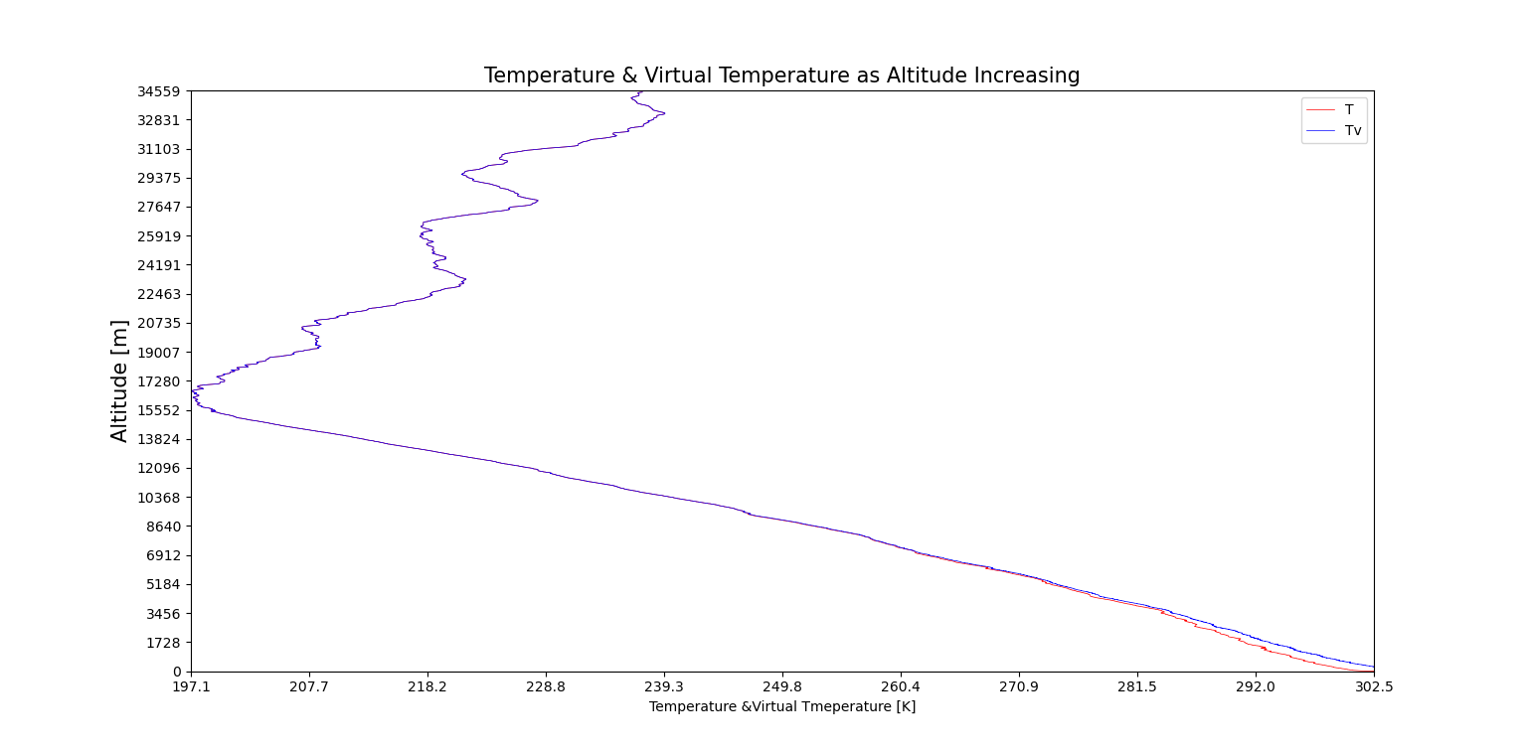

The profile of the temperature and virtual temperature change as altitude increasing. By using programming, we can know, in this data, virtual temperature is always greater than real temperature.

By examining the equation of virtual temperature:

We can know if there is water vapor in surrounding, then virtual temperature must be greater than real temperature.

Form the plot above, we can know that virtual temperature has the same distributional feature as temperature. Thus, we can compare the two data and know that tropopause is roughly occurring at 15512 m from the surface.

Otherwise, the difference between these two figures has become smaller as altitude increasing. Exact difference will be analyzed at the next topic.

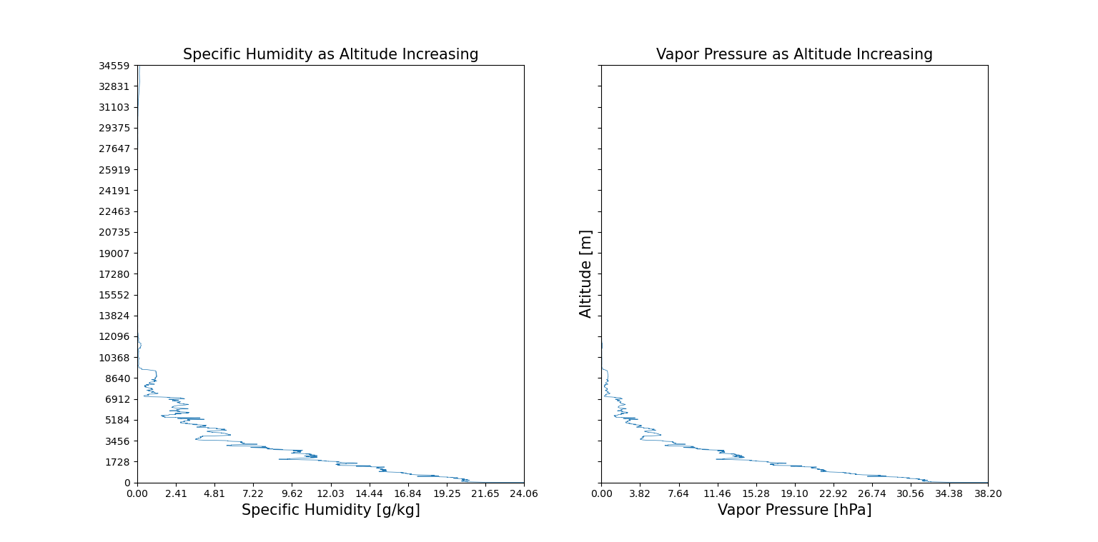

By the definition of specific humidity:

Observing the two graphs above, knowing that both data decreasing as altitude increasing. However, at about the altitude of 31103 m, there is an increasing section of specific humidity. By examining the data, vaper pressure has a little increase when altitude higher than 31103 m. However, pressure is always decreasing as altitude increasing, this causes specific humidity is a great increase in very high altitude.

1. 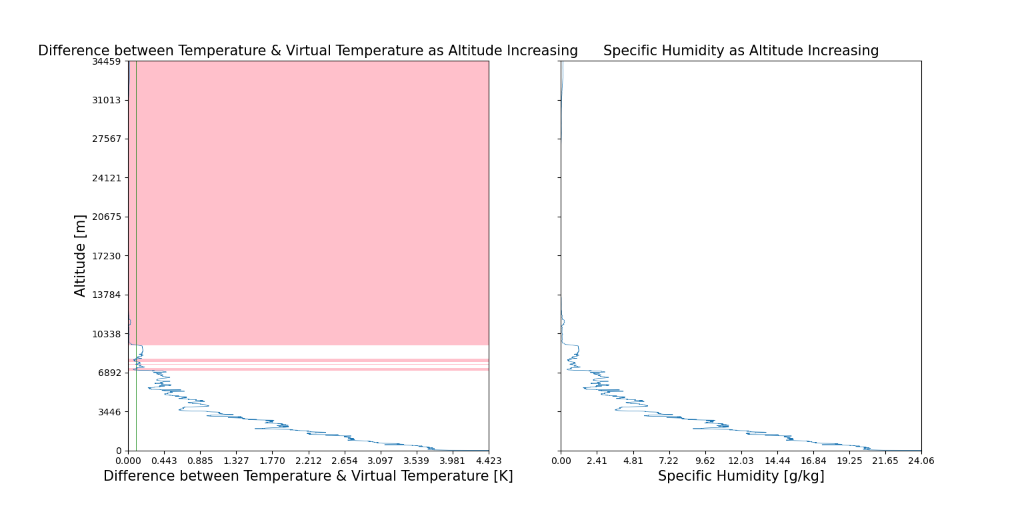Following 1., calculate the vertical profiles of the difference between the virtual temperature and temperature. Start from the surface and find the level when the difference is smaller than 0.1K.

For the left figure, the green vertical line represents the difference is 0.1K, the pink region on the picture represents difference smaller than 0.1K

The left figure represents the difference between temperature and virtual temperature, comparing with specific humidity, the two data has high relationship. By the equation of virtual temperature:

This equation can reflect observations above.

This phenomenon shows that the difference between virtual temperature and temperature is positively relative to specific humidity.

By calculating the relative coefficient of difference and specific humidity, we can explore their relative coefficient is 0.9997533060064201, almost complete positive relative.

1. 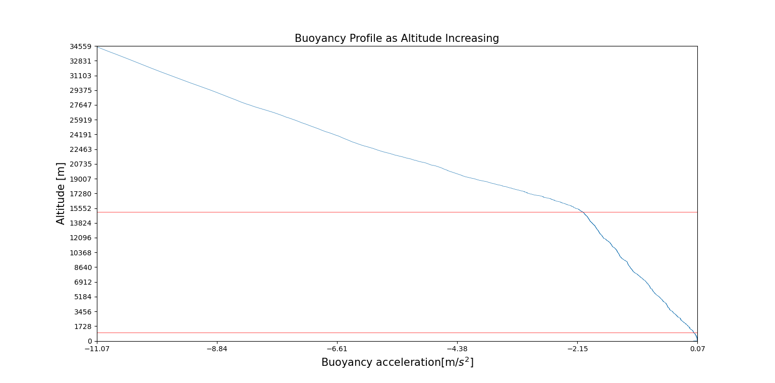Consider a dry air parcel at the surface that has the same density as the first level of your sounding. Set your sounding as environment, what is the buoyancy when the air parcel is lifted to the top of tropopause and 1 km height (Plot the buoyancy profile of the parcel and discuss the feature and value of the profile. Assume that the surface parcel is dry and there’s no condensation, the temperature lapse rate of the parcel is .

The equation of acceleration of air parcel caused by buoyancy:

Due to the air parcel is dry air, the virtual temperature is equal to the real temperature, which is decided by temperature lapse rate of the parcel.

In the graph, there are two red lines. The lower one represents the altitude of 1 kilometer, the upper one is roughly where the tropopause.

The other reason supports 15512 m is roughly tropopause is that: surrounding virtual temperature increasing as altitude increasing in stratosphere, increases. becomes smaller as the altitude increasing, but is increasing as altitude increasing. Relatively, dry air parcel seems to be colder than surroundings. So, acceleration decreasing in stratosphere much faster than troposphere.

The average acceleration changing rate in troposphere is .

The average acceleration changing rate in stratosphere is .

The buoyancy acceleration at 1000 m is , which is calculated by interpolation method, which the data is a altitude 997 m and 1002 m. And the buoyancy at the tropopause is about .

In this topic, valuable discussion only occurs in troposphere and low stratosphere, because the dry air parcel will become no sense temperature in high altitude.

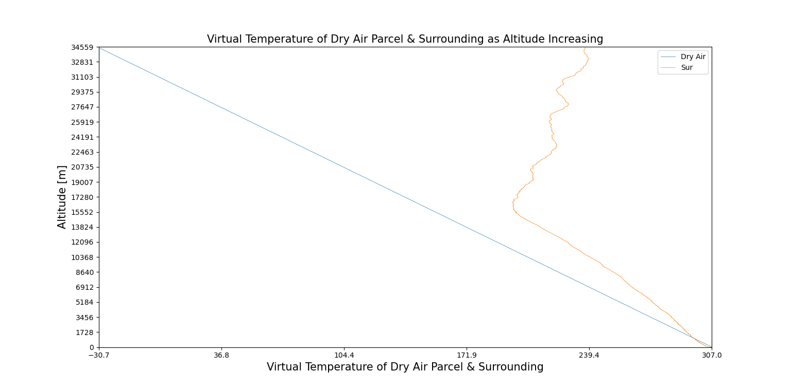The lapse rate of surrounding is smaller than the dry air at near-ground atmosphere, thus the virtual temperature of dry air is higher than surroundings. So, the air parcel will be lifted to an altitude and stay there.

1. Same as 3, but the temperature of the parcel is 10 K higher. Moreover, discuss the difference between 3 and 4.

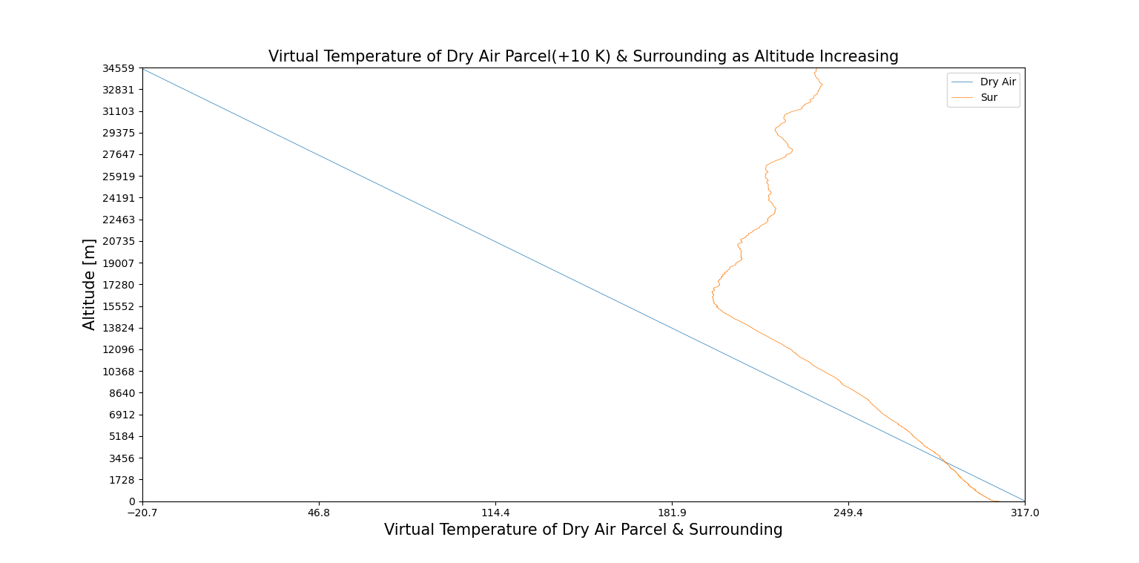

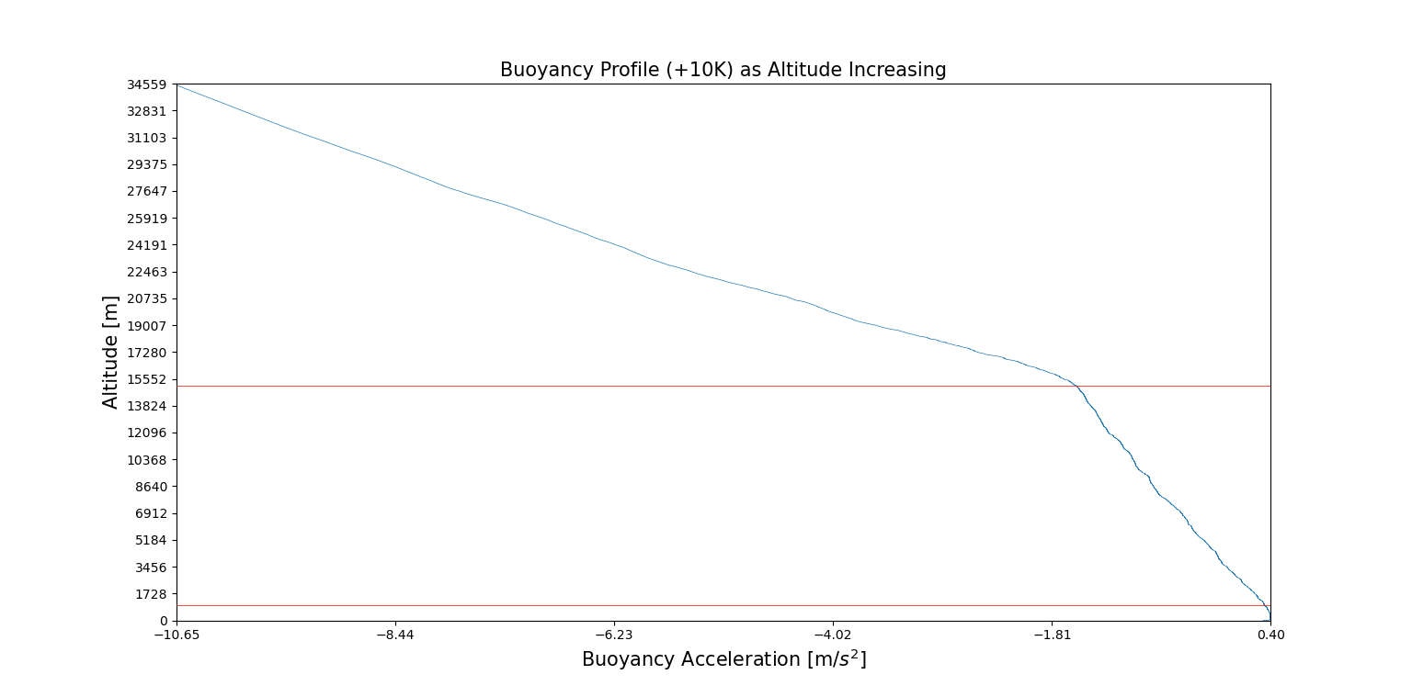The figure above shows that: there is a little section of air column that virtual temperature of dry air is higher than which of surrounding, which means buoyancy in that section is positive, the dry air parcel will be lifted. Compared with which that doesn’t add 10 K, the virtual temperature difference is much more obvious.

Based on the difference of virtual temperature between dry air parcel and surrounding, when the air parcel is near ground, it’ll be lifted into a higher level. However, in much higher level, it becomes lower than surroundings, so it will not be lifted into higher place.

The buoyancy acceleration at 1000 m is , which is calculated by interpolation method, which the data is an altitude 997 m and 1002 m. And the buoyancy at the tropopause is about .

In this topic, valuable discussion only occurs in troposphere and low stratosphere, because the dry air parcel will become no sense temperature in high altitude.