CA4

B11209013 大氣一 甘祐銓

1. Given the sounding, please plot the vertical profiles of dry static energy, discuss the vertical structure, and compare it to the potential temperature.

Figure Plotting:

The graph is composed of static energy and potential temperature. The blue line represents the static energy, the orange line represents potential temperature times heat capacity in isobaric process. The thick blue line represents the tropopause. The thin blue line represents the upper limit of the data.

Discussion:

To derive the relationship between potential temperature and static energy, we need to use the definition of potential temperature and calculus to conduct:

$$θ=T⋅{\left(\frac{P_{0}}{P}\right)}^{\frac{R_{d}}{C_{p}}}$$

$$⇒\ln\left(θ\right)=\ln\left(T\right)+\left(\frac{R_{d}}{C_{p}}\right)(\ln\left(P_{0}\right)-ln⁡(P))$$

$$⇒d\left(\ln\left(θ\right)\right)=d\left(\ln\left(T\right)\right)-\left(\frac{R_{d}}{C_{p}}\right)d(ln⁡(P))$$

$$⇒\frac{1}{θ}dθ=\frac{1}{T}dT-\left(\frac{R_{d}}{C_{p}}\right)\frac{1}{P}dP$$

$$⇒dθ={\left(\frac{P_{0}}{P}\right)}^{\frac{R_{d}}{C_{p}}}dT-\left(\frac{R_{d}}{C_{p}}\right)\frac{1}{P} T⋅{\left(\frac{P_{0}}{P}\right)}^{\frac{R_{d}}{C_{p}}}dP$$

$$⇒dθ=\left(dT-\left(\frac{R_{d}}{C_{p}}\right)\frac{T}{P} dP\right)⋅{\left(\frac{P_{0}}{P}\right)}^{\frac{R_{d}}{C_{p}}}$$

$$⇒dθ=\left(dT-\left(\frac{R_{d}}{C_{p}}\right)\frac{1}{ρR_{d}} dP\right)⋅{\left(\frac{P_{0}}{P}\right)}^{\frac{R_{d}}{C_{p}}}$$

$$⇒dθ=\left(dT-\frac{1}{C_{p}}\frac{1}{ρ}dP\right)⋅{\left(\frac{P_{0}}{P}\right)}^{\frac{R_{d}}{C_{p}}}$$

$$⇒dθ=\left(dT-\frac{1}{C_{p}}\frac{1}{ρ}\left(-ρg\right)dz\right)⋅{\left(\frac{P_{0}}{P}\right)}^{\frac{R_{d}}{C_{p}}}$$

$$⇒dθ=\left(dT+\frac{g}{C_{p}} dz\right)⋅{\left(\frac{P_{0}}{P}\right)}^{\frac{R_{d}}{C_{p}}}$$

$$⇒C_{p}dθ=\left(C_{p}dT+gdz\right)⋅{\left(\frac{P_{0}}{P}\right)}^{\frac{R_{d}}{C_{p}}}$$

$$⇒C_{p}dθ=d\left(S_{d}\right)⋅{\left(\frac{P_{0}}{P}\right)}^{\frac{R_{d}}{C_{p}}}$$

By the relationship of $θ$ and $S_{d}$, we can observe that if $P_{0}≈P$, then:

$$C_{p}dθ≈d\left(S_{d}\right)$$

By the definition of $S_{d}$, the temperature is decreasing, however, the geopotential energy is constantly greater than $C_{p}dT$. In the other cases, the stratosphere temperature is constantly increasing, the sum becomes greater. Therefore, both of lapse rate of the features are greater than troposphere.

In the plot, in lower atmosphere, the two factors are almost the same, however, when the altitude is higher than tropopause, the difference like below:

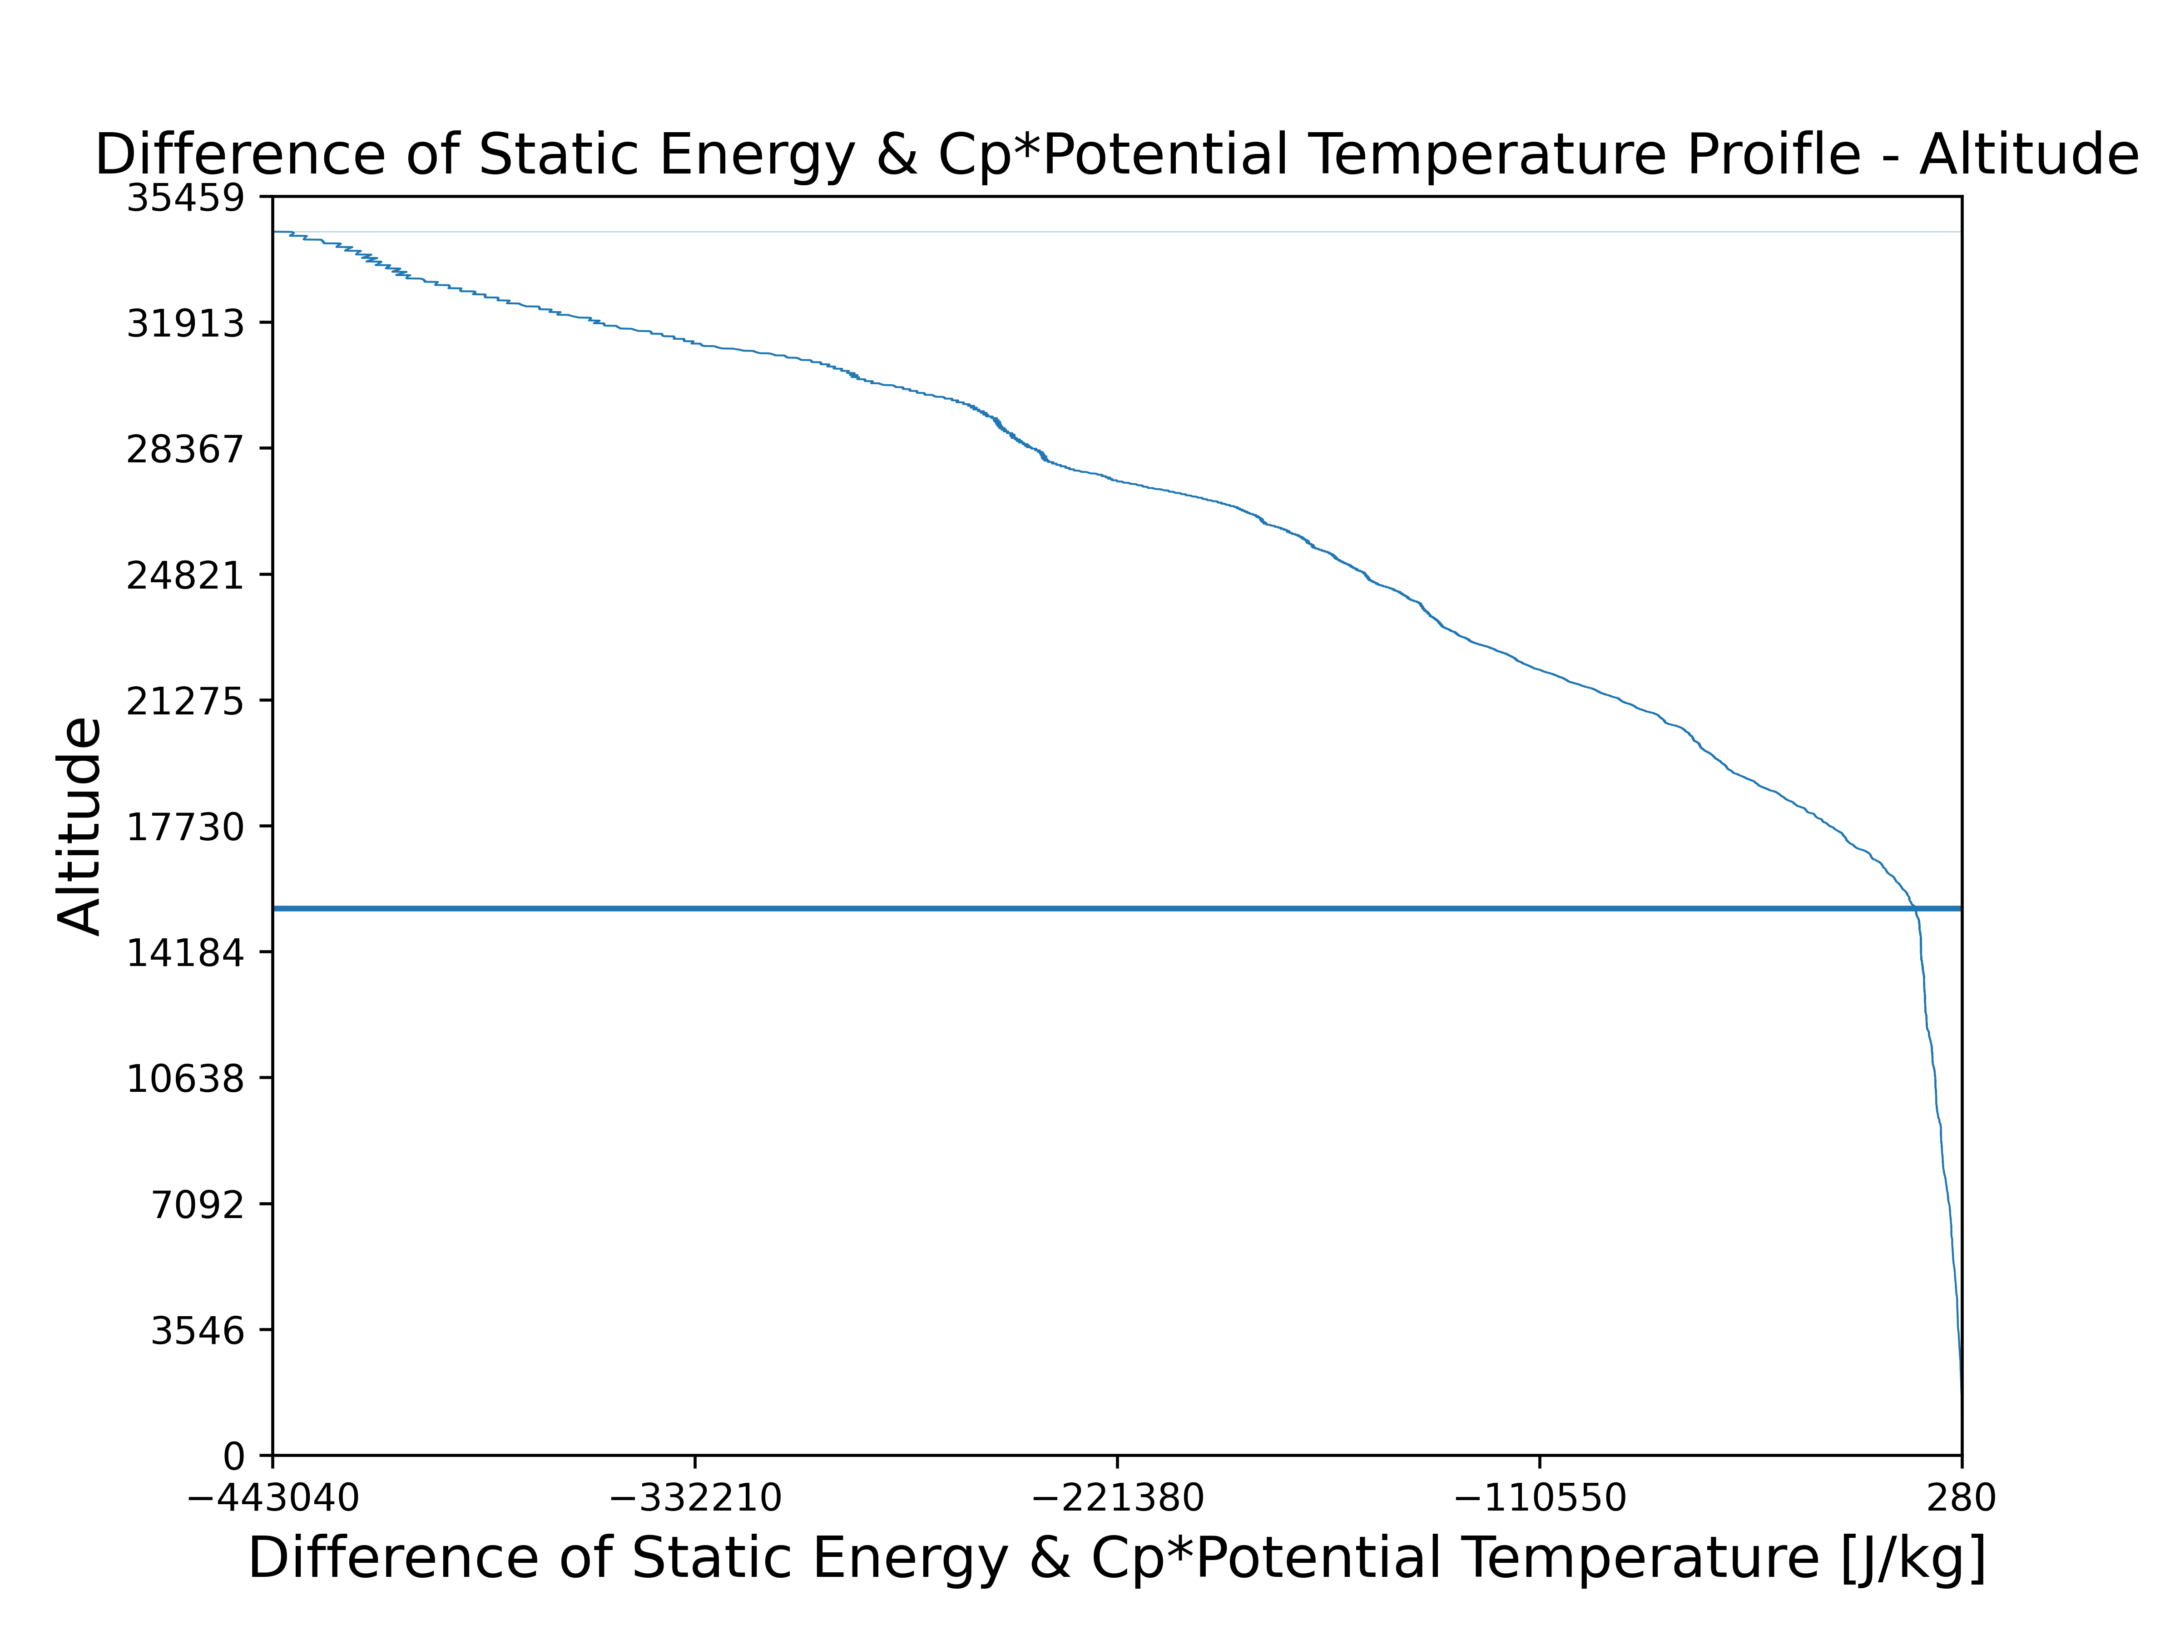

The difference between two features, static energy minus $C_{p}$\*potential temperature, become greater as the altitude increasing.

Because air parcel lifting process in atmosphere can somehow be approximated as adiabatic process. Thus, static energy can be regard as a constant. By the difference be written in:

$$S_{d}-C_{p}θ=S_{d}\left(1-{\left(\frac{P_{0}}{P}\right)}^{\frac{R_{d}}{C_{p}}}\right)$$

In the discussion above, static energy can be regarded as constant. However, the pressure is decreasing as the altitude increasing.

In the discussion above, static energy can be regarded as constant. However, the pressure is decreasing as the altitude increasing. Thus, ${\left(\frac{P_{0}}{P}\right)}^{\frac{R_{d}}{C_{p}}}$ is constantly increasing and positive, $\left(1-{\left(\frac{P_{0}}{P}\right)}^{\frac{R_{d}}{C_{p}}}\right)$ transfer from positive to negative. The difference is constantly decreasing in the profile.

1. Consider an infinitesimally small dry surface parcel which has same temperature as the environment, what is the temperature, potential temperature, and dry static temperature difference between this parcel and the environment if it is moved adiabatically to the tropopause?

For temperature, the profile likes below:

The profile above is the comparison of temperature between the two different conditions.

The reason why the plot only draws the altitude of 16000 m because the temperature of dry are parcel will be no sense in too high altitude.

the blue line represents the sounding profile, the green one represents the condition of dry air parcel. The pink area represents the section of altitude that the temperature of real sound lower than the dry air parcel. Which means that the dry air parcel is easy to lift into upper atmosphere. In another words, the atmosphere below 636 m is unstable, any parcel is likely to lift into higher altitude.

At tropopause, the temperature of

Sounding:

Dry air parcel:

The profile represents the potential temperature of sounding and the dry air parcel. The green line is potential temperature of dry air parcel, and the blue one represents the sounding potential temperature.

By observation, there is a little section that potential temperature of dry air is greater than real sounding. The graph likes below:

There is a intersection a 636 m, this altitude is the same as the temperature of dry air and sounding intersections.

By the definition of potential temperature, the factor that causes the difference is temperature. Therefore, the intersection the same as temperature is reasonable.

At tropopause, the potential temperature of

Sounding:

Dry air parcel:

The plot above shows the static energy of dry air parcel.

The distribution of static energy of dry air parcel seems to be a linear function as altitude increasing.

By the definition of static energy of dry air parcel:

For dry air parcel, can be written in a linear form:

Combining the two equations together:

Therefore, the static energy is a constant when the parcel is lifted to tropopause adiabatically.

This equation shows that the static energy distribution of dry air parcel is linear function.

In the definition of static energy, it’s obvious that it is composed of enthalpy and gravitational energy. As the altitude increases, the gravitational energy increasing, but the temperature decreases, it’ll cause the enthalpy decreasing. Thus, if there is no energy interaction between surrounding and dry air parcel, as so call adiabatic process, the amount of energy in the parcel will not change.

This graph plots the distribution of static energy of real sounding.

the stratosphere temperature is constantly increasing, the sum becomes greater. Therefore, both of lapse rate of the features are greater than troposphere.

The main reason of difference is the difference of lapse rate. The lapse rate of sounding is not as great as dry air; thus, the distribution of static energy will constantly increase.

At tropopause, the potential temperature of

Sounding:

Dry air parcel:

1. Following (2), a line-shaped dry parcel with 1 km thickness is hydrostatic balanced near surface, what is the temperature, potential temperature, and dry static temperature difference between this parcel and the environment if it is moved adiabatically and hit to the tropopause. (Assume that the parcel is still 1 km thick)

Assume that the mass distribution is also homogeneous (by the definition of air parcel). The representative point is at the altitude of 500 m. In this discussion, the initial condition will be set as the sounding where the altitude is 500 m.

And the final state will be divided into 3 cases: top of the line parcel, bottom of the parcel and half of the parcel reaches the tropopause.

Case 1: Top of the parcel

The figure plots temperature of the parcel (blue line) and the surrounding (orange line), the two red lines represent the tropopause and the 500 m altitude. The reason why the feature lines don’t reach the tropopause is because the representative point is at half of the altitude of the parcel.

This figure shows that: temperature of line-shape parcel is constantly equal of lower than surrounding. Due to there is no water vapor in the parcel, its virtual temperature would also constantly lower than the surrounding. Therefore, if there is a parcel like this in this sounding, the parcel is stable, there is no possibility to lift into upper atmosphere if there is no external force done on the parcel.

the temperature that the top of the parcel has reached tropopause:

parcel:

surrounding: (tropopause)

The reason why the temperature in this case will greater than the on in topic two is that the line-shape parcel is homogeneous, so the temperature at the top of the parcel is the same as which at 500 m lower than the tropopause.

The figure plots potential temperature of the parcel (blue line) and the surrounding (orange line), the two red lines represent the tropopause and the 500 m altitude. The reason why the feature lines don’t reach the tropopause is because the representative point is at half of the altitude of the parcel.

the temperature that the top of the parcel has reached tropopause:

parcel:

surrounding: (tropopause)

The possible reason for the difference is difference between lapse rate, which of the surrounding is lower than which of dry air parcel.

Due to the scale of dry air parcel is different from surrounding.

Parcel: , surrounding:

Case 2: Middle of the parcel

The case is discussing about when the middle center of the parcel reaches the tropopause, the figure and value would like below:

Temperature:

Sounding:

Dry air parcel:

Potential temperature:

Sounding:

Dry air parcel:

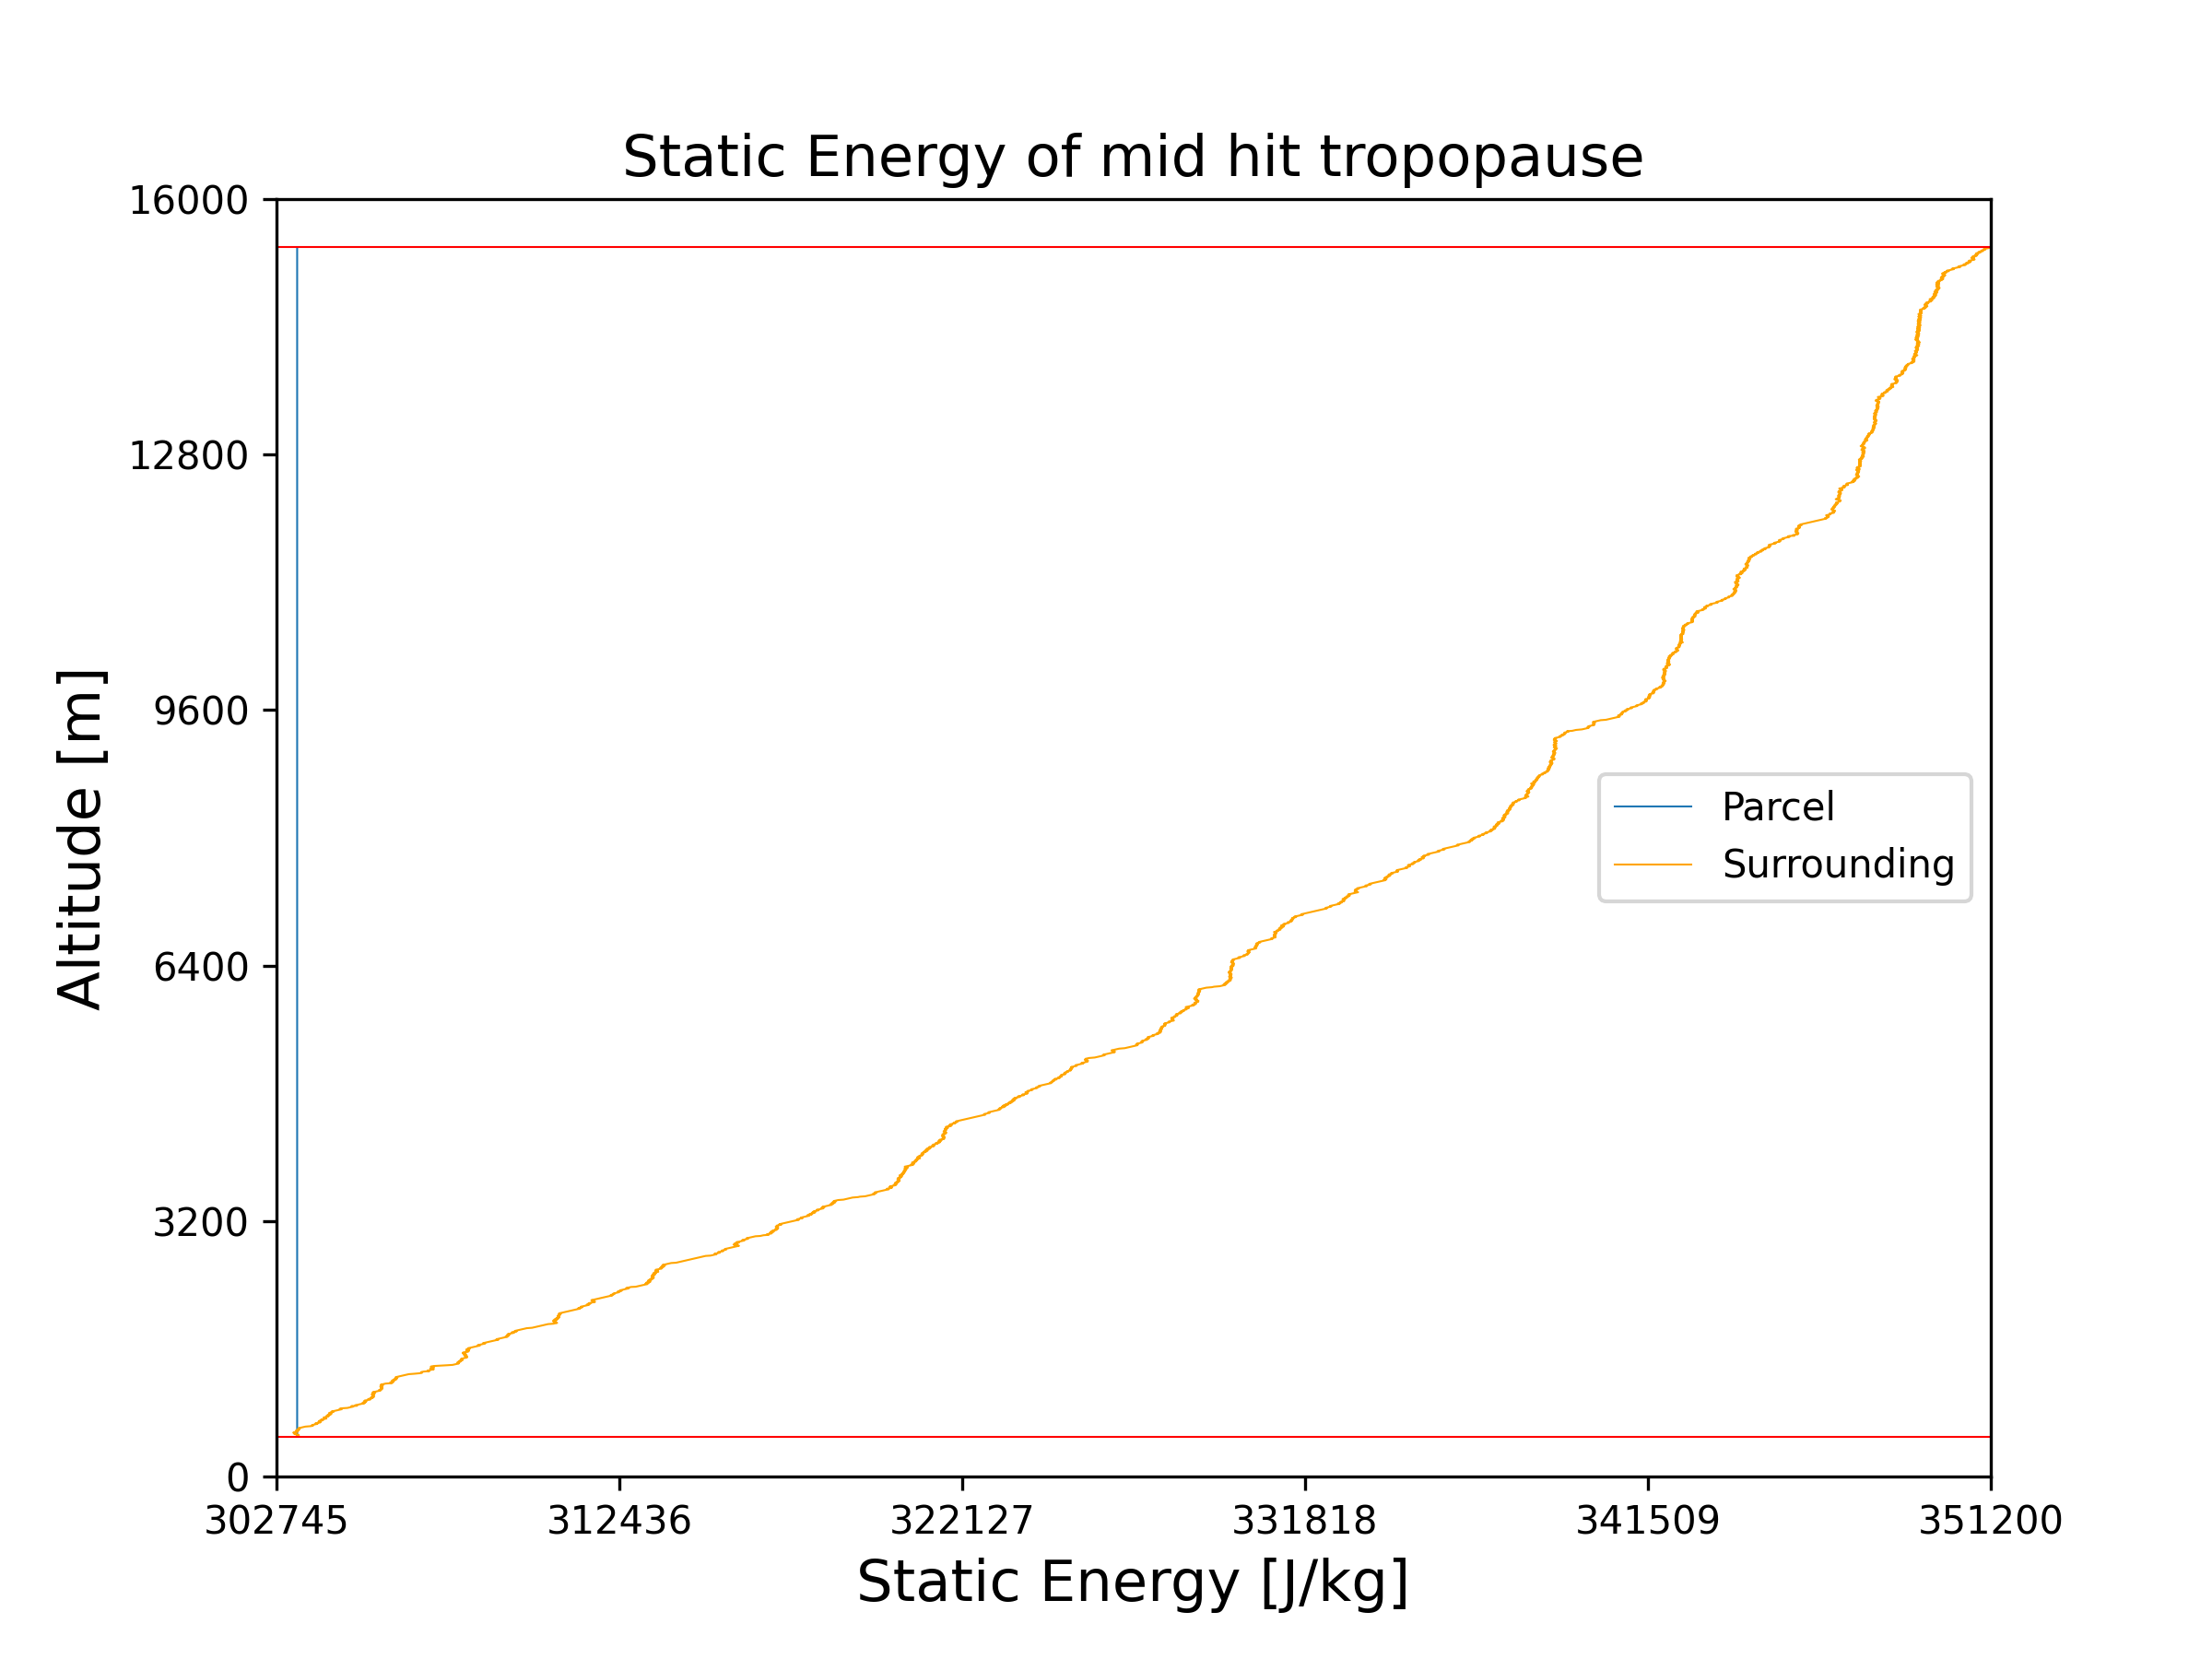Static energy:

Sounding:

Dry air parcel:

Case 3: Bottom of the parcel

Temperature:

Parcel:

Sounding:

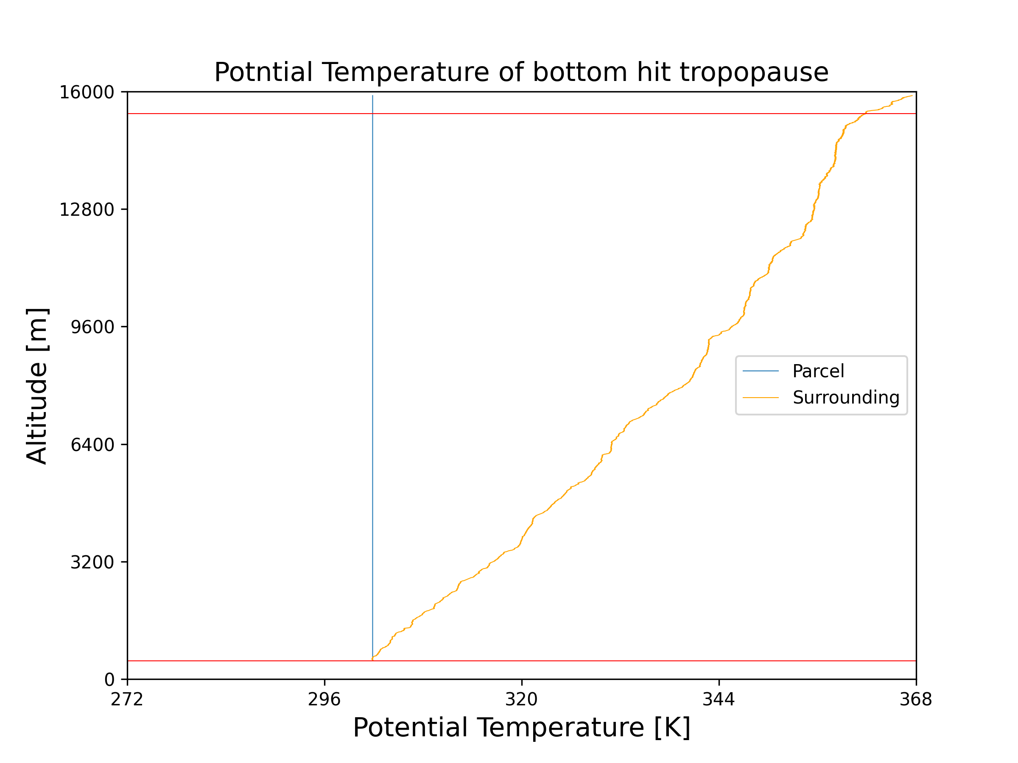

Potential temperature:

Parcel:

Sounding:

Static energy:

Parcel:

Sounding: