(a)

(b)

import math as m

# open hw2_data.txt and read the first line

f0 = open("hw2_data.txt","r")

f0.readline()

f1 = open("hw2b.txt","w")

#write headline of hw2b.txt

f1.write('Time[hh:mm]'+' '+'u[m/s]'+' '+'v[m/s]'+' '+'WS[m/s]'+' '+'WD[deg]'+'\n')

# read data of each row

for i in range(1,25):

a = f0.readline()

b = a.split(' ')

#round WS and WD

WS = float(b[7])

WS = round(WS,1)

b = b[::-1]

WD = float(b[0])

WD = round(WD,1)

b = b[::-1]

#compute U and V

U = WS*m.cos(m.radians(270-WD))

U = round(U,1)

V = WS*m.sin(m.radians(270-WD))

V = round(V,1)

# convert WS and WD into string

WS = str(WS)

WD = str(WD)

#write data into hw2b.txt

if U<0 and V<0:

U = str(U)

V = str(V)

f1.write(b[0]+' '+U+' '+V+' '+WS+' '+WD+'\n')

elif U<0 and V>0:

U = str(U)

V = str(V)

f1.write(b[0]+' '+U+' '+V+' '+WS+' '+WD+'\n')

elif U>0 and V<0:

U = str(U)

V = str(V)

f1.write(b[0]+' '+U+' '+V+' '+WS+' '+WD+'\n')

else :

U = str(U)

V = str(V)

f1.write(b[0]+' '+U+' '+V+' '+WS+' '+WD+'\n')

# close hw2_data.txt and hw2b.txt

f0.close()

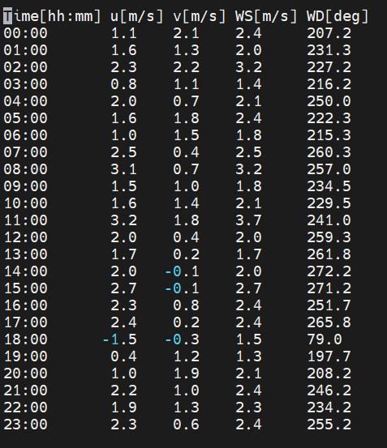f1.close()