Summary:

The colorful feather may be easier to attract predators in other part of the world. While in New Guinea, due to the special geographic feature, bird of paradise can care less about being eaten by the predators, but care about how to continue the species.

Also, in New Guinea, with varied landscape, ethnicities of the same species may be separated into different species through evolution in tens of thousands of years.

Question:

For what kind of geographic features can bird of paradise evolve into what it looks like nowadays？

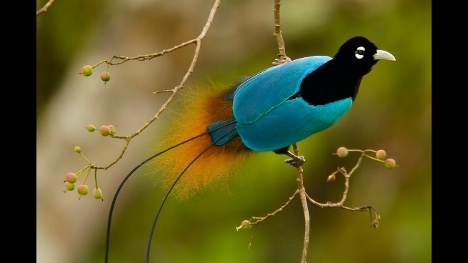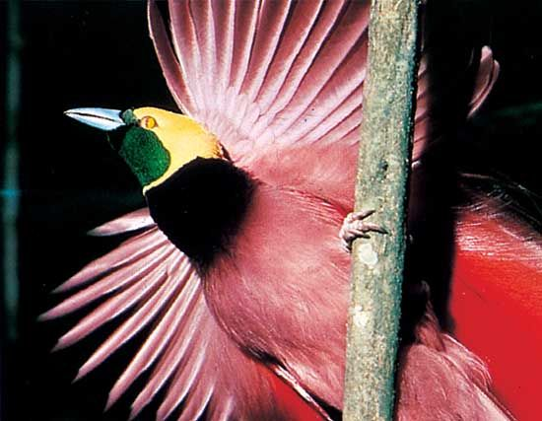

|  |  |  |  |  |
| --- | --- | --- | --- | --- |
| Vocabulary | Line | Definition | Syn. | Ant. |
| contradiction | F8 | A condition that describe two or more things has difference in the same time. | Clash  Collision  conflict | reasonable |
| Undergo | H5 | To do | Conduct |  |
|  |  |  |  |  |
|  |  |  |  |  |
|  |  |  |  |  |