CA#2

B11209013 Department of Atmospheric Sciences 甘祐銓

1. Following Class Activity 1, use the soundings to calculate the vertical profiles of the specific humidity and virtual temperature. Plot the vertical profiles of virtual temperature, specific humidity, and temperature. Discuss their vertical structures. (Plot them in height coordinate up to lower stratosphere)

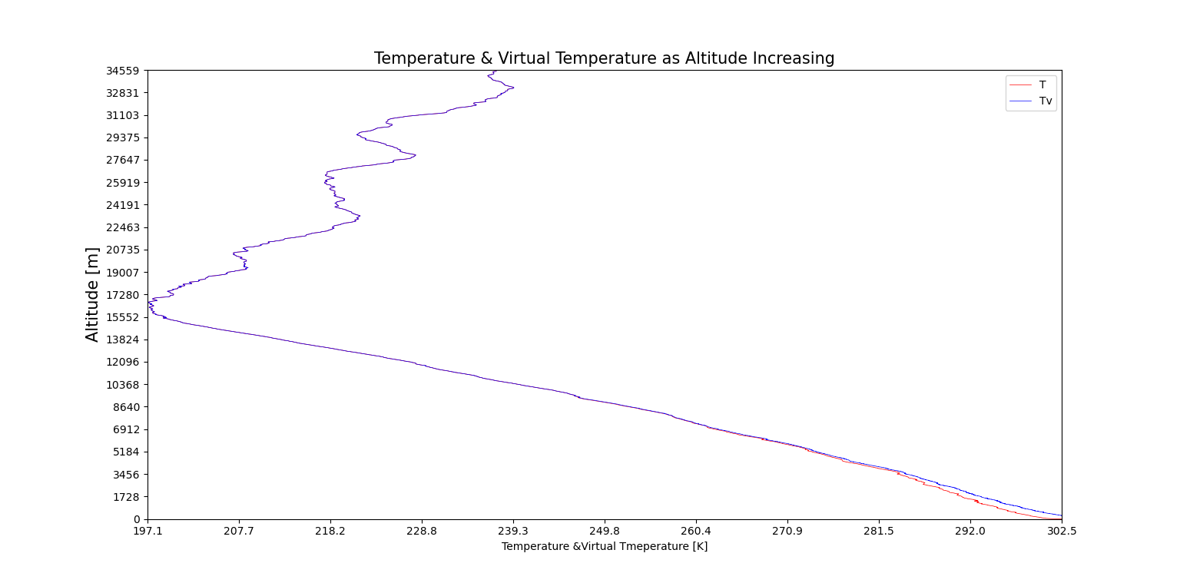

The profile of the temperature and virtual temperature change as altitude increasing. By using programming, we can know, in this data, virtual temperature is always greater than real temperature.

By examining the equation of virtual temperature:

We can know if there is water vapor in surrounding, then virtual temperature must be greater than real temperature.

Form the plot above, we can know that virtual temperature has the same distributional feature as temperature. Thus, we can compare the two data and know that tropopause is roughly occurring at 15512 m from the surface.

Otherwise, the difference between these two figures has become smaller as altitude increasing. Exact difference will be analyzed at the next topic.

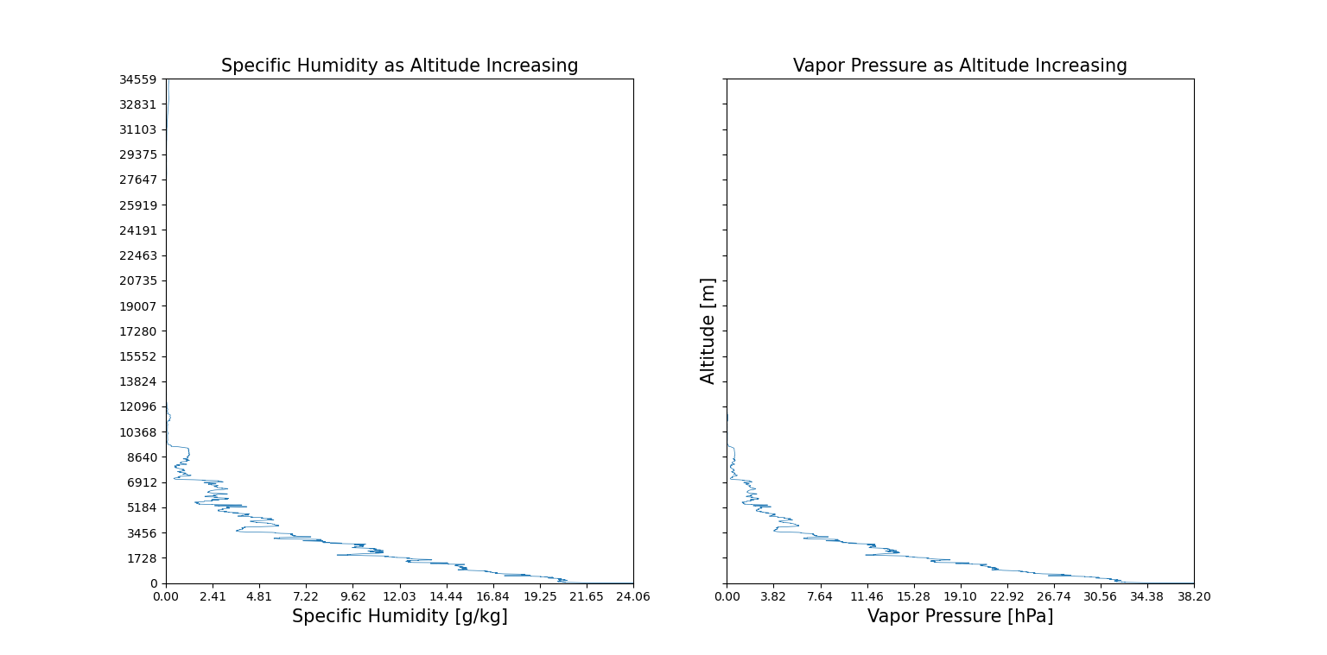

By the definition of specific humidity:

Observing the two graphs above, knowing that both of these two data decreasing as altitude increasing. However, at about the altitude of 31103 m, there is an increasing section of specific humidity. By examining the data, vaper pressure has a little increase when altitude higher than 31103 m. However, pressure is always decreasing as altitude increasing, this causes specific humidity is a great increase in very high altitude.

1. 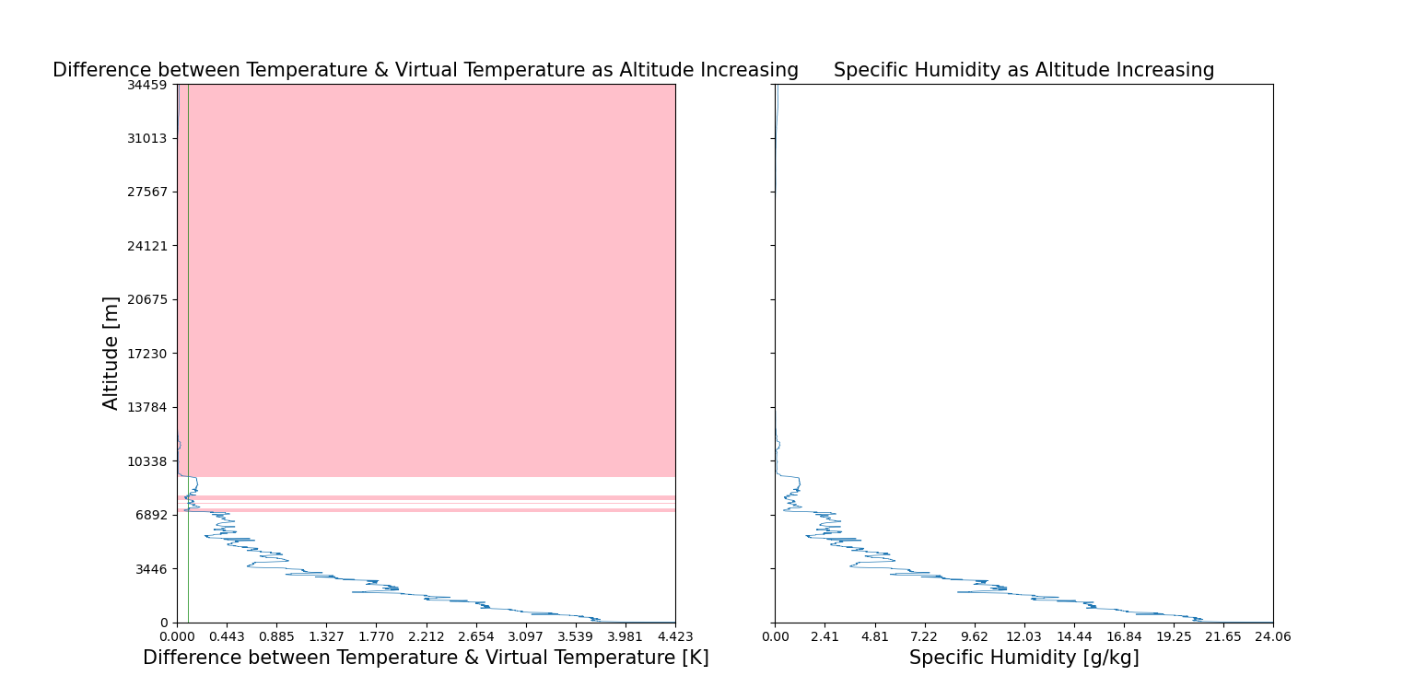Following 1., calculate the vertical profiles of the difference between the virtual temperature and temperature. Start from the surface and find the level when the difference is smaller than 0.1K.

For the left figure, the green vertical line represents the difference is 0.1K, the pink region on the picture represents difference smaller than 0.1K

The left figure represents the difference between temperature and virtual temperature, comparing with specific humidity, the two data has high relationship. By the equation of virtual temperature:

This equation can reflect observations above.

This phenomenon shows that the difference between virtual temperature and temperature is positively relative to specific humidity.

By calculating the relative coefficient of difference and specific humidity, we can explore their relative coefficient is 0.9997533060064201, almost complete positive relative.