**Bangladesh Army University of Science and Technology (BAUST)**

**CSE-4204 Digital Signal Processing**

**Lab Day-7**

Z-Transform

Z-transform is defined as:

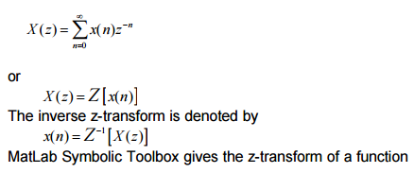

1. %ztransform of finite duration sequence

clc;

close all;

clear all;

syms 'z';

disp('If you input a finite duration sequence x(n), we will give you its z-transform');

nf=input('Please input the initial value of n = ');

nl=input('Please input the final value of n = ');

x= input('Please input the sequence x(n)= ');

syms 'm';

syms 'y';

f(y,m)=(y*(z^(-m)));

disp('Z-transform of the input sequence is displayed below');

k=1;

for n=nf:1:nl

    answer(k)=(f((x(k)),n));

   k=k+1;

end

disp(sum(answer));

**Example of Output**

If you input a finite duration sequence x(n), we will give you its z-transform

Please input the initial value of n = 0

Please input the final value of n = 4

Please input the sequence x(n)= [1 0 3 -1 2]

Z-transform of the input sequence is displayed below

3/z^2 - 1/z^3 + 2/z^4 + 1

**syms ‘z’;**

This statement creates symbolic variable z. syms function is used to creates symbolic variable.

**ztrans(signal, index, point);**

syms n

>> f=0.5^n

f =(1/2)^n

>> ztrans(f)

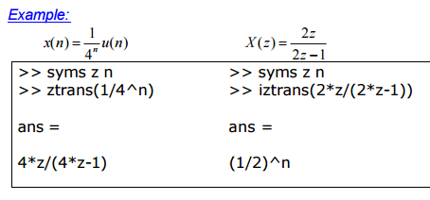

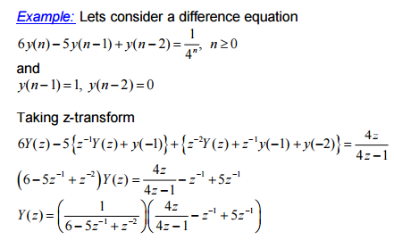



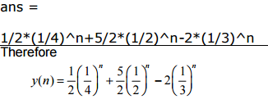

1. **Example:**

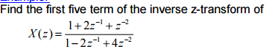

**Z Plan**

Pole-zero Diagram The MatLab function “zplane” can display the pole-zero diagram

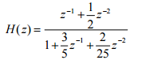

>> b=[0 1 1/2];

>> a=[1 3/5 2/25];

>> zplane(b,a)

### MATLAB program to plot zeros and poles of z-transform

**Program Code**

1. %Plotting zeros and poles of z-transform  
   clc;  
   close all;  
   clear all;  
   disp('For plotting poles and zeros');  
   b=input('Input the numerator polynomial coefficients');  
   a=input('Input the denominator polynomial coefficients');  
   [b,a]=eqtflength(b,a);  
   [z,p,k]=tf2zp(b,a);  
   zplane(z,p);  
   disp('zeros');  
   disp(z);  
   disp('poles');  
   disp(p);  
   disp('k');  
   disp(k);

**Example of Output**

For plotting poles and zeros  
Input the numerator polynomial coefficients[1 2 3 4]  
Input the denominator polynomial coefficients[1 2 3]  
zeros  
  -1.6506            
  -0.1747 + 1.5469i  
  -0.1747 - 1.5469i  
  
poles  
        0            
  -1.0000 + 1.4142i  
  -1.0000 - 1.4142i  
  
k  
  
     1

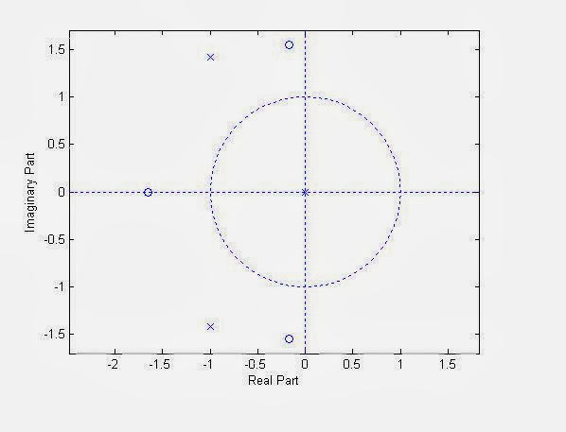

1. Question: x[n] = (1/2) ^ n * u[n] + (-1/3) ^ n * u[n]
2. Find it's z-transform.
3. Plot it's poles and zeros

The birst bit of code you gave uses symbolic math to solve for the z-transform. You'll need to convert the output to a [discrete-time model](http://www.mathworks.com/help/control/examples/creating-discrete-time-models.html) supported by the Control System toolbox.

syms n;

f = (1/2)^n + (-1/3)^n;

F = ztrans(f)

returns z/(z - 1/2) + z/(z + 1/3). You can optionally use [collect](http://www.mathworks.com/help/symbolic/collect.html) to convert this

z/(z - 1/2) + z/(z + 1/3)

F2 = collect(F)

to (12*z^2 - z)/(6*z^2 - z - 1). Then you'll want to find the coefficients of the polynomials in the numerator and denominator and create a discrete-time transfer function object with [tf](http://www.mathworks.com/help/control/ref/tf.html) for a particular sampling period:

[num,den] = numden(F2);

Ts = 0.1; % Sampling period

H = tf(sym2poly(num),sym2poly(den),Ts)

pzmap(H)

## How to matlab z-transform of x(n)=((4/3)^n) u(1-n)

# How can I get the z-transform for the sequence a^|n| (a>0)?

decompose it into 2 sequences, anu[n] and a(-n)u[-n-1] (or should I have it as a(-n-1)u[-n-1] ), is this correct?

ps: with Matlab codes

syms a n

y = ztrans(a^n+a^(-n));

it gives (a*z)/(a*z - 1) - z/(a - z)

   a z            z

-------   -   -----

a z - 1      a - z ,

and y = ztrans(a^n+a^(-n - 1));

we have z/(a*z - 1) - z/(a - z)

>> pretty(y)

      z              z

-------     -    -----

a z - 1         a - z

a|n| = anu[n] + a-nu[-n-1]

                 anu[n]  <----------->   z/(z-a)

              a-nu[-n]  <-----------> (1/z)/((1/z)-a) = 1/(1-az)

        a-n-1u[-n-1]  <-----------> z/(1-az)

    a. a-n-1u[-n-1]  <-----------> az/(1-az) = - az/(az-1)   (-ve sign again)

Another way to find the second term:

           a-nu[-n-1]  <----------->  Sum(n=-inf to +inf) [a-nu[-n-1] z-n]

                                                = Sum(n=-inf to -1) [(az)-n]

                                                = Sum(n=1 to inf) [(az)n]

                                                = az/(1-az)

                                                = - az/(az-1)  (Again -ve sign)

Remember that

Sum (n=n1 to n=n2) [(a)n] = (a)n1-(a)n2+1/(1-a).

Finally, x[n]=a|n|=anu[n]+a-nu[-n-1] and not anu[n]+a-n-1u[-n-1]

proof: x[-1]=a|-1|=a

using the first decomposition a-1u[-1]+a-(-1)u[-(-1)-1]=0+a=a   (correct).

Using the second decomposition a-1u[-1]+a-(-1)-1u[-(-1)-1]=0+1=1 (incorrect).

‘**Task#1:** Express the following z-transform in factored form , plot its poles and zeros,and then determine its ROCs.

*2z4+16z3+44z2+56z+32*

*G(z)= --------------------------------*

*3z4+3z3-15z2+18z-12*

**Task#2:** Determine the partial fraction expansion of the z-transform G(z) given by

18z3

G(z)= ------------------

18z3+3z2-4z-1