**A*:** It is best known from Best first search. It avoids expanding paths that already expensive but expanding most promising path first.

In this algorithm we use a formula:

F(n) = g(n) + h(n).

Where, g(n) = The cost to reach the node.

h(n) = Heuristic value.

F(n) = Estimated total cost to reach the goal.

**Algorithm:**

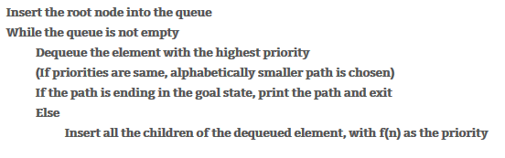

**IDA\***: Iterative deepening A* (IDA*) is a graph traversal and path search algorithm that can find the shortest path between a designated start node and any member of a set of goal nodes in a weighted graph. It is a variant of iterative deepening depth-first search that borrows the idea to use a heuristic function to evaluate the remaining cost to get to the goal from the A* search algorithm.

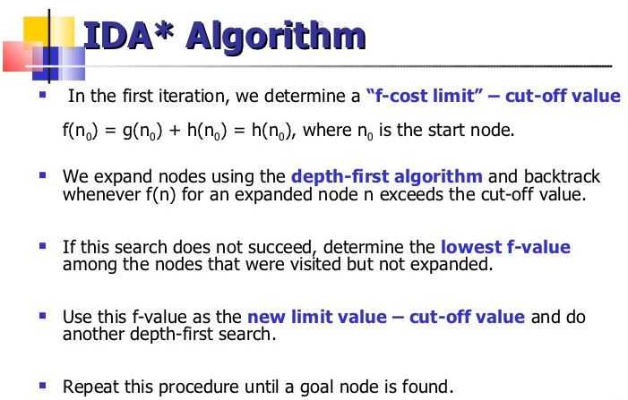**Algorithm:**

**SMA*: Simplified Memory Bounded A\*** is a shortest path algorithm based on the A* algorithm. The main advantage of SMA* is that it uses a bounded memory, while the A* algorithm might need exponential memory. All other characteristics of SMA* are inherited from A*.

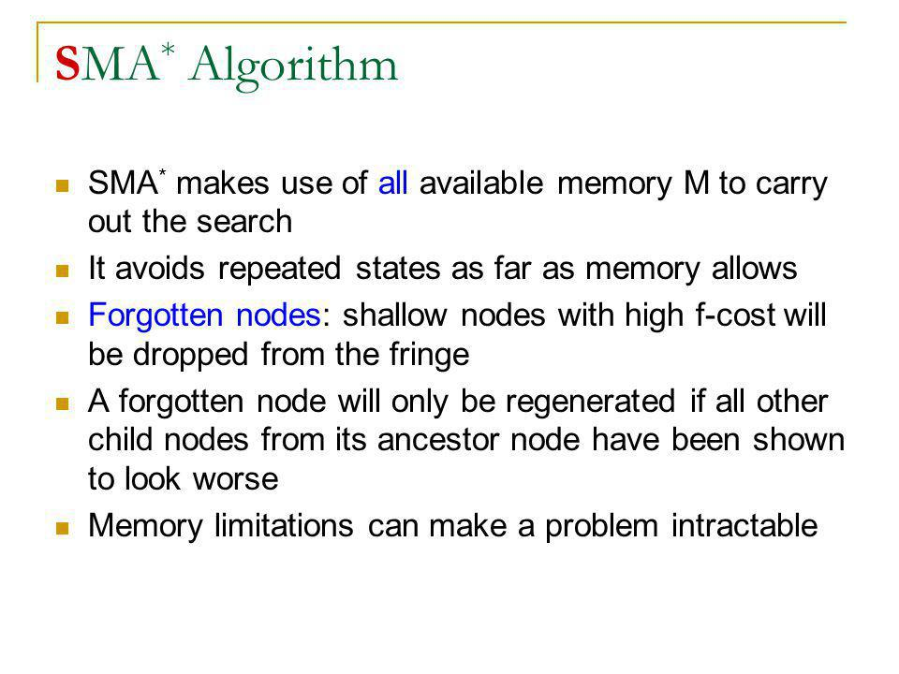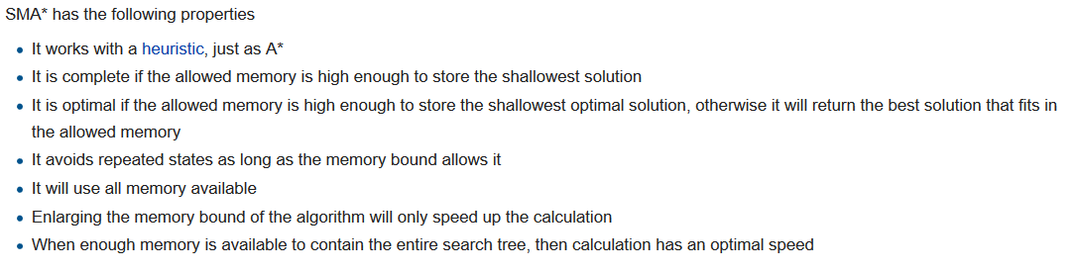**Properties:**