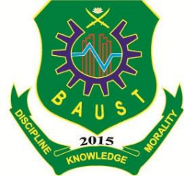

Bangladesh Army University of Science and Technology

**Department of computer science and engineering**

Course Code: CSE-2206

Course Title**:** Digital Electronics & Pulse Technique Sessional

Submitted by Submitted To

Name:S.M Raihan Fatima Jahan Sarmin

ID:150101096 Lecturer,Dept. of CSE

BAUST.