Range
Queries

By: Basel Al-Jabari
Table Of Contents:
Contents
2D Range Sum: 3
Fenwick Tree: 4
Mo’s Algorithm: 5
Segment Tree: 6
1D (Without Lazy Propogation): 6
1D (With Lazy Propogation): 8

2D Range Sum:
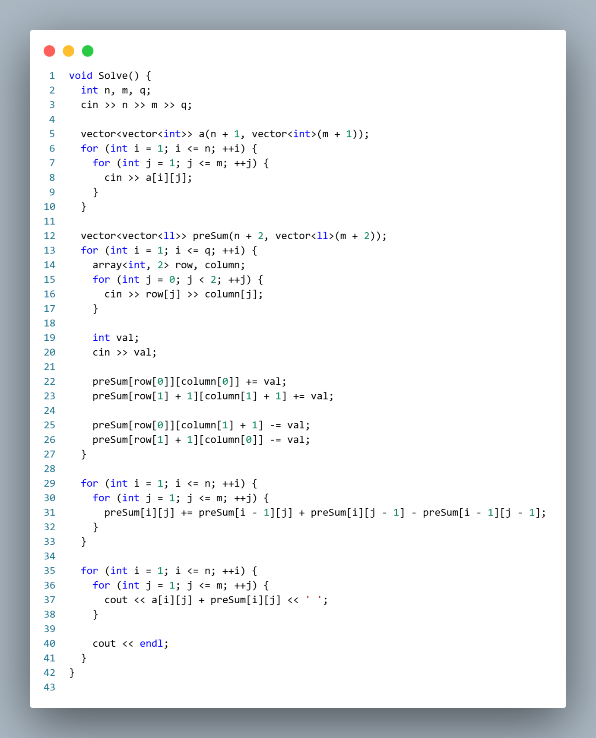

Fenwick Tree:
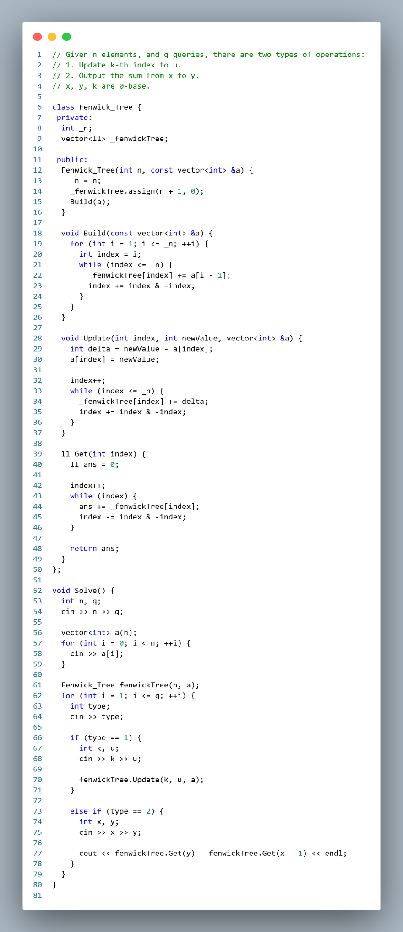

Mo’s Algorithm:
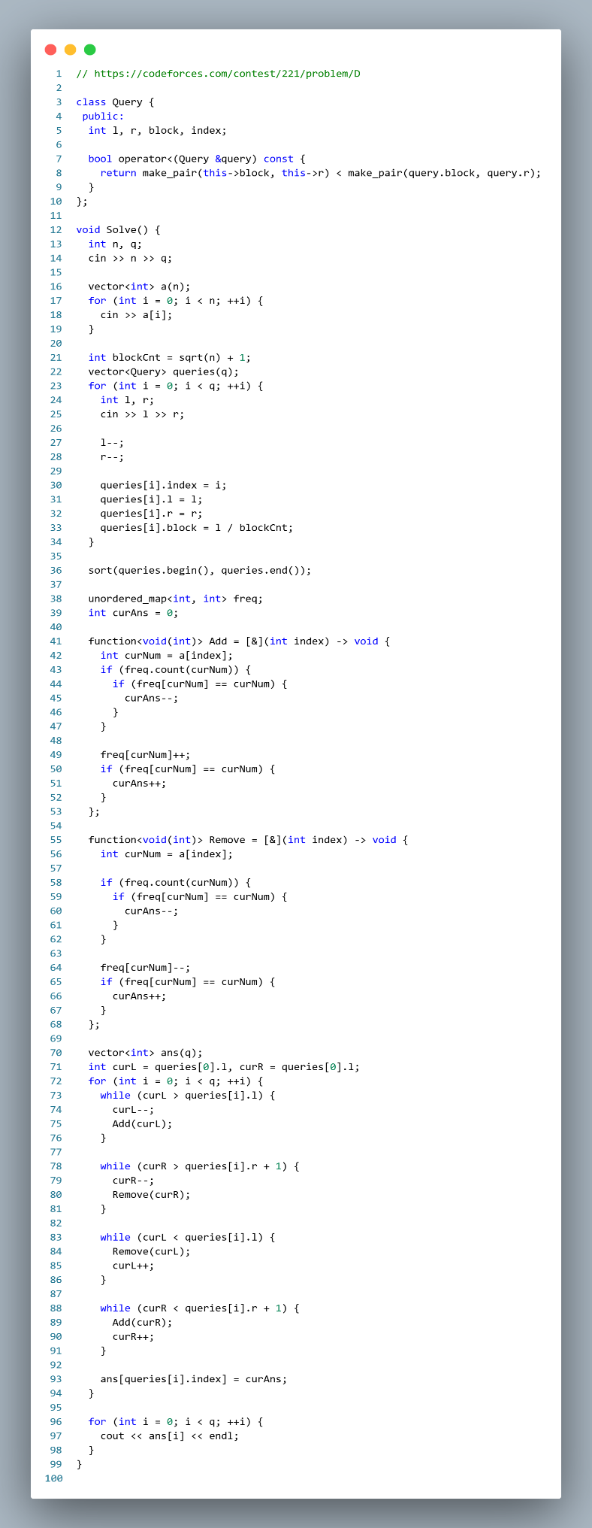

Segment Tree:

1D (Without Lazy Propagation):
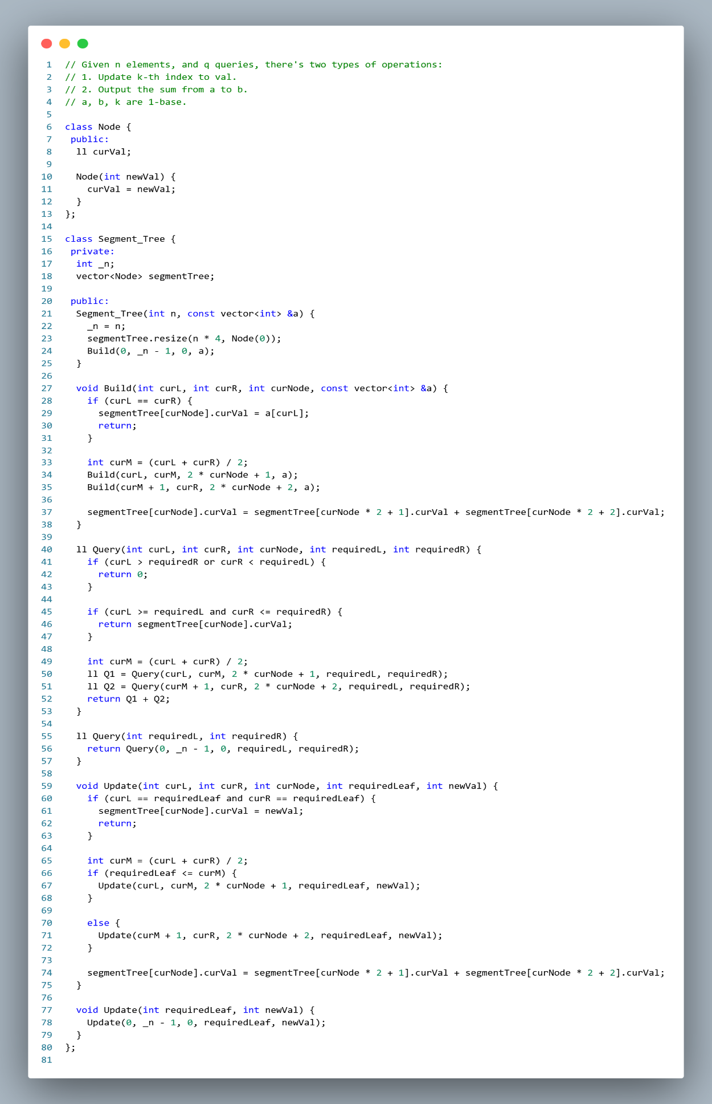
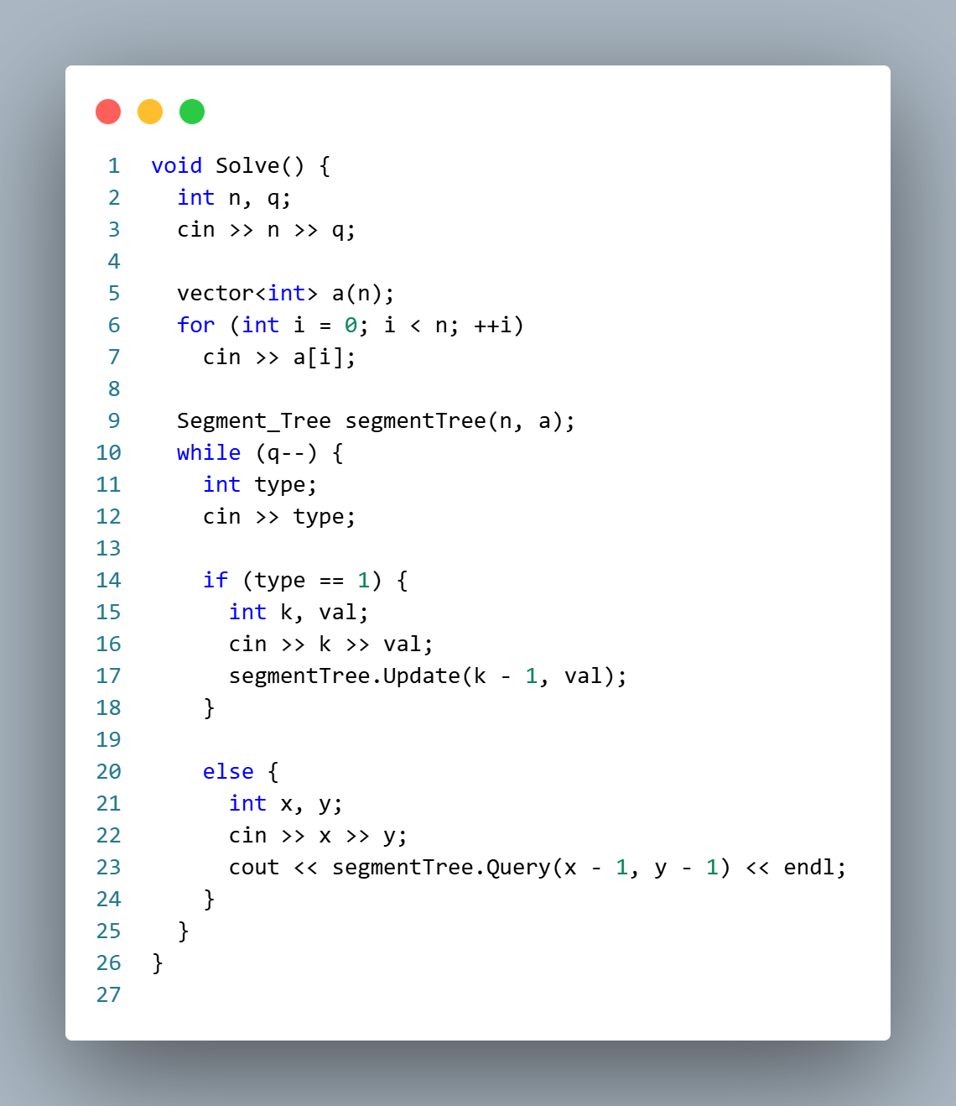

1D (With Lazy Propagation):
