String
Algorithms

By: Basel Al-Jabari
Table Of Contents:
Contents
KMP’s Algorithm: 3
Rabin Karp’s Algorithm: 4

KMP’s Algorithm:
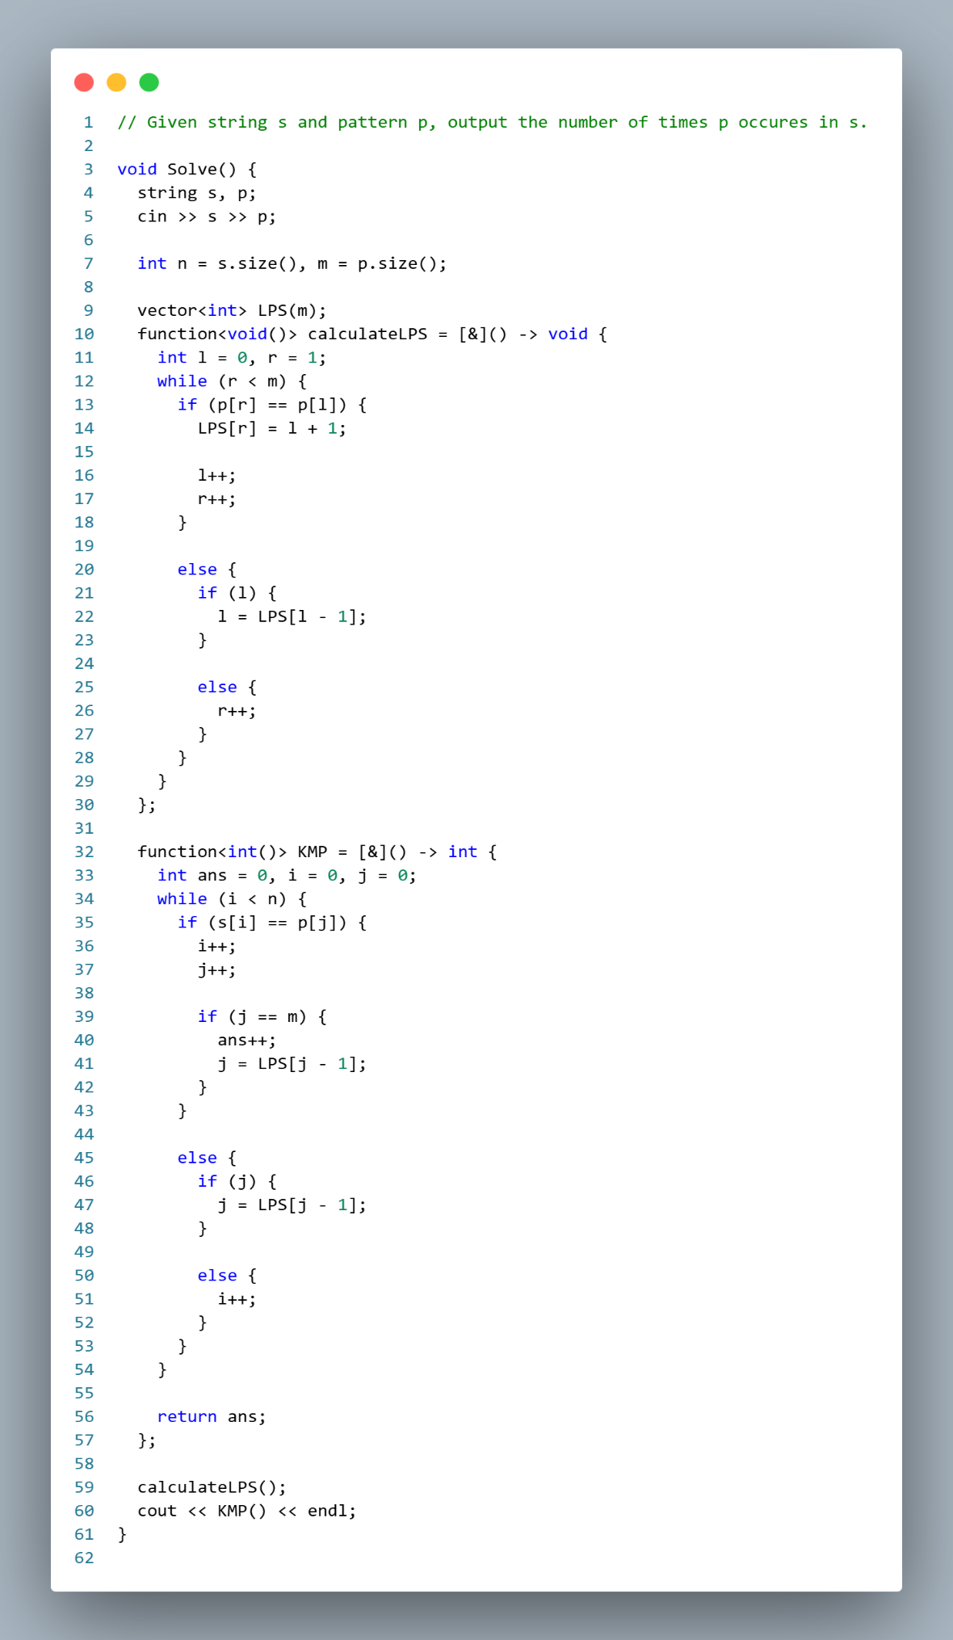

Rabin Karp’s Algorithm:
