Graph
Theory

By: Basel Al-Jabari
Table Of Contents:

Articulation Points (Tarjan’s Algorithm):
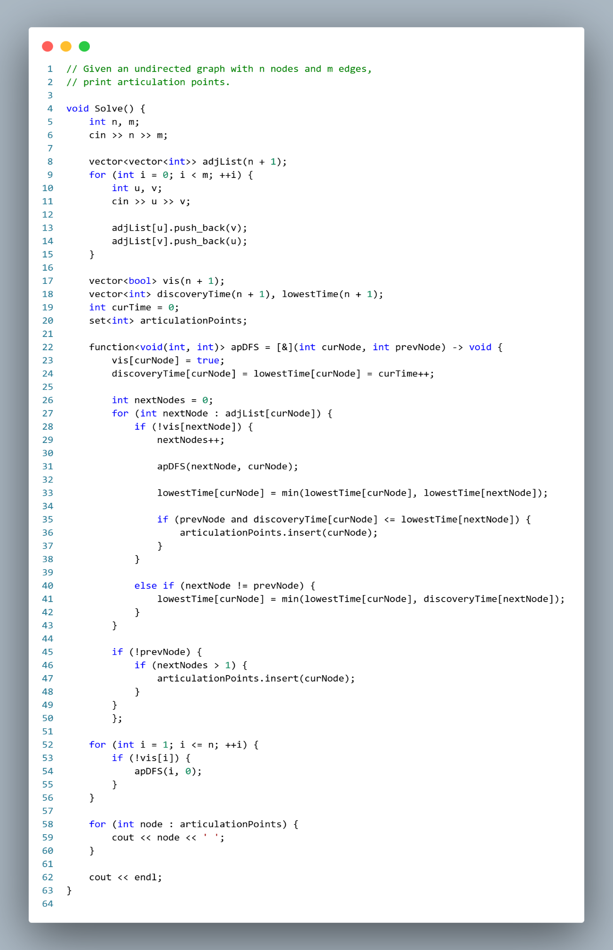
Biconnected Components (Tarjan’s Algorithm):
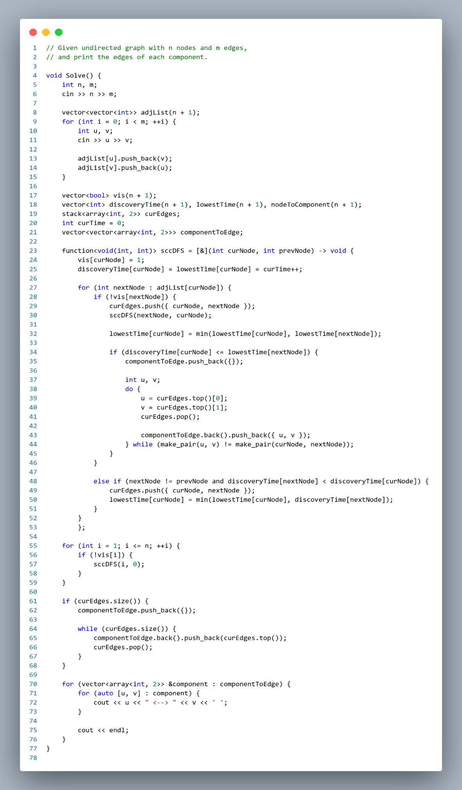
Bridges (Tarjan’s Algorithm):
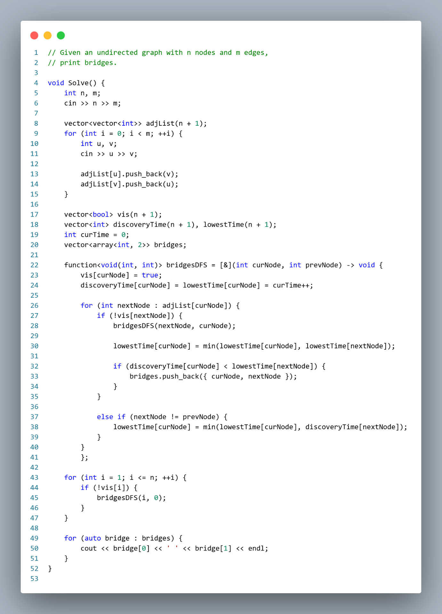

Flow (Dinic’s Algorithm):
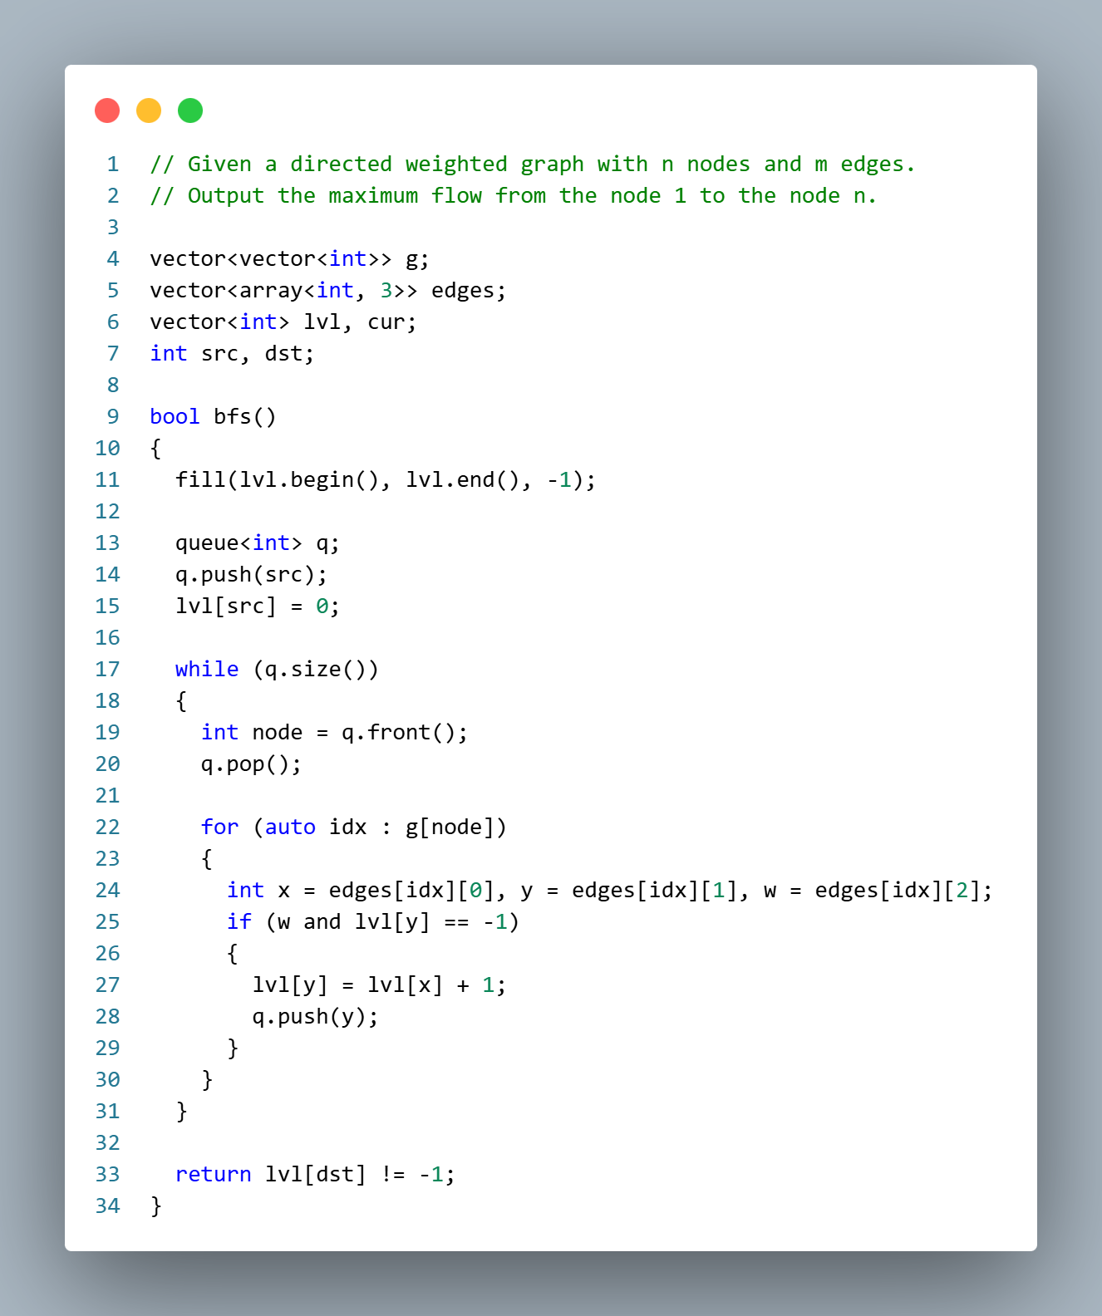
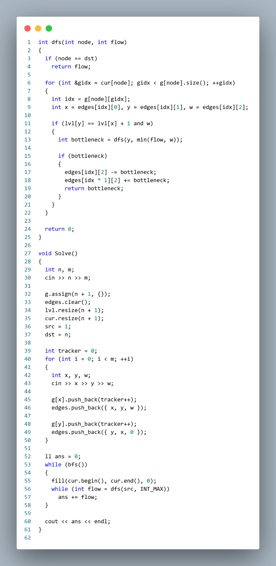
LCA (Binary Lifting):
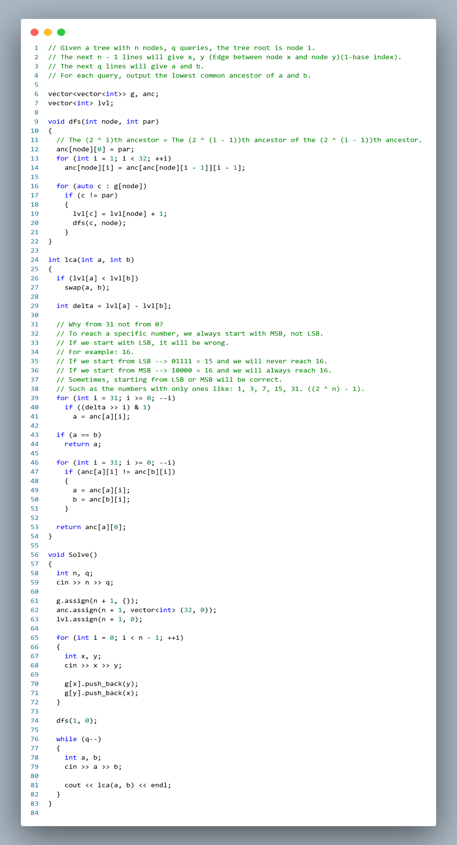
LCA (Euler’s Tour 2):
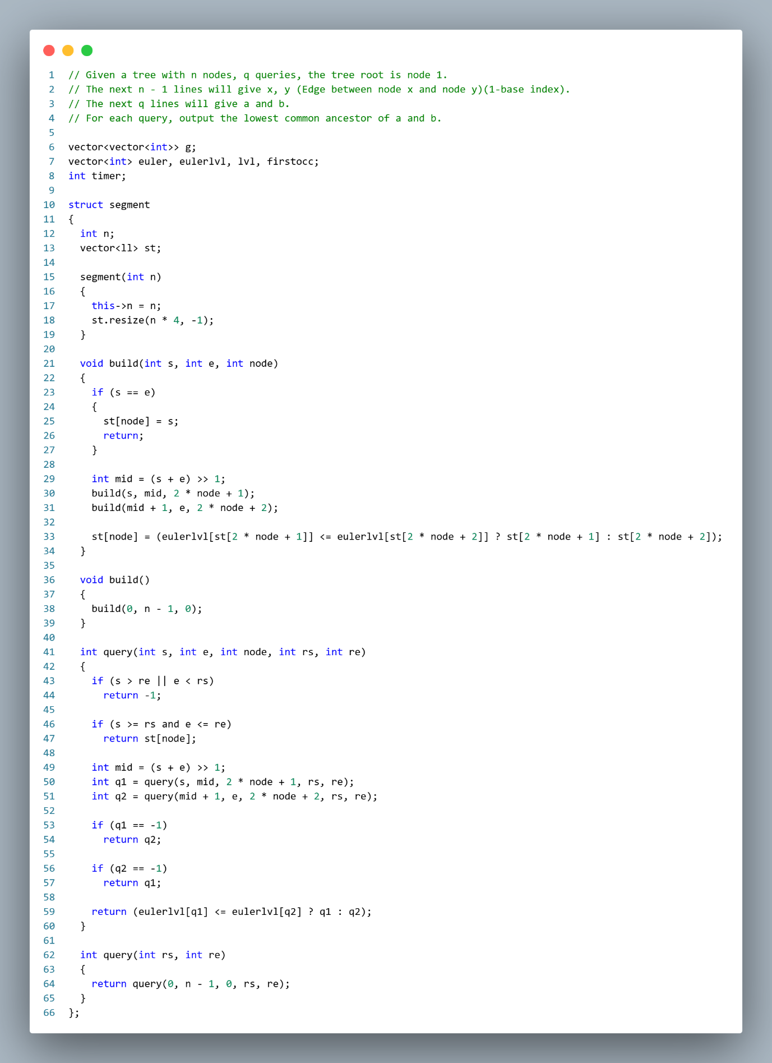
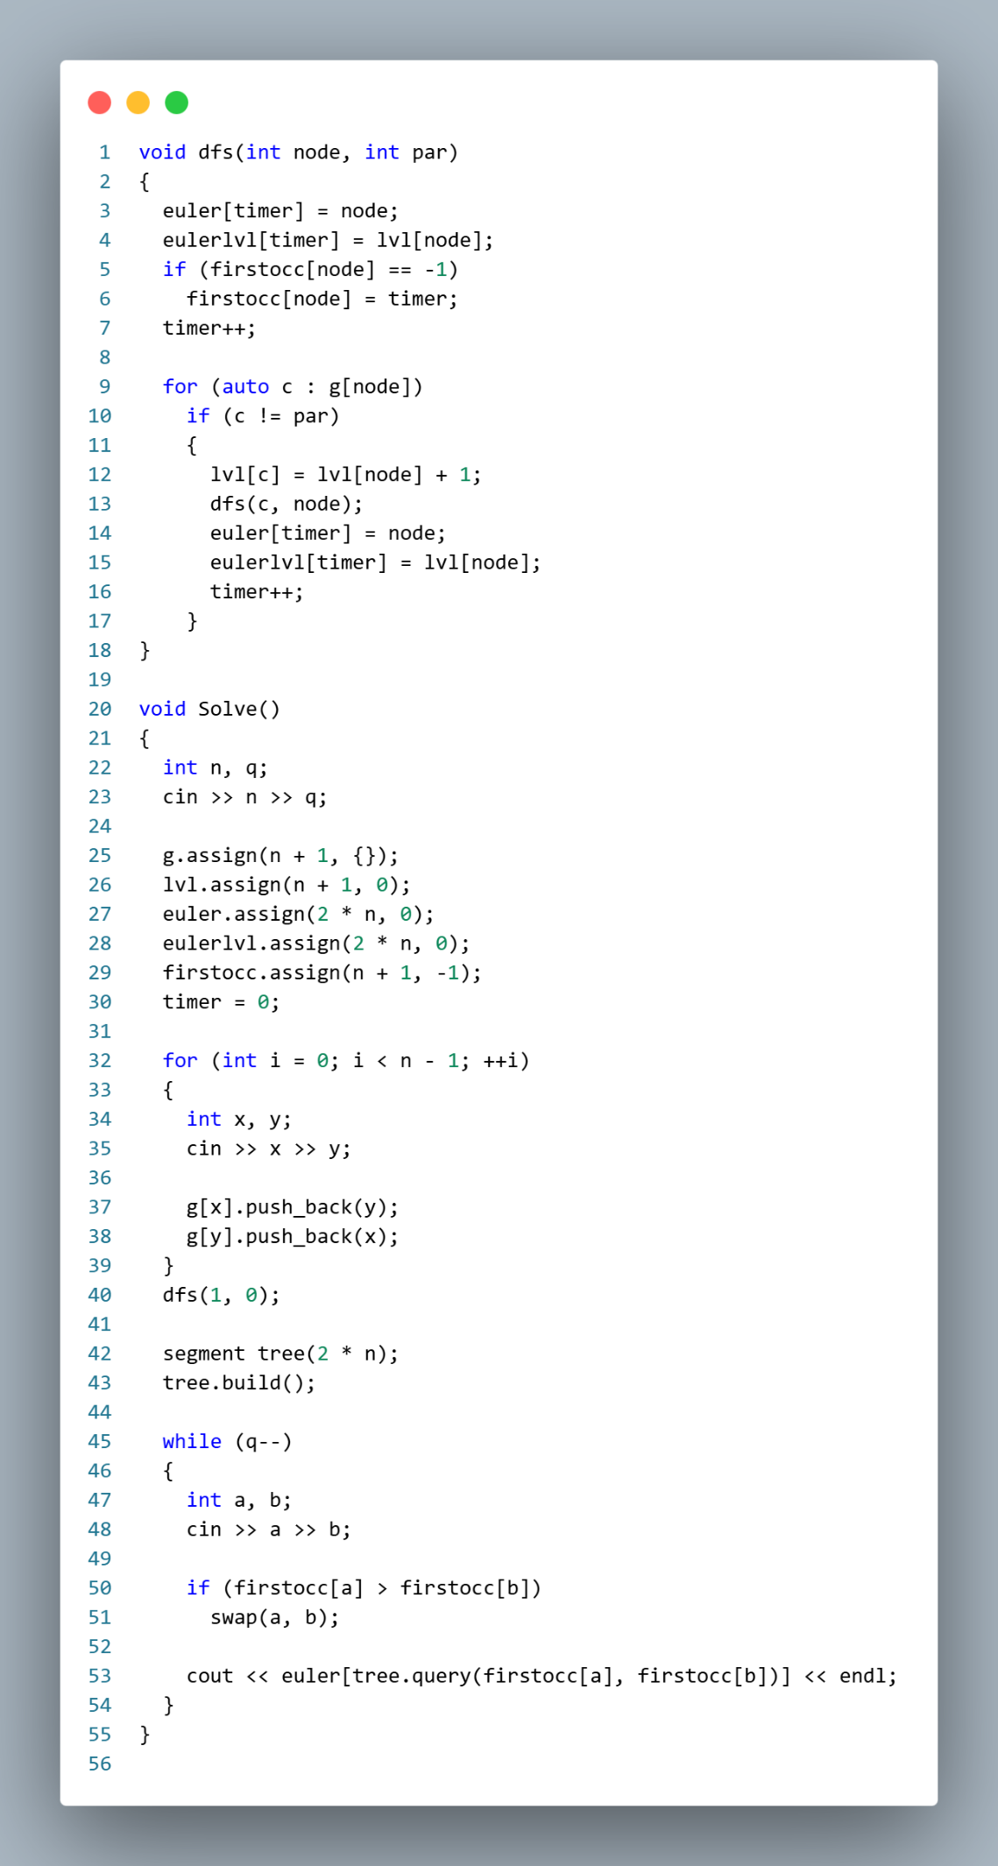

Segment Tree On Tree (Euler’s Tour 3):
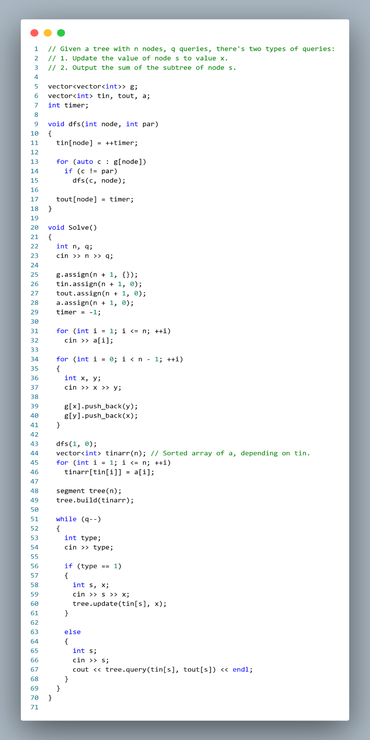
Shortest Path (0-1 BFS):
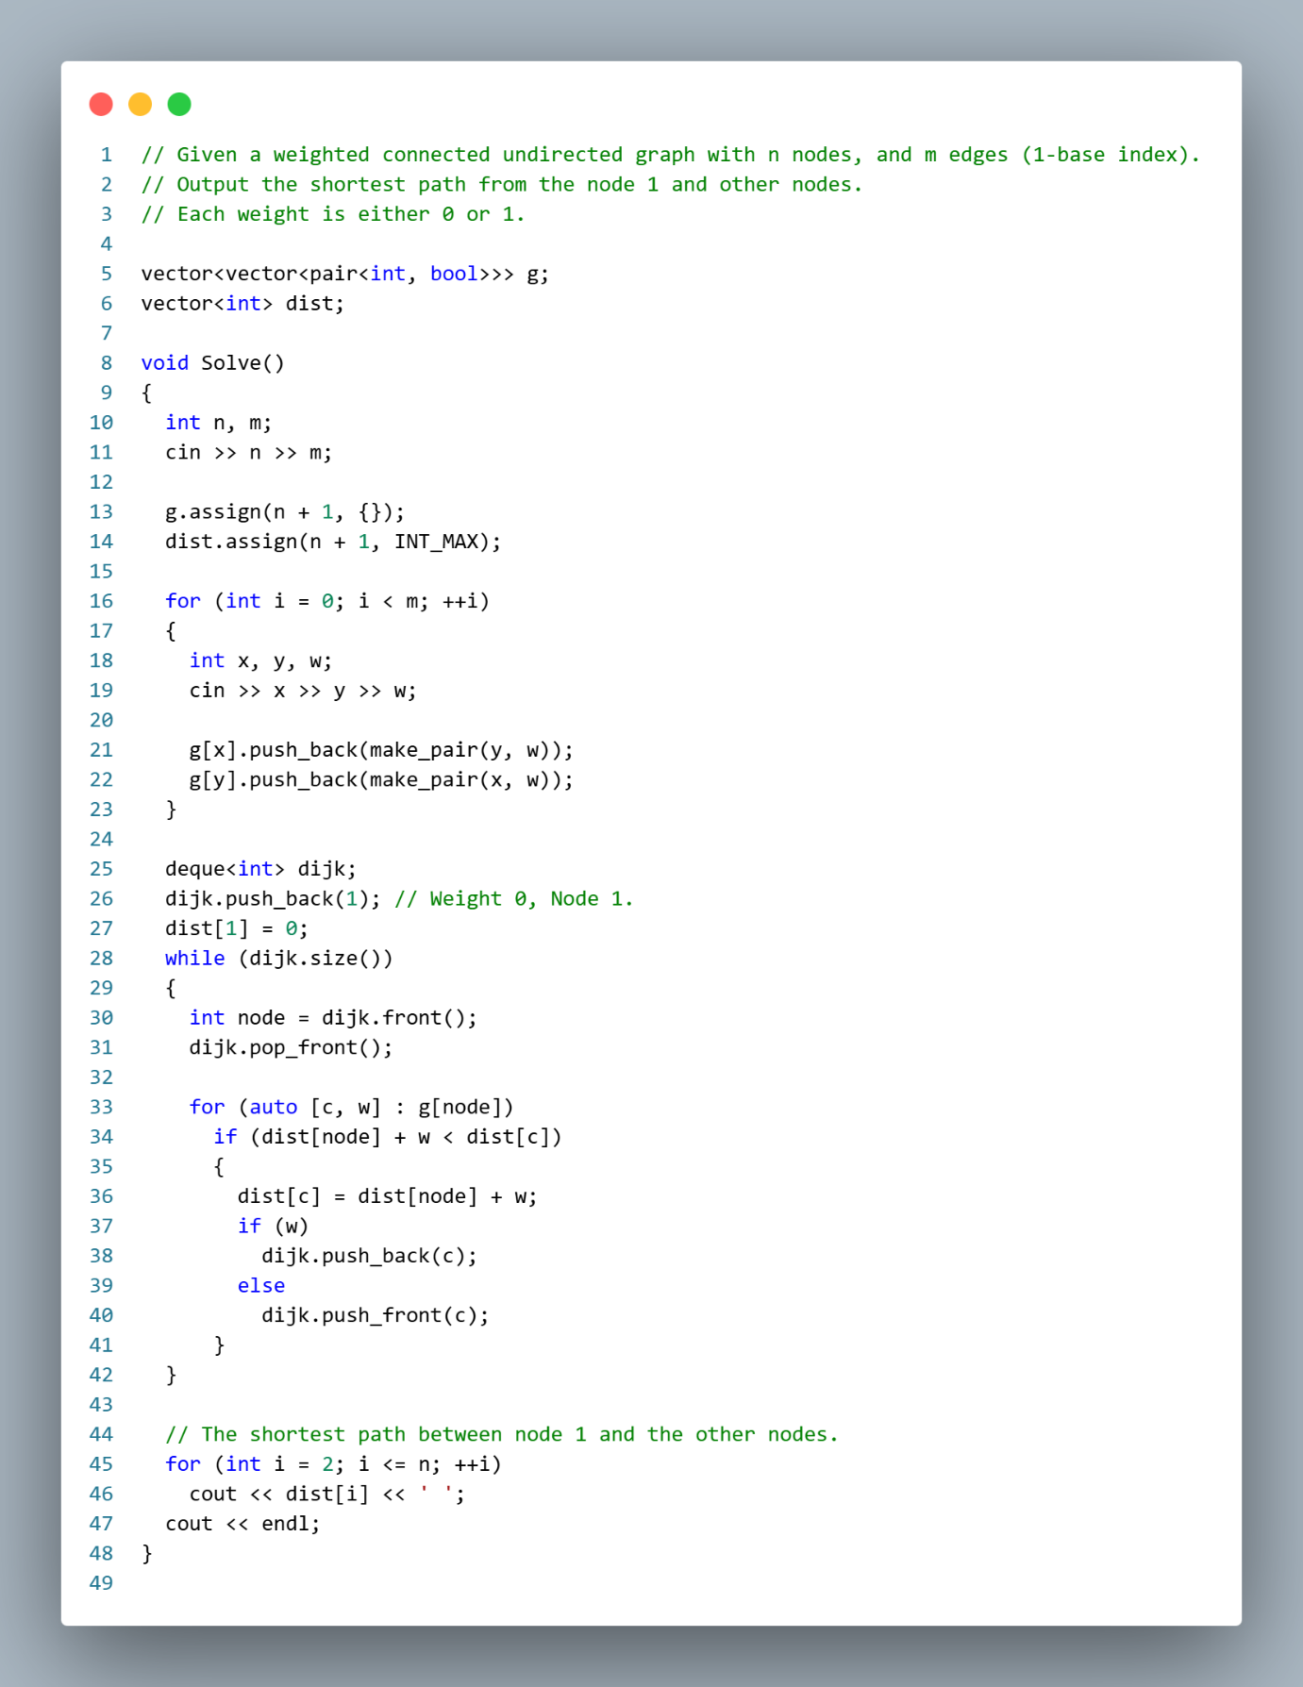

Shortest Path (Dijkstra’s Algorithm):
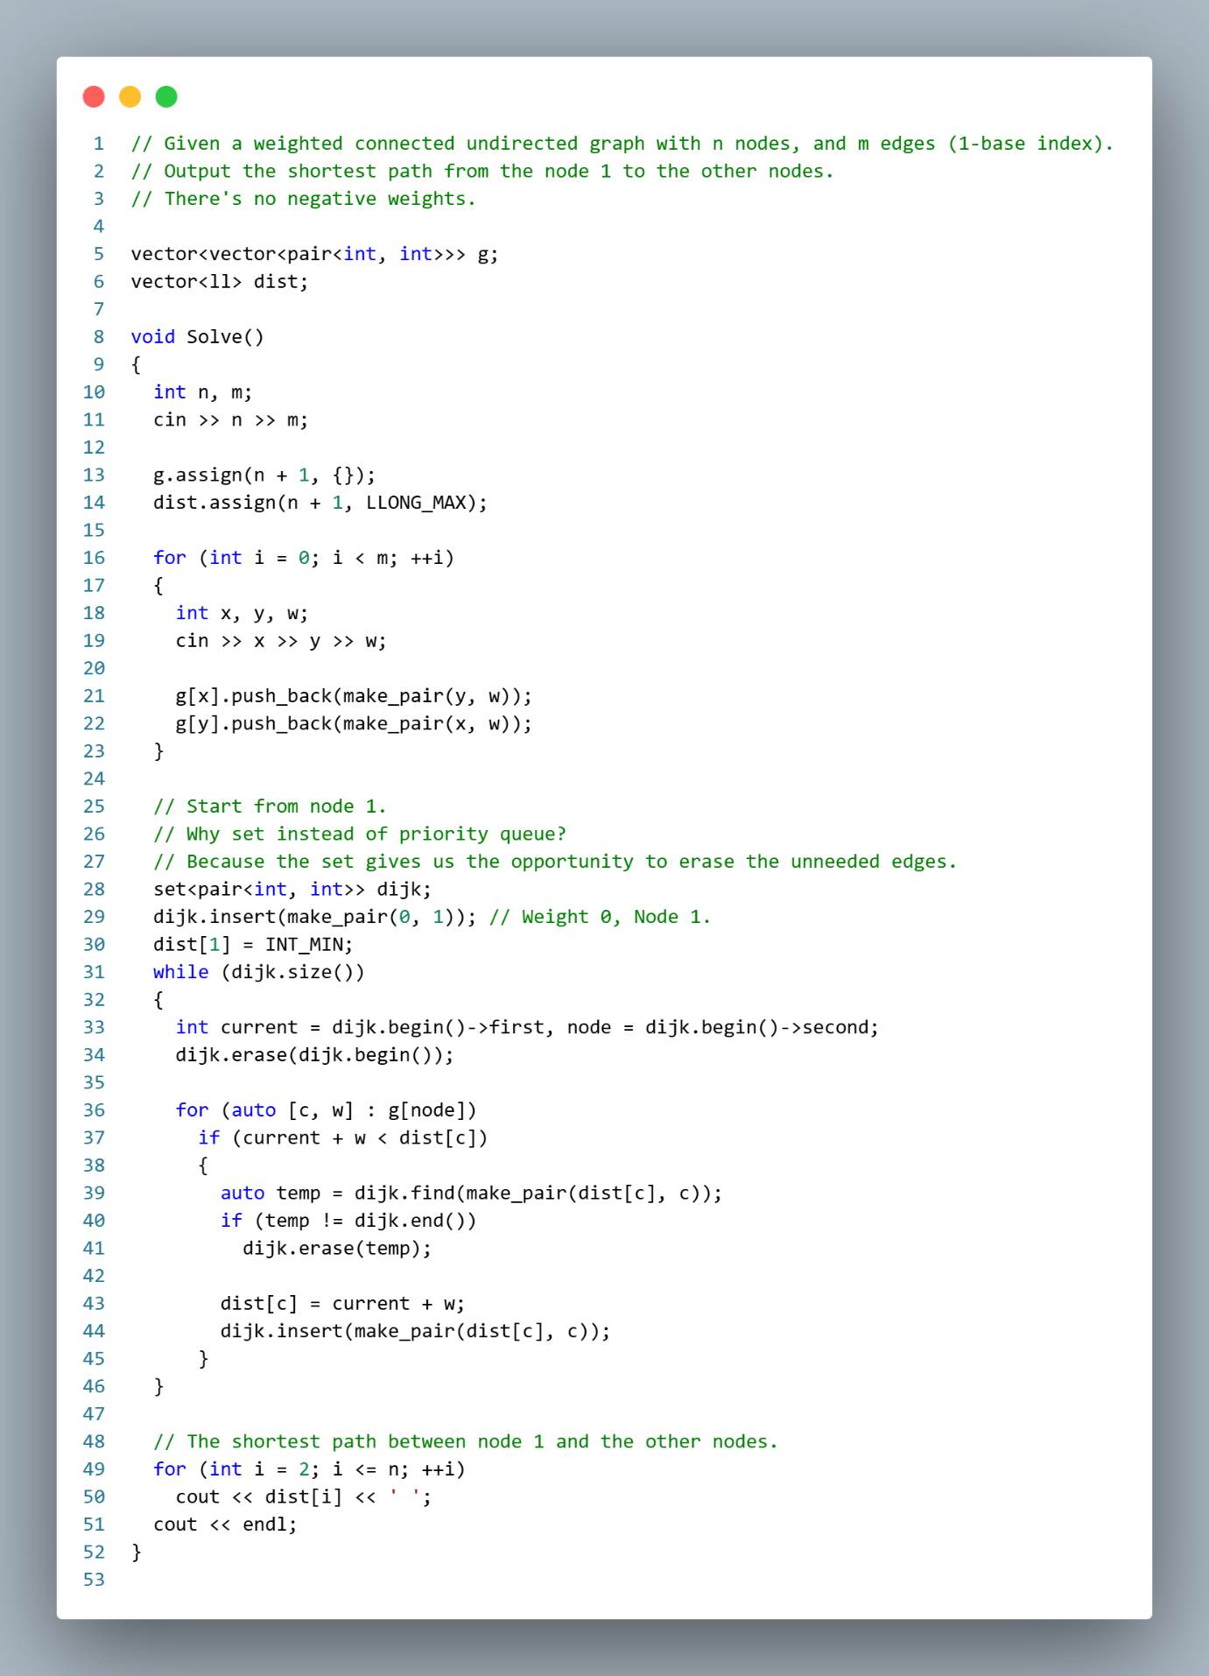

Shortest Path (Bellman Ford’s Algorithm):
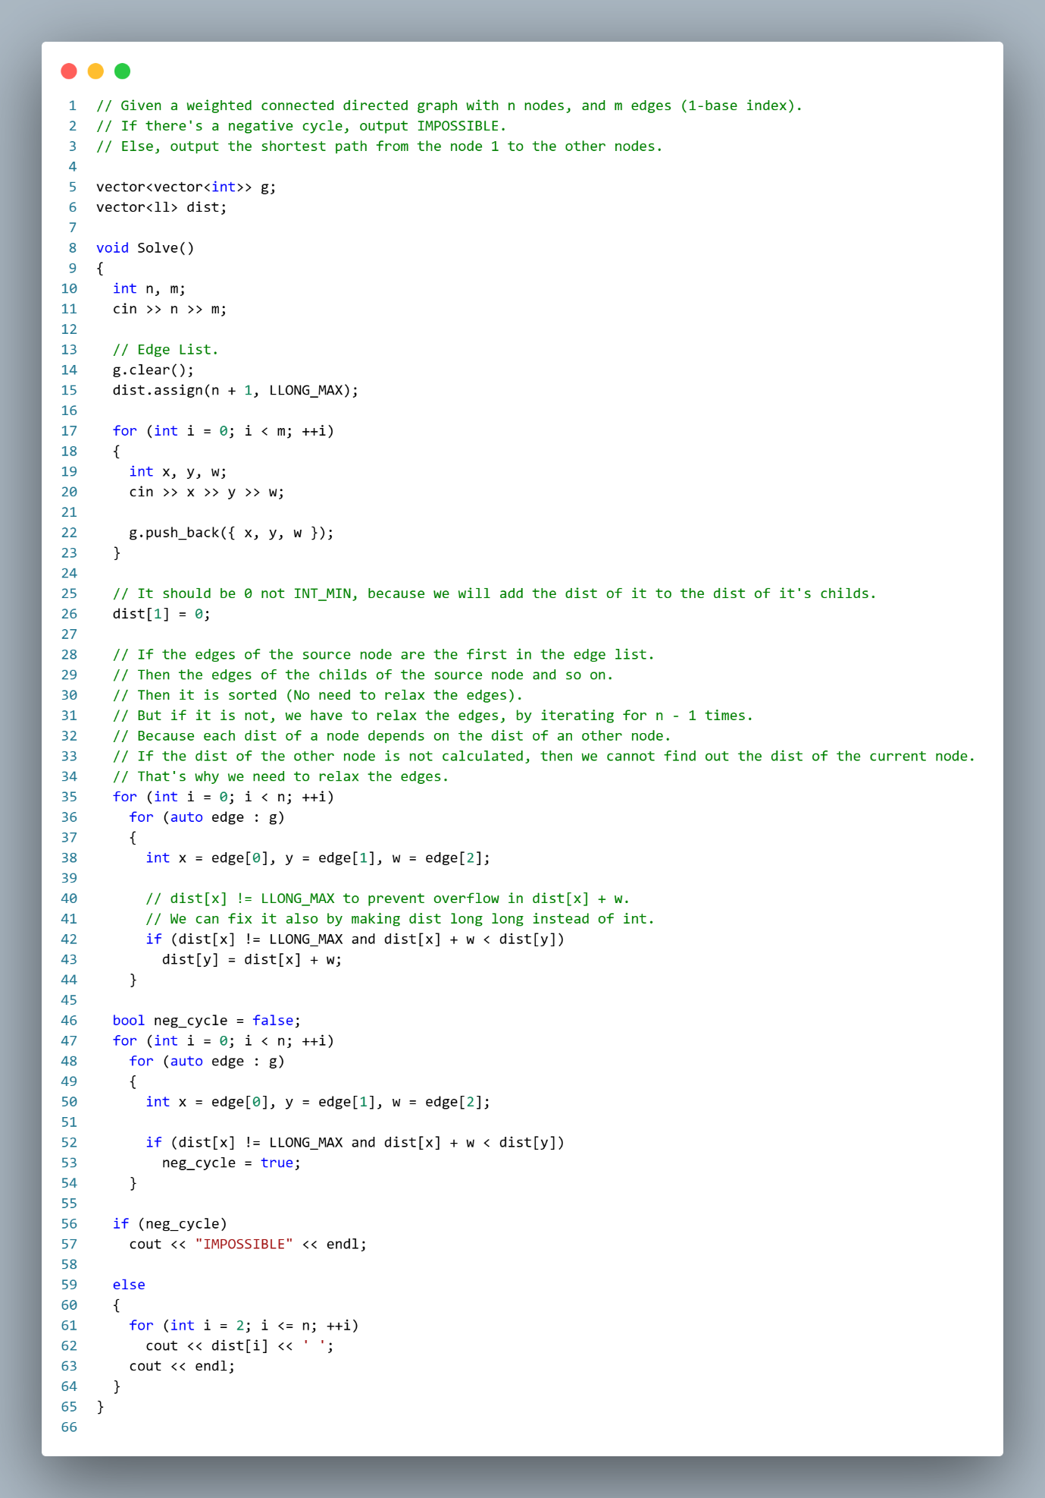

Shortest Path (Floyd Warshall’s Algorithm):

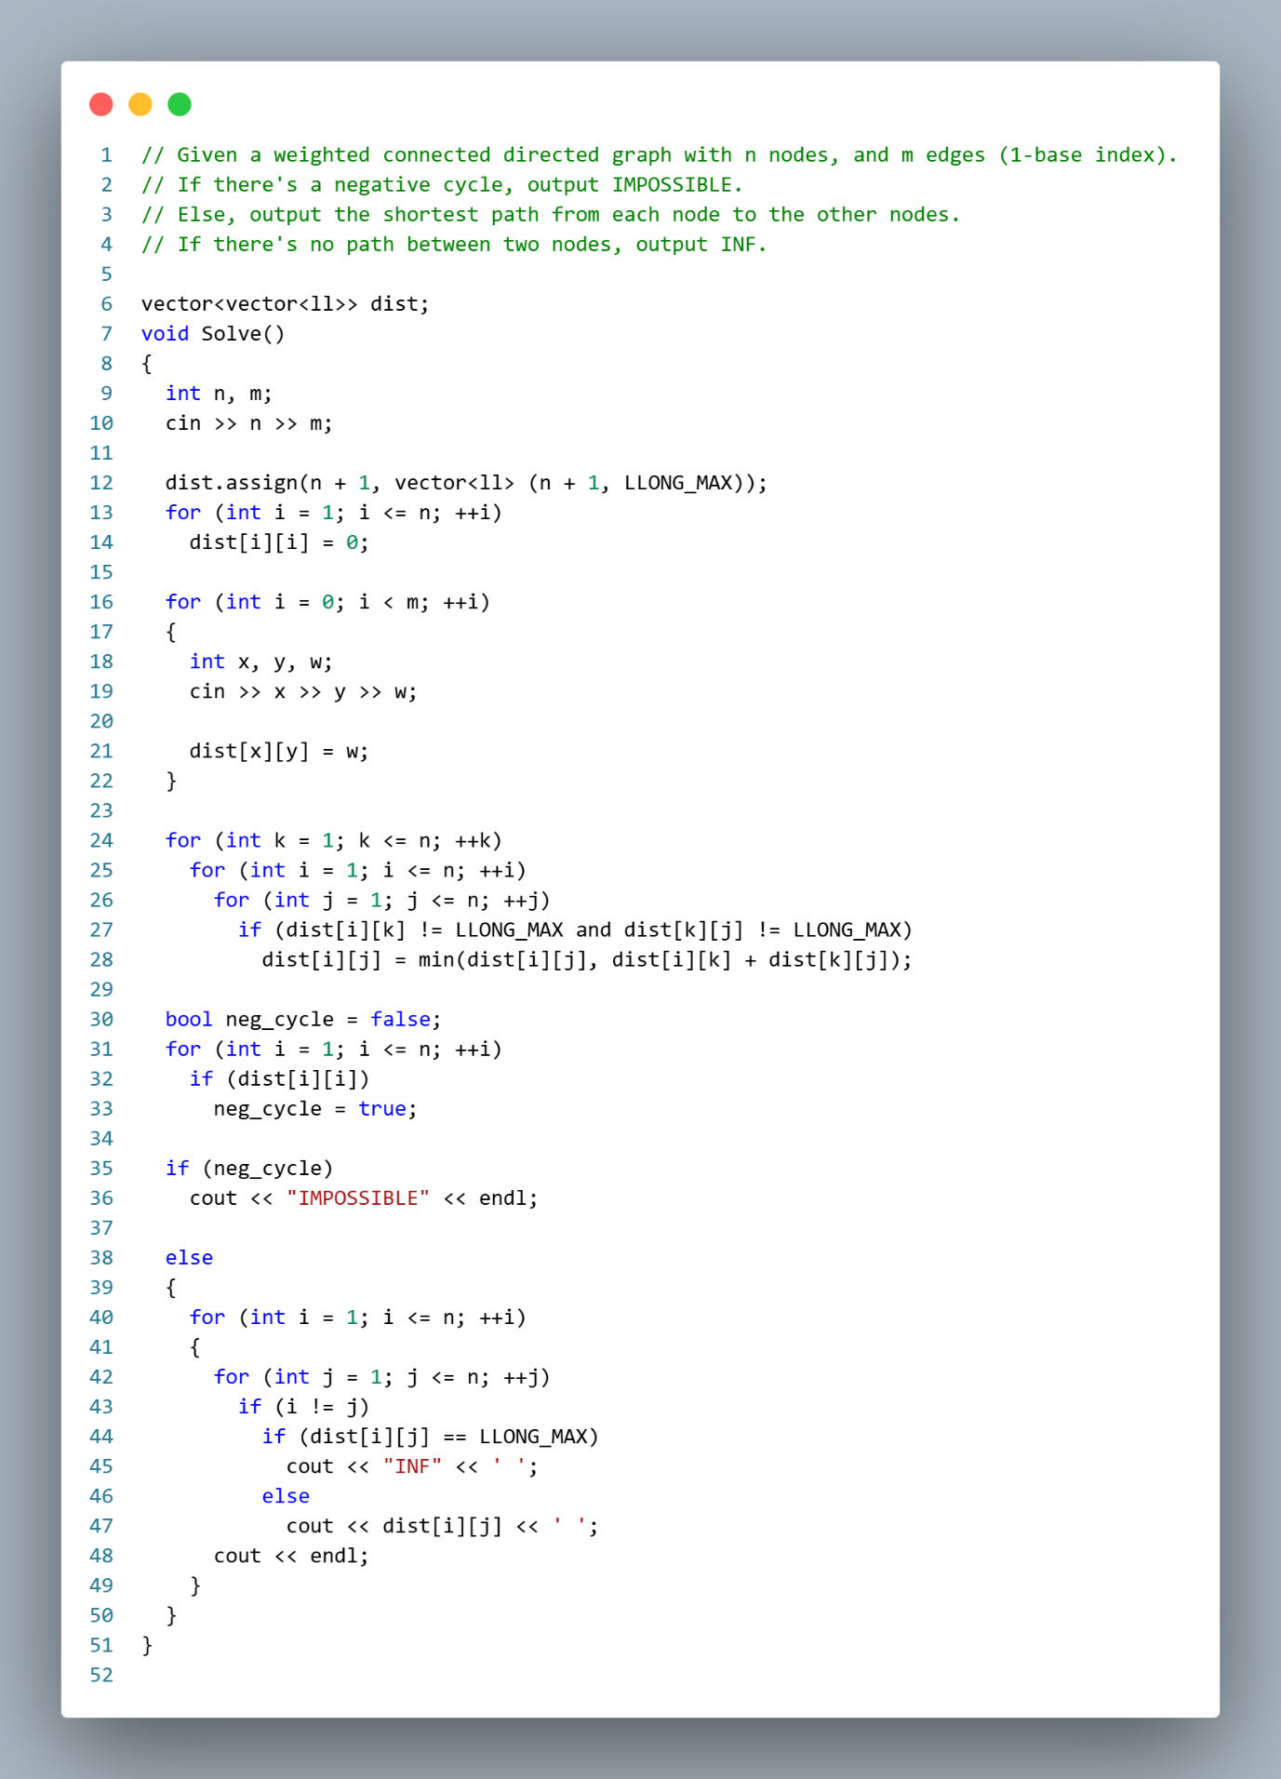

Spanning Tree (Kruskal’s Algorithm):
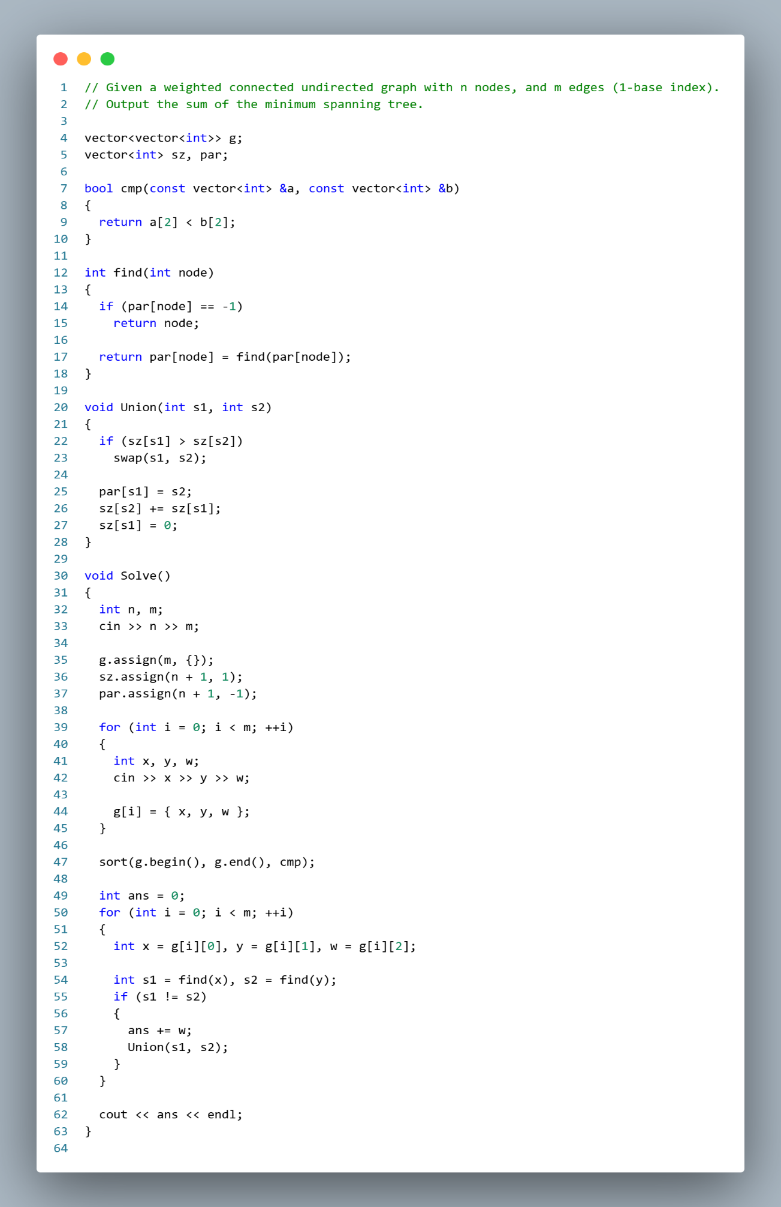
Strongly Connected Components (Tarjan’s Algorithm):
