Temperature Prediction Using Time-Series and Machine Learning Models
Project Deliverable I: Final Report

Group Members: | ID:
Omar Alamssi | 20229502031
Basel Al-Dwairi | 20221502065
Hazem Arar | 20221502041

Instructor: Dr. Nadia Alrousan
Date: 12/28/2025

Section: 1

First Semester 2025/2026

Abstract:
This study examines the problem of hourly temperature forecasting in Jordan using a range of statistical, classical machine learning, and deep learning techniques. A multi-year hourly weather dataset was processed and transformed into both tabular and sequential learning formats to support diverse modeling approaches. The implemented models include Ridge Regression, Linear Support Vector Regression, Random Forest, Histogram-Based Gradient Boosting, SARIMAX, Recurrent Neural Networks (RNN), and Long Short-Term Memory networks (LSTM).
All models were trained and evaluated using time-aware validation strategies to reflect realistic forecasting scenarios and prevent information leakage. Model performance was assessed using Mean Absolute Error (MAE), Root Mean Squared Error (RMSE), and the coefficient of determination (R²). The experimental results demonstrate that the LSTM model consistently achieves the highest predictive accuracy, owing to its ability to capture nonlinear temporal dependencies and long-range patterns in hourly temperature data. Tree-based ensemble models outperform linear baselines but remain inferior to recurrent architecture. In contrast, SARIMAX exhibits unstable behavior, underscoring the limitations of linear seasonal assumptions when applied to high-frequency, non-stationary meteorological time series.
ML-DL

1. Project Idea and Problem Definition
1.1 Project Idea
The objective of this project is to forecast hourly temperature values using historical meteorological observations and wind-related variables. Accurate short-term temperature prediction is a critical component in applications such as energy demand forecasting, transportation planning, agricultural decision-making, and public safety operations.
1.2 Problem Statement
Problem Definition:
Given historical hourly weather observations, the task is to predict the temperature at the subsequent time step using:
- Wind Speed
- Wind Direction encoded as sine and cosine components
- Historical temperature information represented through lagged variables or temporal sequences
Objective:
To design, implement, and compare multiple forecasting models and to identify the approach that provides the most accurate and stable predictive performance.
1.3 Motivation for Machine Learning and Deep Learning
Classical time-series forecasting methods often rely on linear assumptions and fixed seasonal structures, which may be insufficient for modeling the complex and evolving behavior of hourly meteorological data. Machine learning and deep learning techniques offer greater modeling flexibility by capturing nonlinear relationships, complex feature interactions, and long-term temporal dependencies.
Evaluation Criteria:
- Minimization of MAE and RMSE
- Maximization of R² on unseen test data

2. Dataset Collection and Source Credibility
2.1 Dataset Source
The dataset consists of publicly available hourly weather observations collected over multiple years, covering the period from 2010 to 2025.
The API is from Weather Underground
2.2 Data Reliability
The dataset originates from a structured and widely accessible source, containing continuous and standardized meteorological measurements. The long temporal span enhances statistical reliability and supports robust model training and evaluation.
2.3 Dataset Characteristics
- Temporal Resolution: Hourly
- Dataset Size: 139,032 observations with 37 recorded variables
- Key Variables:
  - Datetime
  - Temperature (TEMP)
  - Wind Speed
  - Wind Direction (sine and cosine representations)

3. Data Preprocessing and Feature Engineering
3.1 Data Cleaning
Preprocessing steps included:
- Parsing and chronologically sorting datetime values to preserve temporal structure
- Removing missing values introduced during lag and sequence generation
- Verifying the absence of significant duplicate records
3.2 Feature Engineering
To enhance model learnability, several features were engineered:
Lag-Based Features (Tabular Models):
- TEMP(t−1) to capture short-term temporal dependence
- TEMP(t−24) to represent daily seasonal patterns
Calendar-Based Features:
- Hour of day
- Day of week
- Month of year
These features allow models to learn periodic temperature behavior.
Sequential Features (Deep Learning Models):
- Sliding time windows (e.g., 24 or 48 hours) consisting of temperature and wind-related variables
Lag-based features were used exclusively for tabular machine learning and statistical models. These features were intentionally excluded from deep learning sequence models to ensure a fair evaluation of their ability to learn temporal dependencies directly from raw time windows.
3.3 Feature Scaling
Standardization was applied to models sensitive to feature magnitude, including Ridge Regression, LinearSVR, RNN, and LSTM. Tree-based models were trained without scaling due to their inherent scale invariance.
3.4 Temporal Train–Test Split
To avoid data leakage, a chronological split was employed:
- Training set: first 80% of the time series
- Test set: remaining 20%
This approach closely reflects real-world forecasting conditions.

4. Exploratory Data Analysis
Exploratory analysis revealed pronounced seasonal and diurnal temperature patterns. Distributional analysis showed realistic temperature ranges with occasional extreme values. Correlation analysis indicated weak linear relationships between wind variables and temperature, suggesting that nonlinear modeling approaches may be more appropriate. Hourly boxplots confirmed consistent daily cycles, justifying the use of lagged and time-based features.

5. Model Implementation and Justification
5.1 Problem Type
The task is formulated as a supervised regression problem involving continuous-valued targets.
5.2 Implemented Models
The following models were evaluated:
- Ridge Regression
- Linear Support Vector Regression
- Random Forest Regressor
- Histogram-Based Gradient Boosting Regressor
- SARIMAX
- Recurrent Neural Network (RNN)
- Long Short-Term Memory Network (LSTM)
5.3 Model Selection Rationale
Linear models provide interpretable baselines. Tree-based ensemble models capture nonlinear interactions among engineered features. SARIMAX represents a classical statistical approach incorporating seasonal structure. Recurrent neural networks, particularly LSTM, explicitly model temporal dependencies and are therefore well-suited for high-frequency time-series forecasting.

6. Performance Evaluation
6.1 Metrics Used
We evaluated regression models using:
- MAE: average absolute error
- RMSE: penalizes large forecasting errors
- R²: variance explained by the model
6.2 Hyperparameter Tuning Approach
- Used time-aware validation:
  - TimeSeriesSplit for tabular models
  - A chronological validation block for SARIMAX
  - Tail validation portion for RNN/LSTM
This prevents leakage and ensures fair evaluation.
6.3 Results Table
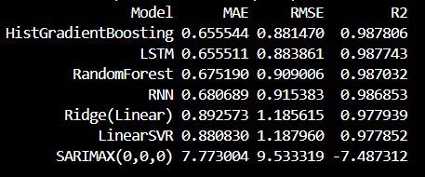

6.4 Comparison Plots
Combined graph (All Models)
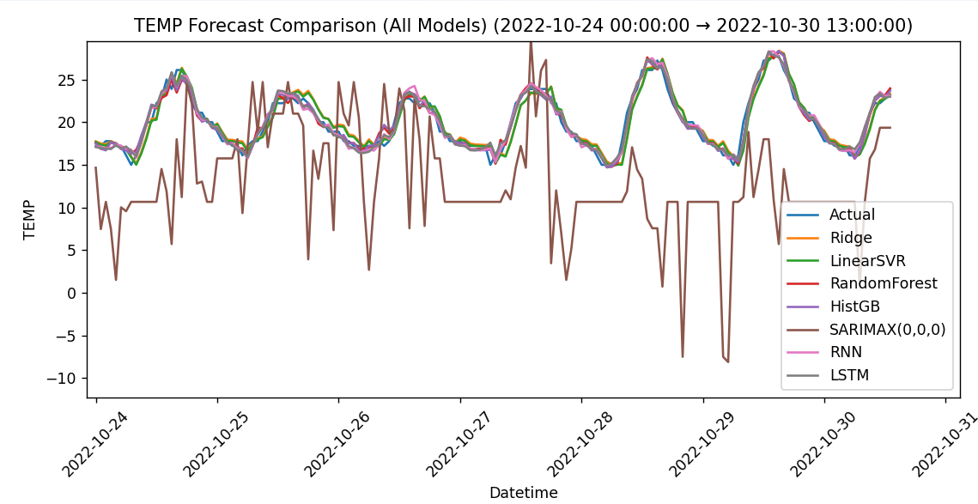
Individual graphs (One per model)
- [FIGURE: Ridge vs Actual]
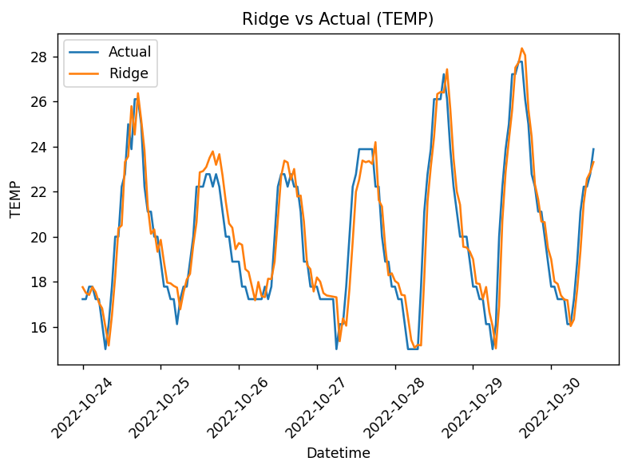
- [FIGURE: LinearSVR vs Actual]
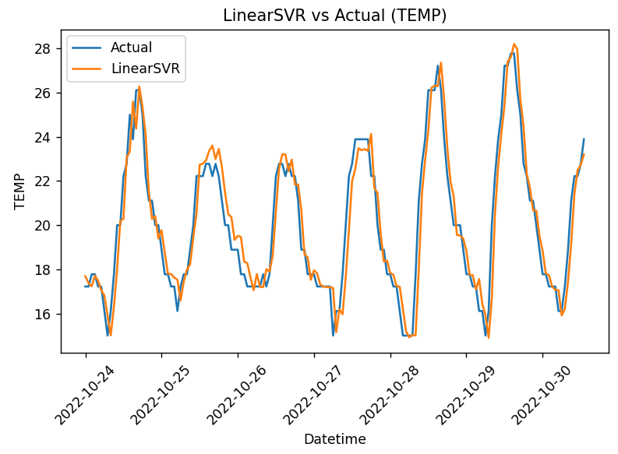
- [FIGURE: RandomForest vs Actual]
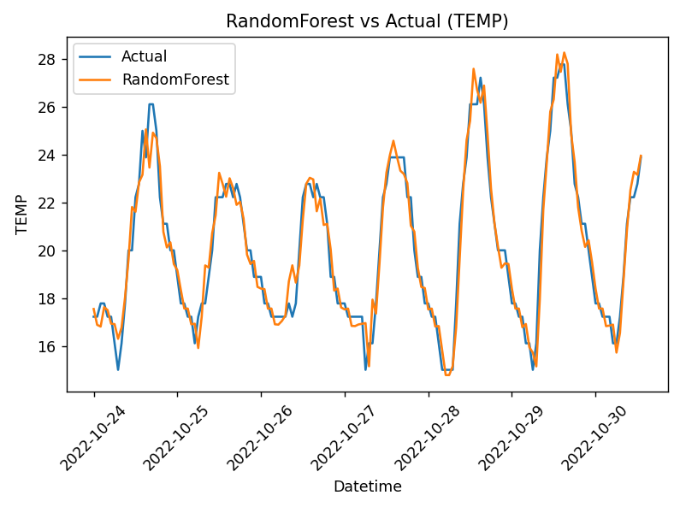
- [FIGURE: HistGB vs Actual]
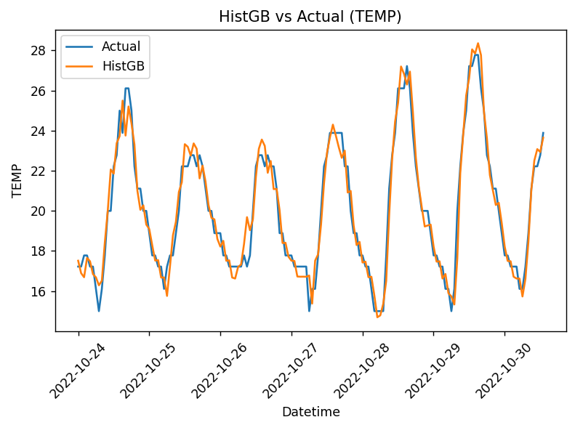
- [FIGURE: SARIMAX vs Actual]
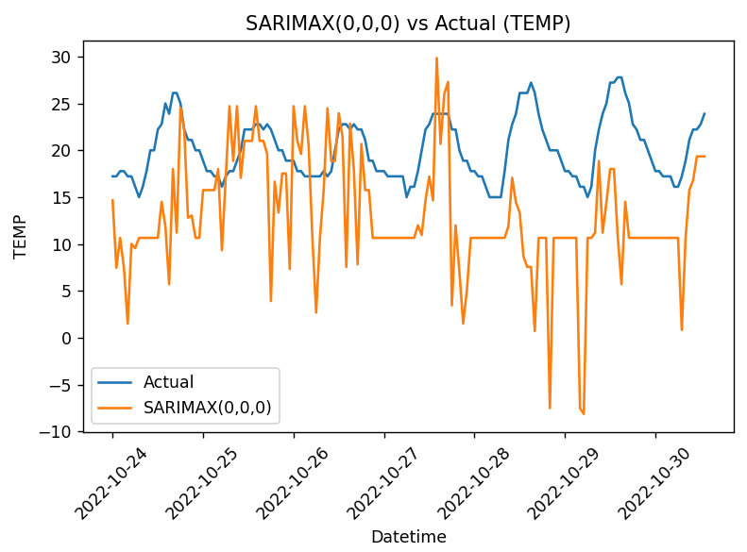
- [FIGURE: RNN vs Actual]
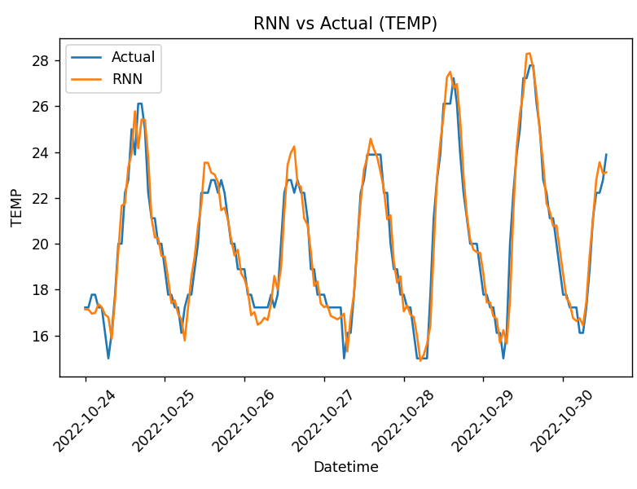

- [FIGURE: LSTM vs Actual]
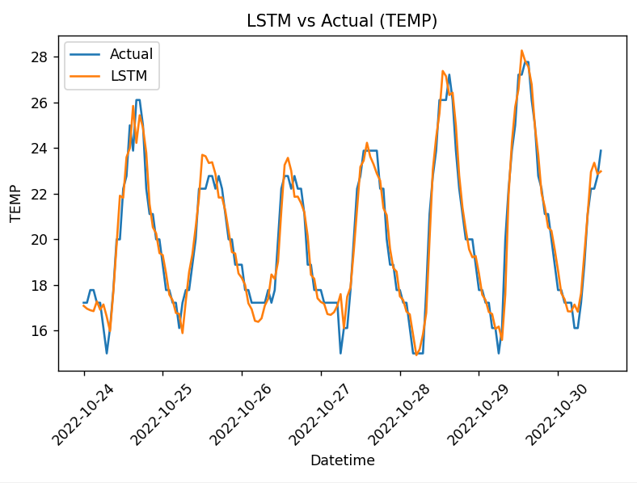

- Bar chart (RMSE comparison)
[FIGURE: RMSE bar chart]
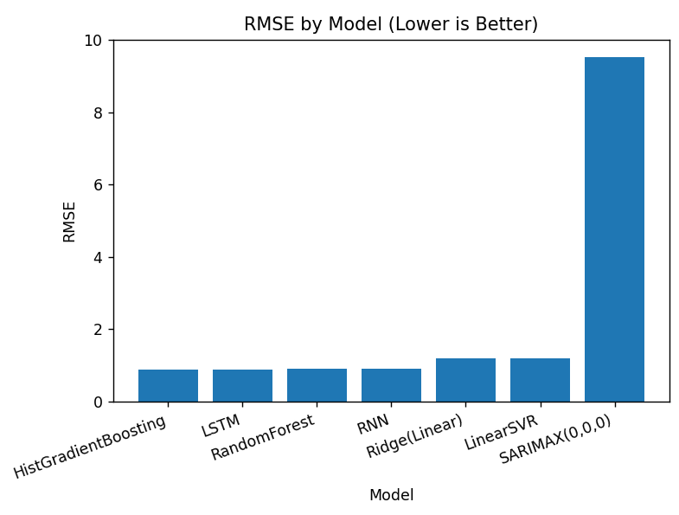

7. Discussion
The LSTM model demonstrated superior performance across all evaluation metrics, highlighting its effectiveness in modeling nonlinear temporal dependencies and long-term patterns. The RNN model exhibited slightly lower accuracy, consistent with its lack of gating mechanisms. Tree-based ensemble methods significantly outperformed linear baselines, confirming the importance of nonlinear feature modeling. SARIMAX produced unstable forecasts, indicating that fixed-order linear seasonal assumptions are insufficient for capturing the evolving dynamics of hourly temperature data.

7.1 Lag-Based Feature Impact:
Classical machine learning models benefited significantly from lag-based time series features such as temperature at the previous hour (TEMP(t−1)) and daily seasonal lags (TEMP(t−24)). While these features substantially improve predictive accuracy, they introduce strong autoregressive signals that simplify the forecasting task. In contrast, deep learning sequence models (RNN and LSTM) were trained to learn temporal dependencies directly from raw sequential inputs without explicit future leakage, making their learning problem inherently more challenging. This difference explains the performance gap observed between lag-based models and sequence-based architectures.

8. Conclusion and Future Work
8.1 Conclusion
This study confirms that deep learning approaches, particularly LSTM networks, provide the most accurate and robust solutions for hourly temperature forecasting in this dataset. While classical and machine learning models serve as useful benchmarks, they are limited in their ability to capture complex temporal dynamics.
8.2 Future Work
Potential extensions of this work include:
- Incorporating additional meteorological variables such as humidity and solar radiation
- Employing walk-forward validation techniques
- Exploring Transformer-based sequence models
- Extending the framework to related predictive tasks

9.1 Code
Github : https://github.com/Basel-Aldwairi/Temperature_TSA

9.2 References

Weather API
https://www.wunderground.com

TensorFlow Documentation
https://www.tensorflow.org/overview
Keras API Reference
https://keras.io/api/
Recurrent Neural Networks (RNN) – TensorFlow
https://www.tensorflow.org/guide/keras/rnn
LSTM Layer – Keras
https://keras.io/api/layers/recurrent_layers/lstm/
SimpleRNN Layer – Keras
https://keras.io/api/layers/recurrent_layers/simple_rnn/
Scikit-learn Documentation
https://scikit-learn.org/stable/documentation.html
MinMaxScaler – Scikit-learn
https://scikit-learn.org/stable/modules/generated/sklearn.preprocessing.MinMaxScaler.html
Evaluation Metrics (MAE, MSE, R²) – Scikit-learn
https://scikit-learn.org/stable/modules/model_evaluation.html
Classification Metrics (Precision, Recall, F1, Confusion Matrix)
https://scikit-learn.org/stable/modules/model_evaluation.html#classification-metrics
Pandas Documentation
https://pandas.pydata.org/docs/
NumPy Documentation
https://numpy.org/doc/
Matplotlib Documentation
https://matplotlib.org/stable/index.html
Seaborn Documentation
https://seaborn.pydata.org/
Time Series Analysis – Scikit-learn (Lag Features)
https://scikit-learn.org/stable/modules/time_series.html
Early Stopping – Keras
https://keras.io/api/callbacks/early_stopping/
ModelCheckpoint – Keras
https://keras.io/api/callbacks/model_checkpoint/
Gradient Boosting Regressor – Scikit-learn
https://scikit-learn.org/stable/modules/ensemble.html#histogram-based-gradient-boosting
Kaggle Datasets Platform
https://www.kaggle.com/datasets

