**Task One: Personal Profile Website**

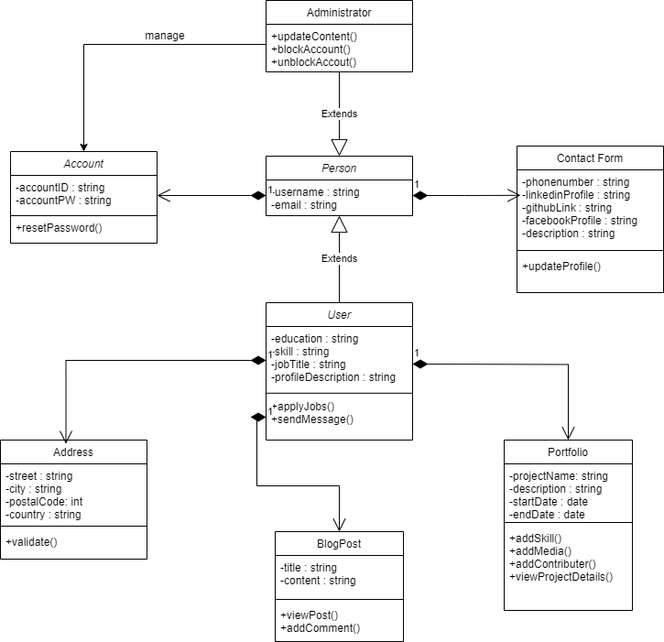**Class Diagram**

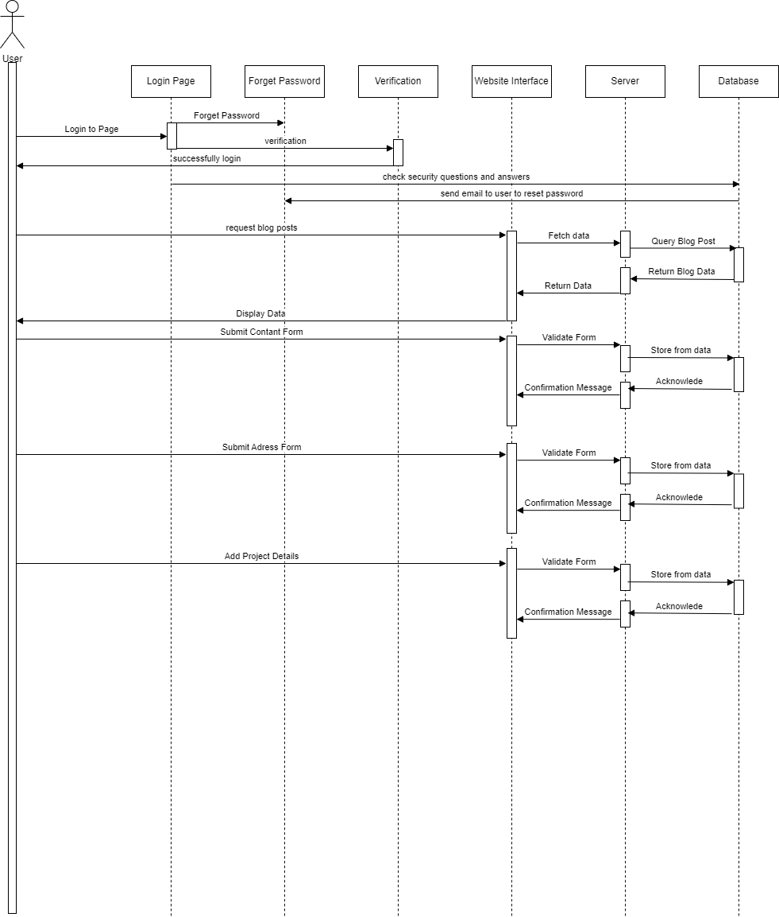**Sequence Diagram**