Project Title: Led Sequence V 1.0

Name: Basel Nagy

Description:

1. ***Hardware Requirements***
   1. *Four LEDs (LED0, LED1, LED2, LED3)*
   2. One button (BUTTON0)
2. ***Software Requirements***
   1. Initially, all LEDs are OFF
   2. Once BUTTON0 is pressed, LED0 will be ON
   3. Each press further will make another LED is ON
   4. At the fifth press, LED0 will changed to be OFF
   5. Each press further will make only one LED is OFF
   6. This will be repeated forever
   7. The sequence is described below
      1. Initially (OFF, OFF, OFF, OFF)
      2. Press 1 (ON, OFF, OFF, OFF)
      3. Press 2 (ON, ON, OFF, OFF)
      4. Press 3 (ON, ON, ON, OFF)
      5. Press 4 (ON, ON, ON, ON)
      6. Press 5 (OFF, ON, ON, ON)
      7. Press 6 (OFF, OFF, ON, ON)
      8. Press 7 (OFF, OFF, OFF, ON)
      9. Press 8 (OFF, OFF, OFF, OFF)
      10. Press 9 (ON, OFF, OFF, OFF)

State machine:

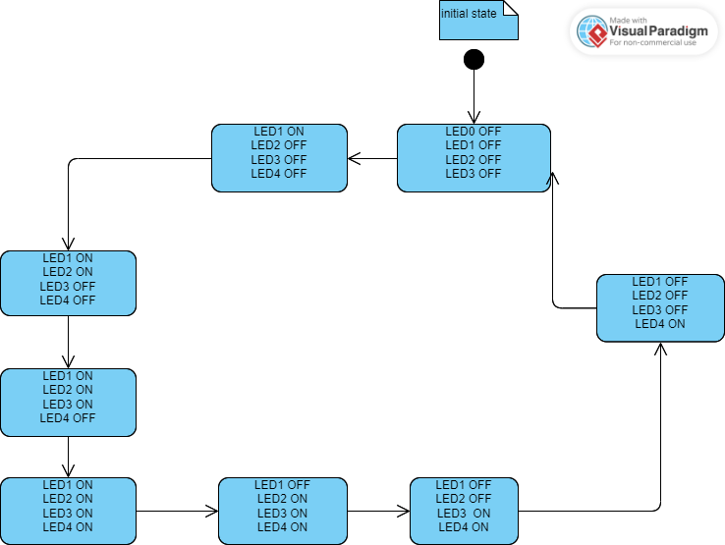

Layered architecture:

APP

HAL

MCAL

APPLICATION

LED BUTTON

DIO DRIVER

Project Modules APIs:

DIO DRIVER:

/*typedef*/

typedef enum DIO_PORTS

{

porta, portb, portc, portd

} DIO_PORTS;

typedef enum DIO_PINS

{

pin0, pin1, pin2, pin3, pin4, pin5, pin6, pin7

} DIO_PINS;

typedef enum PIN_DIRECTION

{

INPUT,

OUTPUT

} PIN_DIRECTION;

typedef enum PIN_STATE

{

LOW,

HIGH

} PIN_STATE;

/****************************************** APIs PROTOTYPES *******************************************************************/

STD_return DIO_INIT (DIO_PORTS port, DIO_PINS pin, PIN_DIRECTION direction);

STD_return DIO_WRITE_PIN (DIO_PORTS port, DIO_PINS pin, PIN_STATE state);

STD_return DIO_READ_PIN (DIO_PORTS port, DIO_PINS pin, uint8_t* vale);

LED APIs:

typedef struct LED

{

DIO_PORTS port;

DIO_PINS pin;

} LED;

/****************************************** APIs PROTOTYPES *******************************************************************/

STD_return LED_INIT (LED* led);

STD_return LED_ON (DIO_PORTS, DIO_PINS);

STD_return LED_OFF (DIO_PORTS,DIO_PINS);

BUTTON APIs:

typedef enum EN_BUTTON_STATE_t {PUSHED,RELEASED} EN_BUTTON_STATE_t;

typedef struct BUTTON

{

DIO_PORTS port;

DIO_PINS pin;

} BUTTON;

/****************************************** APIs PROTOTYPES *******************************************************************/

STD_return BUTTON_INIT (BUTTON* button);

STD_return BUTTON_READ (DIO_PORTS port, DIO_PINS pin, EN_BUTTON_STATE_t* value);