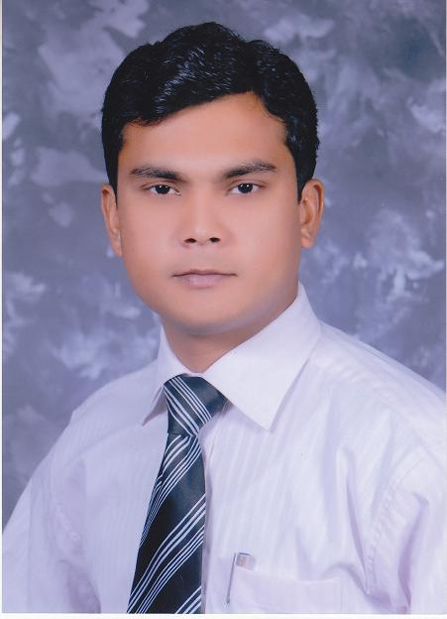
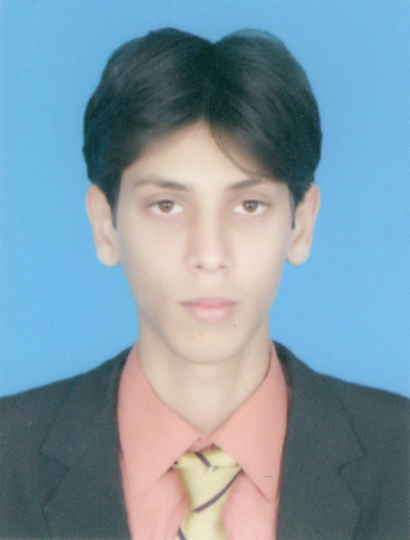
Malik Ibrar Ahmad
Email: ibrarmalik4442@gmail.com
Mobile: 056-9392095
Visa Status: Dbuai visit visa (Valid till 07th August 2016)

Objective

Seeking a well reputed organization where I can execute my dedicated core-capabilities
With long association and career development prospect.

Profile
- 2 Years Experience in Event Managment Company as an “Area Manager” Lahore – Pakistan
- 2 Years Experience in Optician Field as a “Technician Cum Sales Man” at Islamabad - Pakistan
Personal Information
Father’s Name: Faheem Ullah Malik
Nationality: Pakistani
Date of Birth: 31-08-1994
Passport # MM1165861
Marital Status: Single
Education: Matriculation
Professional Experience
- Punjab Youth Festivals - Lahore Pakistan (Area Manager)
(March 2012 To June 2014 )
- Crowd Handeling
- Hr. Department
- Prepration of payment cheques
- Food distribution

- Glassmith By Gulzari Optics – Islamabad, Pakistan
(Technician Cum Sales Man)
(July 2014 To June 2016 )

- Techincial services for glassess on Auto ager machine
- Attending walk-in customers
- Ensure after sales services in-order to meet best customer services standard
- Cash Handeling
- Maintain stock inventory and giving new orders to the suppliers

- Computer Skills

- Emailing , Internet surfing

- Languages

- English, Punjabi, Urdu, (Fluent both in verbal & written)

- Hobbies

- Swiming , Cricket , footboll , Snookers

- Reference Reference can be furnished on demand.

