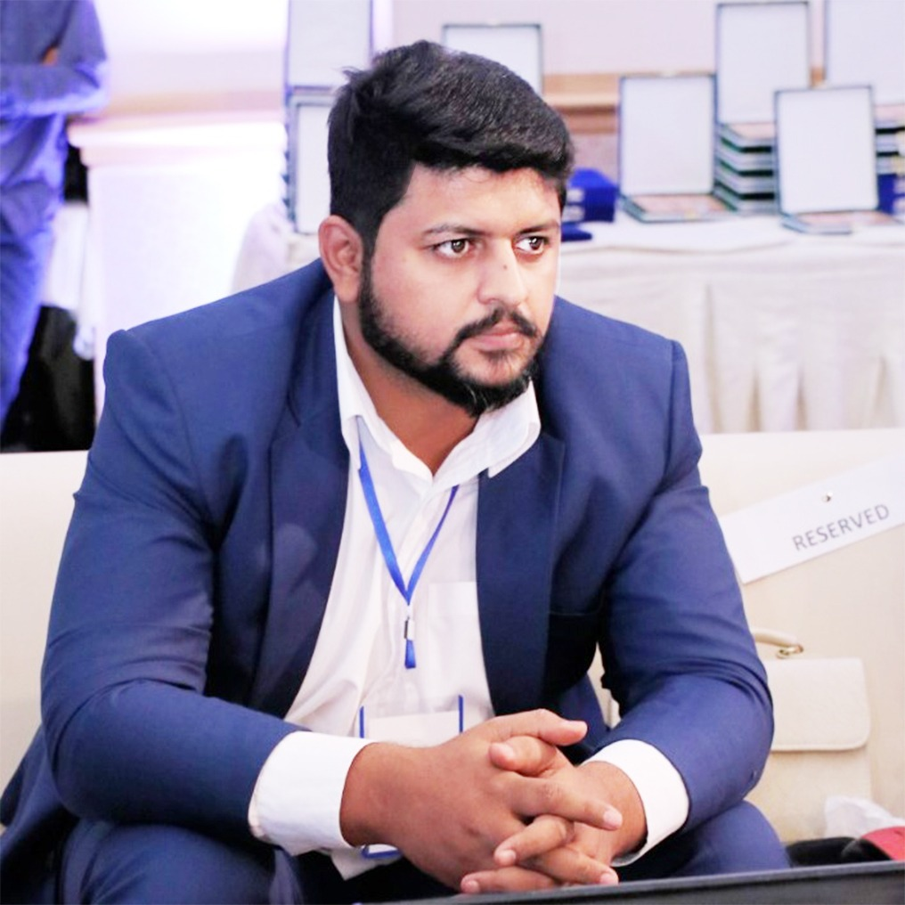 |  | MIAN SAAD BIN SAEED
Mobile: +92 333 1414145 - +92 313 4112149
Email: xaadimian87@gmail.com - xaadimian@outlook.com
Google & HubSpot Certified Consultant

OBJECTIVE

I am a digital marketing specialist with over 9 years of multidimensional fields of Health, Travel, Technology, Carpet Industry, Education, Legal soliciting, Printing, Live Chat Providers, Ecommerce, Online Shopping Store, Humanitarian Sectors, Clothing Brands, fashion magazines and job sites.

Being a certified Google and HubSpot certified Digital Marketing consultant I have a paid (PPC and Social media) spending background of over 1 million$. In the past year only, I have launched 1000+ PPC and social media campaigns for highly targeted audience in different niches. My working is a bit different from others, I begin my work by getting complete product knowledge and preparing a strategy by joining the digital marketing and sales funnels together to attain the best results in a systematic way.

KEY SKILLS

Paid Marketing Strategies (SEM, SMM), Interpersonal communication, Brand Development, Research, Website Strategist ( Structure Design and Revamping analysis), Social Media Marketing, Inbound Marketing, Out Bound Marketing, Traditional Marketing Techniques, ATL BTL Marketing strategies, Search Engine Optimization, Content Management, Creative Designing. Up to date with the latest trends of Internet Marketing, Software Structure Design, Graphics Design, Video Editing, script writing, Content Marketing, Event organization, Corporate collaborations, News writing, Script writing

AREAS OF EXPERTISE

Paid Marketing Strategies (SEM, SMM) | Search Engine Optimization
Digital Marketing | Content Management
ATL & BTL Marketing | Creative Designing
Research & Development | Project Management
Website Strategist | Software Structure Design
Search Engine Optimization & Marketing | Brand Development
Inbound & Outbound Marketing | Content Marketing
Paid Marketing Strategies (ASO, SEM, SMM) | Video Editing

Professional Certifications

Google Certifications
- Fundamentals of Digital Marketing | HubSpot Certifications
- Google Ads Display Certification _ Google | - HubSpot Content Marketing Certified
- Google Ads Fundamentals _ Google | - HubSpot Inbound Marketing Certified
- Google Ads Mobile _ Google | - HubSpot Social Media Marketing Certified

PROFESSIONAL EXPERIENCE

Co-Founder & Head of Digital Marketing March 2019 - Present
Naqeebz Consulting Lahore - Pakistan

Digital marketing strategy creation and implementation
Integration of Sales Funnels into digital marketing strategy
Implementing the latest SEO standards
Website structuring and auditing
Website Crises management
Website penalization consultancy
Project Management
Careful selection of campaigns to be launched
ROI Driven campaign strategies
Power Analytics reporting adjusting our direction
Marketing Automation (Retargeting, Email Sequences, Sales Funnels etc.)

Digital Media, Marketing and Communication Manager July 2017 - Present
Company Names: (Dubai – Lahore – Pakistan)
- NRS International
- HSNDS
- Bilqees Sarwar Foundation - BSF
- Bilqees Sarwar Hospital - BSH
- Tana Netting

Digital Marketing Work:
On Site - Off Site Optimization
Paid Campaigns (High Budget Approx. 1000 $ Daily)
AdWords: PPC
Social Media: Highly intent based Paid marketing
Website auditing
Viral Marketing
Social Media Marketing
Content Supervision
Brand Name Promotion

Traditional Marketing Work:
Launched TVC campaigns on national media channels
Theme based targeted hoarding placements
Product launch campaigns
PR campaigns
Media coverage
Leading complete in-house media productions
Handling traditional and digital media campaigns
Documentary shooting for IHC, UNHCR, USAID
Product Shot for UN, UNHCR, USAID
News writing and reporting
Supervising Product photography and videography
Script writing / story boarding for videos

Other Tasks:
Event organization
Corporate meetings for collaboration
Monitoring and reporting the initiatives of BSF
Sponsorships of the events
Launching new social campaigns

Digital Marketing Manager Jan 2017 – July 2017
Dr. Najeeb Medical Lectures (Lahore-Pakistan)

Major Project:
www.drnajeeblectures.com
YouTube Marketing
On Site - Off Site Optimization
Paid Campaigns (High Budget Approx. 1000 $ Daily)
AdWords: Display Advertising
Social Media: Highly intent based Paid marketing
Website auditing
Landing Page Creation and Optimization
Website Maintenance & Functionality Testing
Implementing Latest Practices of On-Site SEO
Viral Marketing
Social Media Marketing
Content Suggestions
Online Branding
Brand Name Promotion
Research & Development

SEO & Digital Marketing Specialist
Naseeb Networks (Rozee.pk) (Lahore - Pakistan) August 2015 to Jan 2017

Major Projects:
http://www.rozee.pk/
http://www.mihnati.com/

Job Description
On Site White-Hat SEO
Paid Campaigns (AdWords & Social Media)
Social Media Marketing
Website audit
Landing Page Optimization
Google Analytics & Social Media Custom Reporting
Multilingual Optimization
Website Maintenance & Functionality Testing
Implementing Latest Practices of On-Site SEO
QA Testing for Job Engines, Portals, Custom Algorithms
To maintain User & Google Friendliness in Websites
Viral Marketing
Content Suggestions
Online Branding
Brand Name Promotion
Research & Development

SEO/ SMM & Website Strategist
LiveGreeter (LiveAdmins) (Lahore, Pakistan, DMCC, Dubai) Oct 2014- August 2015

Major Projects:
http://www.liveadmins.com/
http://www.customerservice.ae/

Website Strategist & Digital Media Expert
BGC (Blue Group of Companies) May 2012 to Sep 2014

Major Projects:
www.martblue.com
www.printingblue.com
www.artimmix.com
https://www.facebook.com/martblue
https://www.facebook.com/Artimmix
https://www.facebook.com/pages/Basantee-Lawn/679454618778697

SEO Specialist
Pribno Inc. (Lahore - Pakistan) June 2010 to Feb 2012
Major Project: http://www.mobistealth.com /

EDUCATION

MSCS (3.46 C.G.P.A) 2010
(Ms. Communication studies Specialization in Electronic Media)
University of the Punjab
Pakistan

Graduation (1st Div) 2008
Punjab University
Pakistan

LANGUAGE SKILLS

English Fluent Punjabi Native Urdu Native

PROFESSIONAL ENDORSEMENT

Wordpress, Magento, Customized Website CMS, Corel Draw, Adobe Photoshop, Adobe Fireworks, Adobe illustrator & Customized Database Management Applications.

PERSONAL DETAILS

Date of Birth: 10-APR-1987
Nationality: Pakistani

REFERENCES
Will be furnished on request.

