|  |
| --- |
|  |

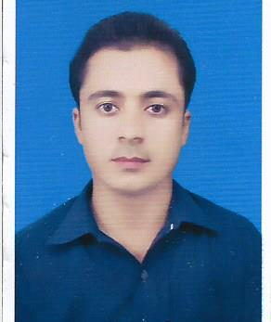

**Muhammad Anwar Khan**

Mobile No:+923355585542

**Lakki Marwat-Pakistan**

***Objective***

# A suitable position with an organization where I can utilize the best of my skills and abilities that fit to my education, skills and experience a place where an encourage and permitted to be an active participant as well vital contribute on development of the Organization.

***Personal Information***

* Name : Muhammad Anwar Khan
* F/Name : Bai salum Khan
* Gender : Male
* Date of Birth : 03/04/1991
* CNIC No. : 11201-8963845-9
* Nationality : Pakistani
* Marital Status : Single
* Address : Village Abbasa Wazir P/O Abbasa Khattak Tehsil and

District Lakki Marwat KPK

* Languages Known : Pashto (native), Urdu (fluent), English (fluent)
* Visa Status : Nil

***SKILLS***

* Excellent communication skills
* Ability to work under pressure and a part of team
* Quick to learn with good interpersonal and organizational skills
* Keen to develop and maintain interpersonal relationship
* Have a high sense of responsibility
* Ability to easily build a rapport with customers
* Committed to personal development

***Education Qualification***

|  |  |  |  |  |
| --- | --- | --- | --- | --- |
| ***Degree*** | ***Passing Year*** | ***Obtained/Total Marks*** | ***Grade/Division*** | ***Board/University*** |
| ***SSC*** | 2009 | 743/1050 | A | BISE Kohat |
| ***F.Sc (Pre Medical)*** | 2011 | 583/1100 | C | KP BTE Peshawar |
| ***B.Sc*** | 2014 | 291/550 | B | KUST Kohat |
| ***M.Sc (Chemistry)*** | 2016 | 3.03/4.00 | A | KUST Kohat |

***Professional Qualification***

* Diploma of Computer Office Automation (06 months) from Islamabad in 2013.
* PTC from AIOU Islamabad in 2016 securing 636/900 in First Division.

***Work Experience***

* Worked as SST (Bio & Chemistry) in High Vision Academy Karak
* Worked as SS in Chemistry in Paradise School and College Karak

***Declaration***

I do hereby declare that all the above mentioned details are true and correct to the best of my knowledge and belief

**Muhammad Anwar Khan**