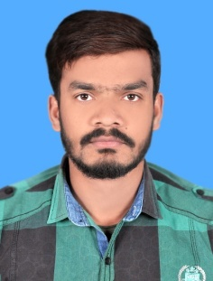

**Syed Shahbahat hussain**

Father Name: Syed Abid Hussain Shah

Cell (Personal): 03124704451

Date Of Birth : 05- 04 1995

CNIC : 35202-8258658-3

E-mail: shabahathussain59@gmail.com

Address: H-21 Ghousia St # 5 Arshad Mohallah Shahdara Town Lahore

**Objectives:**

To succeed in an environment of growth and excellence and earn a job which provides me satisfaction, self-development and help me achieve personal as well as organizational goals.

|  |  |  |  |
| --- | --- | --- | --- |
| Qualification | Year | Institution | Grade |
| DAE (Mechanical Technology) | 2015 | Lahore poly technical institute Lahore Pakistan. | 1st div |
| Diploma in Machinist | 2014 | Govt Technical training institute Gulburg Lahore | 1St div |
| Seecondary School Certificate | 2012 | Private from Lahore Board | 1st div |
| Diploma in CNC Machine operator | 2015 | Precision System Training center, PCSIR Labs Lahore | 1st div |

**Education:**

Computer Skills:

* Basic knowledge

**Experience:**

* 2 year work experience in izhar group of companies (izhar steel mill) 36km multan road Lahore as maintainance fitter

**Reference**

* Will be provided on demand