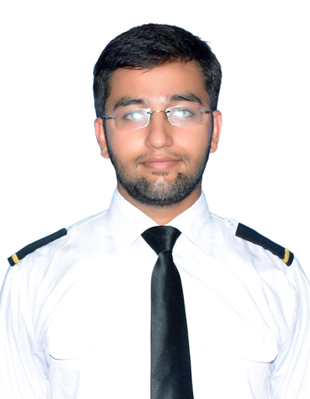

**ARSLAN ASHRAF**

**Chak#124 RB Behlolpur Post office Soh Wala#132 Tehsil Chak Jhumra Disst Faisalabad Pakistan**

**Cell: +92-340-004-1124**

**ArslanAshraf124@gmail.com**

Customer-focused professional with over 02 year of experience in facilitating airline ground operations at regional and international airports. Accomplished in enhancing airline operations through process of improvement. History of success in de-escalating customer issues, enhancing customer experiences and satisfaction, and uniting teams to deliver exceptional service. Looking to take next career step in customer service and leadership roles with a Professional Airline committed to elevating customer travel experiences.

Core Qualifications

* Airline Operations
* Customer Service
* Conflict Resolution and De-escalation
* Airport Operations
* Team Leadership
* Ramp safety on an aerodrome.

Professional Experience

**LOAD CONTROLLER AT (SHAHEEN AIR INTERNATIONAL)**

**FAISALABAD INTL AIRPORT 21/4/2018 – Current**

* Loaded, stowed and baggage, cargo and freight and submitted complete documentation to management.
* Coordinate with ramp agents to verify that all baggage was placed on the correct ongoing flight.
* Doing frequently manual load sheets of All Shaheen air Intl Flights.
* Having competency Certificate though able to prepare load and trim sheets of Airbus **A319-100, A320-232, and A330-200**

**TRAFFIC ASSISTANT AT (SHAHEEN AIR INTERNATIONAL)**

**FAISALABAD INTL AIRPORT**

**17/04/2017 – Current**

* Checked-in passengers for domestic and international on DCS (Departure control system) verified documentation for international and domestic flights.
* Assist misconnected and rerouted passengers during irregular operations; issue travel and hotel vouchers to displaced passengers on overbooked or canceled flights.
* Assisted customers with special needs and quickly addressed and resolved customer complaints.
* Coordinate and conduct internal audits to assess compliance with standard operating procedures, employee standards, and PCAA and airport requirements.
* Manage FIDS (flight information management system) activates at our respective station. .

**INTERNSHIP AT GERRY’S DNATA LAHORE PAKISTAN.**

* Coordinate with supervisor to determine staffing needs for gate and ground operations, including ticket counters and baggage services.
* Address and resolve escalated customer concerns, and assist agents to resolve complex issues.
* Communicate changes in company rules and procedures, and mentor staff to improve performance and efficiency.
* Secure gates by communicating with aircraft and relaying messages to ramp and ticket counter.

Education

**Bachelor of Science: Aviation Management, Superior University Lahore, Pakistan, – 2017**

**Intermediate in science: Superior college Faisalabad,– 2013**

**Matriculation in Science: Govt High School, –2011**