MATLAB Question:

1. .

Signal x:

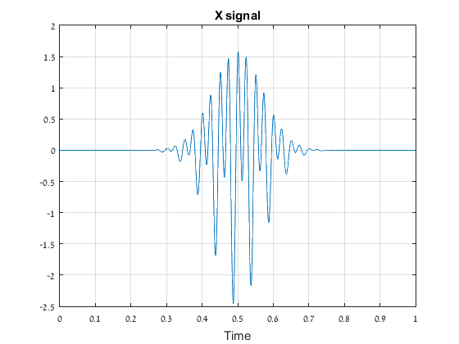

Absolut value of FFT of the signal after shifting:

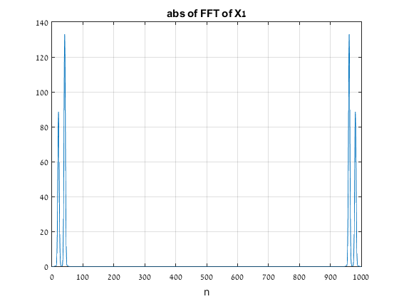

1. .

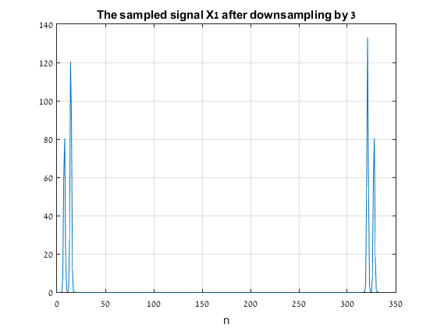

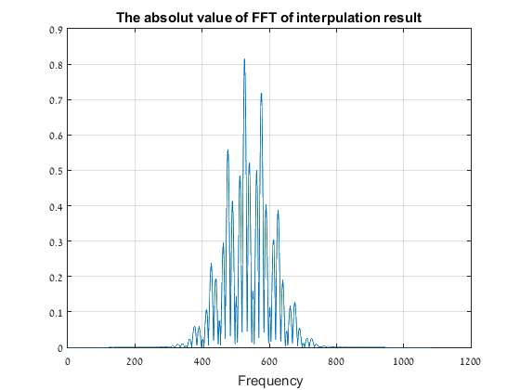

After 3 down sampling and then 3 up sampling:

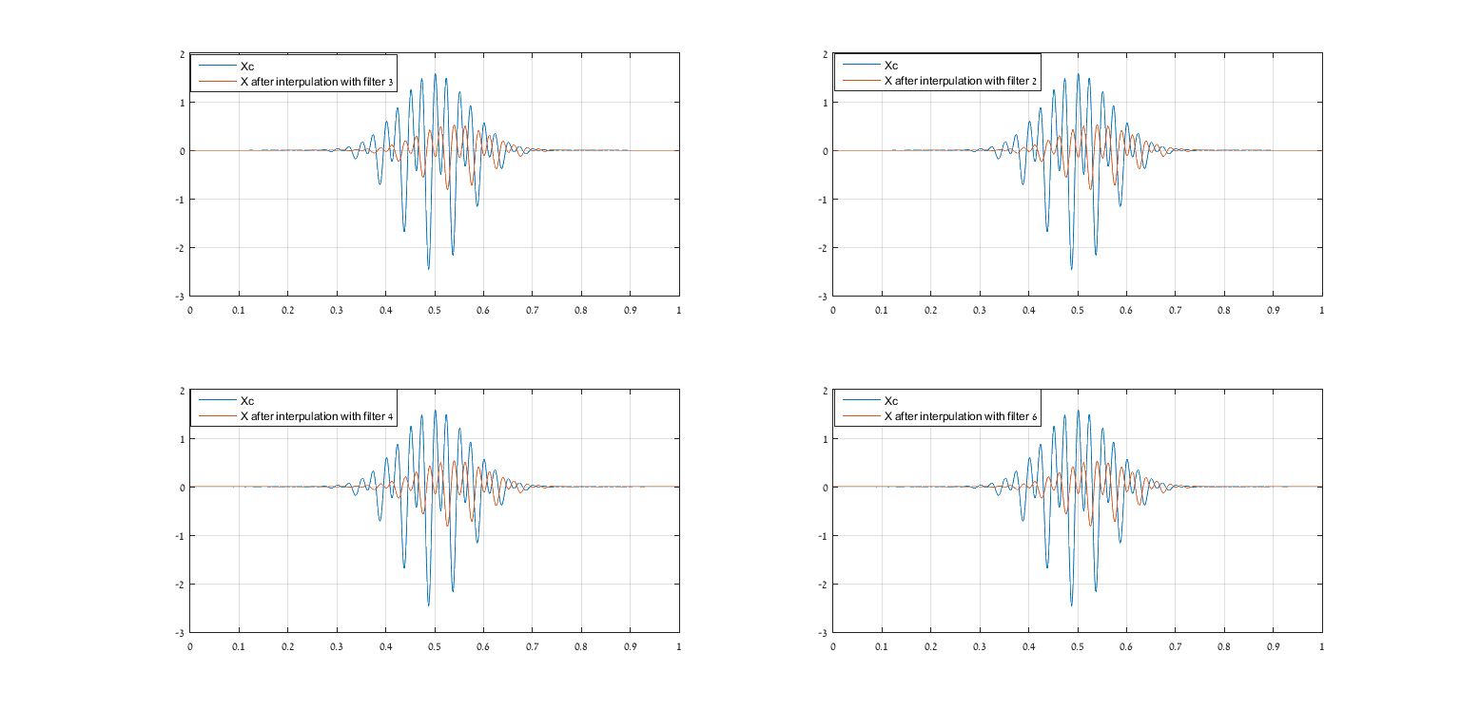

1. After 6 down sampling and then 6 up sampling :

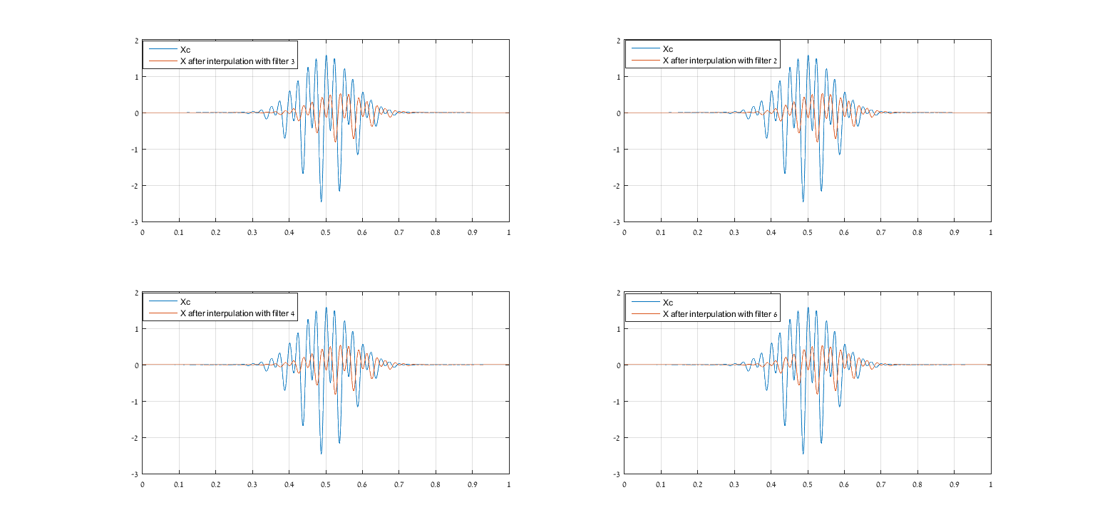

The filters we use:

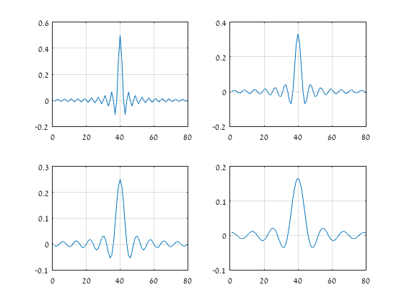

MATLAB code we use:

t=linspace(0,1,1000);

f=1e3;

x=(1.5*cos(2*pi*40*t)+sin(2*pi*20*t)).*exp(-100*((t-0.5).^2));

Ts=1./f;

n=1:1:1000;

%figure(4)

%sample=stem(n,x);

x_s=(1.5*cos(2*pi*40*n.*Ts)+sin(2*pi*20*n.*Ts)).*exp(-100*((n.*Ts-0.5).^2));

x_s3=x_s(1:3:1000);

x_s33=upsample(X_s3,3);

x_s333=conv(X_s33,pidiv3filt);

x_s32=conv(X_s33,pidiv2filt);

x_s34=conv(X_s33,pidiv4filt);

x_s36=conv(X_s33,pidiv6filt);

x_s6=x_s(1:3:1000);

x_s66=upsample(X_s3,3);

x_s666=conv(x_s66,pidiv3filt);

x_s62=conv(x_s66,pidiv2filt);

x_s64=conv(x_s66,pidiv4filt);

x_s66=conv(x_s66,pidiv6filt);

figure(3)

plot(t,x)

title('X signal')

xlabel('Time')

grid on

figure(8)

plot(x_s)

grid on

title('The sampled siganl X1')

X=fft(x);

X_s=fft(x_s);

fftshift(X);

fftshift(X_s);

figure(9)

plot(abs(X_s))

grid on

title('abs of FFT of X1')

xlabel('n')

figure(10)

plot(abs(X_s3))

title('The sampled signal X1 after downsampling by 3')

xlabel('n')

grid on

figure(11)

subplot(2,2,1)

plot(t,x,t,x_s333(1,1:1000))

grid on

legend('Xc','X after interpulation with filter 3')

subplot(2,2,2)

plot(t,x,t,x_s32(1,1:1000))

grid on

legend('Xc','X after interpulation with filter 2')

subplot(2,2,3)

plot(t,x,t,x_s34(1,1:1000))

grid on

legend('Xc','X after interpulation with filter 4')

subplot(2,2,4)

plot(t,x,t,x_s36(1,1:1000))

grid on

legend('Xc','X after interpulation with filter 6')

figure(12)

plot(abs(X_s333))

grid on

title('The absolut value of FFT of interpulation result')

xlabel(' Frequency')

figure(13)

subplot(2,2,1)

plot((x_s333))

grid on

subplot(2,2,2)

plot((conv(x_s33,pidiv6filt)))

grid on

subplot(2,2,3)

plot((conv(x_s33,pidiv2filt)))

grid on

subplot(2,2,4)

plot((conv(x_s33,pidiv4filt)))

grid on

figure(14)

subplot(2,2,1)

plot(t,x,t,x_s666(1,1:1000))

grid on

legend('Xc','X after interpulation with filter 3')

subplot(2,2,2)

plot(t,x,t,x_s62(1,1:1000))

grid on

legend('Xc','X after interpulation with filter 2')

subplot(2,2,3)

plot(t,x,t,x_s64(1,1:1000))

grid on

legend('Xc','X after interpulation with filter 4')

subplot(2,2,4)

plot(t,x,t,x_s66(1,1:1000))

grid on

legend('Xc','X after interpulation with filter 6')