4. RSL Prediction Approach

4.1 What Remaining Shelf Life (RSL) means
Remaining Shelf Life is the number of days a storage unit (SU) of milk can still be kept before its bacterial count reaches the spoilage limit of 20,000 CFU/mL (log10 = 4.30). In the training table this is the column target_rsl_days; it is 0 when the limit has already been exceeded (107 of 12,053 rows). RSL differs from the printed label date: the label assumes ideal cold-chain storage, whereas real units warm up on the dock, in vehicles and on the shop floor, so their true remaining life is shorter or longer than the label suggests.

4.2 Initial model: kinetic baseline on equiv_age_at_4c_days
Bacterial growth speeds up with temperature, so one hour at 8 °C consumes more shelf life than one hour at 4 °C. The project's kinetic model converts the whole temperature history of an SU into a single number, equiv_age_at_4c_days: the number of days at a constant 4 °C that would cause the same growth. The baseline predicts RSL from this one feature only. We evaluated two forms: (K1) a linear regression (RSL = 8.15 − 0.96 × equiv_age) and (K2) a physically constrained fixed-slope form, RSL = max(0, L − equiv_age), where one equivalent day at 4 °C consumes exactly one day of life and the single parameter is L = 8.29 days. The fitted K1 slope (−0.96) is close to the theoretical −1, which supports the kinetic reasoning. We chose this baseline because it is simple, explainable to the supervisor, and sets the bar that any more complex model must beat.

4.3 Extending the model with additional features
Week 2 adds four groups of inputs taken from the logged cold-chain data (12 features in total including equiv_age_at_4c_days):
Group | Meaning | Columns used
stage_hours | Hours spent in each stage | hours_coldroom, hours_dock, hours_vehicle, hours_vehicle_stop, hours_floor, hours_display
degree_hours | Heat exposure over time | meas_dh_above_4, meas_dh_above_8
max_temperature | Highest temperature reached | meas_max_c
missing_hours | Hours with missing sensor data | meas_missing_h, hours_without_sensor

Columns that contain the answer or are derived from it (target_rsl_days, target_log_count, target_over_limit, label_days_left) are never used as inputs, to avoid data leakage.

4.4 Comparing the kinetic baseline with machine learning
The machine-learning model is a Gradient Boosting Regressor (300 trees, depth 3, learning rate 0.05, subsample 0.8). A Ridge regression on all features is included as an intermediate step. All models use exactly the same lot_id-based split: 173 lots (9,560 rows) for training and 44 unseen lots (2,493 rows) for testing (seed 42), with no lot in both sets, plus 5-fold GroupKFold by lot as a robustness check. Splitting by lot is essential because rows of the same lot are almost copies of each other; a random row split would leak information and make every model look better than it is.

4.5 Evaluating accuracy: MAE, RMSE and laboratory data
MAE is the average absolute error in days; RMSE penalises large errors more. Both are in days of RSL.
Model | Hold-out MAE | Hold-out RMSE | 5-fold MAE | 5-fold RMSE
Kinetic baseline – linear (equiv. age only) | 0.854 | 1.129 | 0.761 ± 0.039 | 0.970 ± 0.066
Kinetic baseline – fixed slope, RSL = L − age | 0.850 | 1.127 | 0.759 ± 0.038 | 0.970 ± 0.066
Ridge regression (all 12 features) | 0.856 | 1.108 | 0.758 ± 0.050 | 0.960 ± 0.064
Gradient Boosting (all 12 features) | 0.861 | 1.127 | 0.777 ± 0.039 | 0.989 ± 0.059

Result. All four models perform almost identically: Gradient Boosting does not beat the kinetic baseline (hold-out MAE 0.86 vs 0.85 days; the differences are far smaller than the fold-to-fold spread). Adding the feature groups one by one to Gradient Boosting also gave no gain (hold-out MAE 0.858 with equiv_age alone, 0.861 with all features), and equiv_age_at_4c_days carries about 87% of the model's feature importance. The explanation is in the data: for the same lot, RSL + equivalent age is nearly constant (within-lot SD 0.14 days), but it differs between lots (between-lot SD 0.98 days). This lot-level starting condition, most likely the initial bacterial load, is not contained in any process feature, so it sets a floor of roughly 0.8–0.9 days MAE that more temperature features cannot remove. We therefore recommend keeping the explainable kinetic model as the reference and treating Gradient Boosting as a deployable alternative whose value would come from lot-level information (for example an arrival-time plate count) rather than from more temperature features.
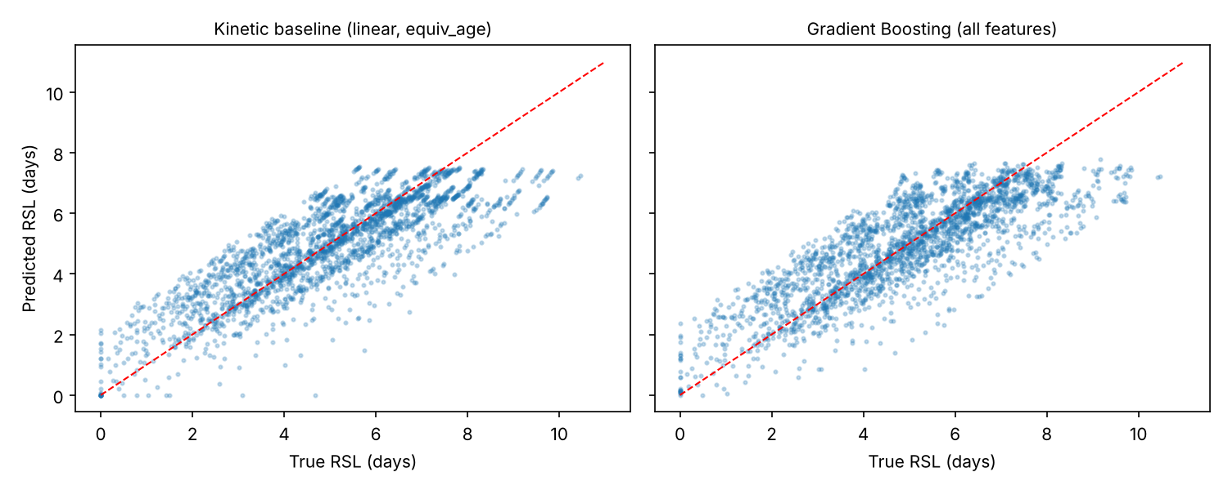
Figure 1. Predicted vs. true RSL on the held-out lots (dashed line = perfect prediction).
Laboratory checks. The lab file has 154 plate counts (log10 CFU/mL, measurement error about ±0.25 log), of which 153 were matched to a training row of the same su_id within 12 h (median gap 5.4 h). Because the lab reports counts, not RSL in days, no MAE/RMSE is computed on it: that would require inventing RSL labels. Instead we report valid indirect checks: (i) the lab counts agree with the count column of the training table (mean difference -0.01 log, SD 0.29; 92% within 0.5 log); (ii) predicted RSL is strongly and negatively rank-correlated with the lab count (Spearman ρ = -0.81 for Gradient Boosting, -0.79 for the baseline); (iii) only 3 lab samples exceed the limit; their mean predicted RSL is 0.9 days versus 5.1 days for the rest, and 2 of the 3 are predicted at ≤ 1 day. With only 3 positives this is a sanity check, not a performance estimate. A days-based lab error will be added once the supervisor confirms a growth rate (and how to treat the lag phase) for converting a count into days.

4.6 Output format and uncertainty
The model is exposed as predict_rsl(data), which returns for each SU: su_id / lot_id, predicted_days (≥ 0) and uncertainty (one standard deviation, in days). The uncertainty is the spread of out-of-fold prediction errors (grouped by lot), about 0.96–1.04 days depending on the predicted RSL; an 80% interval built from it covered 74% of held-out rows, so it is slightly optimistic and should be read as approximate. The exact field names remain to be confirmed with IE-2 and CSE-3.

4.7 Limitations
(1) Lot-level variation dominates the remaining error. (2) Lab data cover 153 matched samples and only 3 above the limit. (3) The data appear to be synthetic/simulated, so real-world accuracy is untested. (4) The deployed model is retrained on all lots; the reported errors come from lots the model had not seen.

