Project: Cryptocurrency Scraper
This Python script scrapes cryptocurrency data from CoinMarketCap, including rank, name, symbol, and price, and displays it in a formatted table.

Libraries:
- requests
- BeautifulSoup (bs4)

My Code:
1. from bs4 import BeautifulSoup
2. import requests
3.
4. # Simple get request and get the page HTML
5. response = requests.get("https://coinmarketcap.com/")
6. soup = BeautifulSoup(response.text, 'html.parser')
7.
8. # Find all table rows
9. rows = soup.find_all('tr')
10.
11. cryptos = []
12.
13. # Extract crypto data from each row
14. for row in rows:
15. rank_tag = row.find('p', class_='sc-71024e3e-0')
16. name_tag = row.find('p', class_='sc-65e7f566-0')
17. symbol_tag = row.find('p', class_='coin-item-symbol')
18. price_tag = row.find('span', string=lambda text: text and '$' in text)
19.
20. if name_tag or symbol_tag:
21. rank = rank_tag.get_text(strip=True) if rank_tag else "NONE"
22. name = name_tag.get_text(strip=True) if name_tag else "NONE"
23. symbol = symbol_tag.get_text(strip=True) if symbol_tag else "NONE"
24. price = price_tag.get_text(strip=True) if price_tag else "NONE"
25.
26. if name != "NONE" or symbol != "NONE":
27. cryptos.append({
28. 'rank': rank,
29. 'name': name,
30. 'symbol': symbol,
31. 'price': price
32. })
33.
34. # Print table
35. if cryptos:
36. print(f"{'Rank':<6} {'Name':<20} {'Symbol':<10} {'Price':<15}")
37. print("=" * 60)
38.
39. for crypto in cryptos:
40. # Shorten long names for better table alignment
41. if len(crypto['name']) > 20:
42. name = crypto['name'][:17] + "..."
43. else:
44. name = crypto['name']
45.
46. print(f"{crypto['rank']:<6} {name:<20} {crypto['symbol']:<10} {crypto['price']:<15}")
47.
48. print(f"\nSuccessfully scraped {len(cryptos)} cryptocurrencies!")
49.

Sample Output:
Rank Name Symbol Price
==========================================================
1 Bitcoin BTC $27,000
2 Ethereum ETH $1,800
...
Successfully scraped (n) cryptocurrencies!

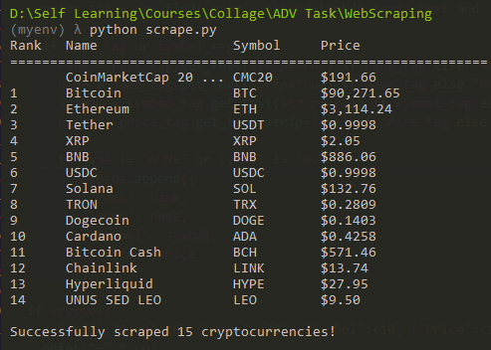
How it works on my machine:

All Code referenced in this document can be found in my repository:
https://github.com/Basem3sam/crypto-scraper


