Section properties
$$b=200=200000 mm$$
$$h=400=400000 mm$$
$$A=b⋅h=80000 mm^2$$
$$I=\frac{b⋅h^{3}}{12}=1066666666.6667 mm^4$$
$$c=\frac{h}{2}=200 mm$$
$$W=\frac{I}{c}=5333333.3333 mm^3$$

Material & loading
$$f_{y}=250=0.0003 MPa$$
$$E=200000=0.2 MPa$$
$$L=6000=6000000 mm$$
$$w=5=0.005 N/mm$$
$$F=45=0.045 kN$$

Beam bending
$$M_{max}=\frac{w⋅L^{2}}{8}=22500000 N·mm$$
$$M_{Ed}=\frac{F⋅L}{4}=67.5 kN·m$$
$$sigma=\frac{M_{max}}{W}=4.2187 MPa$$
$$delta=\frac{5⋅w⋅L^{4}}{384⋅E⋅I}=0.3955 mm$$

Calculus
$$x=3=3$$
$$dfdx=\frac{dx^{3}+2⋅x}{dx}=29$$
$$A_{circle}=\int_{−1}^{1}{\sqrt{1−x^{2}}dx}=1.571$$
$$S_{squares}=\sum_{k1}^{10}{k^{2}}=385$$

Trig
$$theta=0.7854=0.7854$$
$$hyp=\sqrt{{sin(theta)}^{2}+{cos(theta)}^{2}}=1$$

Plots
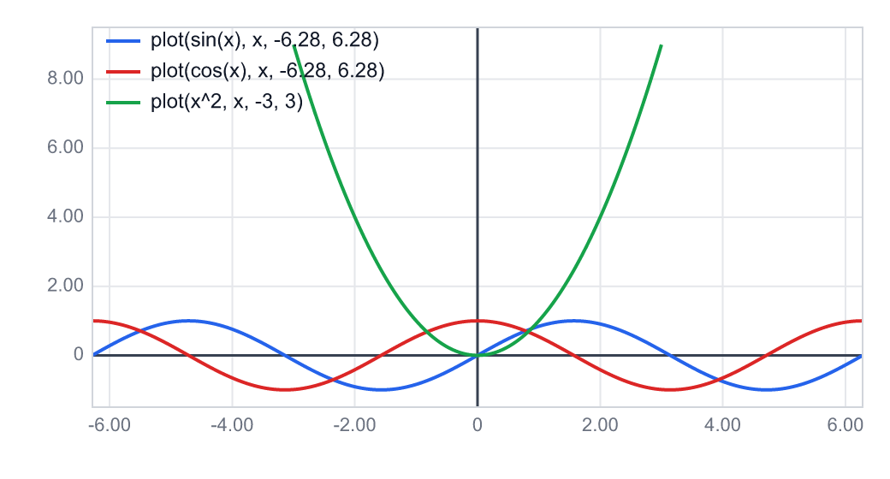

Results table
Parameter | Value
b | 200 mm
h | 400 mm
A | 80000 mm²
I | 2.133e9 mm⁴

