**ASSIGNMENT -1**

**Answer 1:**

**Stage 1: Data Gathering**Data gathering is the process of collecting relevant data from various source.  
  
Excel file is converted to CSV File and the file is read into google colab. 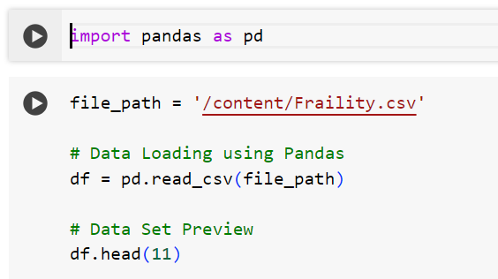

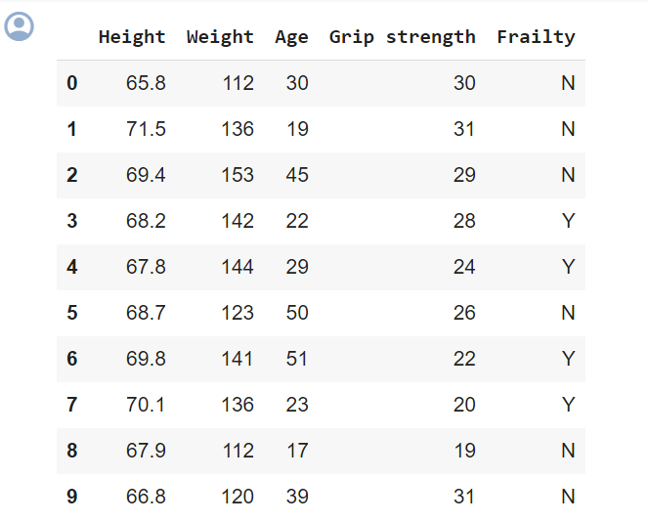

**Stage 2: Data Processing:**

**Identifying ‘NA’ values from the data and omit the rows with frailty=N  
  
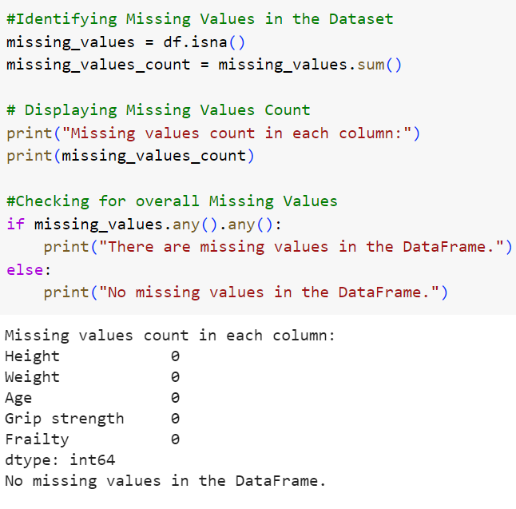**

**Omitting the values with Frailty=N  
  
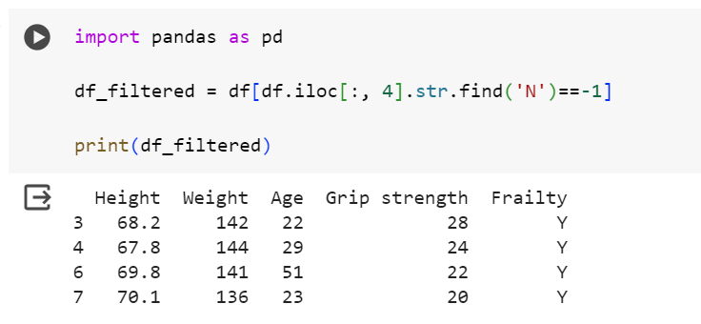**

**Stage 3: Data Analysis  
  
Performing T-Test Analysis on the cleaned data   
  
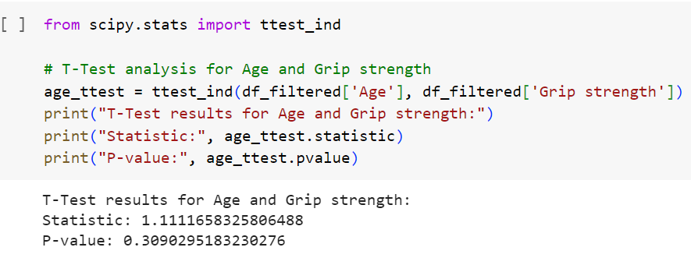**

**Data Analysis:  
  
created a scatter plot between age and grip strength  
  
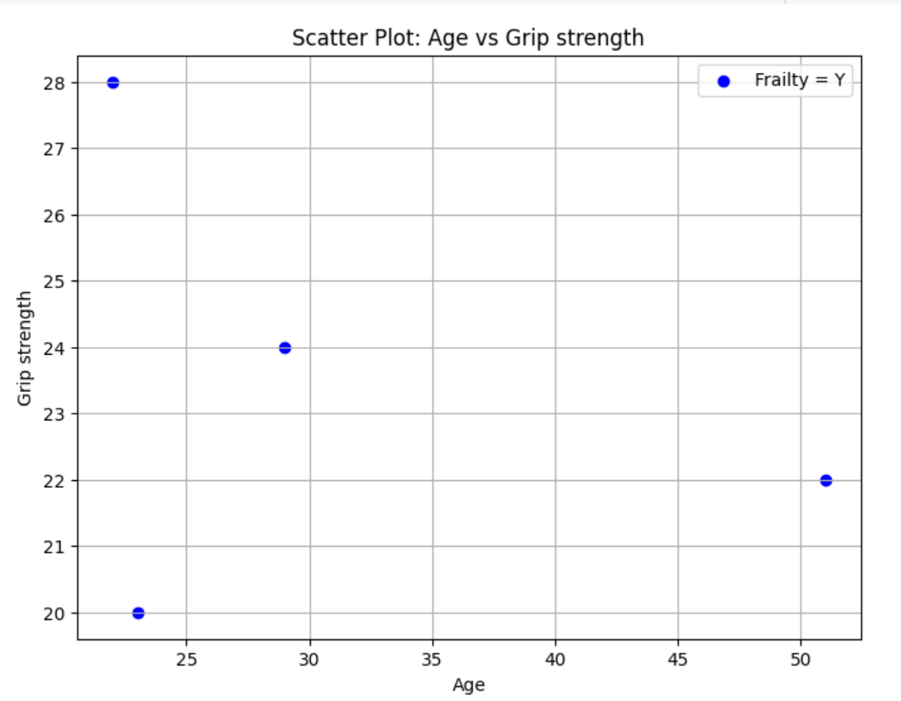  
  
  
Answer 2:  
  
Histogram :** A histogram is a graphical representation of the distribution of numerical data. 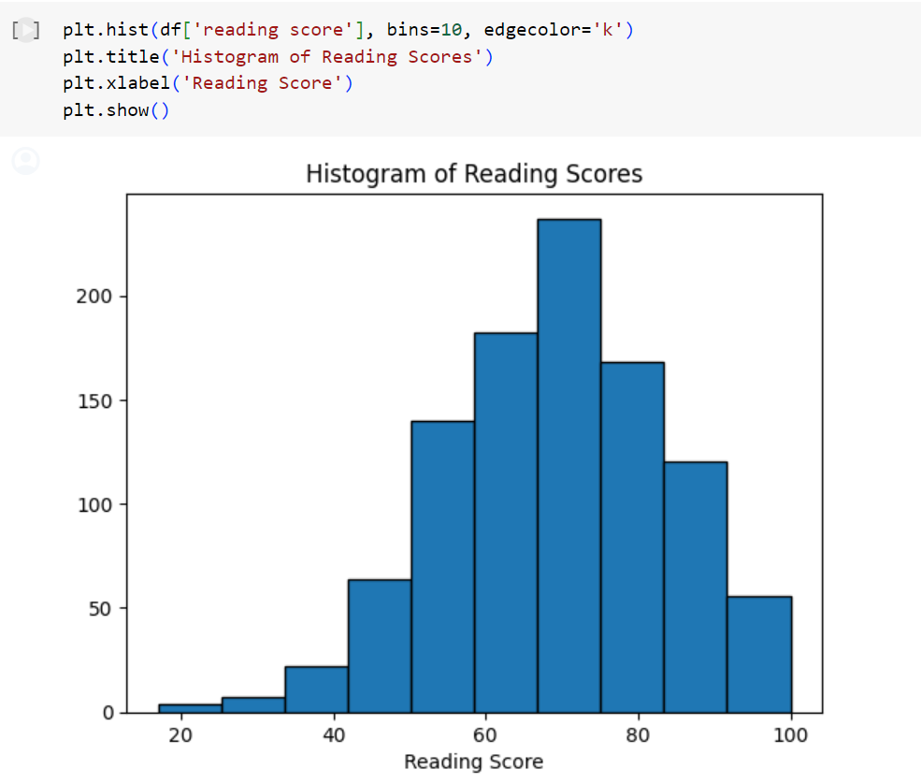

**Line Plot:** A line plot, also known as a line chart, is a type of graph that displays data points connected by straight line segments.  
  
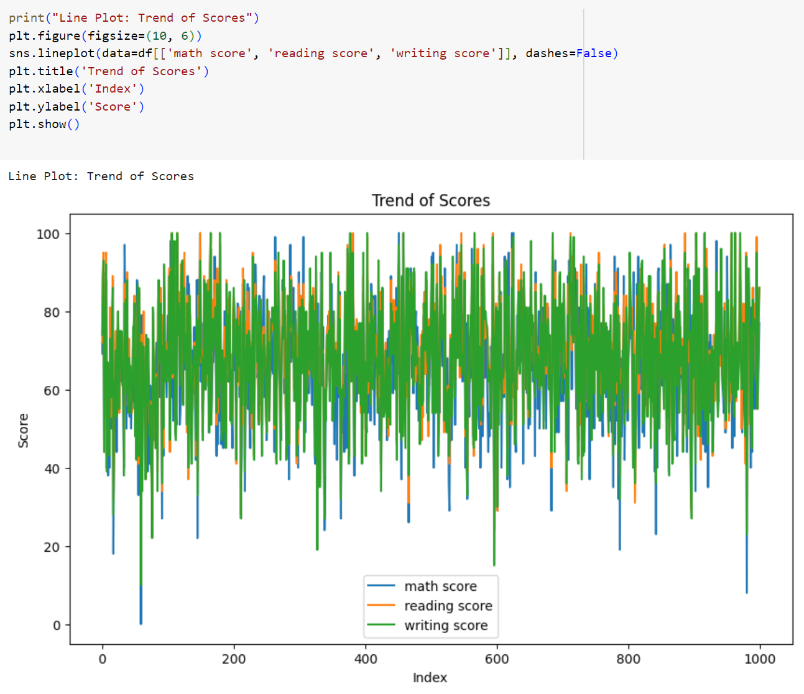

**Pie chart:** A pie chart is a circular statistical graphic that is divided into slices to illustrate numerical proportions. 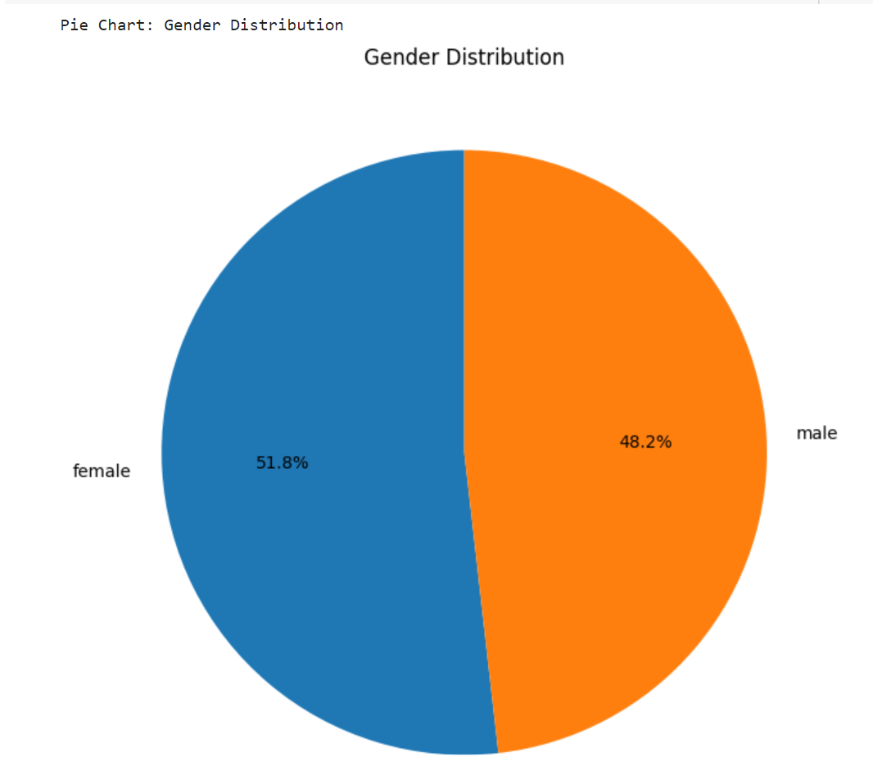

**Q-Q Plot:** A Q-Q plot, short for quantile-quantile plot, is a graphical tool used to compare the distribution of a sample data set to a theoretical distribution, such as the normal distribution.

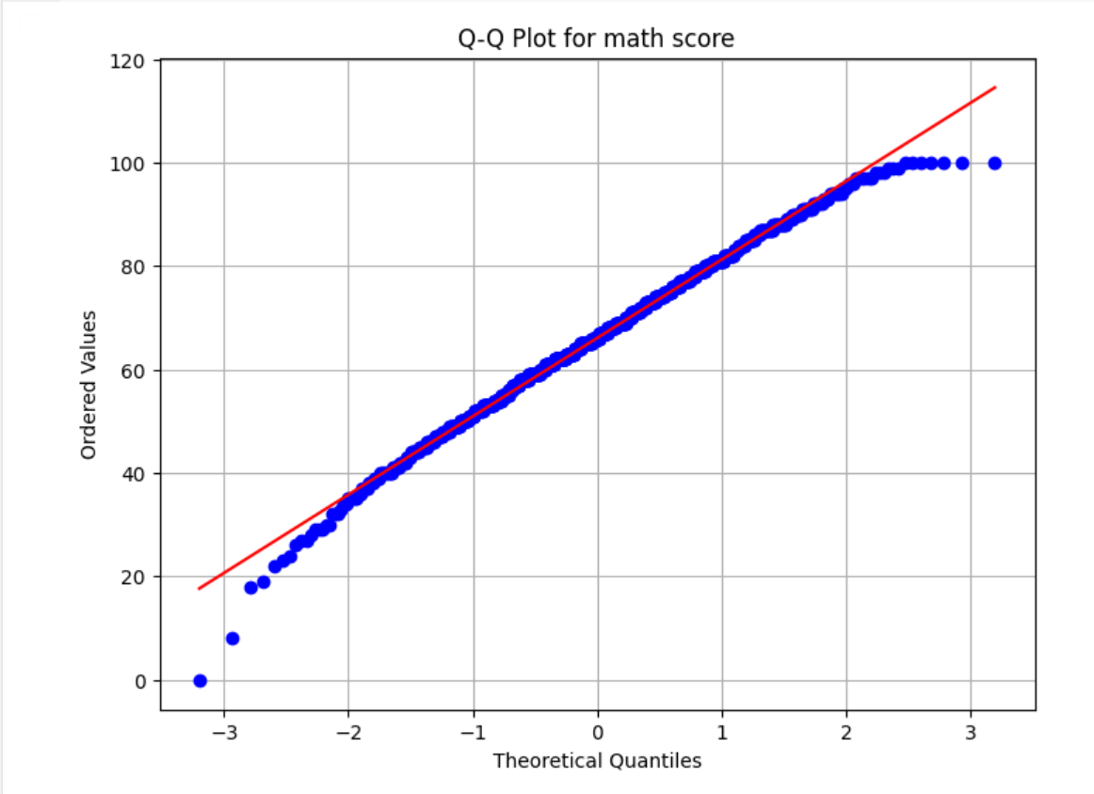

**ScatterPlot:** A scatter plot is a graphical representation of data points in a Cartesian coordinate system, where each point represents the value of two variables. It visually shows the relationship between two variables, allowing for the identification of patterns, trends, and correlations within the data.  
  
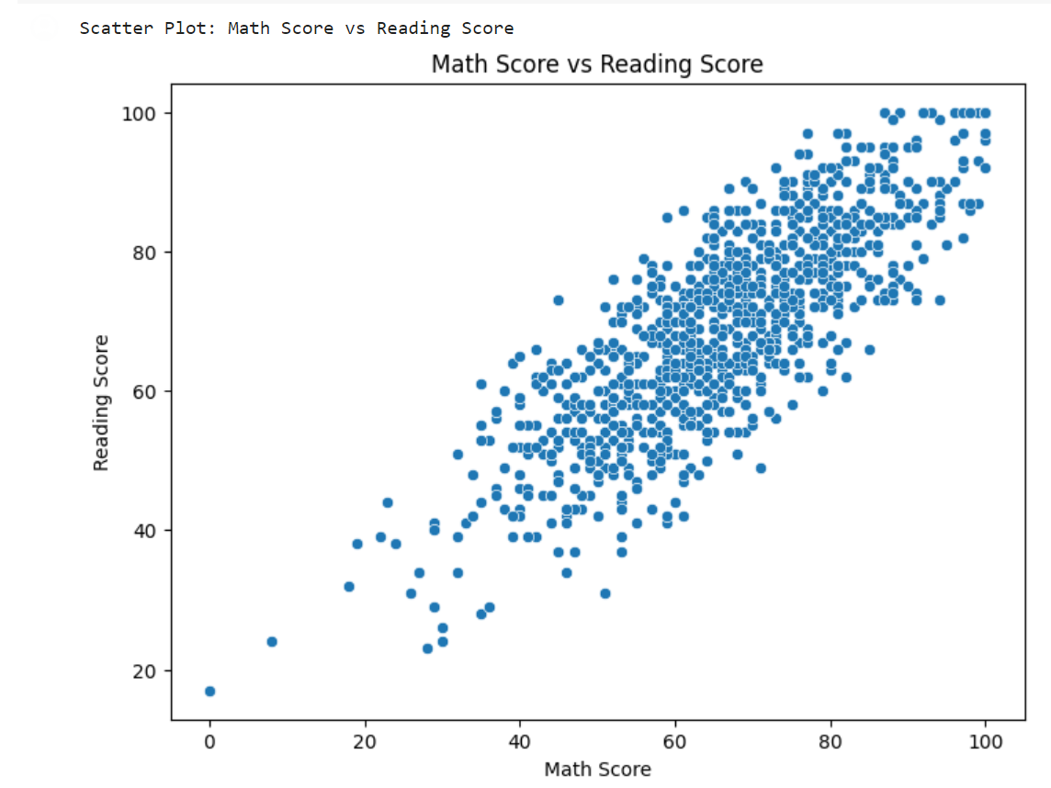

**Scatter Plot Visualization is easier**

The Scatter Plot is the option that makes analysis easier now out of all of them. The development of data visualization libraries and tools has made it easier and more accessible to create scatter plots and analyze the relationships between variables. Easy-to-use functions or modules for creating scatter plots are available in a wide variety of programming languages and software packages, enabling to easily visualize data relationships.