TorGhostX : Anonymous IP Rotation with Tor
--- Bhavesh Mahesh Dhake
1. Download Tor from official website : https://www.torproject.org/
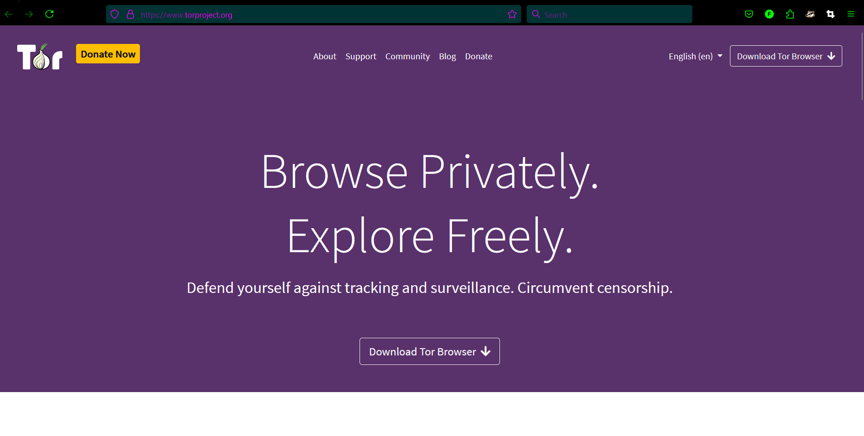
2. Select Windows
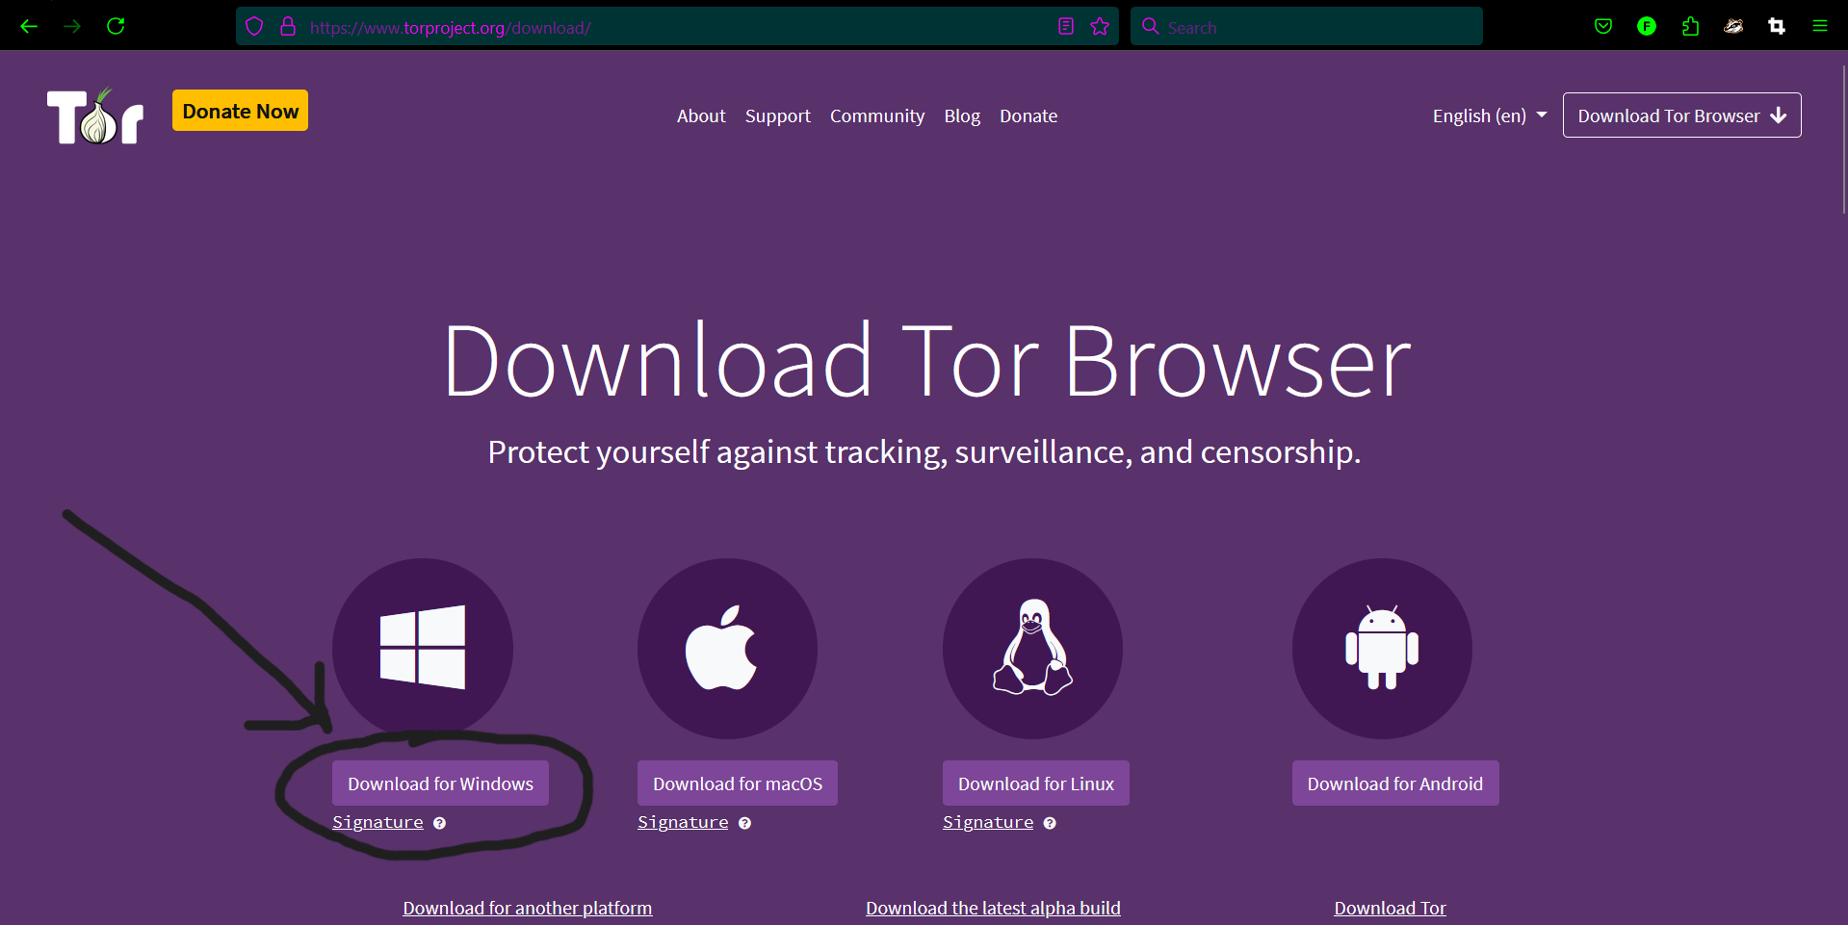
3. Locate the downloaded file : “tor-browser-windows-x86_64-portable-14.0.4.exe” and Launch it
4. Click run
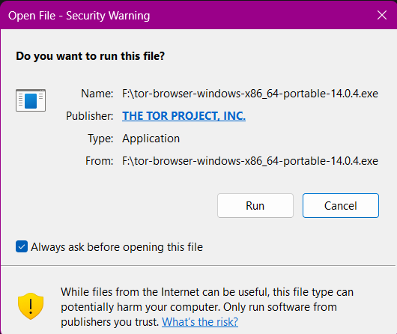
5. click ok :
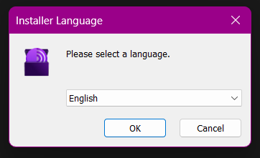
6. click install
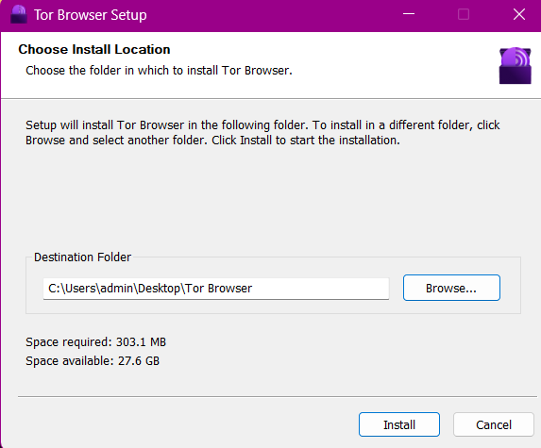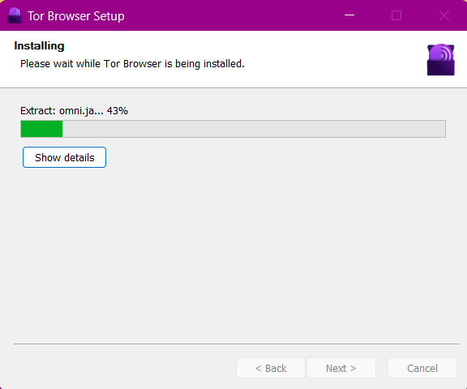
7. click finish
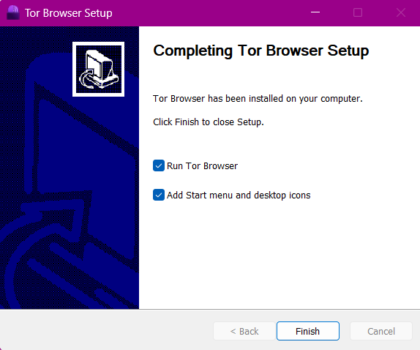
8. Search “tor” in application menu and launch it ,then click connect
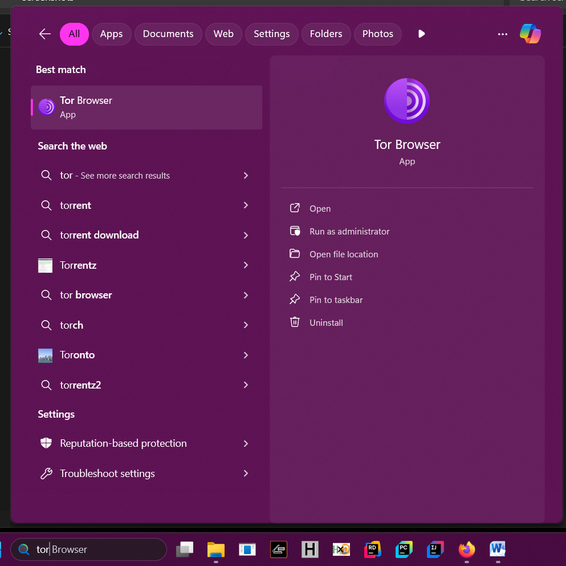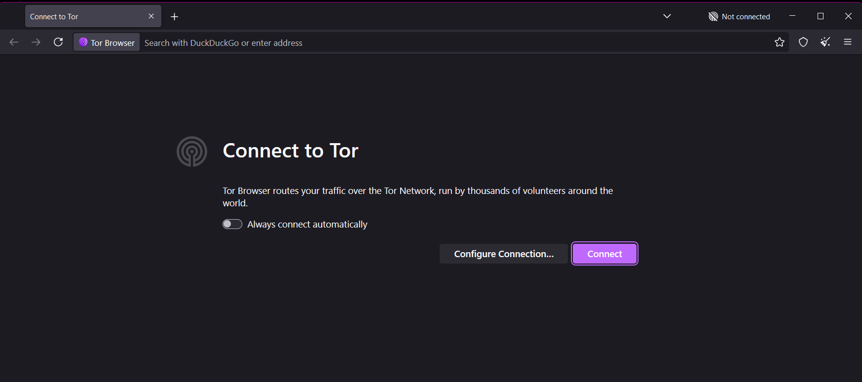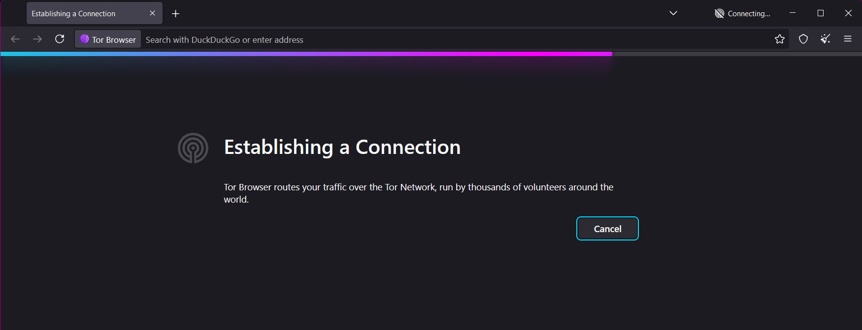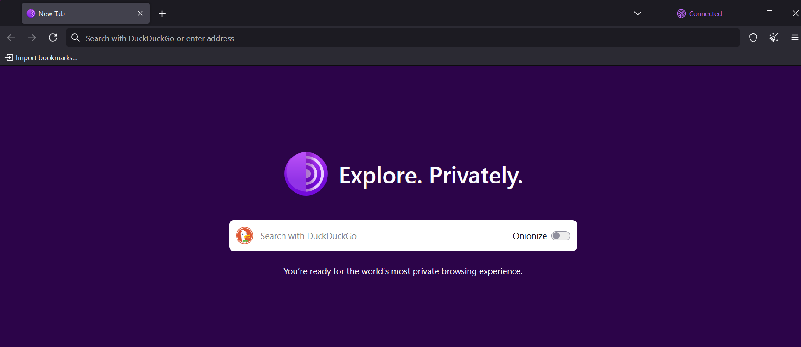
9. click on the 3 horizontal lines at top right , then click settings , then click connection then scroll to bottom and under advanced section click on setting located to right of “Configure how Tor Browser connects to the internet.”
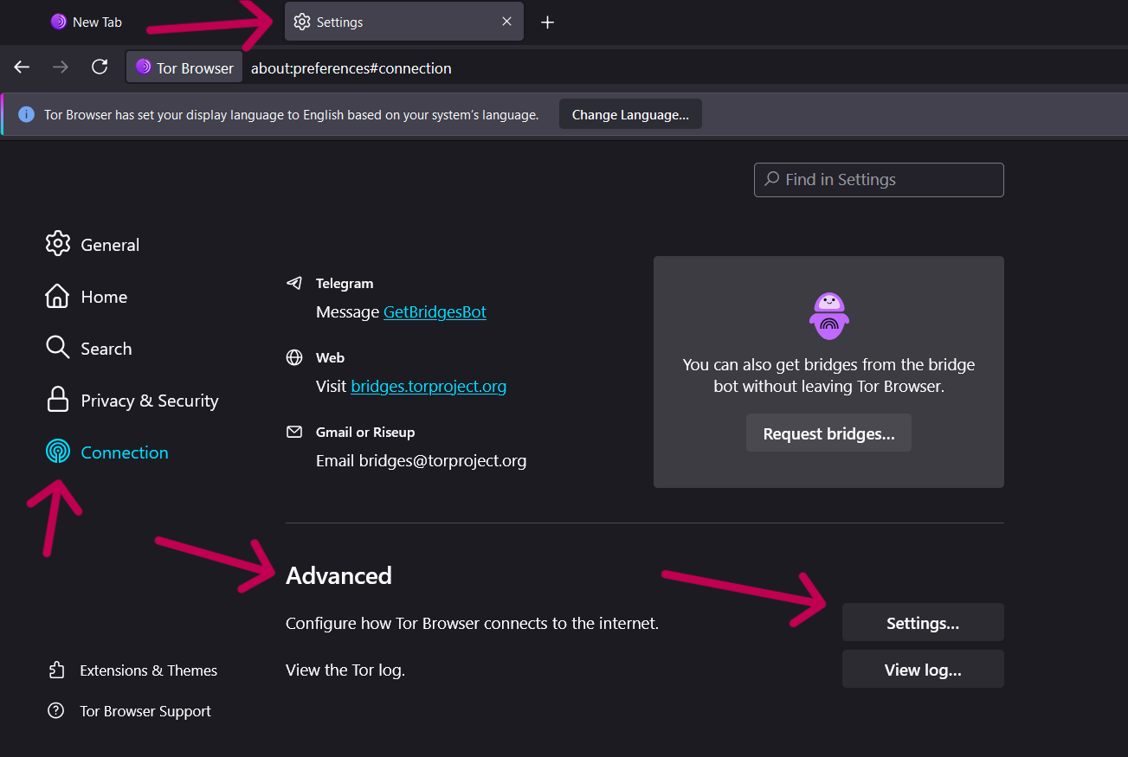
10. select proxy type as SOCKS5, ip address as loopback 127.0.0.1 and port 9050 and click ok
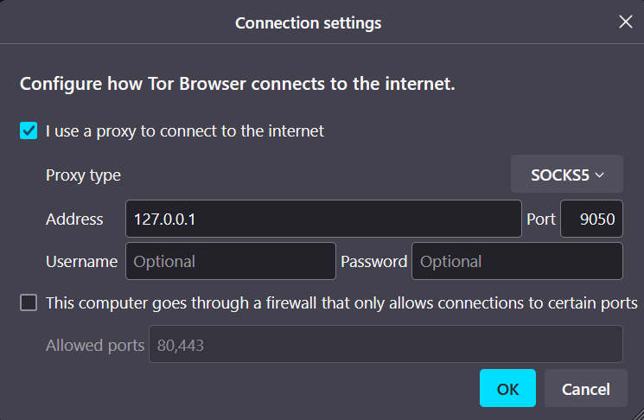
11. Navigate to path shown in pic in file manager and double click tor.exe
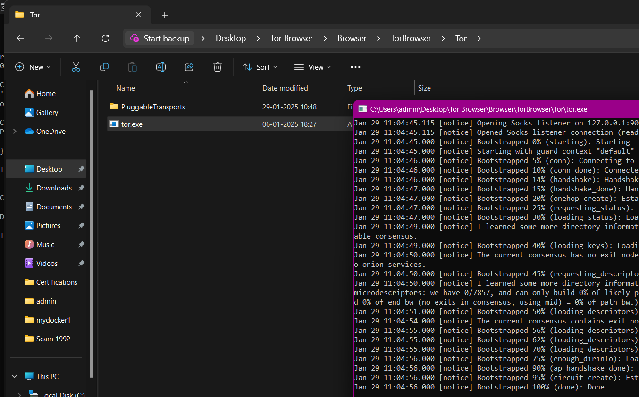
12. Navigate to following path in file manager and select edit with notepad for the torrc file
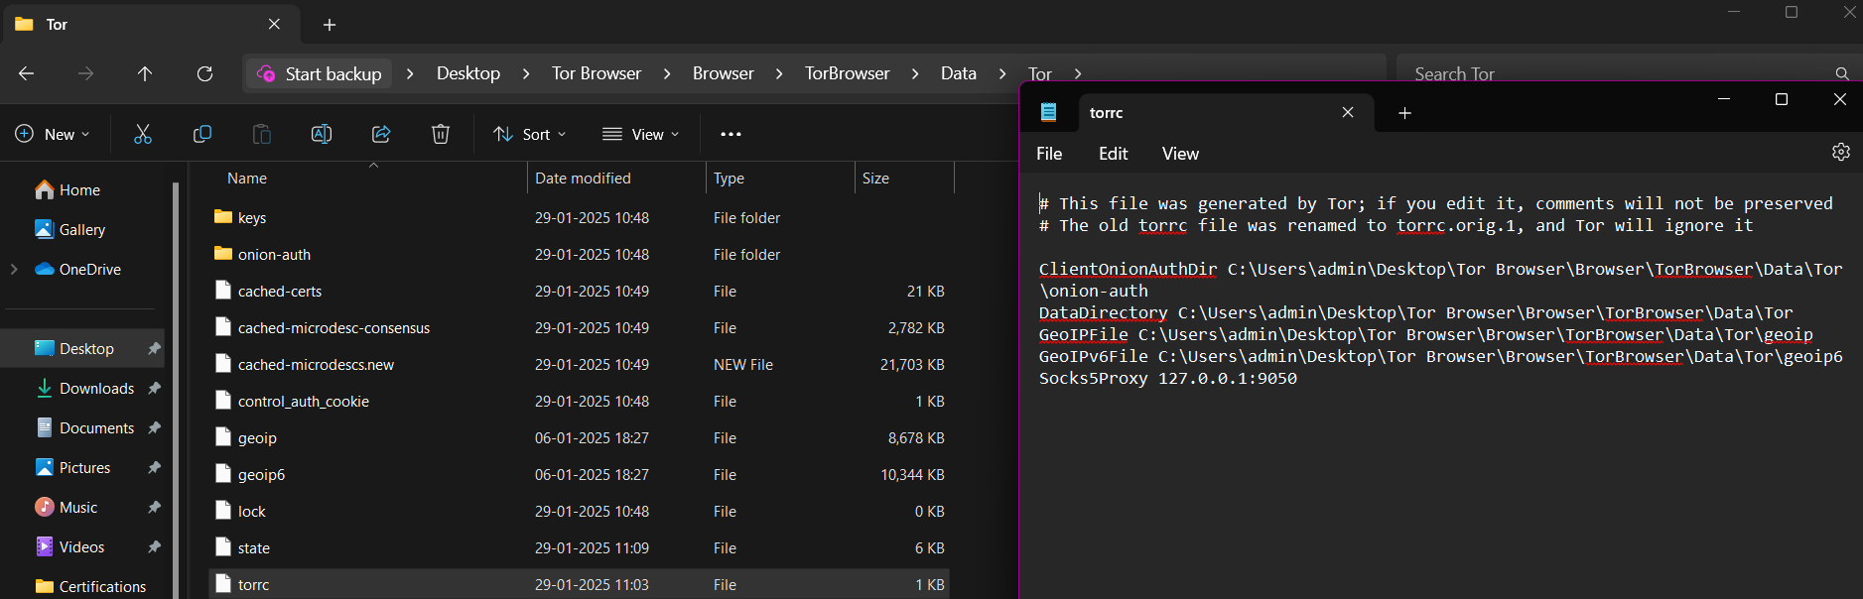

13. add these two lines at end of file and click file ->save -> close :
ControlPort 9051
CookieAuthentication 1
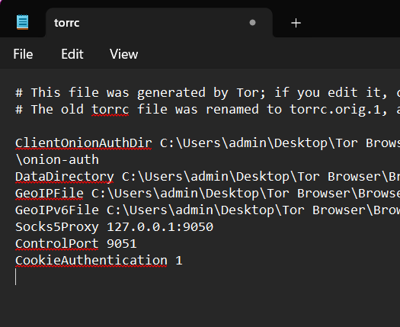
14. close tor browser and the cmd panel from step 11
15. Open task manager , locate “tor.exe” process , right click on it and click end task
16. open cmd and enter command :
cd C:\Users\admin\Desktop\Tor Browser\Browser\TorBrowser\Tor
tor.exe
17. open ur firefox , click on 3 horizontal lines in top right , click settings , click general , scroll down , under network setting click settings
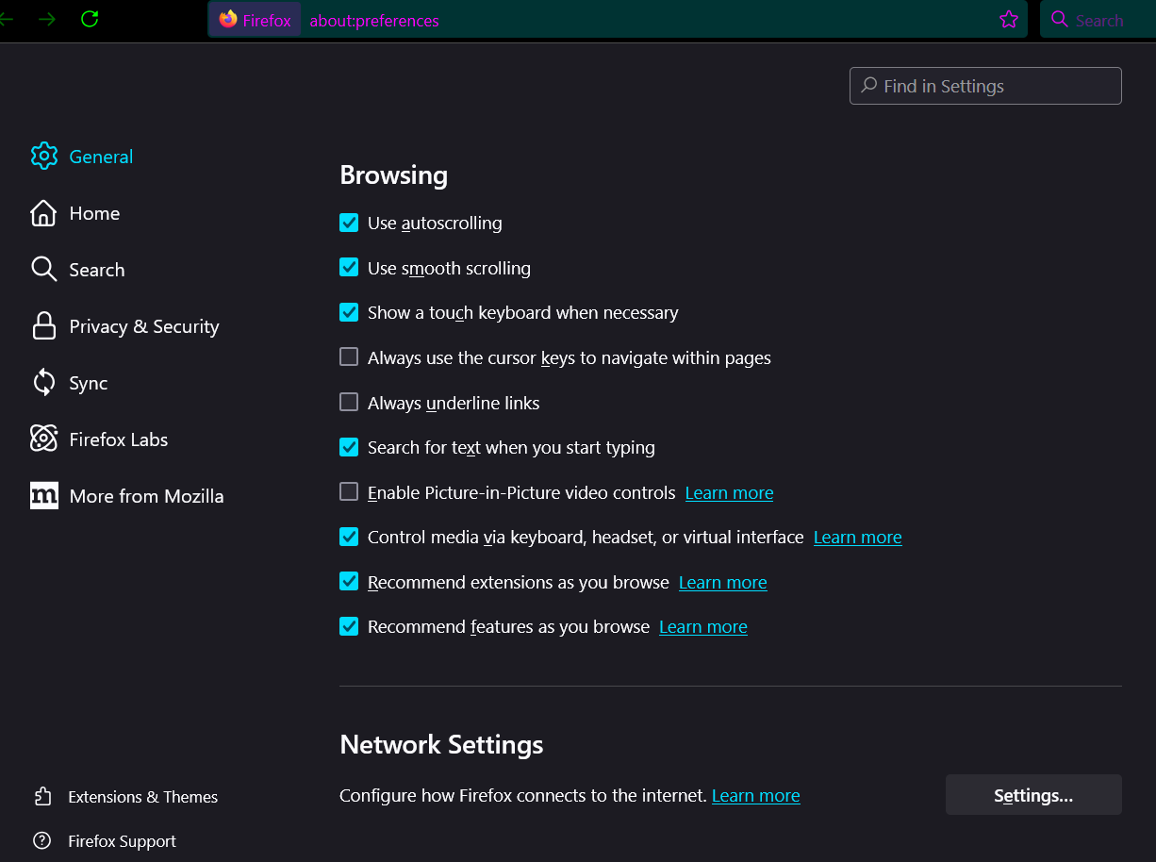
18. click “Manual proxy configuration” and in front of “SOCKS5” enter ip 127.0.0.1 and port 9050 , click ok
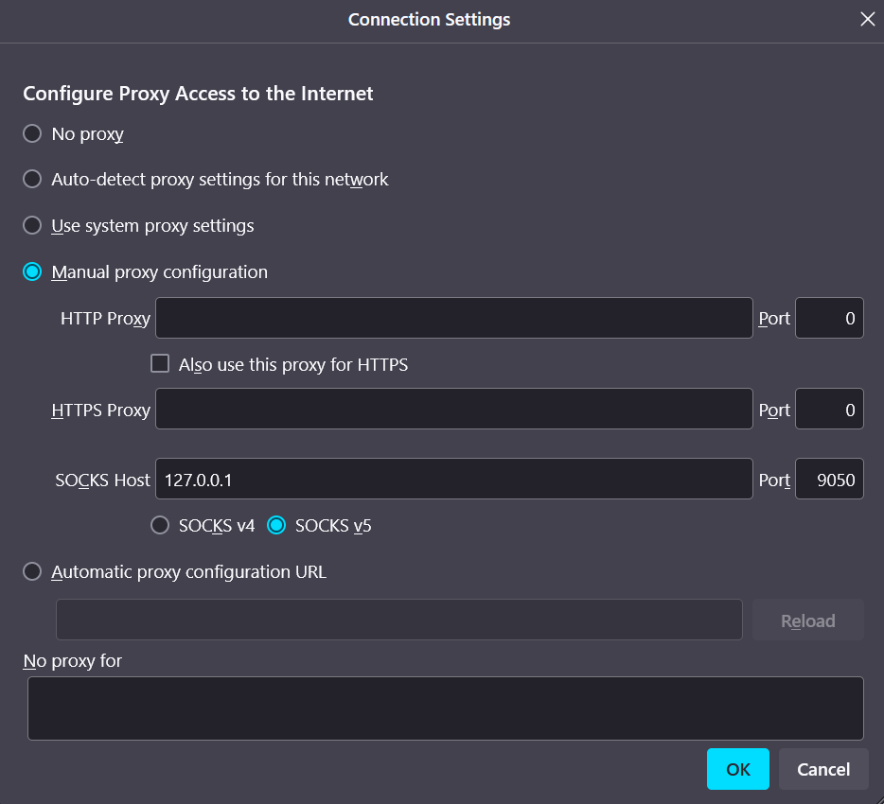

19. Download python from official website : https://www.python.org/
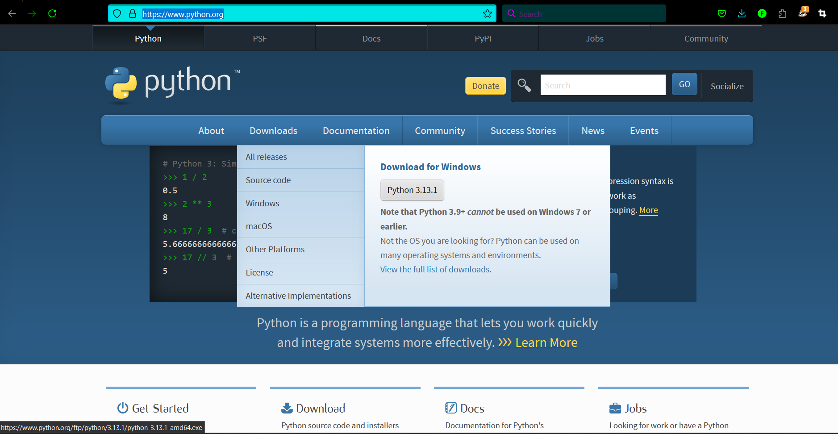
20. Locate the downloaded .exe file and launch and click run
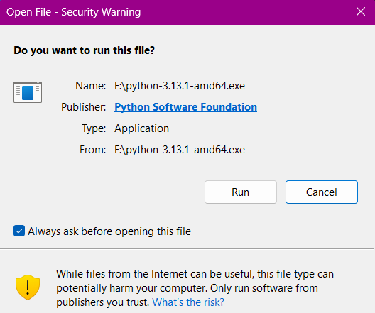
21. Keep everything default by clicking next/continue in every dialogue box that appears and finish the process .
22. Open command prompt as administrator
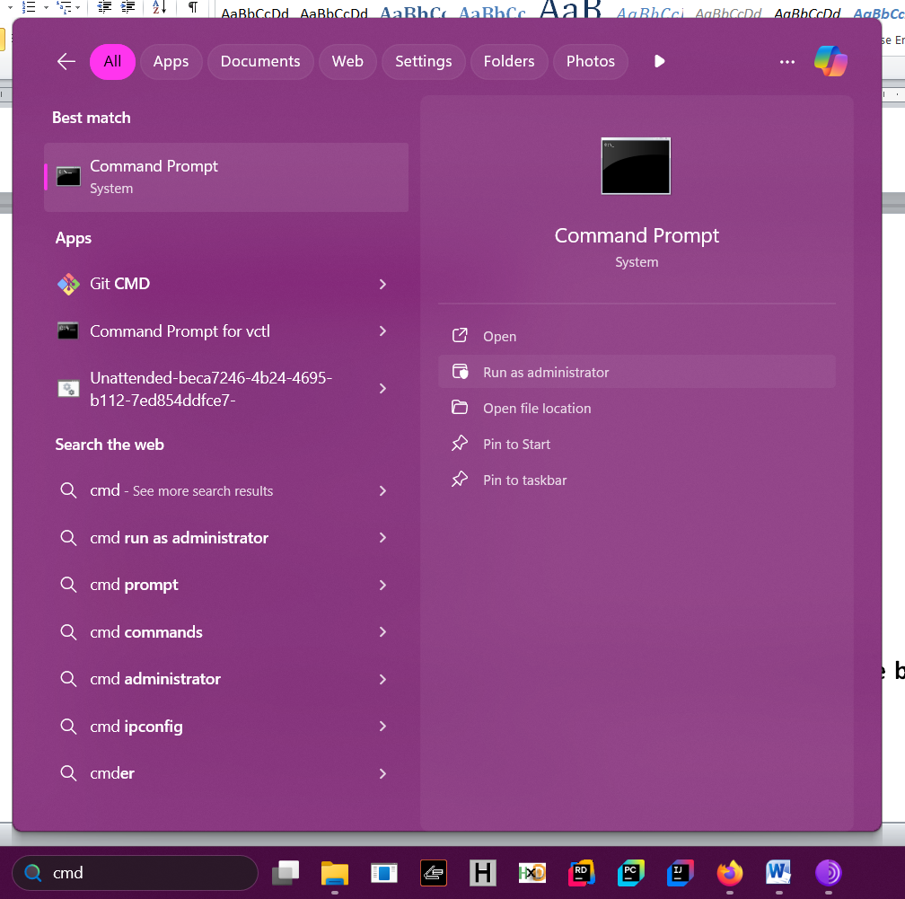
23. To check if python is installed correctly enter following command :
python --version
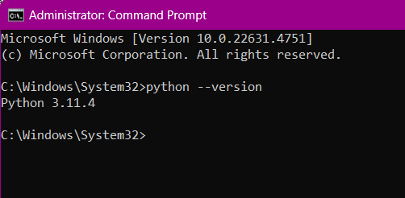
24. Now to install the python libraries required for programming enter command : pip install requests stem
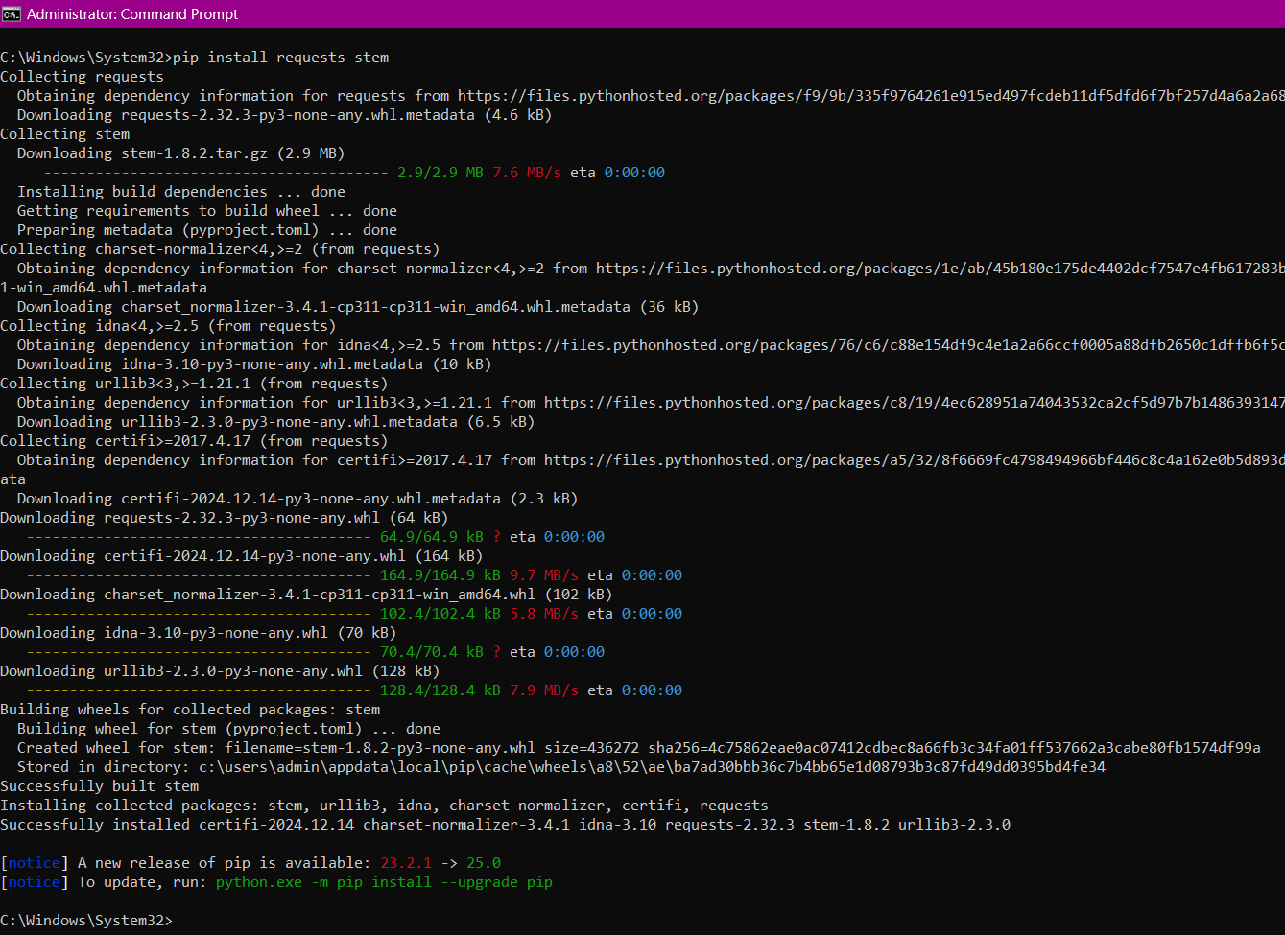
Then enter this command : pip install requests[socks]
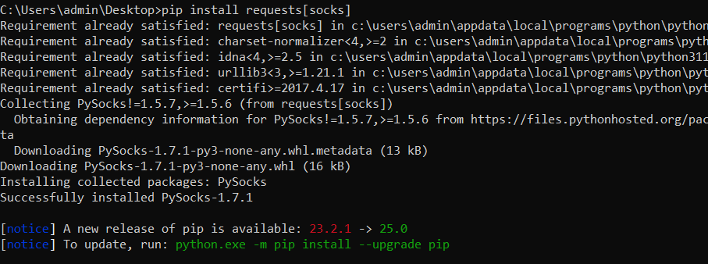
25. now Navigate to Desktop and create a new text file named
“rotate_ip_tor.py” , the only extension file shall have is .py not .txt,
Then right click on that file and select edit with notepad
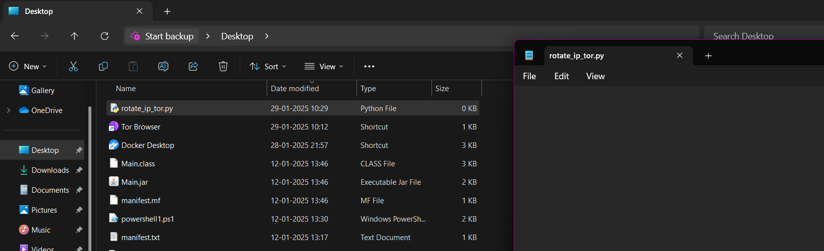
26. Paste the following code in that file and click file -> save and close :
import requests
from stem import Signal
from stem.control import Controller
import time
def get_tor_session():
session = requests.Session()
session.proxies = {
'http': 'socks5h://127.0.0.1:9050',
'https': 'socks5h://127.0.0.1:9050'
}
return session
def change_ip():
with Controller.from_port(port=9051) as controller:
controller.authenticate()
controller.signal(Signal.NEWNYM)
print("IP changed successfully!")
def test_tor():
session = get_tor_session()
url = 'http://httpbin.org/ip'
response = session.get(url)
print(f"Public IP: {response.text}")
def main():
while True:
test_tor()
change_ip()
time.sleep(5)
if __name__ == "__main__":
main()

27. In Command Prompt navigate to desktop where we saved the python file using cd command : cd C://Users/admin/Desktop
28. run the python file usig this command : python rotate_ip_tor.py
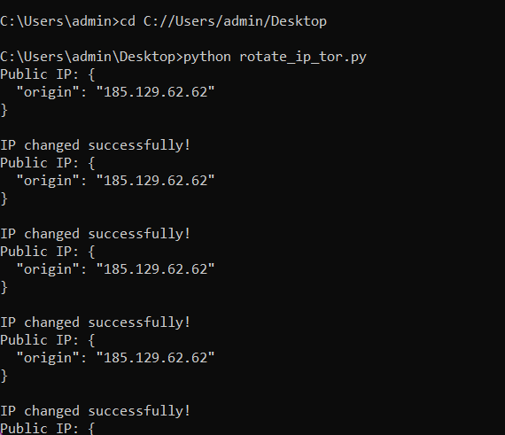
29. open firefox , and search “ What’s my ip” and click on any website
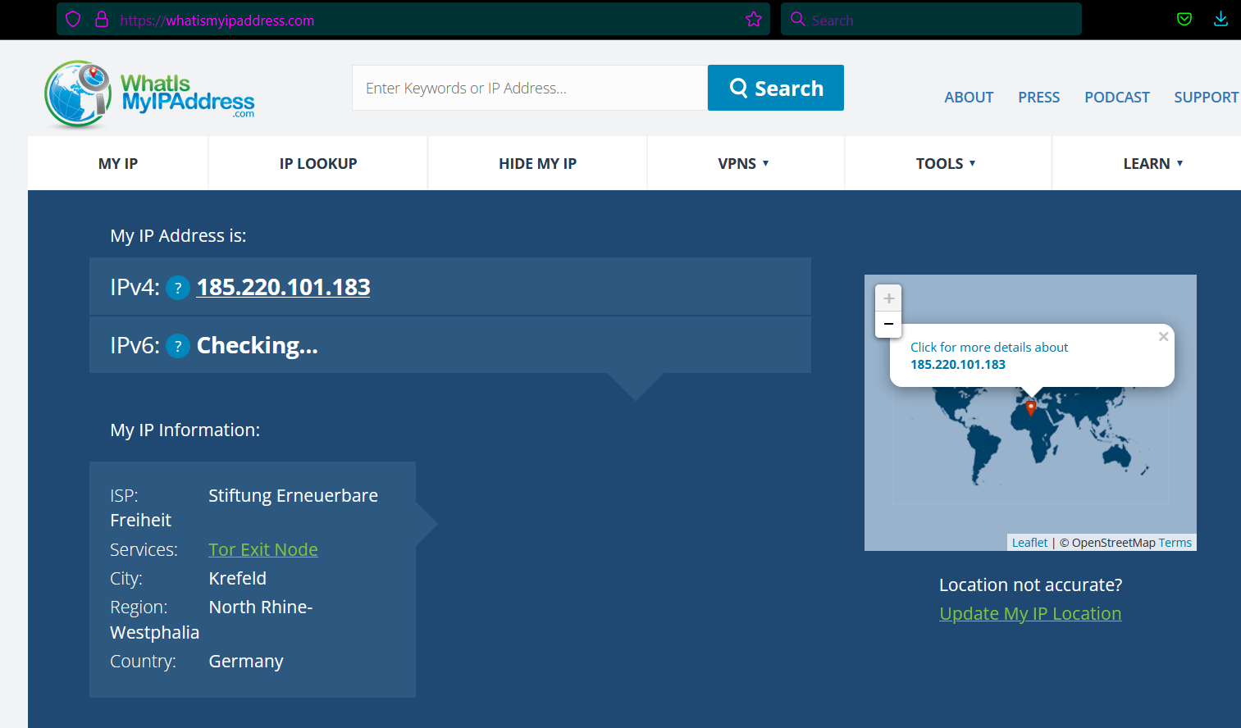
30. SUCCESSFUL !!!!!!!!

