REVIEW 0 - FINAL YEAR PROJECT (2021 - 2022)

Building extraction and classification of aerial images of rooftop for estimating maximal PV panel installation

**Team Members**

Shruthi M - 2018103592

Gayathri M - 201813535

Jayapriya M - 2018103029

**Under the guidance of**

Prof Dr. P. Uma Maheshwari

**INTRODUCTION**

Climate change has become a global concern over the last few decades and it has affected various life forms, and the ecosystem as a whole. One of the primary causes for this could be attributed to burning of fossil fuels for generating electricity which emits huge amounts of CO2 in the atmosphere. Continual usage of generating electricity this way could cause huge havoc to the environment.

This has led to turning towards renewable resources for sustainable development. Renewable resources include biomass energy (such as ethanol), hydropower, geothermal power, wind energy, and solar energy. In recent years, potential tapping of solar power for generating electricity has gained immense popularity and interest. A lot of buildings now have PV panels fitted in their rooftops.

However, managing stochastic power generation from distributed rooftop solar photovoltaic (PV) arrays, such as predicting and reacting to the variations in electric grids have become more challenging in recent times. Traditional approaches such as online assessment and utilities interconnection filings are time consuming and costly, and involve a lot of human effort where concerned people have to go to the site to look into the rooftop area to determine the installation of PV panels.

As a first step, to eliminate and reduce the manual work of profiling rooftop, we use an automated approach to segment rooftops. Using aerial images to identify objects on the earth’s surface has attracted great attention. Due to advancements in aviation and photography, satellites create a vast quantity of aerial remote sensing photographs every day. However the variety and intricate look of the buildings in mixed backdrops has made it difficult for automatic detection of building objects from remote sensing data.

Previous works have used CNN models like U-Net and various SOTA models for medical imagery segmentation. Not much has been done in the field of aerial satellite imagery as public datasets available are very limited. One of the latest benchmark datasets released is the AIRS dataset. The AIRS dataset contains nearly 220k buildings with masked images.

However, the issue here is all rooftops are segmented as the same and there is no segmentation based on the class of rooftops. In our project, we wish to further annotate the AIRS dataset images as flat or roof and use an ensemble approach combining 3 models namely, the U-Net model, Deep U-Net and U-Net with watershed transformation. We compare each individual result as well on the above mentioned dataset.

We finally also provide optimized placement of solar PV cells using a maximum fitting algorithm to maximize the potential of energy consumption.

**OVERALL OBJECTIVES**

To estimate the placement of photovoltaic panels on the rooftop for an aerial satellite image, the following steps are to be performed:

* Detect the building in a given satellite image using U-Net model and perform background subtraction to extract the building.
* Annotate the extracted building rooftops using CVAT/VIA annotator tool.
* Perform object detection to classify roofs based on their type (flat/tilted).
* Use maximum fitting algorithm to find the optimized no of solar panels based on type of roof to maximize energy consumption.

**LITERATURE SURVEY**

|  |  |  |  |  |
| --- | --- | --- | --- | --- |
| **S.NO** | **CITATION** | **METHODOLOGY** | **ADVANTAGES** | **LIMITATION** |
| 1. | **An aerial image segmentation approach based on enhanced multi-scale convolutional neural network, 2019**  Xiang Li, Yuchen Jiang, Hu Peng and Shen Yin in [2019 IEEE International Conference on Industrial Cyber Physical Systems (ICPS)](https://ieeexplore.ieee.org/xpl/conhome/8767101/proceeding) | 1. Segmentation model is performed using an encoder-decoder architecture.  2. A U-Net is constructed as the main network, and the bottom convolution layer of U-Net is replaced by a set of cascaded dilated convolution with different dilation rates.  3. Add an auxiliary loss function after the cascaded dilated convolution. | 1. From the aspect of design and training, the approach does not involve manual features and does not require specific preprocessing or post-processing, which can reduce the influence of subjective factors  2. The auxiliary loss function helps to make the network converge faster and optimize. | 1. Segmentation of large buildings work well but boundaries and middle parts are misaligned.  2. The bulges on the boundaries are lost and edges are not detected properly.  3. The algorithm performs well in one of the subset (countryside and forest) but does not perform well when tested on a different subset. |
| 2. | **Convolutional Neural Network Based Solar Photovoltaic Panel Detection in Satellite Photos, 2017**  Vladimir Golovko, Sergei Bezobrazov, Alexander Kroshchanka and Anatoliy Sachenko in 9th IEEE International Conference on Intelligent Data Acquisition and Advanced Computing Systems: Technology and Applications | 1. Collect data from Google Maps.  2. Perform pre-processing techniques like image resizing, image sharpening.  3. Train a 6 layer CNN model. | 1. Here, the authors have used the low-quality satellite imagery (Google Maps photos), instead of the high resolution color satellite orthoimagery that enables decreasing the requirements for the approach.  2. Simple 6 layer CNN model. | 1. Better segmentation could have been performed by training with other CNN models.  2. Bad quality satellite images have led to inaccurate classification.  3. No validation on the dataset as in some cases solar panels look similar to roof tops. |
| 3. | **Deep Convolutional Neural Network Application on Rooftop Detection for Aerial Imagery, 2019**  Mengge Chen, Jonathan Li, in Journal of Computational Vision and Imaging Systems | 1. It is primarily based on Mask R-CNN with 3 stages.  2. Feature extraction is based on an existing deep learning model.  3. RPN (Regional Proposal Network) is used to find RoI.  4. Object classification is then performed. | 1. Efficient and feasible approach to extract detached houses from aerial images.  2. RoIAlign method is used instead of RoIPool for better feature extraction. | 1. Edges of the building are not detected properly.  2. Training data was less and hence less accuracy.  3. Comparatively less precision with other new state of art models. |
| 4. | **Solar Potential Analysis Of Rooftops Using Satellite Imagery, 2019**  Akash Kumar, Delhi Technology University, in *ArXiv* abs/[1812.11606](https://arxiv.org/abs/1812.11606) | 1. Dataset is manually collected for India.  2. Adaptive Edge Detection and Contours are focused to segment out rooftop boundaries and obstacles present inside them along with polygon shape approximation. | 1. Provides a comparative analysis of the solar potential of the building.  2. Several types of the rooftop are considered to learn the intra-class variations. | 1. The image quality of satellite imagery is very deficient hence the edges are not detected properly.  2. There are some outliers that are plotting solar panels outside the building rooftop area. |

**ARCHITECTURE DIAGRAM**

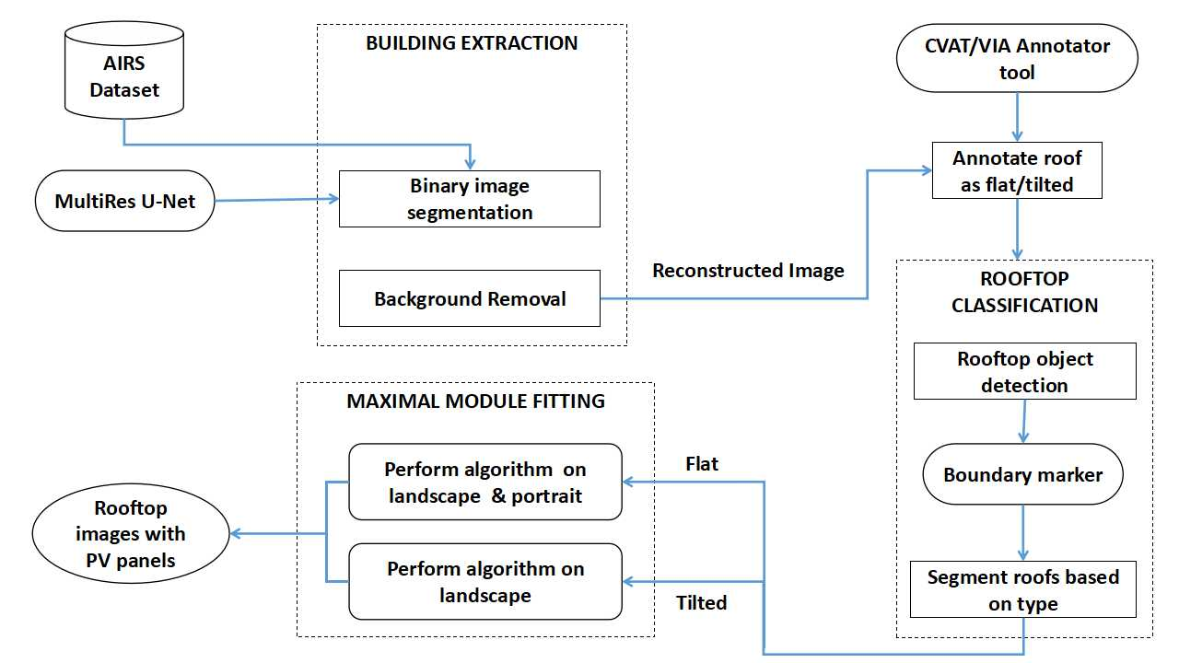

The above block diagram gives a high level overview on the 3 modules.

The 1st module contains AIRS dataset which is fed to the MultiRes U-Net model to detect and extract the buildings. The background is removed, the segmented rooftop is reconstructed and fed to the next module.

We annotate the reconstructed image using CVAT/VIA software to perform rooftop object detection algorithm where boundaries are marked and rooftops are segmented based on type.

Based on the segmented roofs, we set a size for solar panels that gets overlaid on the rooftop image. The number of panels to be fitted needs to be maximized in order to get maximum efficiency and this is done with the help of maximum fitting algorithm.

**LIST OF MODULES**

* Module I - Building Extraction.
* Module II - Rooftop Classification.
* Module III - Maximal Module Fitting.

**MODULE DESIGN**

**MODULE I - BUILDING EXTRACTION**

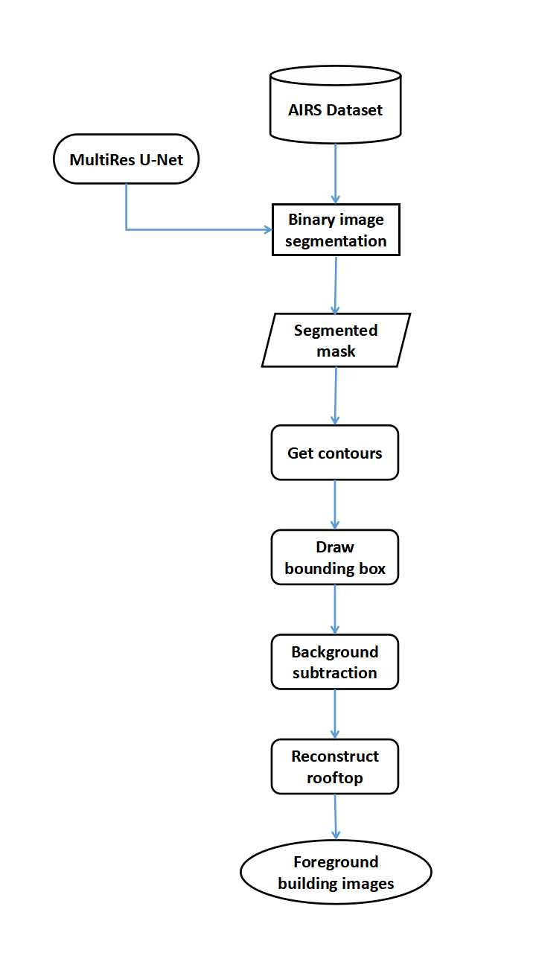

**INPUT:** AIRS Dataset

**OUTPUT:** Reconstructed rooftops without background

* We use AIRS dataset and select around 1k images from the dataset.
* The input images are fed to the MultiRes U-Net model to perform binary segmentation.
* Get the contours of building rooftops to draw the bounding box that marks the buildings as ROI.
* The masked segmented background is subtracted from the original aerial image.
* The segmented rooftop is reconstructed and fed to the next module.

**MODULE II - ROOFTOP CLASSIFICATION**

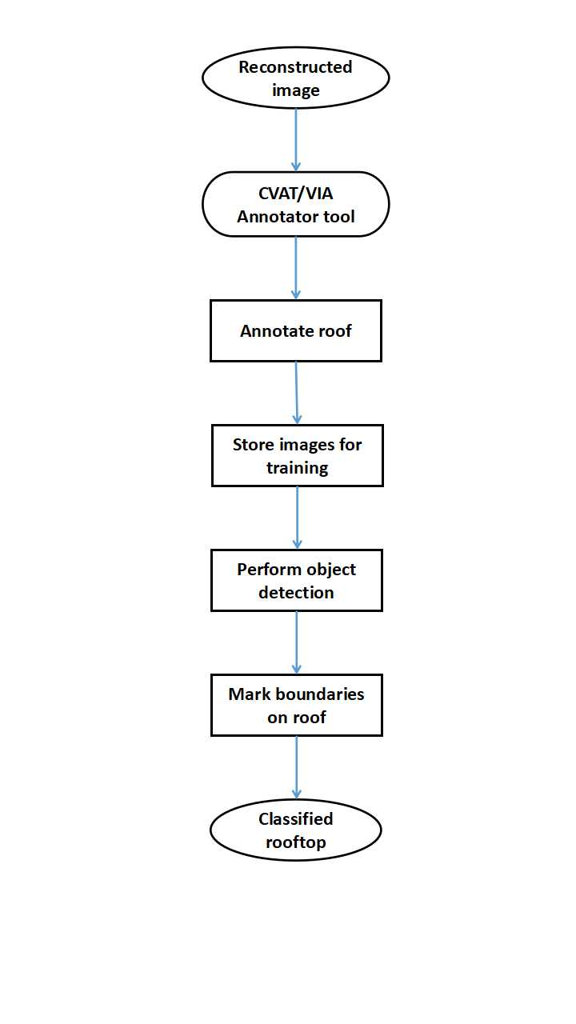

**INPUT:** Reconstructed image

**OUTPUT:** Classified rooftop

* Using the CVAT/VIA tool, we annotate each of the segmented, reconstructed rooftop images as flat or tilted.
* This is done by using the software and marking boundaries on the rooftop and assigning labels.
* The masked image along with input is stored for training.
* Object detection is performed on the masked image to mark boundaries on roof
* The rooftops are classified and segmented based on type.

**MODULE III - MAXIMUM FITTING MODULE**

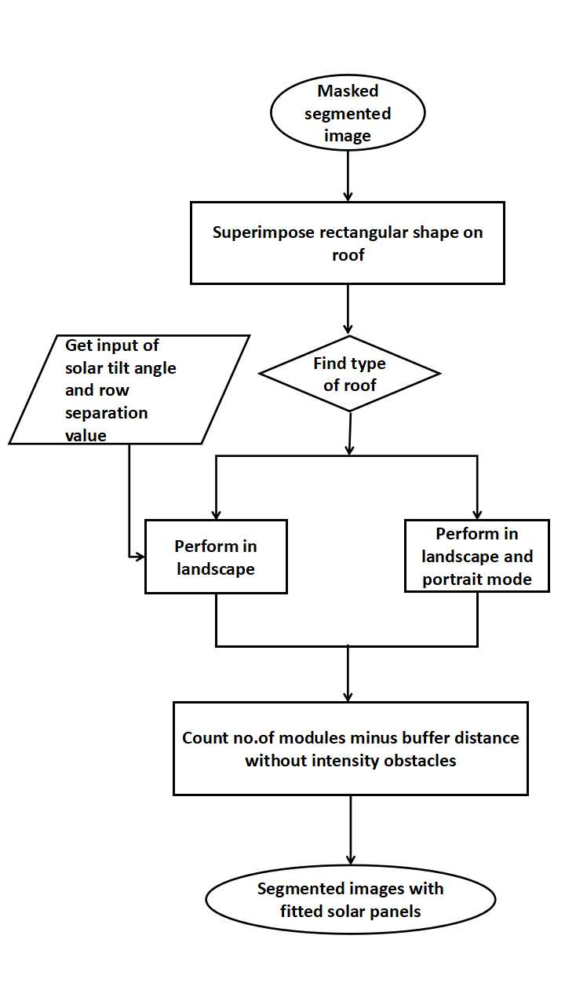

**INPUT:** Masked segmented image.

**OUTPUT:** Segmented image with solar panels of specific size fitted.

* The masked segmented image stored in the new database is taken and the roofs are superimposed with rectangular shape.
* Then the type of the roof is determined as flat or slope.
* If the type of the roof is flat, we get user input (solar tilt angle and row separation value) and perform a maximum fitting algorithm on landscape mode.
* If the type of the roof is slope, we perform a maximum fitting algorithm on landscape and portrait mode.
* The buffer distance without intensity obstacles is subtracted from the count of the number of modules.
* The segmented images are fitted with the solar panels.

**PERFORMANCE MEASURES**

* **IoU - Intersection over Union /Jaccard Coefficient**

To quantify the accuracy of our model to predict size for solar PV arrays, we use Jaccard coefficient which is widely used in prior work to measure the similarity between detected regions and ground truth regions. Jaccard Similarity Index (JSI) measures the similarity for the two sets of pixel data, with a range from 0% to 100%. The higher the percentage, the more precise prediction. It is defined as follows:

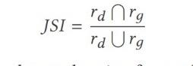

where rd denotes the detected region for a solar PV array, and rg indicates the ground truth region for a solar PV array

* **DICE Coefficient**

We use DICE coefficient to compare the pixel-wise agreement between a predicted segmentation and its corresponding ground truth. DICE coefficient is 2 times the area of overlap divided by the total number of pixels in both the images. The formula is given by:

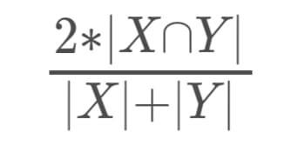

where X is the predicted set of pixels and Y is the ground truth.

* **MCC - Matthews Correlation Coefficient**

We use the MCC, a standard measure of a binary classifier’s performance, where values are in the range −1.0 to 1.0, with 1.0 being perfect roof segmentation, 0.0 being random roof segmentation, and −1.0 indicating roof segmentation is always wrong. The expression for computing MCC is below, where TP is the fraction of true positives, FP is the fraction of false positives, TN is the fraction of true negatives, and FN is the fraction of false negatives, such that TP+FP+TN+FN= 1.

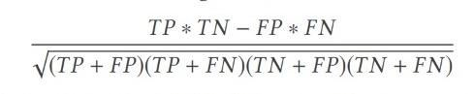

* **Accuracy**

Accuracy is the percentage of correct predictions for the test data. It can be calculated easily by dividing the number of correct predictions by the number of total predictions.

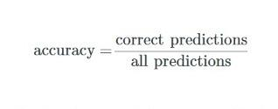

**DATASET**

**AIRS Dataset -** The AIRS (Aerial Imagery for Roof Segmentation) dataset provides a wide coverage of aerial imagery with 7.5 cm resolution and over 220k buildings.

AIRS dataset covers almost the full area of Christchurch, the largest city in the South Island of New Zealand during the flying seasons of 2015 and 2016, and the supplied images are ortho-rectified DOMs with RGB channels.

It contains around 800 images in the training set, 90 each in testing and validation set. We select around 1000 images from residential areas and use the VIA tool to annotate the type of roofs and combine both the images to form an annotated dataset.

**REFERENCES**

[1] Q. Li, Y. Feng, Y. Leng and D. Chen, " SolarFinder: Automatic Detection of Solar Photovoltaic Arrays," 2020 19th ACM/IEEE International Conference on Information Processing in Sensor Networks (IPSN), 2020, pp. 193-204, doi: 10.1109/IPSN48710.2020.00024.

[2] Edun, Ayobami & Harley, Joel & Deline, Chris & Perry, Kirsten. (2021). Unsupervised azimuth estimation of solar arrays in low-resolution satellite imagery through semantic segmentation and Hough transform. Applied Energy. 298. 10.1016/j.apenergy.2021.117273.

[3] B. Chatterjee and C. Poullis, "On Building Classification from Remote Sensor Imagery Using Deep Neural Networks and the Relation Between Classification and Reconstruction Accuracy Using Border Localization as Proxy," 2019 16th Conference on Computer and Robot Vision (CRV), 2019, pp. 41-48, doi: 10.1109/CRV.2019.00014.

[4] V. Golovko, S. Bezobrazov, A. Kroshchanka, A. Sachenko, M. Komar and A. Karachka, "Convolutional neural network based solar photovoltaic panel detection in satellite photos," 2017 9th IEEE International Conference on Intelligent Data Acquisition and Advanced Computing Systems: Technology and Applications (IDAACS), 2017, pp. 14-19, doi: 10.1109/IDAACS.2017.8094501.

[5] Kumar, Akash & Sreedevi, Indu. (2018). Solar Potential Analysis of Rooftops Using Satellite Imagery. *ArXiv* abs/[1812.11606](https://arxiv.org/abs/1812.11606).

[6] Chen, Mengge and Jonathan Li. “Deep convolutional neural network application on rooftop detection for aerial image.” *ArXiv* abs/1910.13509 (2019): n. Pag.

[7] Peiran Li, Haoran Zhang, Zhiling Guo, Suxing Lyu, Jinyu Chen, Wenjing Li, Xuan Song, Ryosuke Shibasaki, Jinyue Yan. (2021). Understanding rooftop PV panel semantic segmentation of satellite and aerial images for better using machine learning. Advances in Applied Energy, Elsevier. Volume 4, 100057, ISSN 2666-7924. [doi: 10.1016/j.adapen.2021.100057](https://doi.org/10.1016/j.adapen.2021.100057).

[8] Qi, Chen & Wang, Lei & Wu, Yifan & Wu, Guangming & Guo, Zhiling & Waslander, Steven. (2018). Aerial Imagery for Roof Segmentation: A Large-Scale Dataset towards Automatic Mapping of Buildings. ISPRS Journal of Photogrammetry and Remote Sensing, Elsevier. Volume 147, pp. 42-55.

[9] Cai, Yuwei & He, Hongjie & Yang, Ke & Fatholahi, Sarah Narges & Ma, Lingfei & Xu, Linlin & Li, Jonathan. (2021). A Comparative Study of Deep Learning Approaches to Rooftop Detection in Aerial Images. Canadian Journal of Remote Sensing. 47. 1-19. 10.1080/07038992.2021.1915756.

[10] Srinivasan Iyengar, Stephen Lee, David Irwin, Prashant Shenoy, and Benjamin Weil. 2018. WattHome: A Data-driven Approach for Energy Efficiency Analytics at City-scale. In Proceedings of the 24th ACM SIGKDD International Conference on Knowledge Discovery & Data Mining.