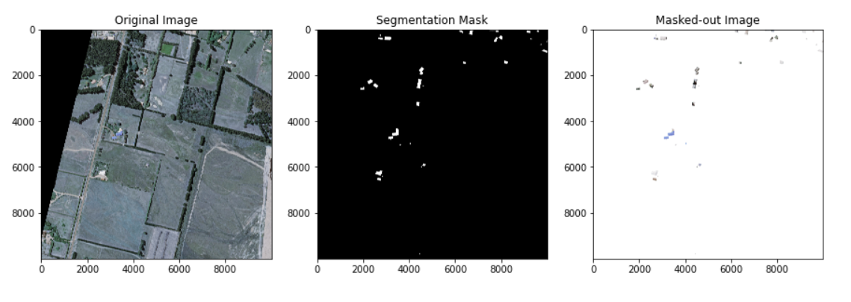

|  |  |  |  |
| --- | --- | --- | --- |
| **FLAT** |  |  |  |
| **GABLE** |  |  |  |
| **HIP** |  |  |  |

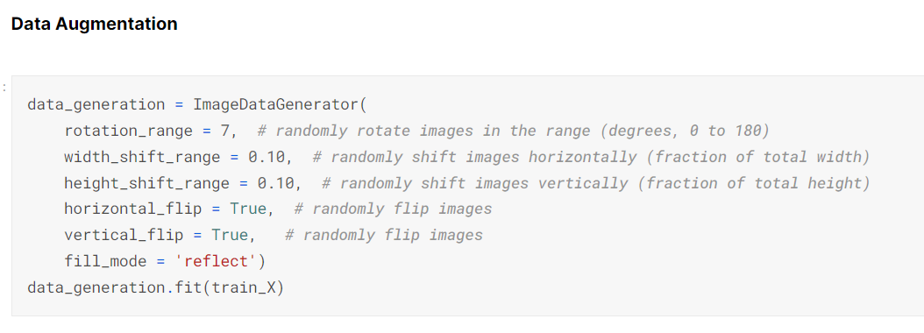

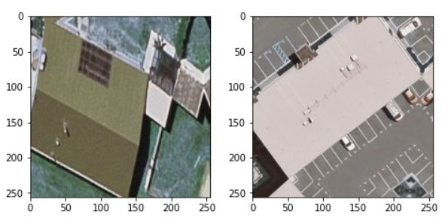

CNN

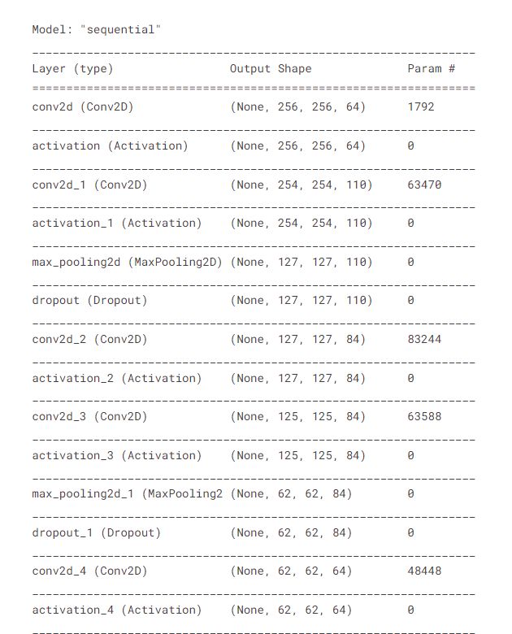

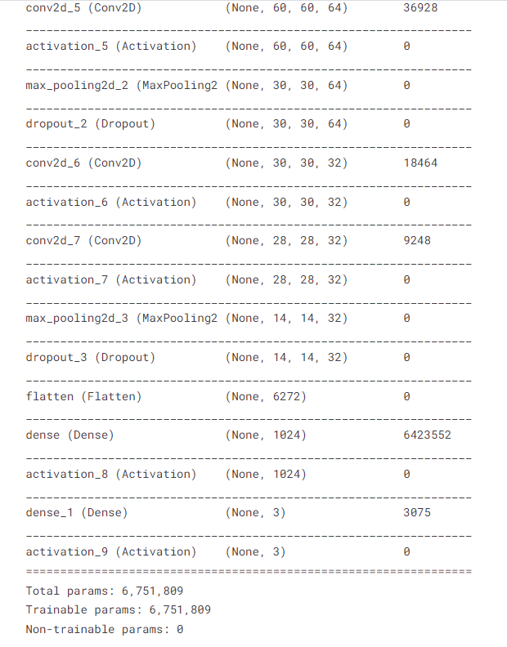

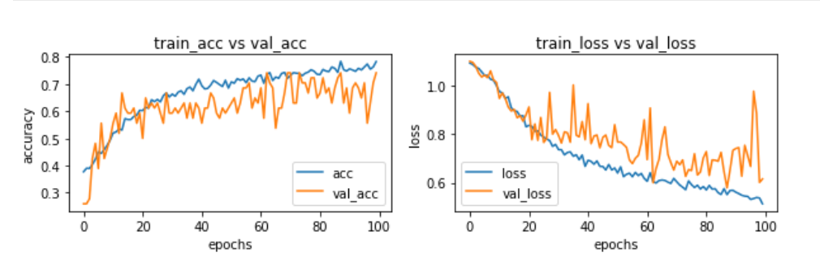

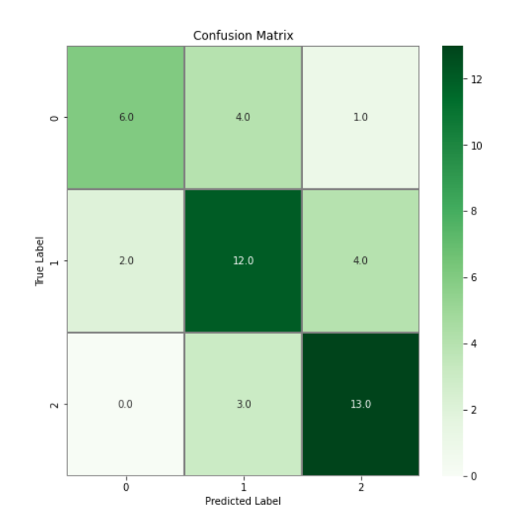

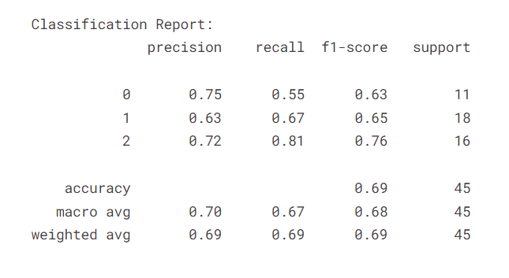

ResNet50

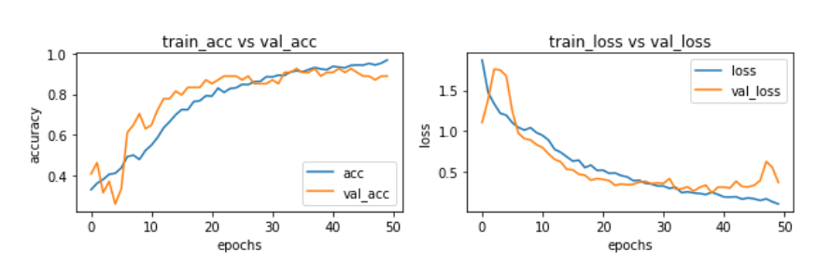

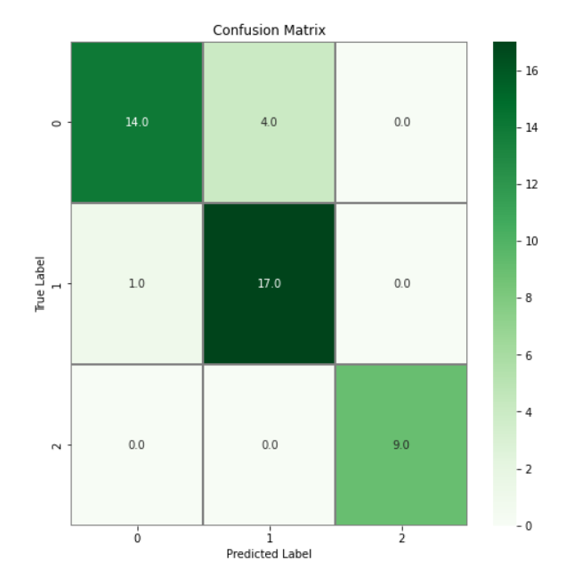

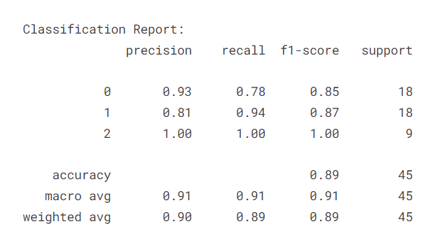

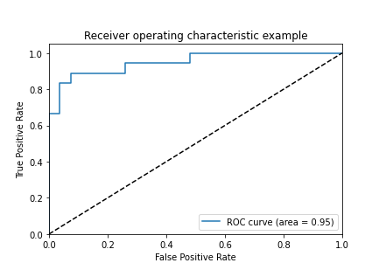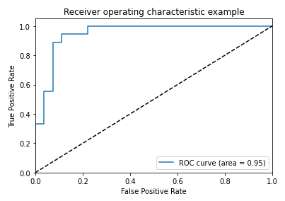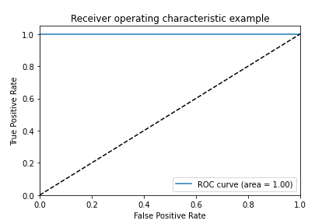

EfficientNetB4

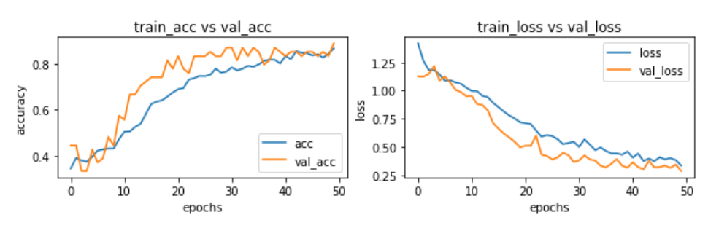

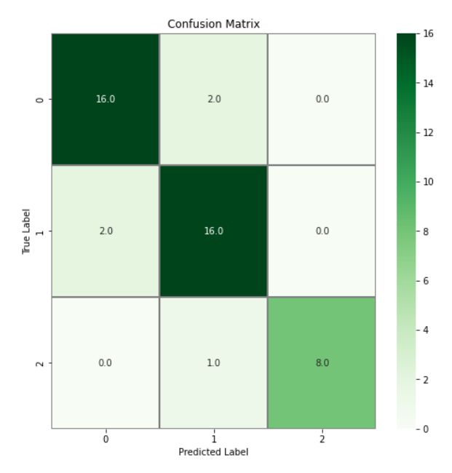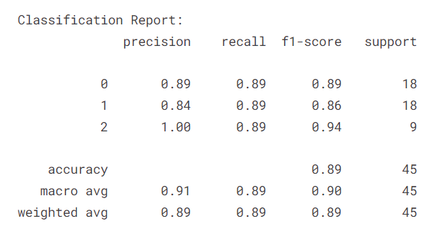

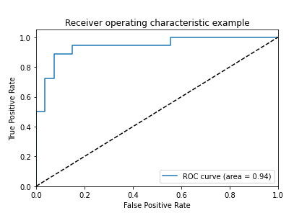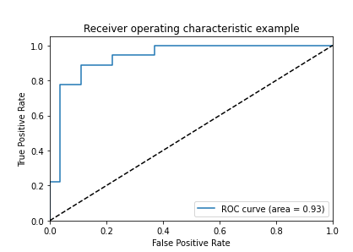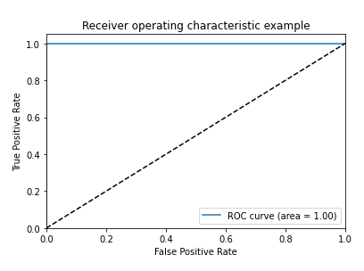

VGG16

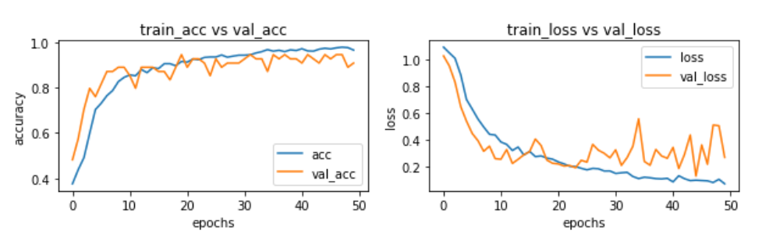

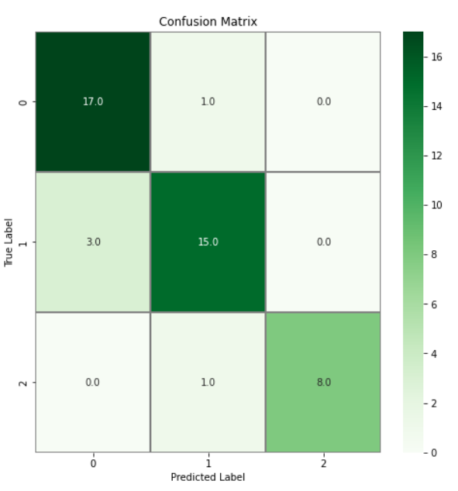

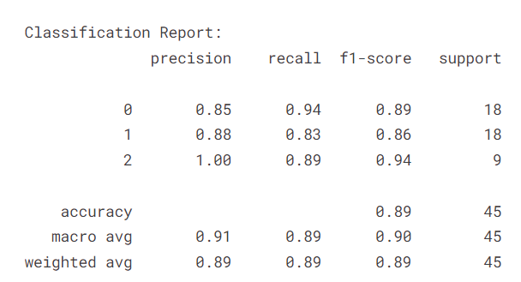

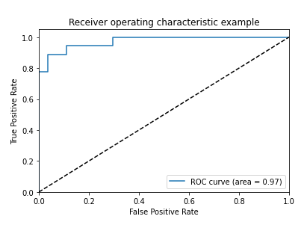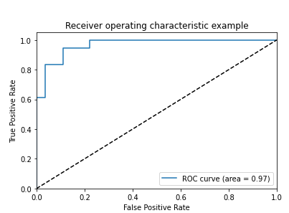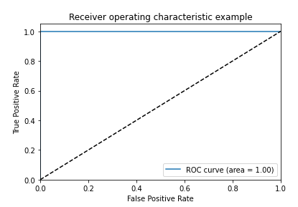

Potsdam with resnet

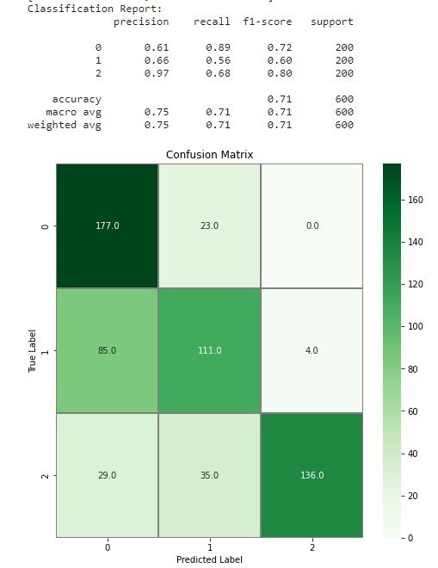

Potsdam with CNN

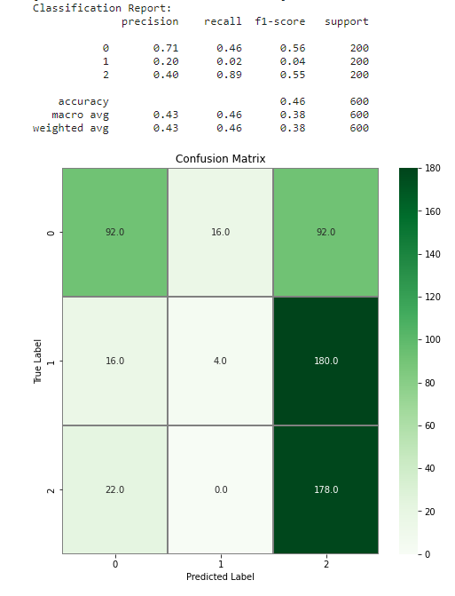

Potsdam with efficientnet-adam

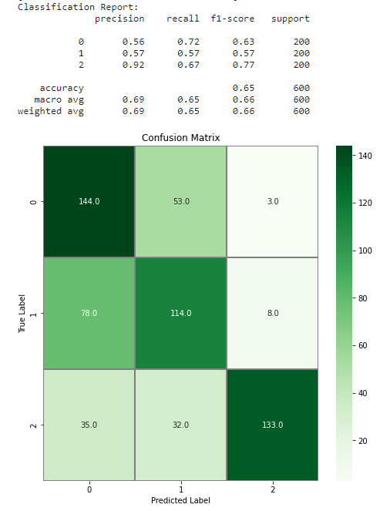

Potsdam with vgg16

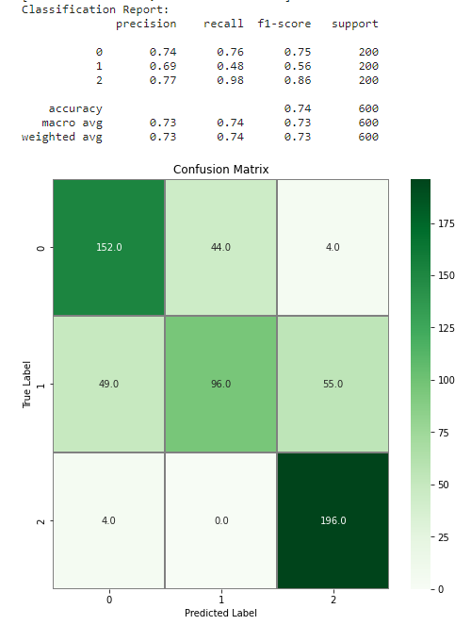

Potsdam samples

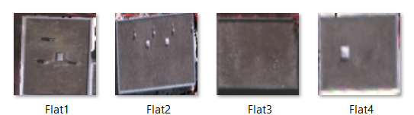



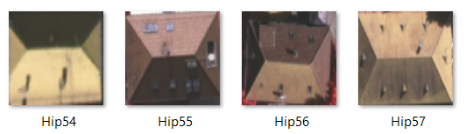

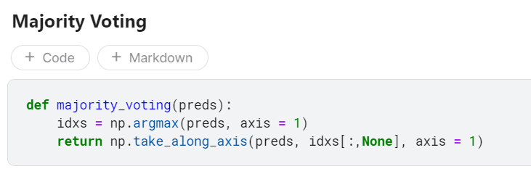

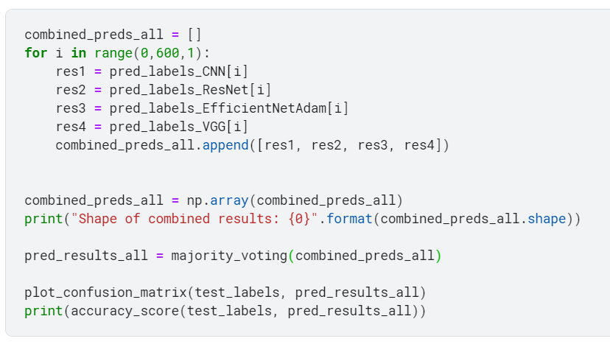

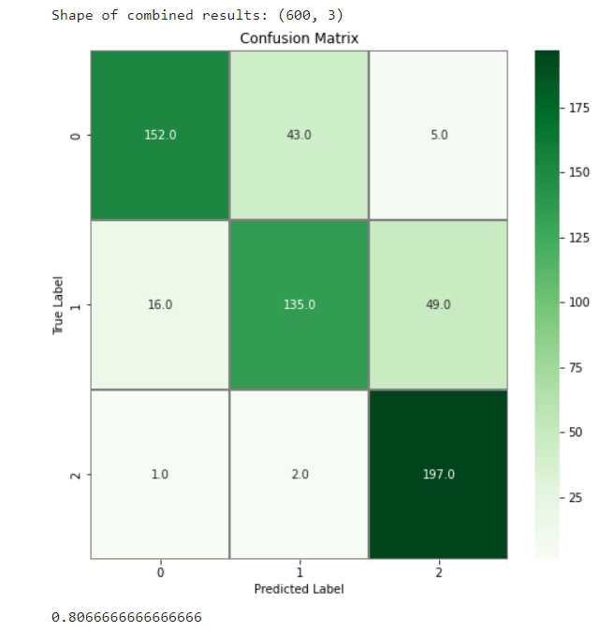

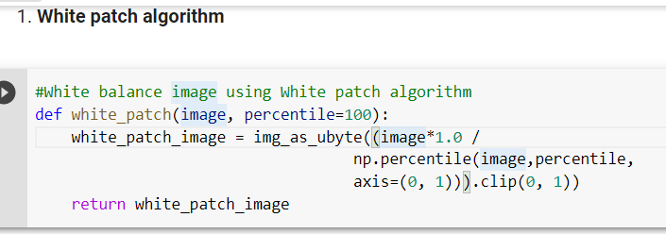





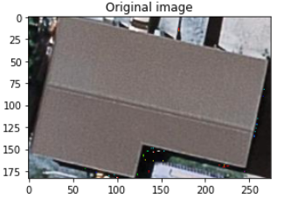

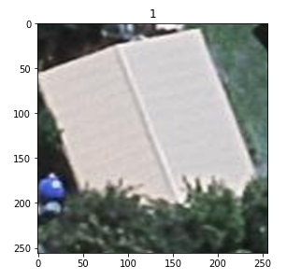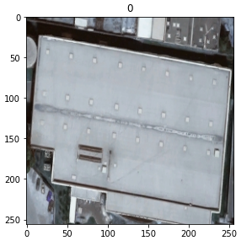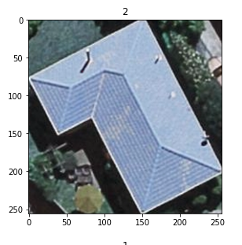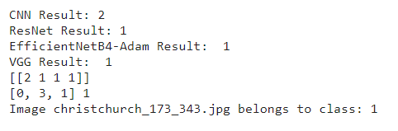

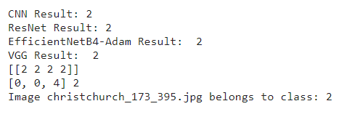

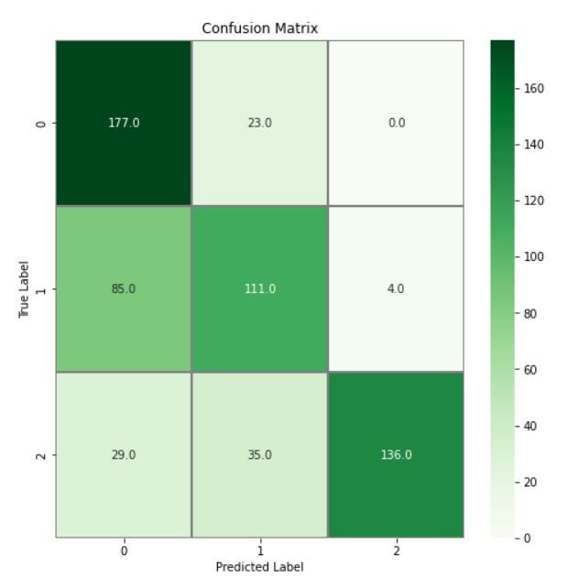

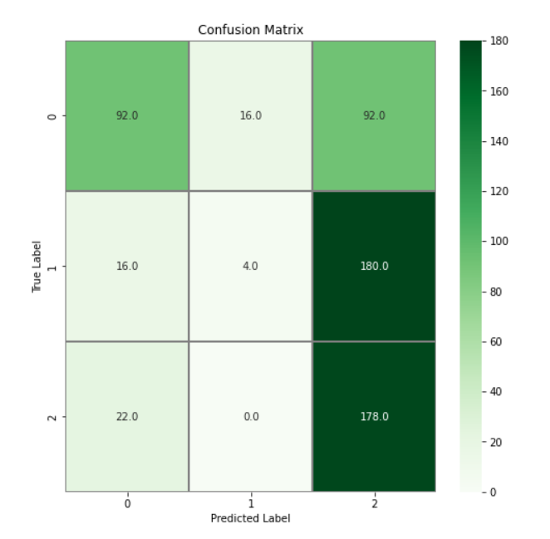

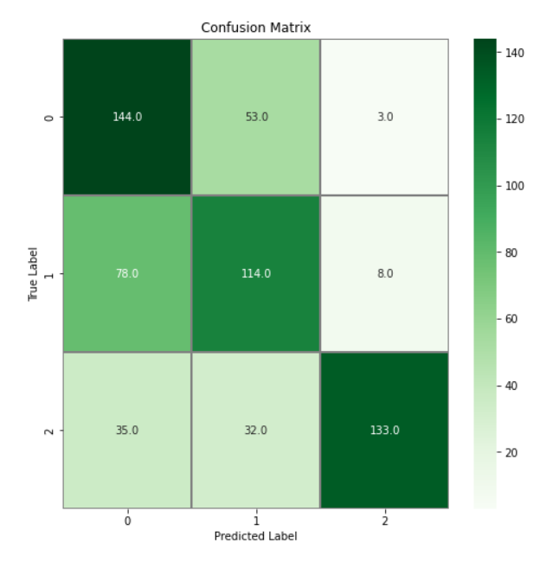

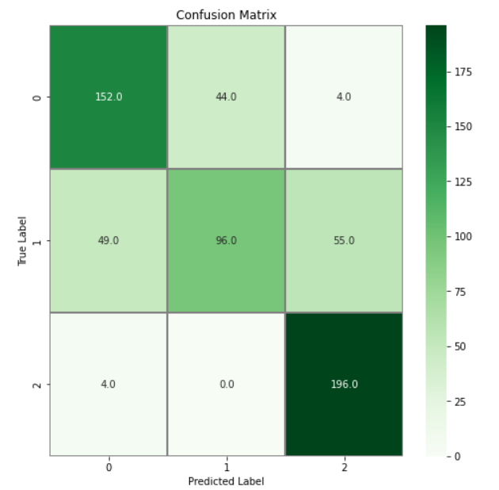

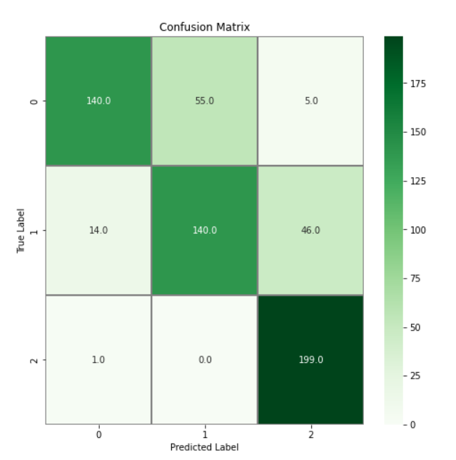

**Demand driven Supply chain**

As …., demand driven supply chain is where we sense and react based on real time needs and demand of network of customers, suppliers, distributors to cater to their needs and provide greater efficiency giving a demand-pull technique.

Here, let’s now take the case study of famous cereal and snack company Kellogg’s. The brand was still underdeveloped in Latin America region yet was growing at a rapid pace. So in such a case, they conducted an assessment which revealed that they were inwardly focusing on operational efficiency but not on business strategy. As a result, they were losing out on opportunities to accommodate the requirements from customers, consumers and sales channels. Now this assessment was mainly based on SCOR model – Plan, Source, Make, and Deliver - revealed that the least developed practice in the region was that of planning.

### Hence they mainly followed some demand driven methodologies. One of which is demand driven MRP (Material Requirements Planning). MRP is the calculation engine that specifies which materials and parts to order, how many of each are required, when they will be needed, and when activity must begin to complete the work so products are ready by the forecasted completion date. Traditional MRP is inherently forecast driven. Forecasts is mainly based on past activity, and they are not always accurate in predicting the future.

DDMRP takes variability out of the equation by using “pull” for materials in a demand-driven approach. Rather than relying on forecast accuracy – and buffering for fluctuations in demand and supply – DDMRP tracks actual usage and manages replenishment through a simple visual system. Buffer inventory is only used to ensure the availability of key items that are deemed to be of strategic importance. With the use of DDMRP, there is less inventory overall and fewer shortages.

As a result, plant service rates are already showing a strong upward curve, reflecting an average improvement of 10 percentage points, with Brazil recording a dramatic turnaround of over 50 percentage points. the introduction of Lean in administrative processes is proving to not only make it more efficient and effective, but that it is also an essential ingredient in achieving a truly Lean supply chain — one where customer demand is anticipated and met ‘‘on time and in full’’ with lower overall resource requirements. This is illustrated by a 94.5% reduction on unplanned orders and change requests over an eight-week period — through adherence to planning discipline, value-added metrics and visibility of impact to scheduling.