Panels-together: 3, length: 10, width: 10, solar angle: 5

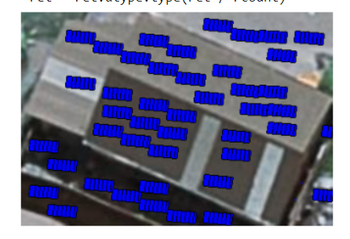

Panels-together: 4, length: 10, width: 10, solar angle: 5

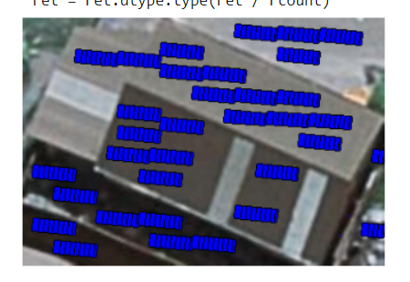

Panels-together: 5, length: 10, width: 10, solar angle: 5

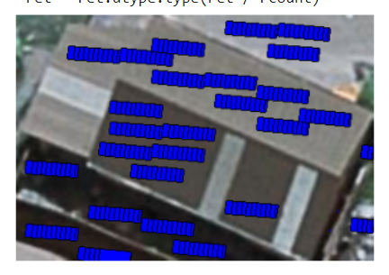

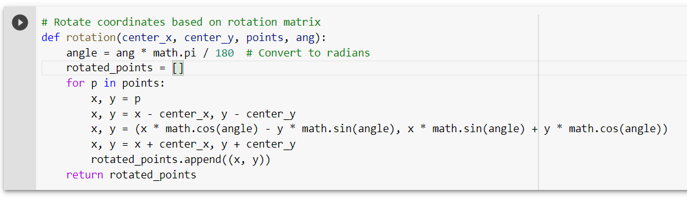

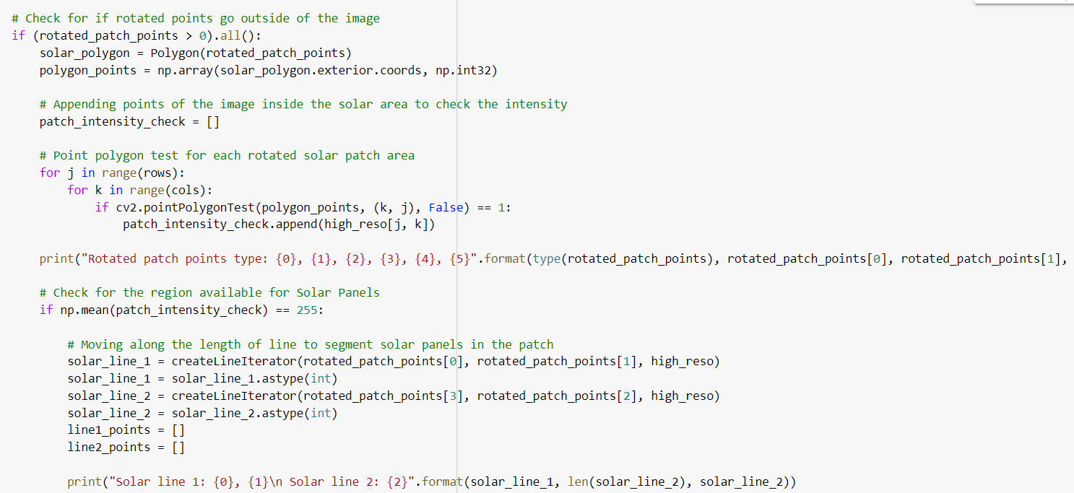

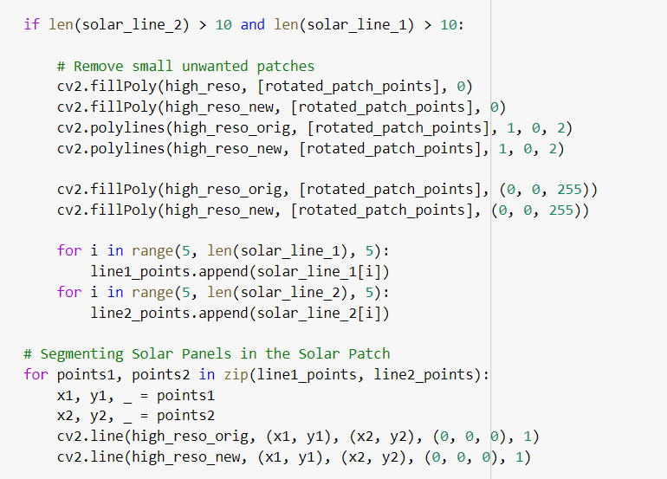

crop-saved/18.tif

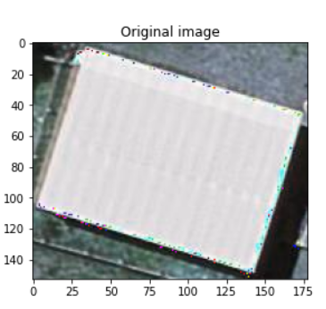 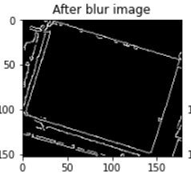

Length:20 Width:10 Angle:30

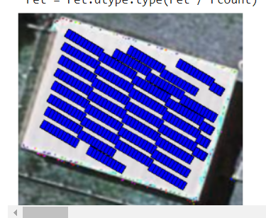

Length:20 Width:20 Angle:30

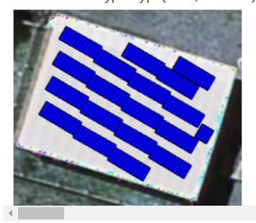

Length:20 Width:10 Angle:40

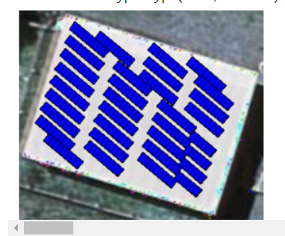

Length:20 Width:20 Angle:40

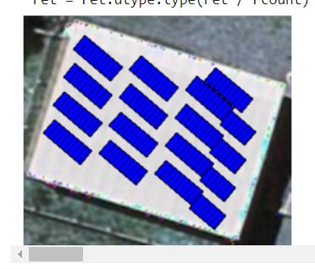

Gable: Length:30 Width:20 Angle:10

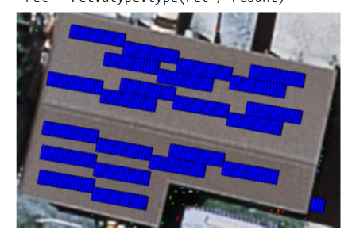

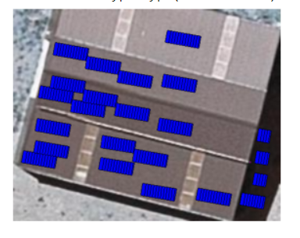

Length:20 width:20 angle:15

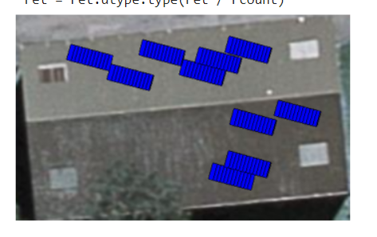

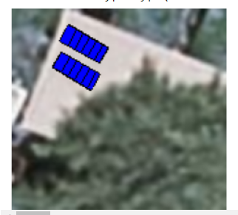

|  |  |  |  |  |  |  |
| --- | --- | --- | --- | --- | --- | --- |
| Model | Results on AIRS dataset | | | Results based on ISPRS paper | | |
|  | Precision | Recall | F1 score | Precision | Recall | F1 score |
| Shallow CNN | 70 | 67.67 | 68 | 81 | 81.67 | 81 |
| ResNet50 | 91.34 | 90.67 | 90.67 | 82.34 | 86.34 | 84.34 |
| EfficientNetB4 | 91 | 89 | 89.67 | 81 | 84 | 82.34 |
| VGG16 | 91 | 88.67 | 89.67 | 84.67 | 89.67 | 86.67 |
|  |  |  |  |  |  |  |
|  |  |  |  |  |  |  |

|  |  |  |  |  |  |  |
| --- | --- | --- | --- | --- | --- | --- |
| Model | Results on AIRS dataset | | | Results based on ISPRS paper | | |
|  | Precision | Recall | F1 score | Precision | Recall | F1 score |
| Shallow CNN | 70 | 67.67 | 68 | 81 | 81.67 | 81 |
| ResNet50 | 91.34 | 90.67 | 90.67 | 82.34 | 86.34 | 84.34 |
| EfficientNetB4 | 91 | 89 | 89.67 | 81 | 84 | 82.34 |
| VGG16 | 91 | 88.67 | 89.67 | 84.67 | 89.67 | 86.67 |

**Table 1 Hyperparameter values used in training our MultiRes UNet model**

**Table 2 Distribution of roof type dataset**

**Table 3 Samples of images of each class from Christchurch, New Zealand**

**Table 4 Performance results of the model on training and validation set**

**Table 5 Results of different models on our manually labeled dataset**

**Table 6 Results of testing our trained models on Potsdam dataset**

**Table 7 Comparative analysis for building segmentation using MultiRes UNet model**

**Table 8 Comparative analysis of different DL models on AIRS dataset and dataset used in [5]**

**Fig. 3.1 Overall System Architecture**

**Fig. 4.1 Module Design of Building Detection**

**Fig. 4.2 Module Design for Roof type classification & Boundary detection**

**Fig. 4.3 Module Design for PV Module Fitting**

**Fig. 5.1 Code snapshot for image clipping**

**Fig. 5.2 Original Aerial Image**

**Fig. 5.3 Patches of image after performing clipping on the original image**

**Fig. 5.4 Ground Truth segmented image**

**Fig. 5.5 Corresponding patched segmented image after clipping**

**Fig. 5.6 Code snapshot for image normalization**

**Fig. 5.7 Aerial view and ground truth mask after resizing and employing min-max scaler.**

**Fig. 5.8 MultiRes Block**

**Fig. 5.9 Res Path**

**Fig. 5.10 Architecture of MultiRes UNet**

**Fig. 5.11 MultiRes Block**

**Fig. 5.12 Res Path**

**Fig. 5.13 Defining the MultiRes model**

**Fig. 5.14 Brief Model Summary**

**Fig. 5.15 Training the model for 100 epochs**

**Fig. 5.16 Results of building segmentation with MultiRes UNet model**

**Fig. 5.17 Comparison of results before and after applying threshold**

**Fig. 5.18 Comparison of ground truth images with our predictions before and after applying threshold**

**Fig. 5.19 Code implementation of drawing contours**

**Fig. 5.20 Bounding boxes drawn around the segmented mask images**

**Fig. 5.21 Original satellite image (left), masked image after training on MultiRes UNet model (center), extracted rooftops (right)**

**Fig. 5.22 Implementation of data augmentation techniques**

**Fig. 5.23 Results of image after performing data augmentation**

**Fig. 5.24 Model summary of CNN model**

**Fig. 5.25 Architecture of VGG16 model**

**Fig. 5.26 Architecture of ResNet50 model**

**Fig. 5.27 Architecture of EfficientNetB4 model**

**Fig. 5.28 Code implementation of majority voting**

**Fig. 5.29 Results on Potsdam dataset after applying majority voting**

**Fig. 5.30 Images after performing white balancing to remove haze**

**Fig. 5.31 Boundaries detected on rooftops by applying different techniques**

**Fig. 5.32 Implementation of rotation of points**

**Fig. 5.33 Implementation for region availability of solar panels**

**Fig. 5.34 PV panels with dimensions length - 20mm; tilt angle - 40; width - 10 mm (left) and 20mm (right).**

**Fig. 5.35 Placement of PV panels when there are obstacles.**

**Fig. 5.36 Graphs of the various performance metrics**

**Fig. 5.37 Graphs showing the training and validation accuracy and loss for CNN model**

**Fig. 5.38 Confusion matrix and classification report on test data for CNN model**

**Fig. 5.39 Graphs showing the training and validation accuracy and loss for ResNet-50**

**Fig. 5.40 AUC-ROC metrics for ResNet-50 model**

**Fig. 5.41 Confusion matrix and classification report on test data for ResNet-50 model**

**Fig. 5.42 Graphs showing the training and validation accuracy and loss for EfficientNetB4**

**Fig. 5.43 AUC-ROC metrics for EfficientNetB4 model**

**Fig. 5.44 Confusion matrix and classification report on test data for EfficientNetB4 model**

**Fig. 5.45 Graphs showing the training and validation accuracy and loss for VGG-16 model**

**Fig. 5.46 AUC-ROC metrics for VGG-16 model**

**Fig. 5.47 Confusion matrix and classification report on test data for VGG-16 model**