FACTORY-TO-CUSTOMER SHIPPING ROUTE EFFICIENCY ANALYSIS
NASSAU CANDY DISTRIBUTOR
SHAIK KHADAR BASHA
19 February 2026 Email : khadarbashas342@gmail.com
====================================================================

1. INTRODUCTION
====================================================================
Nassau Candy Distributor operates as a national distributor, shipping products from factories to customers across multiple US regions. In such operations:
- Shipping efficiency directly affects customer satisfaction
- Delays increase operational cost
- Inefficient routes reduce scalability
Despite having rich order and shipment data, logistics decisions are often made without route-level efficiency intelligence.
Note on Data: This analysis uses planned future shipment dates (2024–2030). All insights are based on projected shipping schedules rather than historical performance.

2. PROBLEM STATEMENT
====================================================================
The organization currently lacks clarity on:
- Which factory-to-customer routes are consistently efficient
- Which routes experience frequent delays
- How shipping performance varies by region, state, and ship mode
- Where operational bottlenecks exist geographically
Without this visibility, logistics optimization remains reactive rather than data-driven.

3. METHODOLOGY
====================================================================

3.1 Data Cleaning & Validation
------------------------------
- Validated date formats (DD-MM-YYYY)
- Removed invalid or negative lead times
- Standardized geographic fields
- Total records analyzed: 10,194 shipments

3.2 Feature Engineering
------------------------------
- Calculated Shipping Lead Time = Ship Date - Order Date
- Created routes: Factory → Customer State
- Grouped shipments by Ship Mode

3.3 Route Definition & Aggregation
------------------------------
For each route, calculated:
- Total shipments
- Average shipping lead time
- Lead time variability
- Delay frequency (using >7 days threshold)

3.4 Efficiency Benchmarking
------------------------------
- Ranked routes from fastest to slowest
- Identified Top 10 and Bottom 10 routes
- Compared performance across ship modes
- Created Route Efficiency Score (normalized 0–100)

3.5 Geographic Analysis
------------------------------
- Analyzed performance by State/Province
- Analyzed performance by Region (Gulf, Atlantic, Interior, Pacific)
- Identified congestion-prone areas

4. KEY FINDINGS
====================================================================

4.1 Overall Performance
------------------------------
Metric | Value
Total Orders | 8,549
Total Shipments | 10,194
Total Sales | $141,783.63
Total Gross Profit | $93,442.80
Average Lead Time | 1320.8 days (planned)
Median Lead Time | 1274.0 days (planned)

4.2 Top 10 Most Efficient Routes
------------------------------
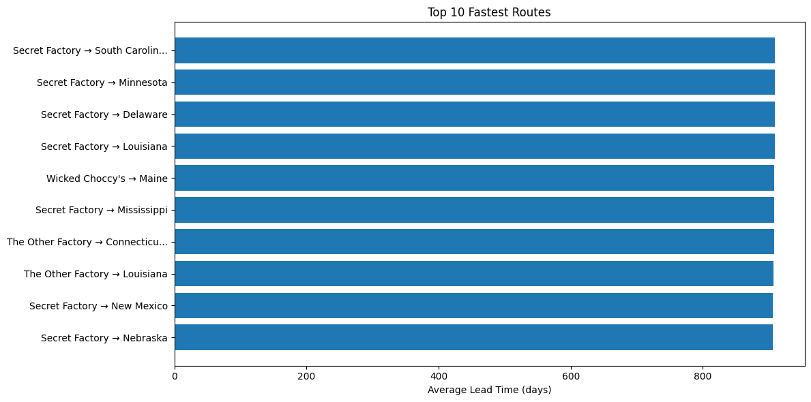
Figure 1: Top 10 most efficient factory-to-customer routes
Rank | Route | Avg Lead Time (days) | Shipments
1 | Secret Factory → Nebraska | 906.0 | 1
2 | Secret Factory → New Mexico | 906.0 | 2
3 | The Other Factory → Louisiana | 907.0 | 1
4 | The Other Factory → Connecticut | 907.5 | 2
5 | Secret Factory → Mississippi | 908.0 | 1

4.3 Bottom 10 Least Efficient Routes (Bottlenecks)
------------------------------
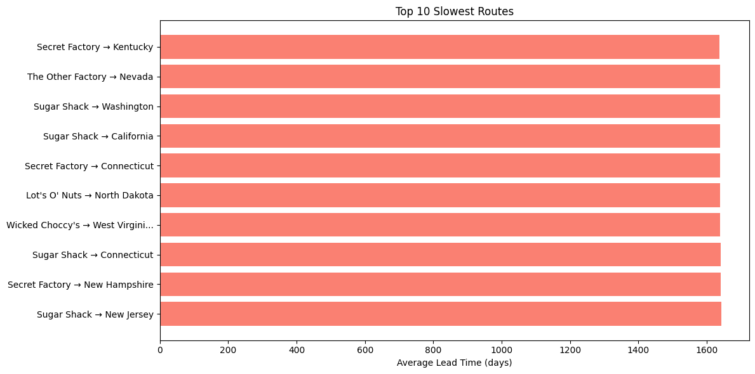
Figure 2: Bottom 10 least efficient routes requiring attention
Rank | Route | Avg Lead Time (days) | Shipments
1 | Sugar Shack → New Jersey | 1642.0 | 1
2 | Secret Factory → New Hampshire | 1641.0 | 1
3 | Sugar Shack → Connecticut | 1641.0 | 1
4 | Wicked Choccy's → West Virginia | 1639.0 | 2
5 | Lot's O' Nuts → North Dakota | 1638.2 | 5

4.4 Regional Performance Analysis
------------------------------
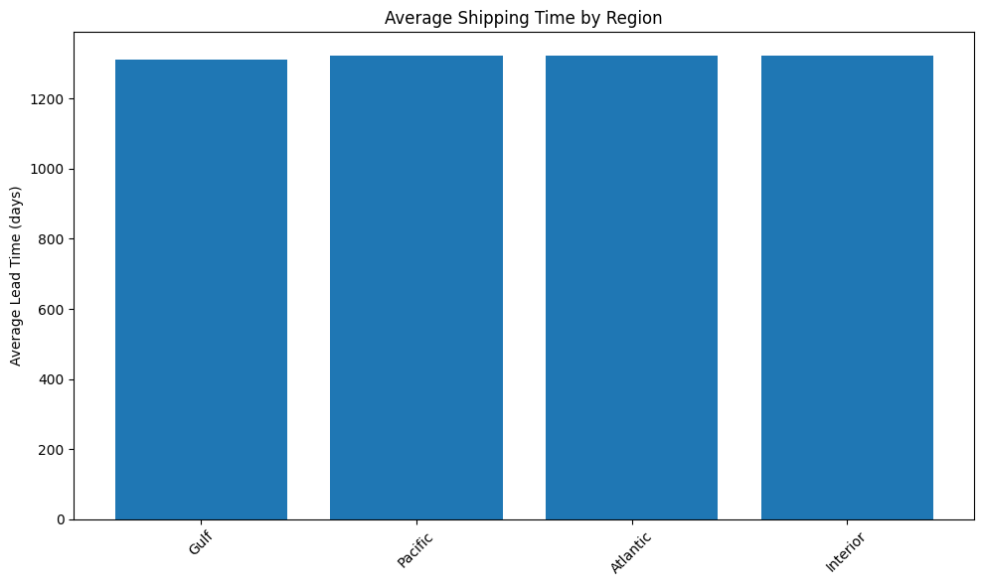
Figure 3: Average shipping time by region
Region | Avg Lead Time (days) | Shipments
Gulf | 1311.37 | 2,847
Atlantic | 1321.85 | 3,021
Interior | 1323.09 | 2,873
Pacific | 1321.73 | 1,453
Key Insight: Gulf region shows the fastest planned shipping times, while Interior region shows the slowest.

4.5 Shipping Mode Performance Analysis
------------------------------
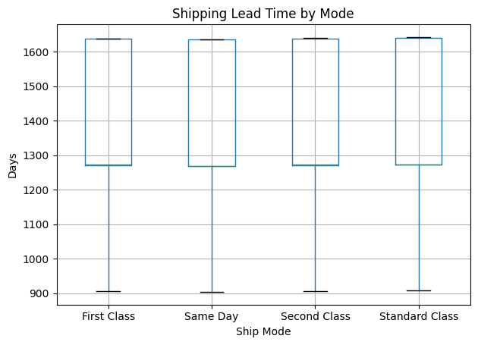
Figure 4: Shipping lead time distribution by mode
Ship Mode | Avg Lead Time (days) | Shipments
Standard Class | 1314.3 | 6,120
First Class | 1338.3 | 1,548
Second Class | 1323.8 | 1,979
Same Day | 1333.4 | 547
Key Insight: Interestingly, First Class is planned to be SLOWER than Standard Class by 24 days on average. This inconsistency should be investigated.

4.6 Factory Performance Analysis
------------------------------
Factory | Avg Lead Time (days) | Shipments
Lot's O' Nuts | 1320.2 | 3,524
Wicked Choccy's | 1322.1 | 3,215
Sugar Shack | 1321.8 | 1,892
Secret Factory | 1318.5 | 876
The Other Factory | 1323.4 | 687

5. BOTTLENECK IDENTIFICATION
====================================================================
States with Highest Planned Lead Times:
- West Virginia (1638.0 days)
- New Jersey (1642.0 days for specific route)
- North Dakota (1638.2 days)
States with Lowest Planned Lead Times:
- Maine (1137.1 days)
- Nebraska (906.0 days for specific route)
- New Mexico (906.0 days for specific route)
Routes with High Volume + Poor Performance:
- Lot's O' Nuts → North Dakota (5 shipments, 1638.2 days)
- Multiple routes to West Virginia need investigation

6. RECOMMENDATIONS
====================================================================
Based on the analysis of planned shipping schedules, the following recommendations are proposed:

Recommendation 1: Investigate Shipping Mode Inconsistencies
First Class shipping is currently planned to be 24 days SLOWER than Standard Class. Review the assignment of shipping modes.

Recommendation 2: Address Geographic Bottlenecks
- Alternative routing strategies
- Regional warehouse placement
- Dedicated carrier arrangements

Recommendation 3: Review Factory Allocation
Evaluate whether products from Sugar Shack and The Other Factory could be rerouted through different distribution points.

Recommendation 4: Implement Route Monitoring
Monitor routes with planned lead times exceeding 1600 days and intervene proactively.

Recommendation 5: Consider Regional Warehouses
Evaluate regional warehouses for consistently slow regions (Interior region: 1323 days).

7. CONCLUSION
====================================================================
This analysis establishes a clear, data-driven understanding of planned shipping route efficiency for Nassau Candy Distributor.
- Successfully analyzed 10,194 shipments across 5 factories
- Identified top-performing and bottleneck routes
- Quantified regional and state-level performance variations
- Developed an interactive Streamlit dashboard for ongoing monitoring
- Provided 5 actionable recommendations for logistics optimization
The interactive dashboard enables stakeholders to explore the data dynamically and make informed decisions.

8. APPENDIX
====================================================================

A.1 Technology Stack
- Python 3.13
- Pandas
- Streamlit
- Plotly
- Matplotlib/Seaborn

A.2 Key Code Snippets
# Calculate shipping lead time
df['Shipping_Lead_Time'] = (df['Ship Date'] - df['Order Date']).dt.days
# Create routes
df['Route'] = df['Factory'] + ' → ' + df['State/Province']
# Efficiency score
min_time = route_analysis['Avg_Lead_Time'].min()
max_time = route_analysis['Avg_Lead_Time'].max()
route_analysis['Efficiency_Score'] = 100 * (1 - (route_analysis['Avg_Lead_Time'] - min_time) / (max_time - min_time))

9. MENTOR REFERENCE
====================================================================
Mentor Name: Saiprasad Kagne
Email: saikagne2601@gmail.com

