PROJECT DOCUMENTATION
AI FAQ ASSISTANT
A Web-Based Intelligent Frequently Asked Questions System
This document presents the design, implementation, testing, and demonstration details of an AI-powered FAQ Assistant developed as a full-stack web application. The system combines a browser-based interface with a Node.js and Express backend, MongoDB data storage, JWT-based authentication, FAQ management, and AI-assisted answer generation.
Project Detail | Information
Project Name | AI FAQ Assistant
Application Type | Full-Stack Web Application
Frontend | HTML5, CSS3, JavaScript / Web Interface
Backend | Node.js with Express.js
Database | MongoDB
Authentication | JSON Web Token (JWT)
AI Component | AI-powered answer and FAQ generation service
Development Tool | Visual Studio Code
API Testing Tool | Thunder Client
Academic Level | B.Sc. Computer Science – Project Documentation
Documentation Year | 2026
TEAM PROJECT
Team Member | Role in Project
Team Member 1 | Project coordination and backend integration
Team Member 2 | Frontend interface and user experience
Team Member 3 | Database design and data management
Team Member 4 | API testing and documentation
Team Member 5 | AI integration and system testing
Note: The five role descriptions are used for documentation structure. Replace the member labels with the official student names before final submission.

TABLE OF CONTENTS
No. | Chapter / Section | Page
1. | Project Overview | 3
2. | Certificate and Declaration Format | 4
3. | Acknowledgement | 5
4. | Abstract and Keywords | 6
5. | Introduction | 7
6. | Problem Statement and Objectives | 8
7. | Existing and Proposed System | 9
8. | System Requirements and Feasibility | 10
9. | System Architecture and Workflow | 11
10. | Functional Modules | 12
11. | Database Design | 13
12. | API Design and Authentication | 14
13. | AI FAQ Processing | 15
14. | Implementation Details | 16
15. | Testing and Validation | 17
16. | Output and Demonstration Screens | 18
17. | Security, Limitations and Future Scope | 19
18. | Conclusion and References | 20
Document structure: The report is intentionally arranged into twenty continuous pages. Each page contains a complete documentation section, table, explanation, or project evidence so that there are no intentionally empty content pages.
Formatting standard: Main headings use consistent hierarchy; body paragraphs are justified; tables are centered and aligned; figures are centered with captions; page numbers are included in the footer.

1. PROJECT OVERVIEW
The AI FAQ Assistant is a web-based application designed to help users obtain answers to frequently asked questions through a structured FAQ repository and an AI-assisted response mechanism. The project is implemented as a full-stack system so that the presentation layer, application logic, data layer, authentication layer, and AI service can communicate through well-defined APIs.
The application follows a client-server architecture. The user interacts with the web interface, while the Express.js server receives HTTP requests, validates input, communicates with MongoDB, checks authenticated sessions through JWT, and forwards suitable questions to the AI service. This separation makes the application easier to test, maintain, and extend.

Project Scope
- Provide a simple interface for accessing frequently asked questions.
- Allow users to register and authenticate securely.
- Issue a JWT after successful login for protected operations.
- Retrieve FAQ information through REST-style API endpoints.
- Provide AI-assisted answers for user questions.
- Support AI-assisted generation of FAQ content where the feature is enabled.
- Store application data in MongoDB.
- Allow API behavior to be verified independently using Thunder Client.

Project Characteristics
Characteristic | Description
Usability | Simple browser-based interaction with clear navigation and responses.
Modularity | Authentication, FAQ, AI, database, and server components are separated.
Scalability | Additional FAQ categories, users, and AI capabilities can be added.
Maintainability | Node.js modules and Express routes keep server responsibilities organized.
Testability | REST endpoints can be tested independently using Thunder Client.

2. CERTIFICATE AND DECLARATION FORMAT
The following page content is provided as a clean academic certificate/declaration format that can be placed into the final college submission. The exact institutional wording can be adjusted according to the department format.
CERTIFICATE
This is to certify that the project entitled “AI FAQ Assistant – A Web-Based Intelligent Frequently Asked Questions System” is a bonafide project work carried out by the project team as part of the requirements for the completion of the B.Sc. Computer Science programme during the academic year 2026.
The project demonstrates the application of web development, REST API design, database management, authentication, software testing, and AI-assisted information retrieval. The work has been developed, tested, and documented by the project team under the guidance of the concerned faculty.
Academic / Approval Field | Details
Project Title | AI FAQ Assistant
Programme | B.Sc. Computer Science
Academic Year | 2026
Internal Guide | Faculty Guide
Internal Examiner | Department Examiner
External Examiner | University / External Examiner
Date of Submission | 2026
Declaration
We declare that the project work presented in this documentation is prepared for academic evaluation and that the implementation, testing records, screenshots, and explanations included in the report correspond to the project demonstration. Any external libraries, services, or frameworks used by the project are acknowledged in the references section.

3. ACKNOWLEDGEMENT
We express our sincere gratitude to our institution and the Department of Computer Science for providing the academic environment, laboratory facilities, and guidance required to complete this project. The project gave us an opportunity to apply concepts learned in programming, database management, web technologies, software engineering, and system design to a practical application.
We are thankful to our project guide for valuable suggestions throughout the planning, development, debugging, testing, and documentation stages. The guidance helped us understand how to divide a larger application into independent modules and how to connect those modules through APIs.
We also thank the teaching faculty and laboratory staff for their support in providing the required software and development environment. The availability of Visual Studio Code, Node.js, MongoDB, browser tools, and API testing tools helped the team verify the application in a practical manner.
We acknowledge the contribution of all team members who participated in requirements analysis, interface development, backend programming, database configuration, API testing, AI integration, troubleshooting, and documentation. The team-based approach helped us compare solutions, identify errors, and improve the final demonstration.
Finally, we thank our friends and classmates who provided feedback during testing and helped us identify areas where the interface and responses could be made clearer. Their suggestions were useful while preparing the final project demonstration and documentation.

Team Contribution Summary
Area | Team Responsibility
Planning | Problem identification, objectives, scope and module planning.
Frontend | Page structure, styling, navigation and user interaction.
Backend | Express server, route handling, controllers and middleware.
Database | MongoDB connection, collections and application data.
Authentication | Registration, login, JWT generation and protected access.
AI Integration | Question processing and AI-assisted answer generation.
Testing | Thunder Client requests, response verification and error checking.
Documentation | Screenshots, explanations, test results and final report.

4. ABSTRACT AND KEYWORDS
The AI FAQ Assistant is a full-stack web application developed to simplify access to frequently asked information. Traditional FAQ pages usually depend on fixed question-and-answer pairs, which can make it difficult for users to find the exact information they need when their question is phrased differently. This project combines a structured FAQ system with an AI-assisted response capability to provide a more flexible interaction model.
The backend is developed using Node.js and Express.js. MongoDB is used for persistent data storage, while JSON Web Tokens are used to authenticate users and protect selected API resources. The application exposes REST-style endpoints for registration, login, profile access, FAQ retrieval, AI-based answers, and AI-assisted FAQ generation. Thunder Client is used to verify the API requests and responses during development.
The system follows a modular design in which authentication, FAQ processing, AI operations, middleware, and database communication are handled as separate responsibilities. This approach makes it possible to identify errors at the API level before connecting the complete frontend workflow.

Keywords
Keyword | Meaning in the Project
AI | Artificial Intelligence used to process questions and generate useful responses.
FAQ | Frequently Asked Questions maintained as structured application content.
REST API | HTTP-based interface used for communication between client and server.
Node.js | JavaScript runtime used to execute the backend application.
Express.js | Backend framework used for routes, middleware and HTTP handling.
MongoDB | Document-oriented database used to store application records.
JWT | JSON Web Token used for authenticated API requests.
Thunder Client | VS Code extension used to test API endpoints.
The main outcome of the project is a working foundation for an intelligent FAQ platform in which conventional FAQ retrieval and AI-based assistance can coexist within the same web application.

5. INTRODUCTION
Frequently asked questions are common in educational platforms, service portals, organizational websites, support systems, and online applications. A well-designed FAQ module reduces repeated support requests by making common information available in a structured form. However, users may not always know the exact wording of a stored question. An AI-assisted FAQ system can reduce this limitation by interpreting natural-language questions and producing an appropriate response.
The project therefore focuses on the development of an application in which authentication, FAQ management, and AI response generation are exposed through backend APIs. The web interface can consume these APIs, while the API layer can also be tested independently during development.

Need for the System
- Users need a faster method to locate answers without reading a large collection of FAQ entries.
- Administrators or application managers need a structured way to store and retrieve FAQ content.
- Developers need authenticated endpoints so that protected information is not exposed to unauthenticated requests.
- The system should support natural-language questions rather than depending only on exact FAQ wording.
- API-based design allows the same backend to support a web frontend and future client applications.

Development Approach
The application is developed incrementally. First, the server environment and routes are configured. Next, MongoDB connectivity and user authentication are implemented. After registration and login are verified, protected profile access is tested using JWT. FAQ endpoints are then tested, followed by AI-related endpoints. This sequence reduces debugging complexity because each layer is validated before the next layer depends on it.

Demonstration Evidence
The supplied screen recording demonstrates the project architecture and Thunder Client API testing workflow. The recorded sequence shows the project structure in Visual Studio Code and successful API responses for registration and login, followed by protected API testing.

6. PROBLEM STATEMENT AND OBJECTIVES

Problem Statement
A conventional FAQ system generally depends on predefined questions and answers. Users may have difficulty locating information when their wording does not match the stored questions. In addition, an FAQ application that does not provide authentication may have limited control over user-specific or administrative operations. A practical solution should therefore combine structured FAQ storage, authenticated API access, and an AI-assisted response mechanism.

Primary Objective
To design and implement a web-based AI FAQ Assistant that provides authenticated users with structured FAQ information and AI-assisted answers through a modular REST API backend.

Specific Objectives
- Create a user registration mechanism with server-side validation.
- Implement login authentication and generate a JWT for successful users.
- Protect selected resources using authentication middleware.
- Provide an API to retrieve FAQ information.
- Provide an API for AI-assisted answers to user questions.
- Provide an API for AI-assisted FAQ generation where enabled.
- Store user and FAQ-related information in MongoDB.
- Create a backend structure that is easy to test and maintain.
- Validate requests and responses using Thunder Client.
- Prepare a responsive and understandable user interface for practical use.

Expected Benefits
- Faster access to common information.
- Improved interaction through natural-language questions.
- Centralized FAQ data management.
- Protected API access using JWT.
- Clear separation between frontend, backend, database, and AI services.
- Reusable API endpoints for future applications.

7. EXISTING AND PROPOSED SYSTEM

Existing System
In a basic FAQ implementation, users view a static list of questions and manually search for an answer. The approach is simple but depends heavily on the user finding the correct question. A static system also provides limited personalization and does not naturally support conversational questions.

Limitations of a Basic FAQ System
- Exact wording may be required to locate the desired information.
- Large FAQ lists can become difficult to navigate.
- Static pages do not provide AI-assisted interpretation.
- Authentication and protected operations may not be available.
- Updating and testing content can become difficult as the application grows.

Proposed System
The proposed AI FAQ Assistant combines structured FAQ retrieval with an AI-assisted answer service. The user can interact with the web application while the backend handles authentication, FAQ retrieval, database operations, and AI requests. REST APIs provide a clear contract between the frontend and backend.
Feature | Basic FAQ | AI FAQ Assistant
FAQ retrieval | Available | Available through API
Natural-language question | Limited | Supported by AI layer
User authentication | Optional / often absent | JWT-based authentication
Database | May be static | MongoDB
API testing | Limited | Thunder Client supported
AI answer | Not available | Supported
Extensibility | Moderate | Modular backend design

Advantages of the Proposed Architecture
The proposed system is easier to extend because new routes and modules can be added without redesigning the complete application. MongoDB provides flexible document storage, while Express middleware allows authentication and validation logic to be reused across protected routes.

8. SYSTEM REQUIREMENTS AND FEASIBILITY

Hardware Requirements
Component | Recommended Requirement
Processor | Dual-core processor or above
RAM | 4 GB minimum; 8 GB recommended for development
Storage | At least 2 GB free for project dependencies and database tools
Display | 1366 × 768 or higher for comfortable development
Network | Internet connection required when using cloud AI/database services

Software Requirements
Software | Purpose
Windows / compatible OS | Development environment
Visual Studio Code | Source-code editing and project management
Node.js | Backend JavaScript runtime
Express.js | Web server and API framework
MongoDB | Database management
Thunder Client | REST API testing
Modern Browser | Frontend execution and demonstration
AI Service API | AI-assisted answer and FAQ generation

Feasibility Study
Feasibility Type | Assessment
Technical | The required technologies are widely supported and can be integrated using standard HTTP and database interfaces.
Operational | The application can be operated through a browser interface and tested through simple API requests.
Economic | The project can be developed using commonly available development tools and open-source frameworks; external service costs depend on usage.
Schedule | The modular development approach allows authentication, FAQ and AI modules to be implemented and tested in stages.
Maintenance | Separate routes and services make future modifications easier to isolate.

9. SYSTEM ARCHITECTURE AND WORKFLOW
The system architecture follows a layered client-server approach. The user interface communicates with Express.js through HTTP requests. Express routes forward requests to controllers or service logic. Authentication middleware verifies JWT tokens for protected operations. Database operations communicate with MongoDB. AI-related requests are passed to the configured AI service and the resulting answer is returned to the client.

Architecture Layers
Layer | Responsibility
Presentation Layer | Displays forms, navigation, FAQ content, questions and responses.
API Layer | Receives HTTP requests and returns JSON responses.
Authentication Layer | Creates and validates JWT tokens.
Business Logic Layer | Processes users, FAQs and AI operations.
Data Layer | Reads and writes MongoDB documents.
AI Integration Layer | Sends suitable questions/prompts to the configured AI service.

Typical Request Flow
- The user performs an action in the web interface or sends a request through Thunder Client.
- The request reaches an Express route.
- The route validates request data and applies middleware where required.
- For protected requests, the JWT is extracted from the Authorization header and verified.
- The controller performs the required operation.
- MongoDB is queried or updated when persistent data is required.
- For AI operations, the question is passed to the configured AI service.
- The server constructs a JSON response containing success status, message, and relevant data.
- The client displays the response to the user.

Architecture Diagram Description
For the final printed report, the architecture can be represented as: User Interface → Express REST API → Authentication / Controllers → MongoDB and AI Service → JSON Response → User Interface. The same flow is visible during API testing in the supplied demonstration recording.

10. FUNCTIONAL MODULES

10.1 User Registration Module
The registration module accepts user details such as name, email, and password. The backend validates the request, checks whether the required fields are available, protects the password through hashing, and stores the user record in MongoDB. A successful request returns a structured JSON response indicating that registration has completed.

10.2 Login Module
The login module verifies the supplied credentials against the stored user information. When authentication succeeds, the server creates a JWT containing the user identity and token timing information. The client uses this token for protected requests.

10.3 Profile Module
The profile route is a protected endpoint. It requires an Authorization header containing a Bearer token. The authentication middleware verifies the token before allowing profile data to be returned. An invalid, expired, or missing token results in an authorization error.

10.4 FAQ Module
The FAQ module provides access to frequently asked questions stored by the application. The API layer makes FAQ retrieval independent from the user interface, which allows the same data to be consumed by different clients.

10.5 AI Answer Module
The AI answer module accepts a user question and passes suitable input to the configured AI service. The returned answer is converted into the application's JSON response structure so that the frontend can display it consistently.

10.6 AI FAQ Generation Module
The AI FAQ generation module can be used to create FAQ-style content from an input topic or prompt. This reduces manual effort when preparing question-and-answer content and provides a foundation for future administrative FAQ management.

10.7 API Testing Module
Thunder Client is used to send requests, inspect status codes, verify response bodies, and test authenticated routes. This module is especially important during development because backend errors can be identified before frontend integration.

11. DATABASE DESIGN
MongoDB is used as the database layer because it stores information as flexible documents and integrates naturally with Node.js applications. The application can organize records into collections representing users, FAQs, and other domain data required by future versions.

User Data Structure
Field | Purpose | Example Type
_id | Unique MongoDB document identifier | ObjectId
name | User display name | String
email | Login identifier | String
password | Protected password hash | String
createdAt | Account creation timestamp | Date

FAQ Data Structure
Field | Purpose | Example Type
_id | Unique FAQ identifier | ObjectId
question | Frequently asked question | String
answer | Stored response | String
category | FAQ grouping or topic | String
createdAt | Creation timestamp | Date

Database Operations
- Create: used when registering a new user or adding FAQ information.
- Read: used to retrieve profile or FAQ data.
- Update: can be used for future profile or FAQ editing functions.
- Delete: can be used for administrative FAQ removal where authorization permits.
- Query: used to locate records based on identifiers, email addresses, categories, or other fields.

Database Design Considerations
Passwords must never be stored as plain text. Application-level validation should be applied before database operations. Frequently accessed fields can be indexed where appropriate. MongoDB credentials and connection strings should be stored in environment variables rather than source code.

12. API DESIGN AND AUTHENTICATION

Core API Endpoints
Method | Endpoint | Purpose | Protection
POST | /api/auth/register | Register a new user | Public
POST | /api/auth/login | Authenticate user and return JWT | Public
GET | /api/auth/profile | Return authenticated user profile | JWT required
GET | /api/faqs | Retrieve FAQ information | As configured
POST | /api/ai/answer | Generate an AI-assisted answer | As configured
POST | /api/ai/generate-faq | Generate FAQ content using AI | As configured

Registration Test
The demonstration shows a successful POST request to the registration endpoint. The response includes a success indicator, a confirmation message, user-related information, and authentication information according to the current implementation.

Login Test
The login request is submitted with the registered credentials. A successful response confirms authentication and returns a JWT. The token is copied into Thunder Client for testing protected endpoints.

JWT Authentication Flow
- User submits valid login credentials.
- Server validates the credentials.
- Server signs a JWT using the configured secret.
- Client stores or forwards the token for protected requests.
- Client sends Authorization: Bearer <token>.
- Middleware extracts and verifies the token.
- If valid, the request continues to the protected controller.
- If invalid or missing, the server returns an authorization error.
During testing, an authorization failure was observed when a token could not be verified. This confirms that the middleware is actively protecting the profile endpoint rather than allowing unauthenticated access.

13. AI FAQ PROCESSING
The AI component extends the traditional FAQ concept by allowing a question to be interpreted as natural-language input. Instead of requiring an exact stored question, the AI layer can receive a user query and produce a contextual answer according to the application's prompt and configured service.

AI Answer Processing Flow
- The user enters a question.
- The frontend sends the question to the AI answer API.
- The backend validates the request body.
- The server constructs the AI prompt or request.
- The configured AI service processes the input.
- The service returns generated content.
- The backend converts the result into the application's JSON response.
- The frontend displays the generated answer.

AI FAQ Generation Flow
The FAQ generation feature can accept a topic or source prompt and request a question-and-answer structure from the AI service. Generated content should be reviewed by an authorized user before being treated as official FAQ content because AI-generated responses can require correction, clarification, or domain-specific validation.

Prompt and Response Handling
Stage | Action
Input validation | Check that the request contains a meaningful question or topic.
Prompt construction | Provide the AI service with clear instructions and relevant context.
AI request | Send the request using the configured service credentials.
Response parsing | Extract the useful answer or FAQ content.
API response | Return a predictable JSON structure to the client.
User display | Present the answer clearly in the application interface.

AI Usage Considerations
- Avoid sending passwords, tokens, or confidential user data to the AI service.
- Validate and review generated content before administrative publication.
- Handle AI service failures with user-friendly error responses.
- Keep the API key in environment variables and never hard-code it in source files.

14. IMPLEMENTATION DETAILS

Project Structure
Component | Typical Responsibility
src/server.js | Starts the Node.js/Express application.
src/app.js | Creates/configures the Express application and middleware.
routes | Defines URL paths and maps requests to controllers.
controllers | Contains request-processing and response logic.
middleware | Handles reusable authentication and request-processing logic.
models | Defines database-related structures and operations.
.env | Stores environment-specific configuration and secrets.
package.json | Defines dependencies and project scripts.

Server Startup
The project is started through the Node.js package script. The package configuration identifies src/server.js as the server entry point. When the server starts successfully, the application listens on the configured local port, allowing Thunder Client and the browser to send requests.

Environment Configuration
Sensitive configuration such as database connection strings, JWT secrets, and AI API keys should be placed in environment variables. The .env file should not be committed to a public repository. A safe project submission should use a .env.example file containing variable names without real secret values.

Error Handling
The backend should return meaningful HTTP status codes and JSON messages. Typical categories include successful creation for registration, successful authentication for login, unauthorized responses for invalid tokens, not-found responses for missing resources, and server-error responses for unexpected failures.

Frontend Integration
The frontend communicates with the backend through fetch or equivalent HTTP calls. The interface should handle loading states, successful JSON responses, authentication failures, and server errors. Keeping API URLs centralized makes it easier to move the application from localhost to a deployment environment.

15. TESTING AND VALIDATION
Testing was performed using Thunder Client inside Visual Studio Code. The purpose of API testing is to verify that the backend accepts valid input, rejects invalid input, returns appropriate status codes, and protects authenticated routes.
Test Case | Request | Expected Result | Observed / Validation
TC01 | POST register with valid user data | User created successfully | Successful registration response observed.
TC02 | POST login with valid credentials | JWT returned | Login success and token observed.
TC03 | GET profile without token | 401 Unauthorized | Protected route rejects missing authentication.
TC04 | GET profile with invalid/failed token | 401 Unauthorized | Token verification failure is reported.
TC05 | GET FAQ endpoint | FAQ JSON response | Endpoint available for testing.
TC06 | POST AI answer with valid question | AI answer JSON | Designed for AI response verification.
TC07 | POST AI generate FAQ | Generated FAQ JSON | Designed for AI FAQ verification.

Validation Principles
- Verify HTTP method and endpoint before testing request data.
- Use valid JSON syntax in request bodies.
- Check the HTTP status code as well as the response body.
- Repeat authentication tests with missing, valid, and invalid tokens.
- Check server terminal output when a request returns an unexpected status.
- Avoid exposing API keys, passwords, or JWTs in screenshots shared publicly.

Observed Authentication Issue
During the demonstration, the profile request returned HTTP 401 Unauthorized with the message “Not authorized, token failed.” The request was configured with a Bearer token, so the issue is associated with token verification rather than the absence of an Authorization field. The appropriate diagnostic step is to generate a fresh login token and, if the issue persists, compare the JWT signing secret and verification configuration in the authentication controller and middleware.

16. OUTPUT AND DEMONSTRATION SCREENS
The following figures are extracted from the supplied screen recording and are included as project evidence. They show the application architecture screen, Visual Studio Code project structure, and Thunder Client API testing responses.
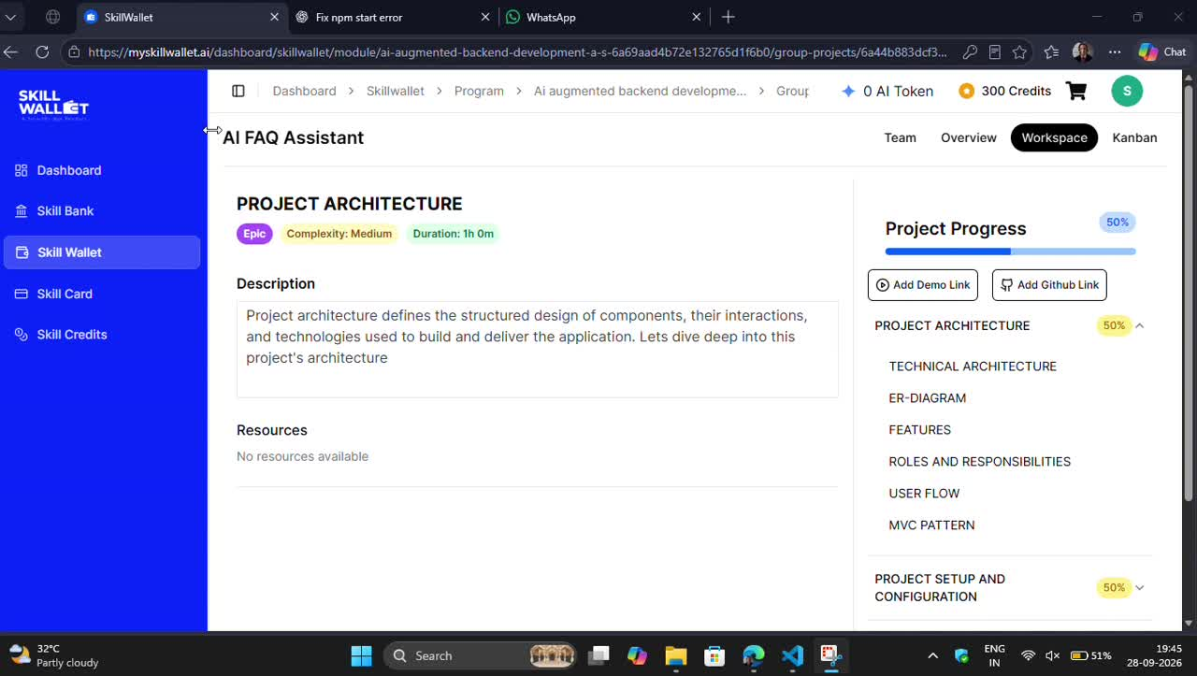
Figure 16.1 – Project architecture screen and AI FAQ Assistant interface
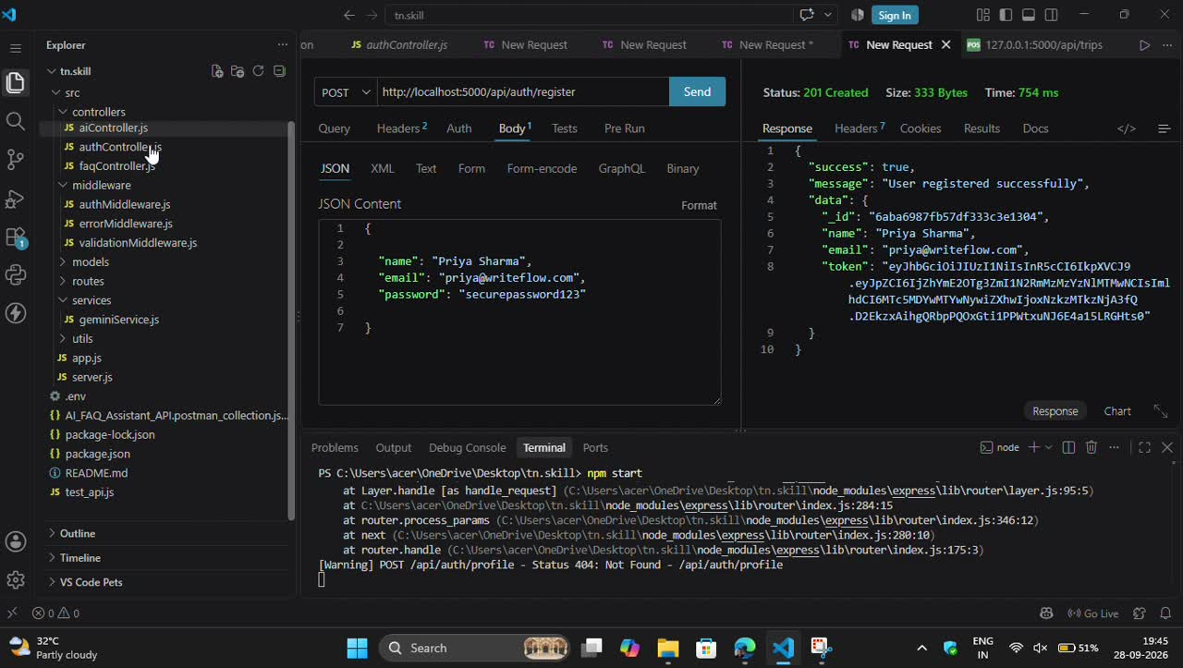
Figure 16.2 – Visual Studio Code project structure and successful API response
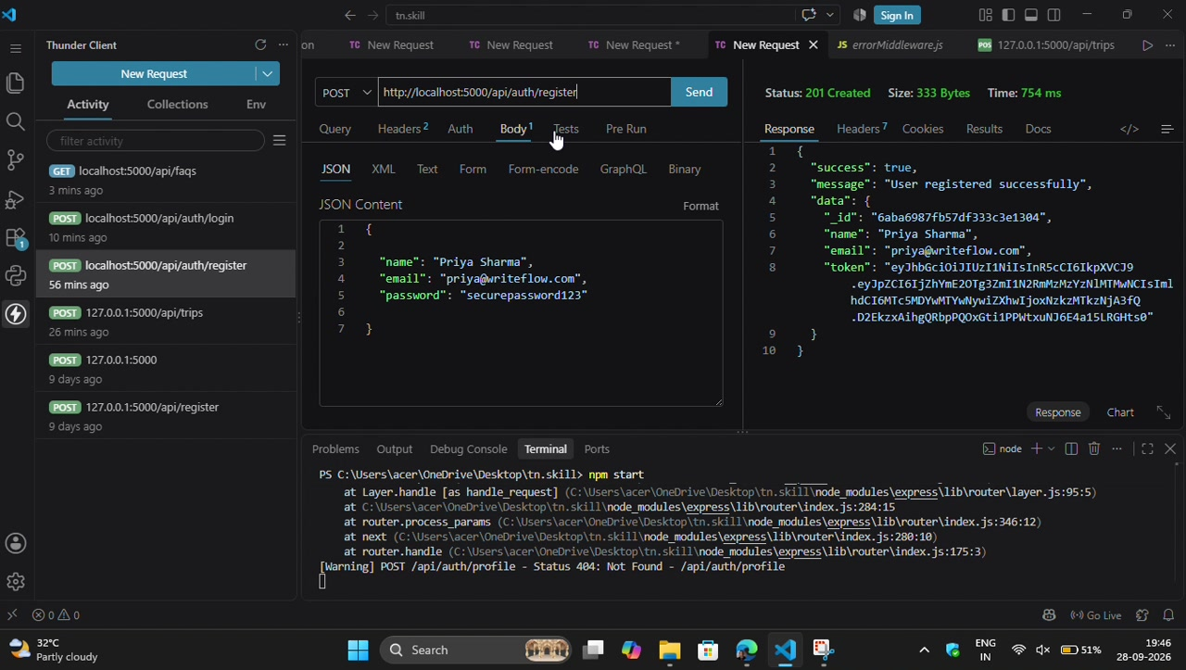
Figure 16.3 – Thunder Client registration/login API testing
The recording also shows the backend terminal running locally and the API request/response panels inside Thunder Client. These outputs demonstrate the practical testing stage of the project rather than only static source-code screenshots.

17. SECURITY, LIMITATIONS AND FUTURE SCOPE

Security Measures
- Passwords should be hashed before storage.
- JWT secrets must be stored outside the source code.
- AI API keys and MongoDB credentials must remain private.
- Protected routes should reject missing or invalid tokens.
- Input validation should be applied to registration, login, FAQ and AI requests.
- Error messages should not expose database credentials or internal secrets.
- Production deployment should use HTTPS.

Current Limitations
- AI responses depend on the availability and configuration of the external AI service.
- Generated AI content may require human review.
- The local demonstration environment is not the same as a production deployment.
- Advanced role-based administration can be expanded in future versions.
- The current project focuses on the core FAQ, authentication and AI workflow.

Future Enhancements
- Admin dashboard for creating, editing and deleting FAQ entries.
- Role-based access control for administrators and normal users.
- FAQ categories, search and filtering.
- Conversation history for authenticated users.
- Feedback buttons to identify useful or incorrect answers.
- Analytics dashboard showing frequently asked questions.
- Multilingual FAQ and AI responses.
- Cloud deployment with HTTPS and managed MongoDB.
- Rate limiting and stronger API abuse protection.
- Automated unit and integration testing.

Maintenance Plan
Future maintenance should be performed module by module. Changes to authentication should be tested against registration, login, profile and all protected routes. AI changes should be tested with normal, empty, long, and unsupported questions. Database changes should be validated against existing records before deployment.

18. CONCLUSION AND REFERENCES

Conclusion
The AI FAQ Assistant demonstrates how a modern web application can combine conventional FAQ management with AI-assisted question answering. The project uses a modular full-stack architecture in which the web interface communicates with a Node.js and Express.js backend, the backend communicates with MongoDB for persistent data, JWT provides authenticated access, and an AI service supports intelligent responses.
The development process also demonstrates the importance of incremental testing. Registration and login were verified first, followed by protected profile access and FAQ/API testing. Thunder Client provided a practical way to inspect requests, HTTP status codes, JSON responses, and authentication behavior without depending entirely on the frontend.
The project provides a strong foundation for future expansion into a complete intelligent support platform. With additional administration, analytics, multilingual support, feedback collection, and production security, the system can be extended beyond a student demonstration into a broader FAQ and support application.

Key Learning Outcomes
Area | Learning Outcome
Web Development | Understanding client-server communication and web application structure.
Backend Programming | Creating Express routes, middleware and API responses.
Database | Connecting an application to MongoDB and handling persistent records.
Authentication | Understanding registration, login, JWT creation and verification.
AI Integration | Connecting application requests with an AI-assisted response service.
Testing | Using Thunder Client to verify APIs and diagnose errors.
Documentation | Preparing structured technical documentation and demonstration evidence.

References
- Node.js documentation and runtime concepts.
- Express.js framework documentation and REST API concepts.
- MongoDB documentation and document database concepts.
- JSON Web Token (JWT) standards and implementation guidance.
- Thunder Client documentation for API testing.
- Documentation for the configured AI service/API used by the project.
- Project source code, configuration files, API collection, and supplied screen recording used as project evidence.
END OF PROJECT DOCUMENTATION

