Aether Key Account Management (KAM) System
Complete Technical Architecture & Process Blueprint
For digitizing the existing Excel-based KAM process into a centralized, auditable, workflow-driven internal platform
Version 1.0 | Prepared for Internal Review | May 2026

Document Item | Details
Document Purpose | Define the target architecture, process design, data model, scoring approach, workflows, integrations, dashboards, and migration plan for an internal KAM system.
Current State | The organization follows a six-step KAM process and maintains information in Excel sheets.
Target State | A centralized web-based KAM platform with Account 360, scoring, health tracking, escalation SLA, workflow automation, reporting, and auditability.
Primary Users | Key Account Managers, Sales/Growth Leadership, Project Managers, Finance, Legal/Contracts, Executive Sponsors, Admins, and optional client stakeholders.

Table of Contents
- 1. Executive Summary
- 2. Current Process and Recommended Improvements
- 3. Enhanced KAM Business Process Lifecycle
- 4. End-to-End Technical Architecture
- 5. Business Module Mapping
- 6. Functional Module Design
- 7. Scoring Engine and Account Health Model
- 8. Contract, Commercial, Project, and Financial Health
- 9. Retention, Growth, White Space, and Client Education
- 10. Escalation and SLA Management
- 11. Data Architecture and Database Design
- 12. API and Application Layer Design
- 13. Dashboards, Reporting, and Analytics
- 14. Security, Access Control, Audit, and Compliance
- 15. Integrations and Excel Migration
- 16. Deployment Architecture and DevOps
- 17. Non-Functional Requirements
- 18. MVP Scope and Implementation Roadmap
- 19. Appendices: Formulas, Sample APIs, Glossary, and References

1. Executive Summary
This document defines a complete technical and process architecture for an internal Key Account Management system. The proposed system preserves the existing six-step process while adding governance, scoring consistency, workflow automation, auditability, dashboards, integration readiness, and a structured migration path from Excel sheets.
The target platform should become the single source of truth for all key account information: client profile, business context, stakeholders, meetings, services provided, white space opportunities, contract details, project health, financial health, client feedback, education history, escalations, and action items.
The recommended architecture is modular: a web portal and dashboards on top, an API and security layer in the middle, business services for KAM operations, a central scoring engine, workflow and notification services, operational databases and document storage, an analytics layer, and external integrations with tools such as CRM, project management, finance/ERP, HR/resource systems, calendar/email, survey tools, and BI platforms.

Key Outcomes
- Replace scattered Excel sheets with a centralized, structured, auditable KAM platform.
- Introduce Account 360 views for client, stakeholder, contract, delivery, finance, growth, and escalation data.
- Standardize account scoring using configurable scorecards and weighted health models.
- Automate the 48-hour escalation meeting SLA with warnings, leadership alerts, action tracking, and feedback capture.
- Improve retention and growth visibility through white space analysis, renewal planning, project updates, and advisory history.
- Provide leadership dashboards for account health, revenue, contract renewals, risk, profitability, escalation trends, and growth opportunities.

2. Current Process and Recommended Improvements
The existing KAM process has six major steps: Know Your Client, Score Marketing Metrics, Contract Scoring, Retention vs Growth, Educate Client, and Escalation. These steps are practical and should remain the foundation of the new system. However, to make the process scalable and system-ready, two additional lifecycle controls are recommended: Step 0 for governance and segmentation, and Step 7 for continuous review and improvement.

Improved Operating Model
Lifecycle Step | Purpose | Main System Output
0. Governance and Segmentation | Define which accounts qualify as key accounts, assign owners, set tiers, review cadence, approval rules, and data requirements. | Account tier, ownership, mandatory fields, review cadence, score thresholds.
1. Know Your Client | Capture client industry, business model, business flow, people, stakeholders, goals, pain points, and strategic context. | Account 360 profile and client intelligence record.
2. Relationship and Marketing Score | Score relationship quality, meeting frequency, cooperation, stakeholder strength, engagement, and relationship risk. | Relationship score and risk signals.
2a. White Space Analysis | Identify current services, missing service areas, upsell/cross-sell potential, small client details, and opportunity priority. | White space matrix and opportunity pipeline.
3. Contract Scoring | Assess contract type, duration, value, margin, renewal probability, SWOT, feedback, and scope stability. | Contract score and commercial risk profile.
3a. Health and RAG Analysis | Track profit health, project health, resource/source health, financial health, and overall Red/Amber/Green status. | Delivery health, financial health, account health trend.
4. Retention vs Growth | Track what is offered, what is delivered, renewals, project updates to client, growth plan, and risk mitigation. | Retention plan, growth roadmap, client update history.
5. Educate and Advise Client | Share suggestions, best approaches, advisory history, education sessions, knowledge sharing, and decision logs. | Education/advisory history and recommendation record.
6. Escalation | Handle client escalations with 48-hour meeting SLA, issue logging, feasibility checks, action items, resolution, and feedback. | Escalation case, action plan, SLA status, closure feedback.
7. Review and Improve | Run QBR/MBR reviews, track score changes, lessons learned, and improve playbooks and scoring rules. | Review notes, lessons learned, improved account plan.

3. Enhanced KAM Business Process Lifecycle
The lifecycle below keeps the company’s existing six steps, adds governance at the beginning, separates white space and health analysis for clarity, and adds continuous review at the end. The loop ensures account data, scores, risks, opportunities, and action plans are continuously refreshed rather than maintained as one-time Excel updates.
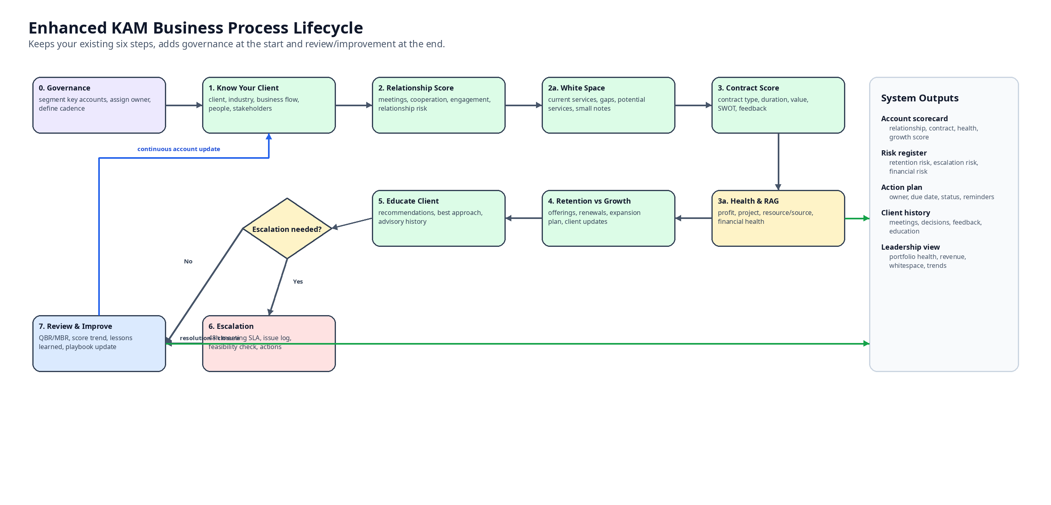
Figure 1: Enhanced KAM Business Process Lifecycle

Lifecycle Control Rules
- Each key account must have an owner, executive sponsor, tier, review cadence, and next review date.
- The account health score should be recalculated when contract, project, financial, feedback, escalation, or relationship inputs change.
- Amber, Red, and Critical accounts should automatically trigger action plans and leadership visibility.
- Escalations must automatically start the 48-hour meeting SLA timer and notify responsible owners.
- Client recommendations, education sessions, and meeting notes must be stored as account history.

4. End-to-End Technical Architecture
The target architecture is organized into users and stakeholders, experience layer, security/API layer, core KAM services, platform support services, data and analytics layer, integration layer, and observability/operations. The design supports future integration with CRM, ERP/finance, project tools, HR/resource systems, survey platforms, calendar/email systems, and BI tools.

Architecture Layers
Layer | Purpose | Key Components
Users and Stakeholders | People who create, maintain, approve, consume, or act on KAM information. | KAM, sales/growth head, project manager, finance, legal/contracts, executive sponsor, admin, optional client user.
Experience Layer | User-facing applications and dashboards. | KAM web portal, admin console, portfolio dashboards, optional client view, responsive UI.
Access, Security, and API Edge | Secure access, authorization, request validation, and API entry point. | SSO/IAM, MFA, RBAC/ABAC, API gateway/BFF, rate limits, audit logging, app security controls.
Core KAM Application Layer | Main business capabilities that digitize the KAM lifecycle. | Account 360, client intelligence, relationship scoring, white space, contract scoring, health/RAG, retention/growth, education, escalation.
Platform Support Services | Cross-cutting business platform capabilities. | Workflow/SLA engine, rules/scoring engine, action items, notifications, documents, feedback, search, knowledge base.
Data and Analytics Layer | Persistent storage and reporting foundation. | KAM transactional DB, audit store, object storage, search index, analytics warehouse.
Integration Layer | Connectors to internal and external systems. | Email/calendar, project tools, finance/ERP, HR/resource allocation, CRM, surveys, industry data, ETL/event bus.
Observability and Operations | Operational monitoring and supportability. | Logs, metrics, traces, alerts, backups, disaster recovery, monitoring dashboards.

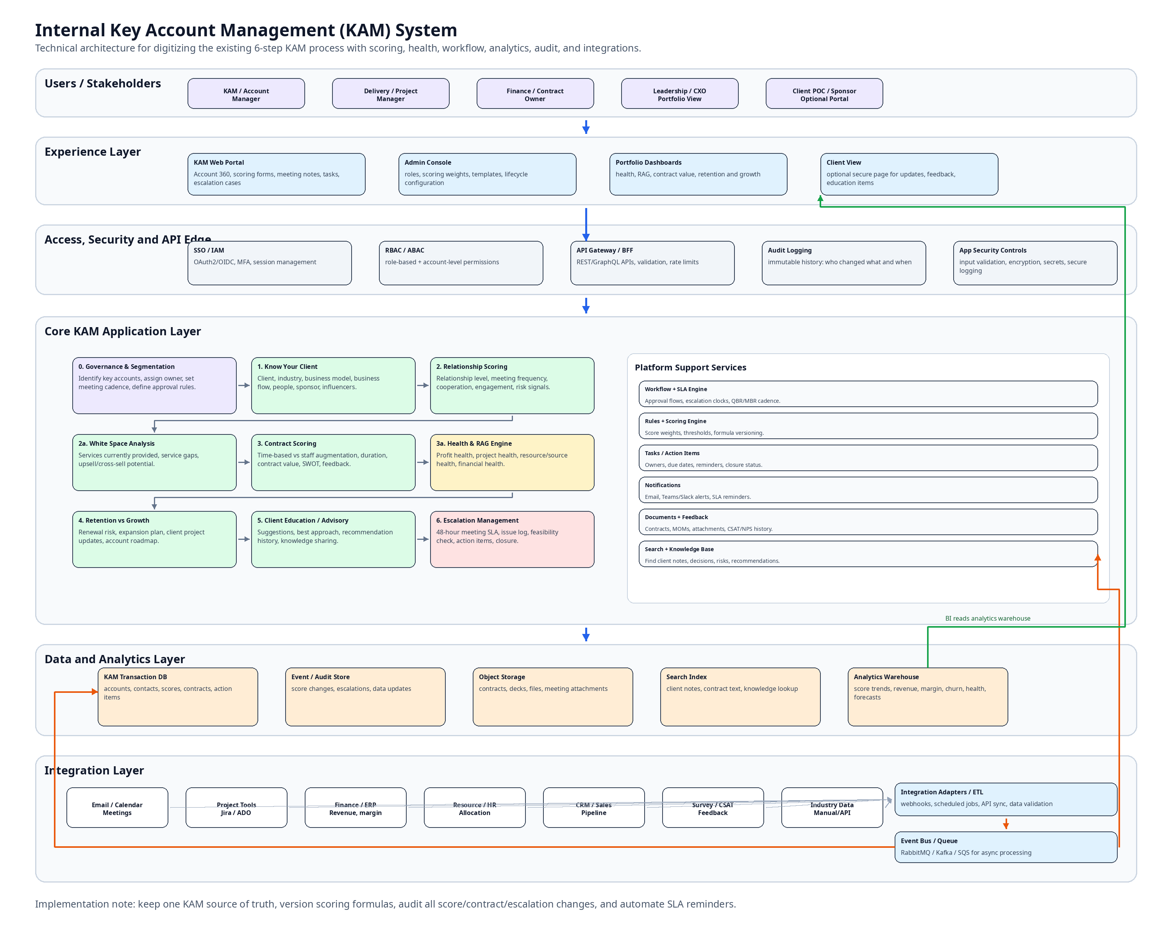
Figure 2: End-to-End Technical Architecture for Internal KAM System

5. Business Module Mapping
The system should map every existing KAM step to one or more product modules. This prevents the new system from becoming a generic CRM and ensures it directly supports the company’s current operating process.
Existing Step | Recommended Module | System Responsibilities
Know Your Client | Account 360 + Client Intelligence | Store industry info, business info, client business flow, people, stakeholders, goals, pain points, service history, account owner, sponsor, and account tier.
Score Marketing Metrics | Relationship Score + Engagement Tracking | Score relationship strength, meeting frequency, cooperation, sentiment, stakeholder coverage, communication history, and engagement health.
White Space Analysis | White Space + Opportunity Engine | Track services provided, services not provided, service gaps, potential upsell/cross-sell, opportunity priority, expected revenue, and next action.
Contract Scoring | Contract + Commercial Health | Track contract type, duration, value, margin, renewal status, SWOT, payment health, feedback, and score impact.
Activity to Increase Score | Project/Financial/Resource Health + Action Plans | Track profit health, project RAG, resource/source health, financial health, actions, owners, due dates, and completion status.
Retention vs Growth | Retention and Growth Planning | Track what is being offered, renewal strategy, project updates to client, account roadmap, expansion plan, and risk mitigation.
Educate Client | Client Education / Advisory History | Store suggestions, best approaches, advisory sessions, meeting notes, QBR decks, decisions, and knowledge-sharing history.
Escalation | Escalation and SLA Management | Create escalation case, enforce 48-hour meeting SLA, document issue, feasibility check, recommendation, action items, feedback, and closure.
Missing Control | Governance, Analytics, Audit | Define qualification, account tiering, approvals, audit trail, reporting, score rules, score history, review cadence, and leadership visibility.

6. Functional Module Design

6.1 Account 360 Module
Account 360 is the central profile for every key account. It should give a consolidated view of the client, business context, stakeholders, active contracts, current projects, financial health, project health, services provided, white space, risks, escalation history, feedback history, and growth plan.
- Client name, industry, region, company size, account tier, strategic importance, account owner, executive sponsor.
- Main business flow, business model, client goals, pain points, competitors, strategic initiatives, procurement cycle, and budget cycle.
- Existing services, current projects, active contracts, revenue contribution, margin, renewal status, and payment health.
- Relationship score, stakeholder map, meeting cadence, last meeting date, next review date, open action items, and open escalations.

6.2 Client Intelligence Module
Client Intelligence supports the Know Your Client step. It should convert informal client understanding into structured knowledge that can be used by account managers, delivery teams, leadership, and future account owners.
- Industry profile, client business information, main workflows, business goals, known pain points, technology stack, competitors, and growth initiatives.
- Decision-making process, stakeholder influence, budget and procurement cycles, buying signals, and engagement notes.
- Client-specific small details, preferences, historical decisions, meeting notes, advisory history, and lessons learned.

6.3 Stakeholder and Relationship Mapping Module
Field / Capability | Description
Stakeholder Profile | Name, designation, department, location, preferred communication channel, internal relationship owner.
Influence and Decision Power | Decision maker, influencer, approver, evaluator, sponsor, detractor, neutral, or operational contact.
Relationship Status | Strong, good, neutral, weak, at-risk, unknown; supported by interaction history and sentiment.
Engagement Tracking | Meeting frequency, last interaction, next planned interaction, response quality, cooperation level.
Coverage Risk | Identify single-person dependency and missing executive/sponsor relationships.

6.4 Platform Support Services
- Workflow engine for approvals, account reviews, escalation flows, renewal reviews, and action plans.
- Notification service for email, Teams/Slack, calendar reminders, SLA warnings, contract renewal alerts, and task reminders.
- Document service for contracts, meeting minutes, proposals, QBR decks, feedback attachments, and escalation evidence.
- Search and knowledge base for client notes, decisions, recommendations, contracts, lessons learned, and risks.
- Rules and scoring engine for configurable score weights, thresholds, formula versions, and score history.

7. Scoring Engine and Account Health Model
A central scoring engine should replace Excel formulas. Scores must be rule-driven, versioned, recalculable, auditable, and configurable by authorized admins. Every score should store the inputs used, score version, calculated value, timestamp, and reason for score change.
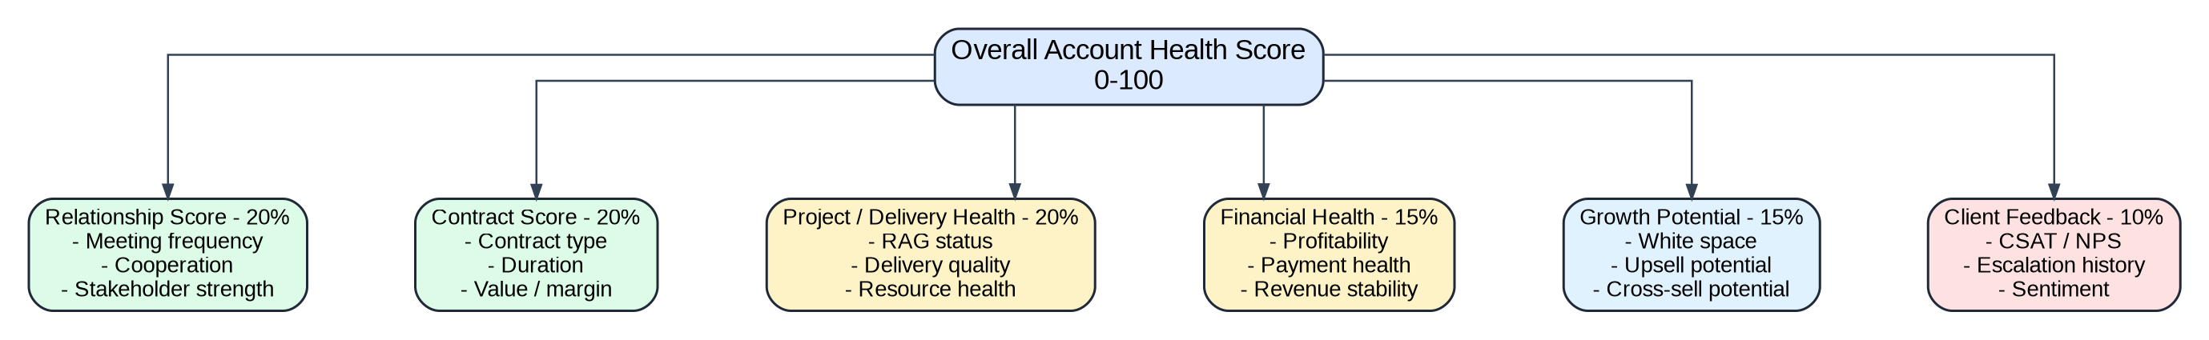
Figure 3: Recommended Account Health Scoring Model

Overall Account Health Formula
Account Health Score =
(Relationship Score x 0.20)
+ (Contract Score x 0.20)
+ (Project Health Score x 0.20)
+ (Financial Health Score x 0.15)
+ (Growth Potential Score x 0.15)
+ (Client Feedback Score x 0.10)

Account Status Thresholds
Score Range | Status | Meaning | Required Action
85-100 | Green | Strong relationship, healthy delivery, solid contract, and visible growth opportunity. | Continue planned cadence and growth execution.
70-84 | Light Green | Generally healthy account with some areas requiring monitoring. | Review in regular cadence; maintain action list.
55-69 | Amber | Risk exists in relationship, delivery, contract, finance, feedback, or growth pipeline. | Create action plan and monitor weekly/biweekly.
40-54 | Red | High account risk requiring leadership attention. | Leadership review, mitigation plan, and tracked recovery actions.
Below 40 | Critical | Immediate risk of churn, severe escalation, major delivery issue, or commercial exposure. | Immediate executive sponsor involvement and escalation workflow.

Score Governance Rules
- Every score formula should have a version number and effective date.
- Score inputs should be traceable to source records such as contracts, meetings, feedback, escalations, project health, and financial data.
- Manual score overrides should require reason, approver, timestamp, and expiry date.
- Score recalculation should run automatically when key input data changes and periodically through scheduled jobs.
- Historical scores should be preserved for trend analysis and leadership reporting.

8. Contract, Commercial, Project, and Financial Health

8.1 Contract Scoring
Contract scoring evaluates the commercial value and stability of the account. It should support time-based/T&M, staff augmentation, fixed-price, retainer, dedicated team, support and maintenance, and hybrid contracts.
Contract Factor | Suggested Weight | Example Inputs
Contract value | 20% | Total contract value, monthly recurring revenue, annualized value.
Profit margin | 20% | Gross margin, billing rate, cost rate, delivery cost.
Contract duration | 15% | Start date, end date, remaining duration, renewal date.
Renewal probability | 15% | Sponsor support, delivery satisfaction, current renewal discussions.
Payment health | 10% | Invoice aging, delayed payments, disputed invoices.
Scope stability | 10% | Scope creep, change requests, requirement volatility.
Client feedback | 10% | CSAT, NPS, sentiment, escalation history.

8.2 Project Health and RAG Analysis
In this document, RAG means Red, Amber, and Green status. Project health should reflect delivery performance and should feed the overall account health score.
Health Area | What to Track | Examples of Risk Signals
Project Health | Timeline, milestone progress, quality, scope stability, change requests, client satisfaction. | Delayed milestones, repeated defects, unclear requirements, client dissatisfaction.
Resource / Source Health | Team availability, skill fit, attrition risk, ramp-up time, backup resources. | Single-resource dependency, over-allocation, skill mismatch, unexpected unavailability.
Profit Health | Margin, utilization, change request recovery, cost leakage. | Low margin, unbilled work, excessive rework, scope creep.
Financial Health | Revenue stability, payment health, billing status, invoice aging. | Delayed payments, invoice disputes, contract value decline.

8.3 Activities to Increase Score
- Create project recovery actions for Red or Amber project health.
- Improve profit health by reducing leakage, formalizing change requests, and reviewing margin drivers.
- Improve relationship score by increasing meaningful meetings, expanding stakeholder coverage, and addressing cooperation blockers.
- Improve financial health by resolving invoice issues, monitoring payment aging, and escalating commercial risks early.
- Improve growth potential by converting white space into qualified opportunities and client education sessions.

9. Retention, Growth, White Space, and Client Education

9.1 Retention vs Growth Planning
Retention and growth should be managed as two related but separate motions. Retention focuses on protecting the existing relationship, delivery, contract, and renewal. Growth focuses on expanding services through white space analysis, client education, proposal tracking, and opportunity management.
Area | Retention Focus | Growth Focus
Client Updates | Regular updates on current project status, risks, delivery progress, and action items. | Introduce new solution ideas, transformation themes, and value-add recommendations.
Account Plan | Renewal plan, risk mitigation, stakeholder engagement, satisfaction improvement. | Expansion roadmap, upsell/cross-sell plan, service gap opportunities.
Measurement | Churn risk, renewal probability, delivery health, feedback, escalation trend. | Pipeline value, white space value, proposal stage, opportunity win probability.
Cadence | Weekly/monthly operational reviews and QBR/MBR reviews. | Growth discovery meetings, education sessions, solution workshops, proposal reviews.

9.2 White Space Analysis
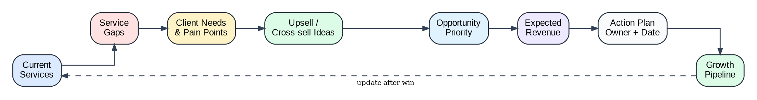
Figure 4: White Space Analysis Flow
Service Area | Currently Provided? | Client Need | Opportunity Level | Recommended Action
Web Development | Yes | High | Existing | Maintain quality, report value, and identify adjacent needs.
Mobile App Development | No | Medium | Cross-sell | Discuss in next QBR and validate business case.
QA Automation | No | High | Upsell | Prepare discovery agenda and automation assessment.
Cloud / DevOps | Partial | High | Expansion | Plan technical discovery and roadmap workshop.
AI / Data Analytics | No | Medium | Future | Educate client and capture use cases for future proposal.

9.3 Client Education and Advisory History
The system should store what the company recommended to the client, why it was recommended, when it was discussed, who attended, what the client decided, and what action followed. This creates an advisory history that helps account continuity and prevents repeated conversations.
- Recommendation title, business problem, recommended approach, expected value, owner, client stakeholders, decision date, and status.
- Education session history, QBR/MBR decks, meeting minutes, solution workshops, best-practice suggestions, and follow-up actions.
- Client decision logs and reason for acceptance, rejection, deferment, or revision.

10. Escalation and SLA Management
Escalation management should be fully workflow-driven. When an escalation is created, the system should automatically calculate the 48-hour client meeting deadline, notify the responsible owners, track warnings, capture root cause analysis, create action items, and require client feedback before closure.
Figure 5: Escalation Workflow with 48-Hour Meeting SLA

Escalation Case Fields
Field Group | Required Fields
Basic Information | Account, client stakeholder, reported by, reported date/time, severity, issue category, description.
SLA Tracking | 48-hour meeting deadline, meeting scheduled date/time, SLA status, 24-hour warning, 40-hour leadership alert.
Issue Analysis | Client expectation, feasibility/unrealistic requirement check, root cause, impact, affected project/contract.
Resolution Plan | Recommended solution, internal owner, action items, due dates, dependencies, target resolution date.
Closure | Resolution summary, client confirmation, client feedback, lessons learned, closure date.

Escalation Severity Levels
Severity | Definition | Expected Handling
Critical | Severe client dissatisfaction, major business impact, contract/revenue risk, executive concern. | Immediate leadership involvement, 48-hour client meeting, daily tracking until stable.
High | Significant delivery, quality, relationship, or commercial concern. | Owner assigned immediately, client meeting within 48 hours, action plan tracked.
Medium | Issue requires management attention but is not yet severe. | Action plan required, monitor in account review.
Low | Minor concern, question, or improvement request. | Track as action item and review in regular cadence.

11. Data Architecture and Database Design
The data architecture should support transactional operations, search, documents, audit history, analytics, and future integrations. Sensitive finance and contract fields should be permission-controlled, and all important changes should be auditable.
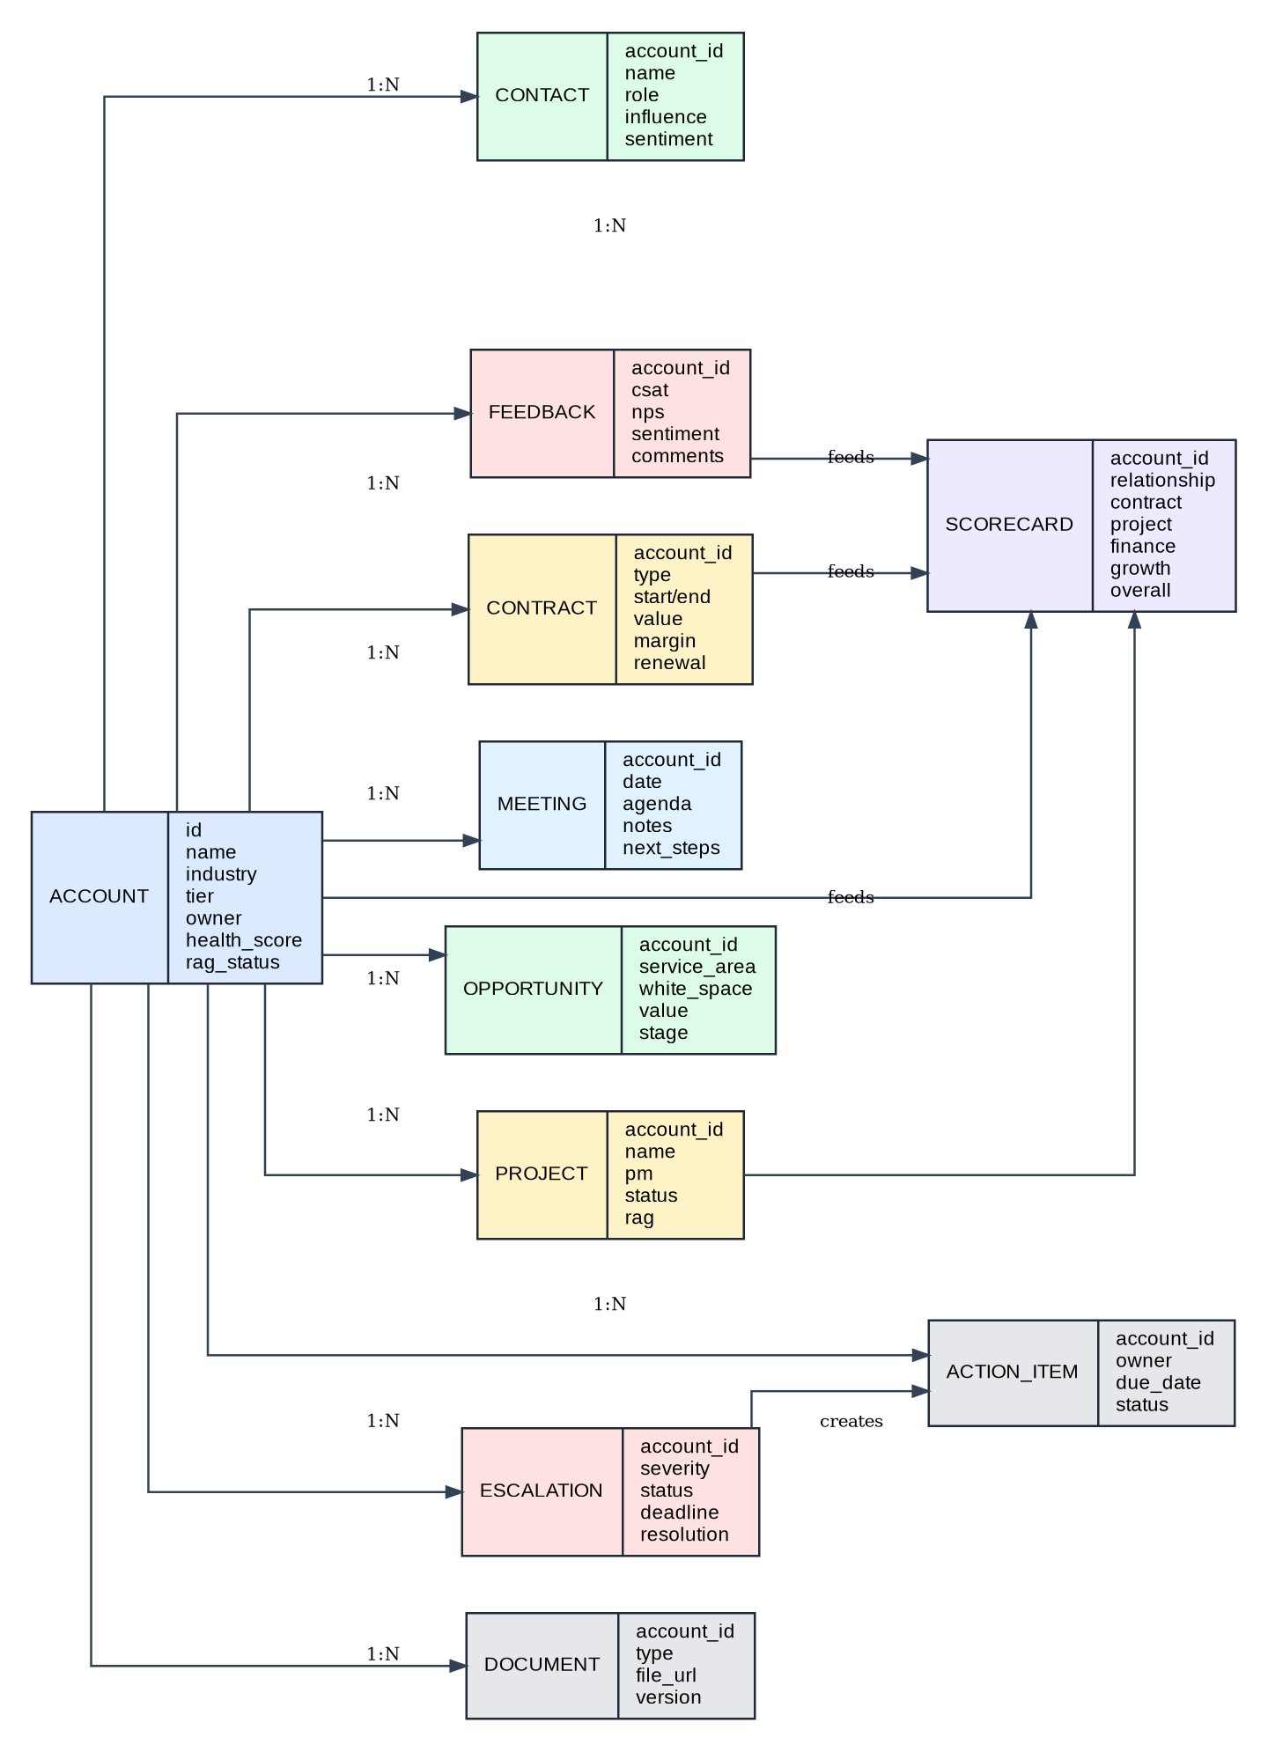
Figure 6: Recommended KAM Data Entity Model

Core Database Tables
users
roles
permissions
accounts
account_tiers
contacts
stakeholders
relationship_scores
client_business_profiles
industry_profiles
contracts
contract_scores
projects
project_health
financial_health
services
account_services
white_space_items
opportunities
meetings
meeting_notes
education_sessions
feedback
scorecards
escalations
escalation_actions
action_items
notifications
workflow_instances
workflow_steps
documents
audit_logs
system_configurations

Data Storage Responsibilities
Store | Purpose | Example Data
Operational Database | Primary transactional system of record. | Accounts, contacts, contracts, scores, projects, escalations, action items.
Document Storage | Large files and attachments. | Contracts, meeting minutes, QBR decks, proposals, feedback evidence.
Search Index | Fast text search across notes and documents. | Client notes, meeting notes, contract text, advisory history.
Immutable Audit Log | Tamper-resistant history of important changes. | Score changes, contract changes, escalation events, permission changes.
Cache | Performance optimization for frequent reads. | Dashboard summary data, account lists, configuration lookups.
Analytics Warehouse | Reporting, trends, forecasting, and BI integration. | Health trends, revenue trends, churn risk, growth pipeline, SLA compliance.

12. API and Application Layer Design
The backend should be modular and expose secure APIs through an API gateway or backend-for-frontend layer. APIs should validate requests, enforce authorization, write audit logs for sensitive actions, and emit events for asynchronous workflows such as score recalculation, notifications, and SLA timers.
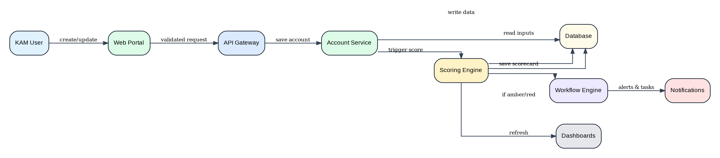
Figure 7: Typical System Workflow for Account Update and Score Recalculation

Recommended Backend Modules
/modules
/accounts
/contacts
/stakeholders
/client-intelligence
/relationship-scoring
/contract-scoring
/project-health
/financial-health
/white-space
/opportunities
/retention-growth
/education-history
/escalations
/feedback
/score-engine
/workflow
/notifications
/reports
/audit
/admin

Representative API Endpoints
Method | Endpoint | Purpose
POST | /accounts | Create a new account profile.
GET | /accounts/{id} | Retrieve Account 360 detail.
PUT | /accounts/{id} | Update account profile and trigger audit if required.
POST | /accounts/{id}/contacts | Add stakeholder/contact.
POST | /accounts/{id}/contracts | Add contract metadata.
POST | /accounts/{id}/projects | Add project or delivery information.
POST | /accounts/{id}/meetings | Log meeting and next actions.
POST | /accounts/{id}/feedback | Capture CSAT/NPS/sentiment.
GET | /accounts/{id}/scorecard | Retrieve latest scorecard.
POST | /accounts/{id}/recalculate-score | Force recalculation with authorized permission.
GET | /accounts/{id}/white-space | View white space matrix and opportunities.
POST | /accounts/{id}/opportunities | Create growth opportunity.
POST | /accounts/{id}/escalations | Create escalation and start 48-hour SLA.
PUT | /escalations/{id}/schedule-meeting | Record client meeting schedule and SLA status.
PUT | /escalations/{id}/resolve | Resolve escalation with closure details and feedback.
GET | /dashboards/leadership | Leadership portfolio dashboard.

13. Dashboards, Reporting, and Analytics

KAM Dashboard
- My key accounts, account health score, upcoming meetings, pending action items, open escalations, at-risk accounts.
- Contract renewal reminders, growth opportunities, missing client data, feedback follow-ups, and overdue actions.

Leadership Dashboard
- Total key accounts, revenue by account, account health distribution, Red/Amber/Green accounts, contract renewal pipeline.
- Client satisfaction trends, escalation volume, top growth opportunities, profitability by account, and account owner performance.

Client 360 Dashboard
- Account profile, stakeholder map, current projects, active contracts, revenue/margin, relationship score, project health, financial health.
- White space opportunities, client education/advisory history, escalation history, feedback history, and action items.

Analytics Metrics
Metric Category | Examples
Account Health | Overall score trend, RAG distribution, score changes by driver, at-risk accounts.
Relationship | Meeting frequency, stakeholder coverage, sentiment, cooperation level, executive sponsor coverage.
Commercial | Revenue, margin, contract value, renewal probability, payment aging, contract expiry.
Delivery | Project RAG, milestone status, defect trend, resource health, delivery satisfaction.
Growth | White space value, opportunity pipeline, service gaps, proposal conversion.
Escalation | Open escalations, SLA compliance, root causes, time to resolution, reopen rate.

14. Security, Access Control, Audit, and Compliance
Security must be designed into the platform from the beginning because the system will contain sensitive client, contract, financial, delivery, and escalation information. Access should be role-based, sensitive fields should be permission-controlled, and all important actions should be auditable.

Role-Based Access Control
Role | Access Scope
KAM / Account Manager | Manage assigned accounts, client info, meetings, feedback, white space, action items, and escalations.
Sales / Growth Head | View all accounts, approve growth plans, review pipeline, monitor health and retention.
Project Manager / Delivery Team | Update project health, risks, delivery status, resource health, and action items.
Finance | Update revenue, margin, billing status, payment health, and financial risk.
Legal / Contracts | Manage contract metadata, contract documents, renewal dates, and obligations.
Executive Sponsor / Leadership | View strategic accounts, escalations, score trends, account risks, and portfolio dashboards.
Admin | Manage users, roles, permissions, scoring rules, workflow templates, system configurations.
Client User - Optional | Limited portal access for feedback, meeting notes, action items, and agreed updates.

Security Requirements
- SSO login through enterprise identity provider, with MFA for admin and leadership roles.
- Role-based and account-level permissions, with field-level controls for finance and contract data.
- Encryption in transit and at rest for databases, documents, backups, and integration traffic.
- Audit logs for account changes, score changes, contract value changes, escalation events, feedback submissions, document uploads, permission changes, and imports.
- Input validation, secure file upload scanning, API rate limiting, session timeout, secure secrets management, and security monitoring.

Audit Log Events
Event Type | Audit Details to Store
Account update | User, timestamp, fields changed, old value, new value, reason if required.
Score change | Score version, inputs, old score, new score, trigger source, formula used.
Contract change | Contract field changed, old value, new value, approver if required.
Escalation event | Created, severity changed, meeting scheduled, SLA warning, action created, resolved, closed.
Feedback submission | Submitted by, source, score, sentiment, related account/project/contract.
Document upload | Document type, file name, version, uploader, account, linked entity.
Permission change | Role changed, permission changed, changed by, approval reference.
Excel import | Source file, import batch, row count, validation errors, approved by, import timestamp.

15. Integrations and Excel Migration

15.1 Integration Architecture
System | Integration Purpose | Data Direction
CRM / Sales Pipeline | Sync account pipeline, opportunity stage, sales activities, and growth opportunities. | Bi-directional or CRM to KAM depending on ownership.
Project Tools - Jira / Azure DevOps | Pull project status, milestones, delivery risks, and health signals. | Project tool to KAM.
Finance / ERP / Billing | Pull revenue, invoice aging, payment health, contract value, and margin data. | ERP to KAM, with controlled write-back if needed.
HR / Resource Management | Pull resource allocation, role coverage, availability, and resource risk. | HR/resource system to KAM.
Email / Calendar / Teams / Slack | Meeting reminders, SLA alerts, notification delivery, and communication tracking. | Bi-directional for events/notifications.
E-signature / Contract Repository | Sync contract documents and signed contract metadata. | Contract system to KAM.
Survey / Feedback Tool | Capture CSAT/NPS and client feedback. | Survey tool to KAM.
BI Platform - Power BI / Tableau / Looker | Portfolio dashboards, score trends, revenue analytics, risk reporting. | KAM warehouse to BI.

15.2 Excel Migration Architecture
The existing Excel sheets should not be imported directly into production tables. A controlled migration process should use staging tables, validation rules, duplicate detection, manual review, approved import, score recalculation, and audit logs.
Figure 8: Controlled Excel Migration Architecture

Migration Rules
- Import every Excel file into staging tables first; never write directly to production tables.
- Define column mapping from current Excel templates to target data model fields.
- Validate required fields such as account name, owner, tier, stakeholder, contract, score inputs, and status values.
- Detect duplicate clients, contacts, contracts, and projects before approval.
- Preserve the original Excel files as archived evidence and attach them to the import batch record.
- Maintain import audit logs with source file, row counts, errors, skipped rows, approved by, and import timestamp.
- Recalculate scores after approved import and flag accounts with missing mandatory data.

16. Deployment Architecture and DevOps
The system should use separate development, test, staging, and production environments. Deployment should be automated through CI/CD with build, test, security scan, artifact creation, environment-specific configuration, database migration, and rollback capability.
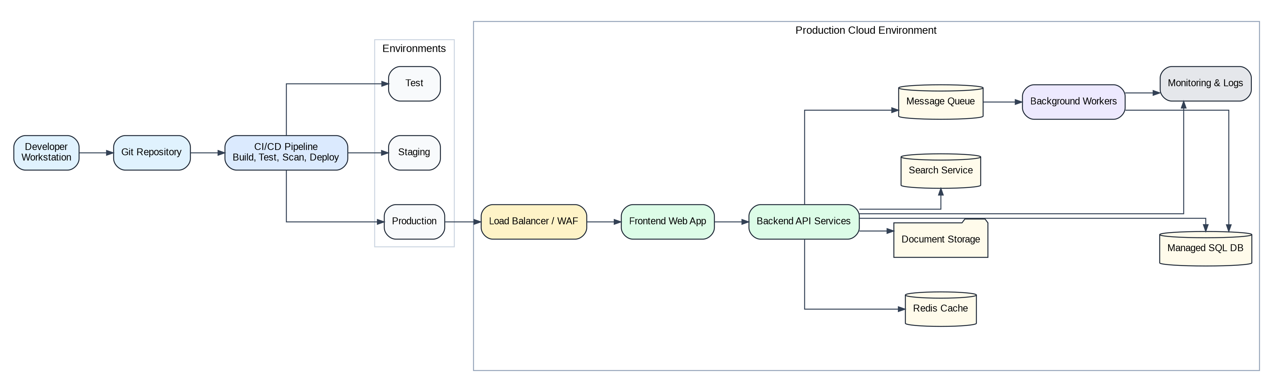
Figure 9: Recommended Deployment Architecture

Recommended Technology Stack
Layer | Recommended Options
Frontend | React.js or Next.js, TypeScript, Material UI or Ant Design, charting library such as Recharts/ECharts.
Backend | Node.js with NestJS, .NET Core, or Java Spring Boot.
Database | PostgreSQL or SQL Server for transactional data; Redis for caching; OpenSearch/Elasticsearch for search.
Documents | Object storage for contracts, meeting minutes, proposals, QBR decks, and attachments.
Integration | REST APIs, webhooks, scheduled jobs, ETL, and message queue/event bus.
Analytics | Analytics warehouse or BI mart integrated with Power BI, Tableau, or Looker.
Infrastructure | Docker, container platform/Kubernetes/container apps, managed database, managed storage, centralized logging, monitoring, and alerting.

CI/CD Controls
- Automated unit tests, integration tests, linting, type checks, and build validation.
- Static security checks, dependency vulnerability scanning, and secrets scanning.
- Database migration review and rollback plan.
- Manual approval gate for production deployments.
- Automated smoke tests after deployment and rollback procedure if health checks fail.

17. Non-Functional Requirements
Category | Requirement
Performance | Dashboard load under 3 seconds for common views; Account 360 under 2 seconds for typical data volume; search under 1 second for common queries.
Scalability | Support increasing accounts, contacts, projects, contracts, attachments, score history, and dashboard usage without redesign.
Availability | Daily backups, point-in-time database recovery, monitored production environment, and disaster recovery plan.
Reliability | Asynchronous score recalculation, retry policies for integrations, queue-backed notifications, and workflow recovery.
Security | SSO, MFA, RBAC, field-level permissions, encryption, audit logs, secure uploads, session timeout, and rate limiting.
Auditability | Every sensitive action must record who changed what, when, from where, and why if reason is required.
Maintainability | Modular codebase, documented APIs, configuration-driven scoring, reusable workflow templates, and automated tests.
Usability | Simple account search, intuitive Account 360 layout, clear score indicators, action-focused dashboards, and minimal manual duplication.
Data Quality | Mandatory fields, validation rules, duplicate detection, score input completeness, and data freshness indicators.

18. MVP Scope and Implementation Roadmap

Recommended MVP Scope
- Login, SSO readiness, roles, permissions, and admin user management.
- Account 360 with client information, industry/business profile, stakeholder management, and meeting history.
- Relationship scoring, contract scoring, project health/RAG, financial health, and central scorecard.
- White space analysis and opportunity tracking.
- Escalation management with automated 48-hour meeting SLA, alerts, action items, and closure feedback.
- KAM dashboard, leadership dashboard, Account 360 dashboard, and basic reports.
- Excel import with staging, validation, duplicate detection, review, approval, and audit logs.
- Document upload for contracts, meeting notes, and supporting attachments.

Phase 2 Scope
- Optional client portal for feedback, meeting notes, agreed action items, and selected updates.
- CRM integration, finance/ERP integration, HR/resource integration, project tool integration, and survey tool integration.
- Advanced analytics, risk prediction, renewal forecasting, churn indicators, and growth recommendation engine.
- Automated QBR/MBR generation using stored account, project, score, and growth data.
- Workflow template library, configurable approval matrix, and advanced audit analytics.

Suggested Delivery Plan
Phase | Duration | Deliverables
Discovery and Design | 2-3 weeks | Finalize requirements, data model, scoring rules, roles, UI wireframes, migration mapping, and architecture.
MVP Build Sprint 1 | 3-4 weeks | Authentication, roles, Account 360, contacts/stakeholders, meetings, documents.
MVP Build Sprint 2 | 3-4 weeks | Scoring engine, contract scoring, project health, financial health, scorecard dashboard.
MVP Build Sprint 3 | 3-4 weeks | White space, opportunities, retention/growth planning, escalation SLA, action items, notifications.
Migration and UAT | 2-3 weeks | Excel import, data validation, duplicate review, UAT fixes, training, go-live readiness.
Go-Live and Stabilization | 2 weeks | Production release, monitoring, support, adoption tracking, backlog prioritization.

19. Appendices

Appendix A: Sample Relationship Score
Relationship Factor | Score Contribution
Decision maker identified | 10
Multiple stakeholder relationships exist | 15
Executive connection exists | 20
Client sentiment is positive | 20
Regular meetings are happening | 20
No single-person dependency | 15
Total | 100

Appendix B: Sample Notification Rules
Trigger | Notification / Action
No meeting in last 30 days | Notify KAM and create follow-up task.
Contract expiring in 90 days | Notify KAM, Sales Head, and Legal/Contracts.
Account score drops below 70 | Notify KAM and create action item.
Account score drops below 55 | Notify KAM and leadership; require mitigation plan.
Escalation created | Notify KAM, PM, and executive sponsor; start 48-hour meeting SLA.
Escalation meeting not scheduled after 24 hours | Send warning alert to owner.
Escalation meeting not scheduled after 40 hours | Send leadership alert.
Feedback score below threshold | Create improvement action and notify owner.
Project health turns Red | Notify KAM, PM, and leadership.

Appendix C: Glossary
Term | Meaning
KAM | Key Account Management.
Account 360 | A consolidated account profile covering client, relationship, contract, delivery, financial, growth, and risk information.
RAG | Red, Amber, Green status indicator for health and risk.
White Space | Potential products/services that can be sold to the client but are not currently provided.
CSAT | Customer Satisfaction score.
NPS | Net Promoter Score.
SWOT | Strengths, Weaknesses, Opportunities, and Threats analysis.
SLA | Service Level Agreement; in this process, escalation client meeting must be arranged within 48 hours.
RBAC | Role-Based Access Control.
ABAC | Attribute-Based Access Control.

Appendix D: External Reference Points
The following public frameworks and product concepts can be used as reference points during detailed design. They are included for architectural alignment and should be validated against internal company standards before implementation.
Reference | Use in This Architecture
Salesforce Account Plans overview | Supports the idea of account KPIs, customer needs, measurable objectives, and relationship mapping as part of account planning.
OWASP Application Security Verification Standard and Logging guidance | Reference for secure application design, application logging, and audit event planning.
NIST Cybersecurity Framework 2.0 | Reference for cybersecurity governance, identification, protection, detection, response, and recovery practices.
Azure/AWS Well-Architected guidance | Reference for security, reliability, operational excellence, performance efficiency, and cost optimization.

Final Architecture Summary
The recommended KAM system should be implemented as a modular internal web platform that keeps the current six-step business process but adds governance, scoring consistency, workflow automation, centralized data, and leadership visibility.
Frontend Portal and Dashboards
-> API Gateway + SSO + RBAC
-> Core KAM Business Services
-> Central Scoring Engine
-> Workflow + Notification Engine
-> Operational Database + Documents + Audit Logs
-> Analytics Warehouse + BI Dashboards
-> External Integrations
This architecture provides a clear path from Excel-based account tracking to a scalable, auditable, integrated KAM platform that supports retention, growth, delivery health, contract health, financial health, client education, and rapid escalation recovery.

