Intelligent Research Assistant

1. Introduction
In the current competitive academic world, scholars are overwhelmed with the published literature in various fields. There is a long and redundant process of identifying the research paper that is relevant and of high quality that proves to distract the researcher form proper analysis and innovations. The process of manual searching, filtering and structuring academic papers creates inefficiencies and chances of overlooking significant studies.
This project was known as Intelligent Research Assistant which helps in solving these problems by creating a system that is automated and which helps the researchers to store, clean and retrieve academic research paper in an efficient manner. The system combines the use of the Semantic Scholar API to receive scholarly metadata and the systematic data cleaning algorithm to filter the results in a fine and reuseable format. During implementation, the system records the logs in detail to ensure that it is transparent, traceable and capable of being demonstrated.
Ensuring high levels of modularity, automation, data quality, and verification are major aspects of the design of the project. Offloading a considerable amount of manual workload traditionally involved in academic research discovery, the Intelligent Research Assistant amplifies both retrieval, cleaning, and storage in addition to testing in a part of one workflow.

2. Project Goal and Objectives

The main aim of the given project is to help the researchers rapidly obtain the appropriate scholarly publications with the minimum amount of manual work. Instead of taking time and searching databases manually and studying hundreds of results, researchers need to trust an automated pipeline that takes care of these tasks in a consistently and efficient way. In order to fulfill this overall objective, a number of objectives were identified:

- The system automates finding academic articles through Semantic Scholar API to get access to valid scholarly metadata including titles, authors, abstracts, and years of publication, and URLs. Automation will remove manual searching that does not give any value and enhance consistency.
- The system utilizes data cleaning and filtering methods to eliminate poor quality/complete entries. Papers without abstracts are filtered out and duplicate records are filtered as well as the user can also filter based on year say latest publications or relevant publications.
- The resulting cleaned data will be stored in an organized CSV format, so it can be inspected easily, shared, and also analyzed through spreadsheets, either with writing programs or analysis pipelines.
- The system also produces a vivid visibility of the execution by informative messages of logging at every key step. These logs aid in debugging, verification, demos in academics and collection of evidence to be used in the assessment.
The combination of these objectives will guarantee that the Intelligent Research Assistant makes research more efficient, more reliable in terms of data, and replicable.

3. Design and System Architecture

The Intelligent Research Assistant is designed along the modular architecture, which makes the matter more open, maintainable, and scalable. All system components have specialized tasks to achieve and modules connect based on well-established data streams. On the interface side of the system, the Query Builder will receive the user input and authenticate the research topic. This module makes sure that the invalid, empty, or malformed inputs are not transferred downstream.

When the query is created, it is sent to SemanticScholarRetriever module which links to Semantic Scholar API. The module processes HTTP requests and retrieves academic papers and can handle potential failures like network issues or API rate limits to attempt a re-run with the help of the retry mechanism.
The DataCleaner module then processes the retrieved non-formatted raw data by imposing quality control. This module eliminates the redundancies on basis of paper titles, eliminates papers that do not contain abstracts and may filter results according to publication year.
Lastly, the cleaned data is sent to the DataStorage module that stores the results in a CSV file in a formatted output folder. Sample records are also printed to the terminal by this module and enable one to check the processed data immediately. This modular design guarantees isolation of concerns which means that the system is easy to test, debug and scale in the future.
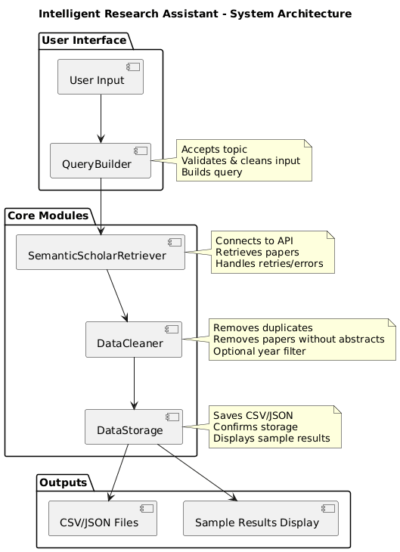
Figure 1: System Architecture

4. Querybuilder - Input Checking and the Query Building

The QueryBuilder module forms the beginning of the system working processes. It takes the task of accepting the research topic in the user and makes sure that the input is valid to go on. Input validation is a very important process as APIs require the structured and meaningful queries. The API can fail, call the API multiple times, or give false data in case of invalid input (e.g. empty strings or uncharacterised characters), which is being sent to the API. The system eliminates unnecessary failures as it checks the topic at its earliest stages and enhances reliability.

When confirmed to be good, the input is normed and converted into a structured query format, which can be used at the Semantic Scholar API. The ordered method guarantees the uniformity of retrieval and foreseeable outcomes.

The fact that QueryBuilder module enforces correctness at the system boundary exhibits good software engineering because there is always the assurance that the downstream modules will always receive valid input.
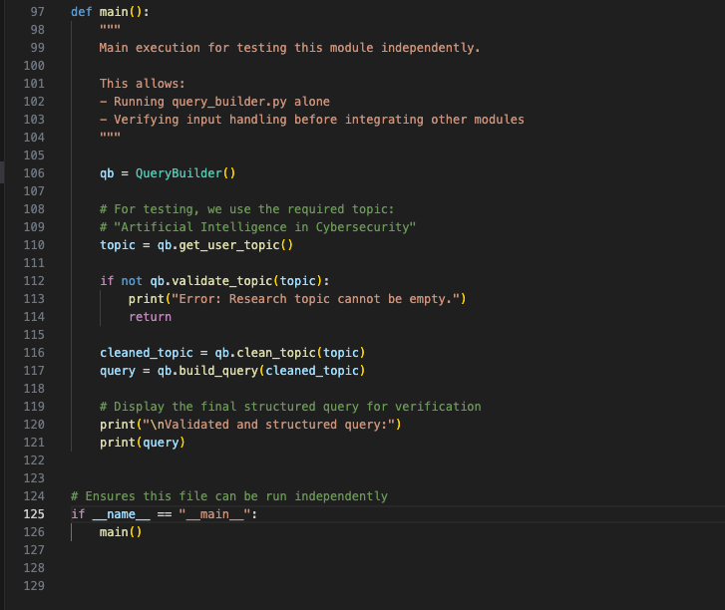
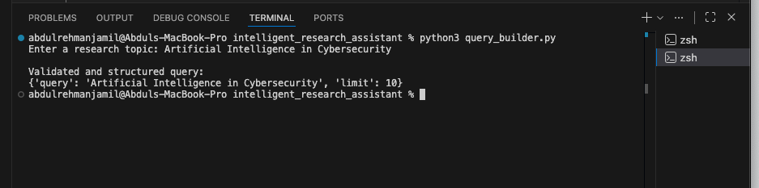
Figure 2: Input Checking and the Query Building

5. Semantic Scholar API Retrieval
The academic papers serving as the primary data source of the system are using Semantic Scholar API. Semantic Scholar was selected, as it is free of charge and allows access to high-quality academic metadata without any form of authentication, thus making it appropriate in terms of academic projects and demonstrations. Retrieval module also makes structured queries to the API and requests certain fields such as the paper title, authors, abstract, year of publication, and URL. This is selective retrieval so as to be efficient and relevant.

To make it even stronger, the module will have logic to support network errors and API rate limiting. In failure cases of a request then the retry is used to provide continuity. This stability is more particularly critical when proving the system or executing batch queries. The system is flexible by making the API interactions abstract and thus modifiable to alternative data sources in future developments.
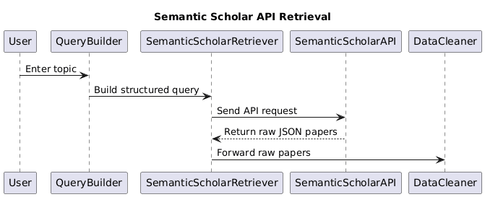

Figure 3: Semantic Scholar API Retrieval Flowchart

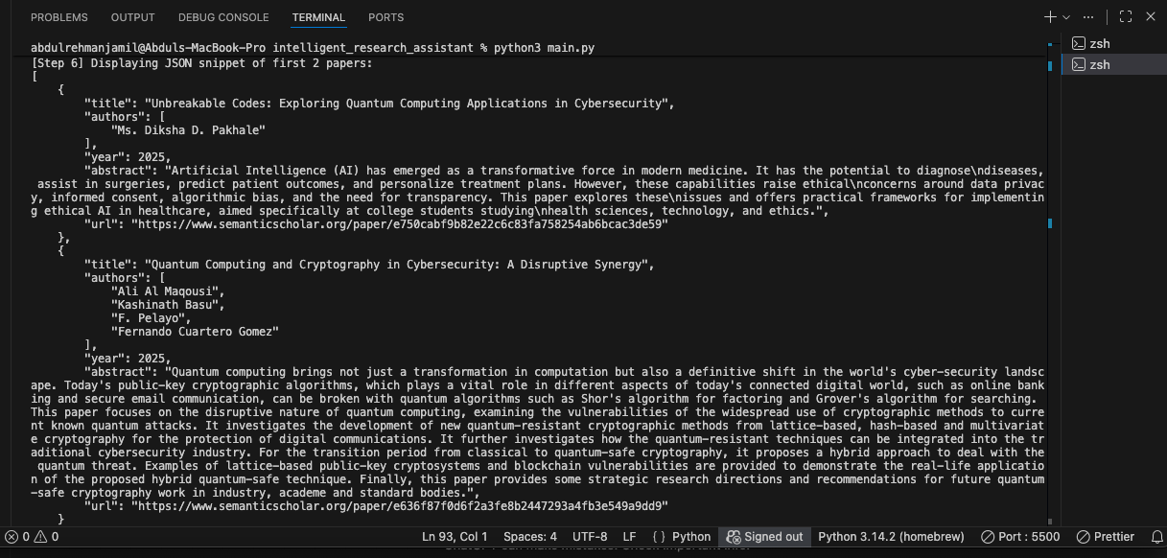

Figure 4: Semantic Scholar API Retrieval Output in JSON Format

6. Data Cleaning and the Quality Assurance

Raw academic information may be full of duplications, missing information or irrelevant information. Thus, intelligent research assistant is an important element of data cleaning.

- There are quality assurance steps that are implemented by the DataCleaner module. First, it allows eliminating papers that lack abstracts. This is because abstracts do create an awareness of how relevant and contributing a paper is and without them the value of research would greatly be impaired.
- Second, duplicate entries are removed in the module through comparison of paper titles. Removal of duplicates makes sure that there are no duplications within the final dataset and the information is much more understandable and useful.
- Third, users can also use optional filtering by the publication year (to see recent or time-specific trends of research). The given feature is especially helpful in rapidly advancing areas like cybersecurity and artificial intelligence.

With such procedures, the DataCleaner module guarantees that the ultimate data set is concise, relevant and can be used in academics.

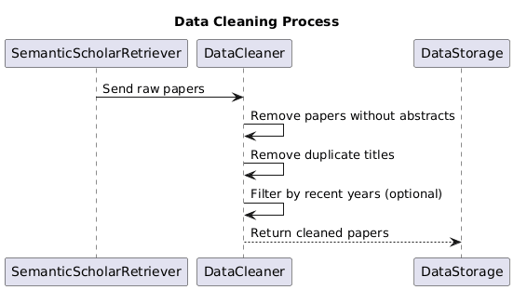

Figure 5: Data Cleaning and the Quality Assurance Process

7. Output Management and the Data storage

The data being processed is sent to DataStorage module after cleaning. It is a module that stores the results in the form of structured and accessible data. CSV (Comma-Separated Values) is the storage format that is used by the project. CSV is easily readable by humans, is broadly supported and can be simply imported into web applications like Excel, Python, and R, and even data visualization software. This option is in concurrence with the intention of maximization of usability and accessibility.
The DataStorage module will create an output directory automatically in the event that it does not exist. The files are put in case of the research topic hence logical arrangement and traceability. The module further displays a preview of the initial few rows of the dataset as a preview on the terminal. This feedback is instant and it tells that the storage has been successful and the user can check the output without opening the file by herself. This structured storage will ensure research data can be analyzed, shared or otherwise presented.
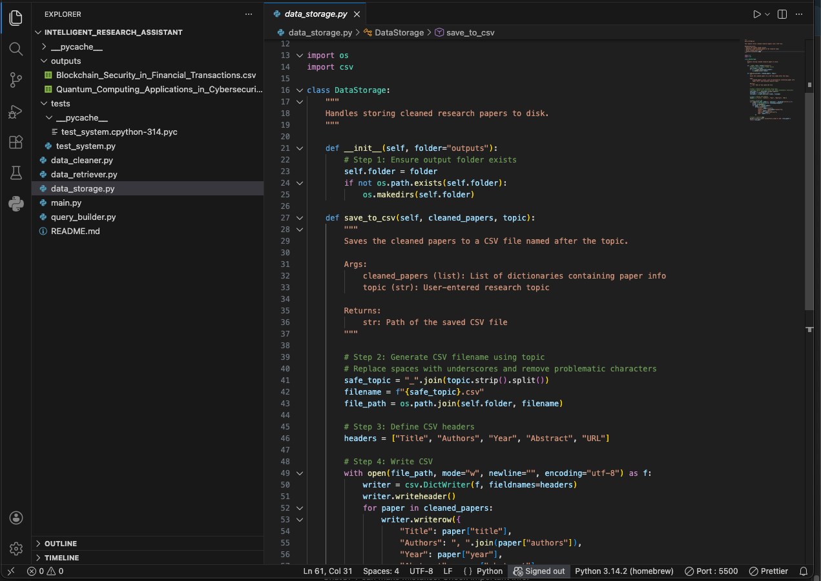
Figure 6: Data Storage Function

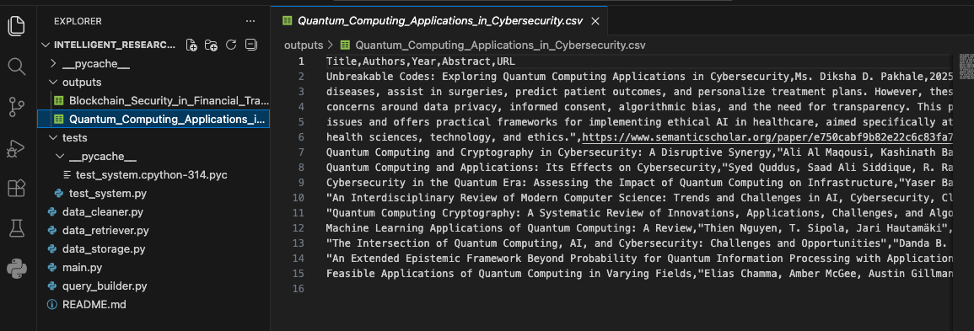
Figure 7: Generated CSV File Output

8. Unit Testing/ Verification

Unit testing was used to test the system to guarantee the reliability of the system and its accuracy to meet values supplied by Python as an unittest framework. Testing can be of importance when it is used in order to validate individual modules as well as to prove this robustness.

- QueryBuilder module is tested up so that it properly validates input and builds queries. None of the invalid inputs are accepted and downward errors avoided.
- DataCleaner module is checked with the help of real retrieved papers to ensure that copies and unfinished records are cleared properly. Real-life testing enhances the confidence of the system on the real world applicability.
- The DataStorage module is tested to ensure that the CSV files are properly generated, they are stored in the desired directory, and to ensure that they hold the cleaned data precisely.
The terminal output of the tests running indicated that all tests were successful, which is a good indication that the system works as expected. The strategy of this testing guarantees academic credibility, maintainability, and reliability.
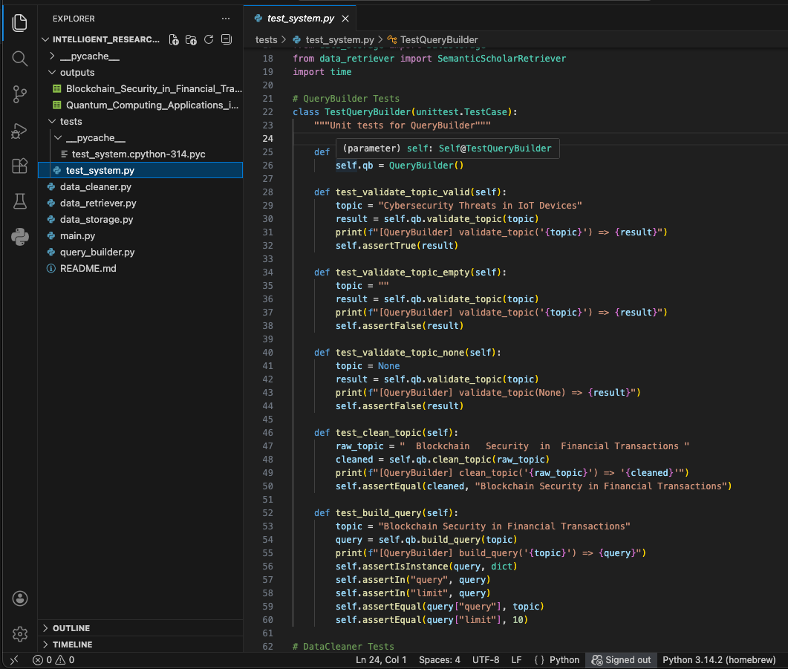
Figure 8: Unit Testing and Verification Code

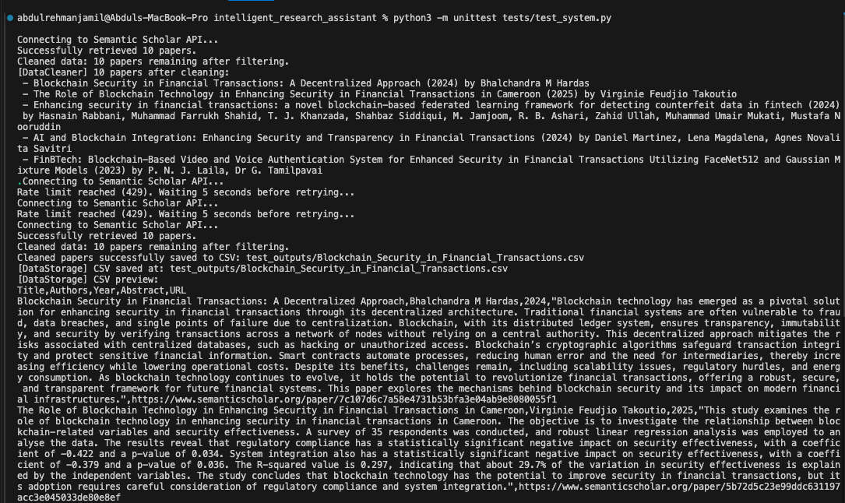
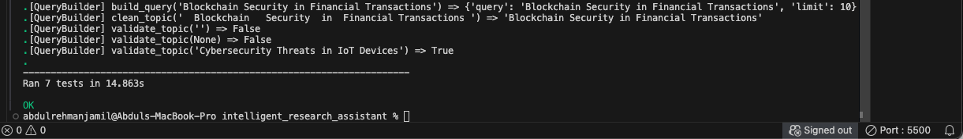
Figure 9: Unit Testing and Verification in Terminal

9. Demonstration and Performance Test Evidence

The system demonstration offers practical facts of accurate implementation and operations. Once the program has been executed in the terminal, it will ask the user to input a research topic. The input is tested and a formulated query is created.

Semantic Scholar API searches and retrieves a list of papers according to the topic. Informational log messages are used to show the amount of papers that were fetched and the status of each processing task. Once it has been cleaned, the system notifies the number of papers that will be left after the duplicate and abstract-based filtering. The data after cleaning is saved into the output directory as a CSV file. Only the first few modified papers appear on the preview in the terminal with titles, authors, publication year, abstracts and URLs. Furthermore, the results of unit test execution indicate that every test is successful. These deliverables can be used as evidence of execution, which satisfies the assessment needs and provides end-to-end functionality.
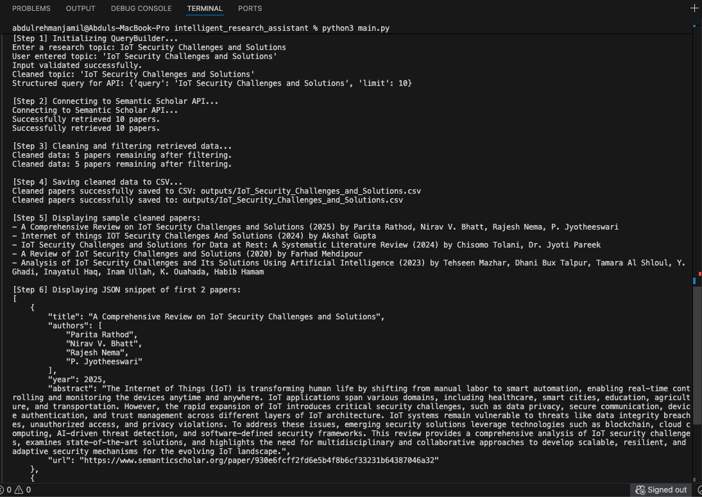
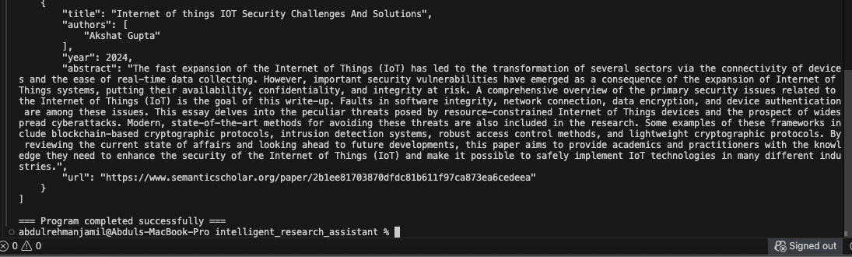
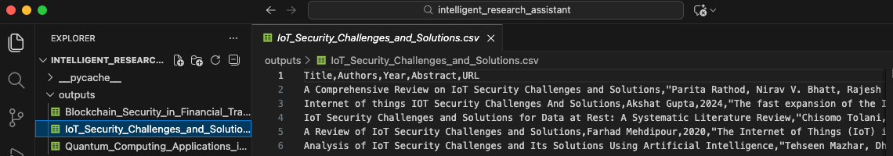
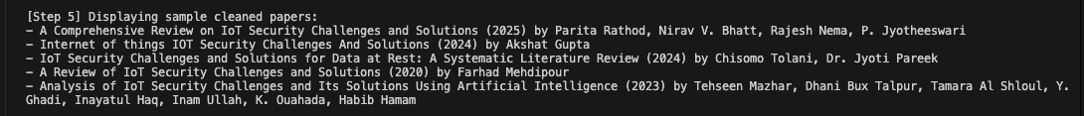
Figure 10: Full System Output in Terminal

10. Conclusion and References

The Intelligent Research Assistant has been able to illustrate that automation can help in streamlining academic research processes. The system can lower the amount of manual work in data retrieval, clean-up, and storage with the addition of automated retrieval, systematic data cleaning, structured data storage, and extensive testing to increase the data quality and reliability. The major learning outcomes of this project are the design of modular software, integration of API, management of data quality, execution visibility logging, and the use of real data to test units. The project also supports the best practices in academic integrity by relying on credible sources of data as well as its clean and original implementation.

It can be improved in the future by adding support of other academic APIs, better relevance ranking, natural language processing to summarise abstracts, and user interface rebuilt into a graphical interface to enhance usability.

References
- Semanticscholar.org. (2026). Semantic Scholar - Academic Graph API. [online] Available at: https://api.semanticscholar.org/api-docs/ [Accessed 16 Jan. 2026].
- Tutorial | Semantic Scholar Academic Graph API. (2018). Semanticscholar.org. https://www.semanticscholar.org/product/api%2Ftutorial
- Python. (n.d.). unittest — Unit testing framework — Python 3.8.2 documentation. Docs.python.org. https://docs.python.org/3/library/unittest.html

