Algorithm for 4-Connected Boundary Fill Program
- Start the program.
- Initialize the graphics mode using initgraph().
- Draw a closed figure (circle) on the screen using the circle() function.
- Select a seed point (x, y) inside the figure.
- Define:
• Fill color (fill_color)
• Boundary color (boundary_color)
- Call the function boundaryFill4(x, y, fill_color, boundary_color).
- Inside the boundaryFill4() function:
• Read the color of the current pixel using getpixel(x, y).
- Check whether the current pixel color is:
• not equal to the boundary color
• and not equal to the fill color
- If the condition is true:
• Fill the current pixel using putpixel(x, y, fill_color).
- Recursively apply the boundary fill function for four neighboring pixels:
• Right pixel → (x + 1, y)
• Top pixel → (x, y + 1)
• Left pixel → (x - 1, y)
• Bottom pixel → (x, y - 1)
- Repeat the process until all interior pixels are filled and the boundary color is reached.
- Display the filled figure.
- Close the graphics mode using closegraph().
- Stop the program.
Code for 4-Connected Boundary Fill Program
#include <graphics.h>
#include <iostream>
#include <conio.h>
using namespace std;
// Function for 4-connected pixels
void boundaryFill4(int x, int y, int fill_color, int boundary_color){
int current = getpixel(x, y);
if (current != boundary_color && current != fill_color) {
putpixel(x, y, fill_color);
delay(5);
boundaryFill4(x + 1, y, fill_color, boundary_color);
boundaryFill4(x, y + 1, fill_color, boundary_color);
boundaryFill4(x - 1, y, fill_color, boundary_color);
boundaryFill4(x, y - 1, fill_color, boundary_color);
}
}

int main(){
int gd = DETECT, gm;
initgraph(&gd, &gm, "..\\bgi");

int x = 250, y = 200, radius = 50;
// Draw boundary (circle outline)
circle(x, y, radius);
// Call boundary fill
boundaryFill4(x, y, YELLOW, WHITE);
cout << "Boundary Fill Algorithm applied inside circle." << endl;
getch();
closegraph();
return 0;
}
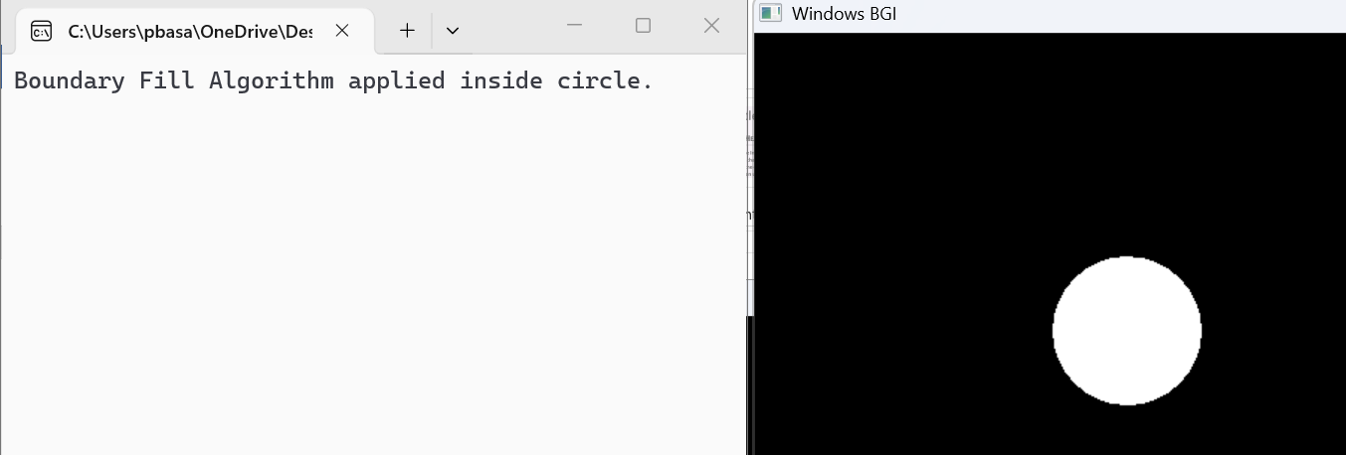
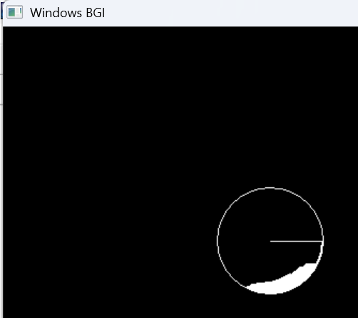
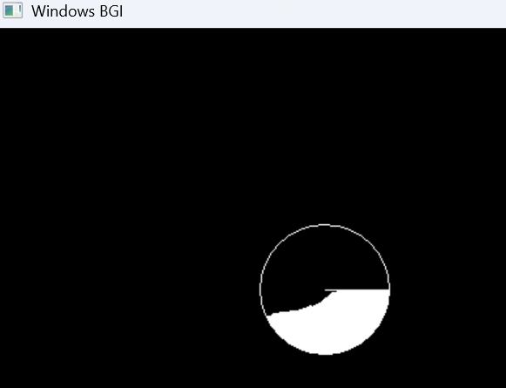
Output

Algorithm for 8-Connected Boundary Fill Program
- Start the program.
- Initialize the graphics mode using initgraph().
- Draw a closed figure (such as a rectangle or circle) on the screen.
- Select a seed point (x, y) inside the figure.
- Define:
• Fill color (fill_color)
• Boundary color (boundary_color)
- Call the function:
BoundaryFill8(x,y,fill_color,boundary_color)
- Inside the BoundaryFill8() function:
• Read the current color of pixel (x, y) using getpixel(x, y).
- Check whether the current pixel color is:
• not equal to the boundary color
• and not equal to the fill color
- If the condition is true:
• Fill the current pixel using putpixel(x, y, fill_color).
- Recursively apply the boundary fill function for eight neighboring pixels:
• Right → (x + 1, y)
• Left → (x - 1, y)
• Top → (x, y + 1)
• Bottom → (x, y - 1)
• Top Right → (x + 1, y + 1)
• Top Left → (x - 1, y + 1)
• Bottom Right → (x + 1, y - 1)
• Bottom Left → (x - 1, y - 1)
Neighbor Representation
(x+1,y), (x−1,y), (x,y+1), (x,y−1), (x+1,y+1), (x−1,y+1), (x+1,y−1), (x−1,y−1)
- Repeat the process until the boundary color is reached.
- Display the filled figure.
- Close the graphics mode using closegraph().
- Stop the program.
Code for 8-Connected Boundary Fill Program
#include <graphics.h>
#include <conio.h>
#include <iostream>
using namespace std; // Function for 8-connected boundary fill
void boundaryFill8(int x, int y, int fill_color, int boundary_color){
int current = getpixel(x, y); // Check whether current pixel is boundary color or
if(current != boundary_color && current != fill_color){ // Fill the pixel
putpixel(x, y, fill_color);
delay(5); // Recursive calls for 8 neighboring pixels
boundaryFill8(x + 1, y, fill_color, boundary_color); // Right
boundaryFill8(x - 1, y, fill_color, boundary_color); // Left
boundaryFill8(x, y + 1, fill_color, boundary_color); // Top
boundaryFill8(x, y - 1, fill_color, boundary_color); // Bottom
boundaryFill8(x + 1, y + 1, fill_color, boundary_color);// Top Right
boundaryFill8(x - 1, y + 1, fill_color, boundary_color);// Top Left
boundaryFill8(x + 1, y - 1, fill_color, boundary_color);// Bottom Right
boundaryFill8(x - 1, y - 1, fill_color, boundary_color);// Bottom Left
}
}
int main(){
int gd = DETECT, gm; // Initialize graphics mode
initgraph(&gd, &gm, "..\\bgi"); // Draw rectangle boundary
rectangle(50, 50, 200, 200);
boundaryFill8(100, 100, YELLOW, WHITE); // Apply 8-connected boundary
cout << "8-Connected Boundary Fill Applied." << endl;
getch(); // Close graphics mode
closegraph();
return 0;
}
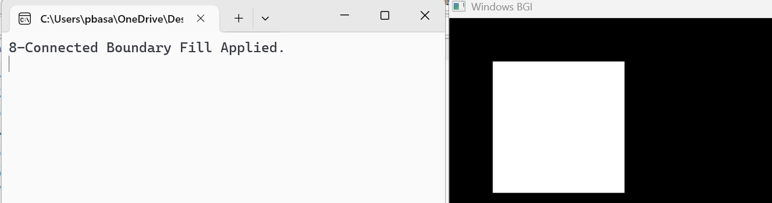
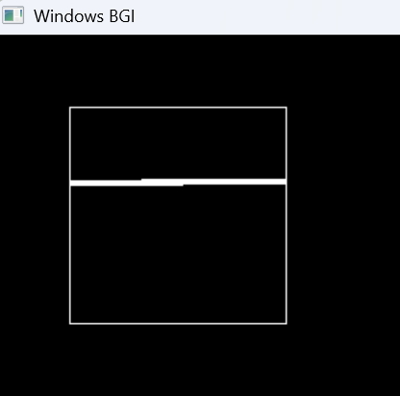
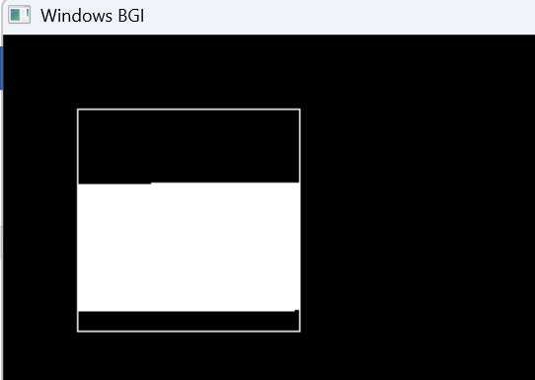
Output
Algorithm for 4-Connected Flood Fill Program
- Start the program.
- Initialize the graphics mode.
- Draw a closed figure or boundary on the screen.
- Select a seed point (x, y) inside the figure.
- Get the old color of the selected pixel.
- Choose the new fill color.
- Check the color of the current pixel:
•If the current pixel color is equal to the old color, then:
•Change the pixel color to the new color.
•Recursively apply Flood Fill to:
•Right pixel (x+1, y)
•Left pixel (x-1, y)
•Upper pixel (x, y-1)
•Lower pixel (x, y+1)
- Repeat the process until all connected pixels of the old color are filled.
- Display the filled figure on the screen.
- Stop the program.
Code for 4-Connected Flood Fill Program
#include <graphics.h>
#include <conio.h>
// 4-connected Boundary Fill
void boundaryFill4(int x, int y, int fill_color, int boundary_color){
int current = getpixel(x, y);
if (current != boundary_color && current != fill_color){
putpixel(x, y, fill_color);// Only 4 directions
boundaryFill4(x + 1, y, fill_color, boundary_color);
boundaryFill4(x - 1, y, fill_color, boundary_color);
boundaryFill4(x, y + 1, fill_color, boundary_color);
boundaryFill4(x, y - 1, fill_color, boundary_color);
}
}
int main(){
int gd = DETECT, gm;
initgraph(&gd, &gm, "C:\\Turboc3\\BGI"); // Set boundary color
setcolor(WHITE); // Draw circle
circle(250, 250, 100); // Fill inside the circle
boundaryFill4(250, 250, RED, WHITE);
getch();
closegraph();
return 0;
}
Output
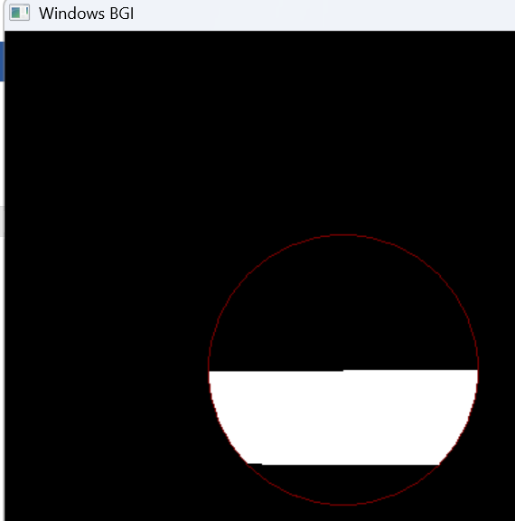
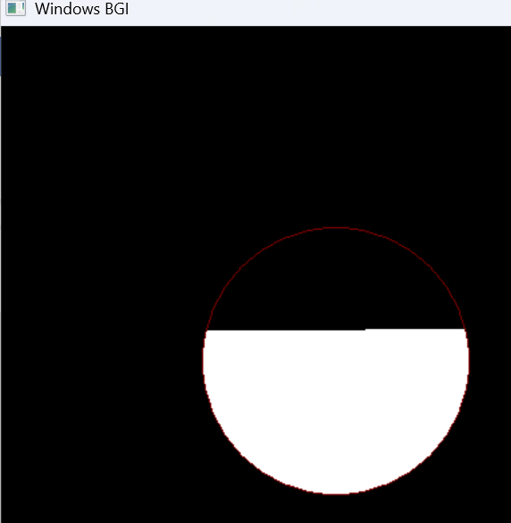
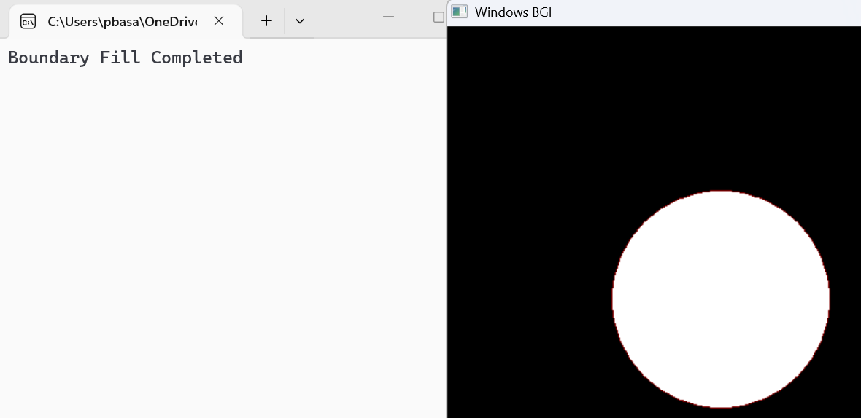

Algorithm for 8-Connected Flood Fill Program
- Start the program.
- Initialize the graphics mode.
- Draw a closed figure or boundary.
- Select a seed point (x, y) inside the figure.
- Get the old color of the selected pixel.
- Choose the new fill color.
- Check whether the current pixel color is equal to the old color:
•If yes:
•Change the current pixel color to the new color.
•Recursively apply Flood Fill to all 8 neighboring pixels:
•Right (x+1, y)
•Left (x-1, y)
•Up (x, y-1)
•Down (x, y+1)
•Top-left (x-1, y-1)
•Top-right (x+1, y-1)
•Bottom-left (x-1, y+1)
•Bottom-right (x+1, y+1)
- Repeat the process until all connected pixels are filled.
- Display the filled figure.
- Stop the program.
Code for 8-Connected Flood Fill Program
#include <graphics.h>
#include <conio.h>

void floodFill8(int x, int y, int oldColor, int newColor){
if (getpixel(x, y) == oldColor){
putpixel(x, y, newColor); // 8 connected neighbors
floodFill8(x + 1, y, oldColor, newColor); // Right
floodFill8(x - 1, y, oldColor, newColor); // Left
floodFill8(x, y + 1, oldColor, newColor); // Down
floodFill8(x, y - 1, oldColor, newColor); // Up
floodFill8(x + 1, y + 1, oldColor, newColor); // Bottom Right
floodFill8(x - 1, y - 1, oldColor, newColor); // Top Left
floodFill8(x + 1, y - 1, oldColor, newColor); // Top Right
floodFill8(x - 1, y + 1, oldColor, newColor); // Bottom Left
}
}
int main(){
int gd = DETECT, gm;
initgraph(&gd, &gm, "C:\\Turboc3\\BGI"); // Draw rectangle
rectangle(150, 150, 300, 300); // Apply flood fill
floodFill8(200, 200, BLACK, WHITE);
getch();
closegraph();
return 0;
}
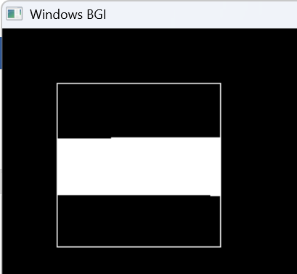
Output
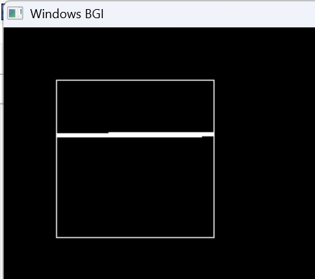
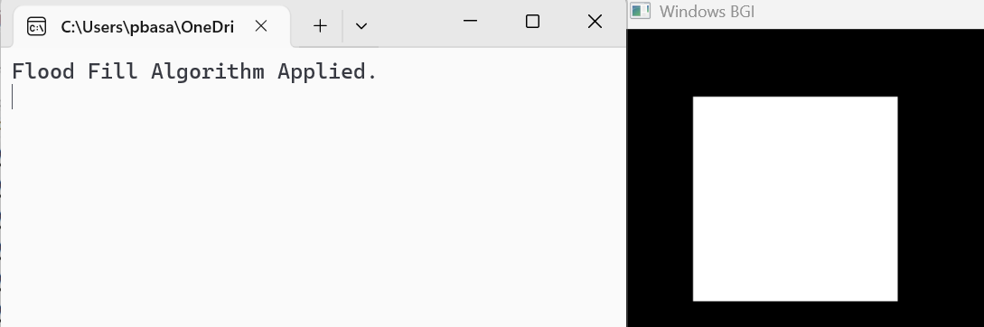

Algorithm for 2D Transformation (2D Translation)
- Start the program.
- Input the coordinates of the object points (x, y).
- Input translation distances tx and ty.
- Apply translation formula:
x′=x+tx ​, y′=y+t
- Calculate new coordinates (x', y').
- Draw the original object.
- Draw the translated object using new coordinates.
- Stop the program.

Code for 2D Transformation (2D Translation)
#include <graphics.h>
#include <iostream>
#include <conio.h>
using namespace std;
int main(){
int gd = DETECT, gm;
initgraph(&gd, &gm, "C:\\Turboc3\\BGI"); // Original rectangle coordinates
int x1 = 100, y1 = 100, x2 = 200, y2 = 200; // Translation factors
int tx = 150, ty = 100; // Draw original object
setcolor(WHITE);
rectangle(x1, y1, x2, y2);
outtextxy(110, 80, "Before Translation"); // Draw translated object
setcolor(WHITE);
rectangle(x1 + tx, y1 + ty, x2 + tx, y2 + ty);
Output

outtextxy(250, 180, "After Translation");
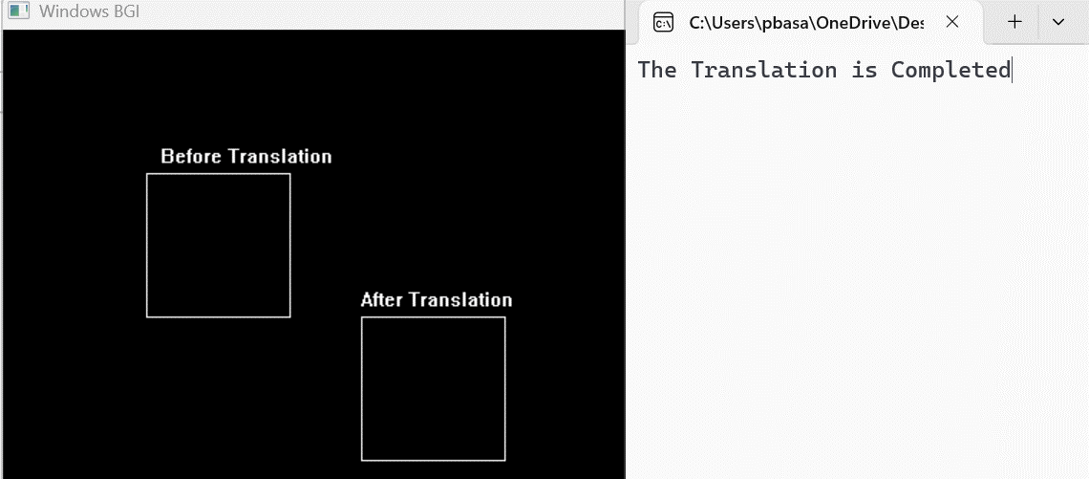
printf("The Translation is Completed");
getch();
closegraph();
return 0;
}

Algorithm for 2D Transformation (2D Rotation)
- Start the program.
- Input the coordinates of the object points (x, y).
- Input rotation angle θ.
- Apply rotation formula:
x′=xcosθ−ysinθ , y′=xsinθ+ycosθ
- Calculate rotated coordinates (x', y').
- Draw the original object.
- Draw the rotated object.
- Stop the program.
Code for 2D Transformation (2D Rotation)
#include <graphics.h>
#include <iostream>
#include <math.h>
#include <conio.h>
using namespace std;
int main(){
int gd = DETECT, gm;
initgraph(&gd, &gm, "C:\\Turboc3\\BGI");// Original triangle coordinates
int x1 = 150, y1 = 150;
int x2 = 200, y2 = 250;
int x3 = 100, y3 = 250;// Rotation angle
float angle = 90 * 3.14 / 180;// Pivot point
int px = 150, py = 200;// Rotate points
int xr1 = px + (x1 - px) * cos(angle) - (y1 - py) * sin(angle);
int yr1 = py + (x1 - px) * sin(angle) + (y1 - py) * cos(angle);
int xr2 = px + (x2 - px) * cos(angle) - (y2 - py) * sin(angle);
int yr2 = py + (x2 - px) * sin(angle) + (y2 - py) * cos(angle);
int xr3 = px + (x3 - px) * cos(angle) - (y3 - py) * sin(angle);
int yr3 = py + (x3 - px) * sin(angle) + (y3 - py) * cos(angle);// Move rotated triangle to the right
int tx = 180; xr1 += tx;
xr2 += tx; xr3 += tx;// Draw original triangle
setcolor(WHITE);
line(x1, y1, x2, y2);
line(x2, y2, x3, y3);
line(x3, y3, x1, y1);
outtextxy(90, 120, "Before Rotation");// Draw rotated triangle
setcolor(WHITE);
line(xr1, yr1, xr2, yr2);
line(xr2, yr2, xr3, yr3);
line(xr3, yr3, xr1, yr1);
outtextxy(330, 120, "After Rotation");
printf("The Rotation to (90 degree) is Completed");
getch();
closegraph();
Output

return 0;
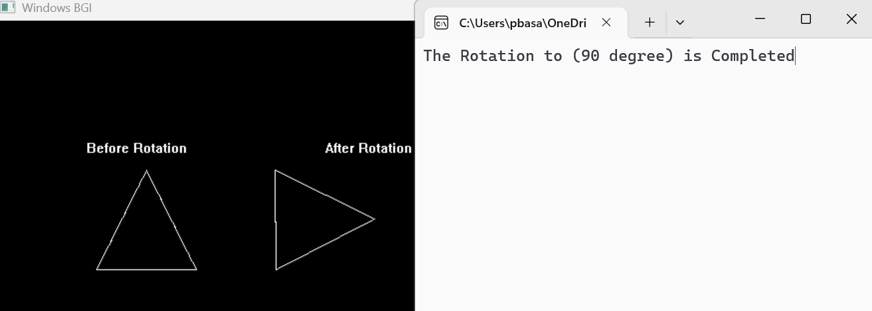
}

Algorithm for 2D Transformation (2D Scaling)
- Start the program.
- Input the coordinates of the object points (x, y).
- Input scaling factors sx and sy.
- Apply scaling formula:
x′=x×sx, y′=y×sy​
- Calculate scaled coordinates (x', y').
- Draw the original object.
- Draw the scaled object.
- Stop the program.
Code for 2D Transformation (2D Scaling)
#include <graphics.h>
#include <iostream>
#include <conio.h>
#include <stdio.h>
using namespace std;
int main(){
int gd = DETECT, gm;
initgraph(&gd, &gm, "C:\\Turboc3\\BGI")
int sx = 2, sy = 2; // ORIGINAL hexagon (closed properly)
int original[] = {
150,100,
200,80,
250,100,
250,160,
200,180,
150,160,
150,100 // closing point (IMPORTANT)
};
setcolor(WHITE);
drawpoly(7, original);
outtextxy(120, 60, "Before Scaling");// SCALED hexagon (also closed)
int scaled[] = {
150*sx, 100*sy,
200*sx, 80*sy,
250*sx, 100*sy,
250*sx, 160*sy,
200*sx, 180*sy,
150*sx, 160*sy,
150*sx, 100*sy // closing point
};
setcolor(WHITE);
drawpoly(7, scaled);
outtextxy(260, 220, "After Scaling");
printf("The Scaling is Completed");
getch();
Output

closegraph();
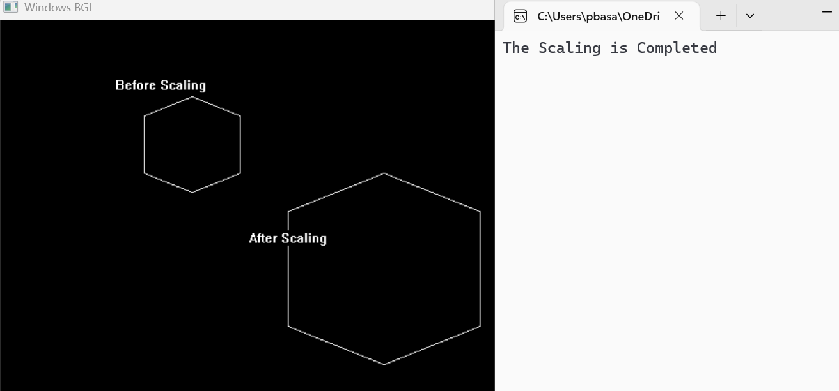
return 0;

}

Algorithm for 2D Transformation (2D Shearing)
- start the program.
- Input the coordinates of the object points (x, y).
- Input shearing factors shx and shy.
- Apply shearing formula:
x′=x+shx​y, y′=y+shy​x
- Calculate sheared coordinates (x', y').
- Draw the original object.
- Draw the sheared object.
- Stop the program.
Code for 2D Transformation (2D Shearing)
#include <graphics.h>
#include <iostream>
#include <conio.h>
using namespace std;
int main(){
int gd = DETECT, gm;
initgraph(&gd, &gm, "C:\\Turboc3\\BGI"); // Original rectangle
int x1 = 100, y1 = 100, x2 = 200, y2 = 200;// Shearing factor
int shx = 1; // Original object
setcolor(WHITE);
rectangle(x1, y1, x2, y2);
outtextxy(90, 80, "Before Shearing"); // Sheared rectangle
setcolor(WHITE);
line(x1 + shx * y1, y1, x2 + shx * y1, y1);
line(x2 + shx * y1, y1, x2 + shx * y2, y2);
line(x2 + shx * y2, y2, x1 + shx * y2, y2);
line(x1 + shx * y2, y2, x1 + shx * y1, y1);
outtextxy(250, 150, "After Shearing");
printf("The Shearing is Completed");
getch();
closegraph();
return 0;
}

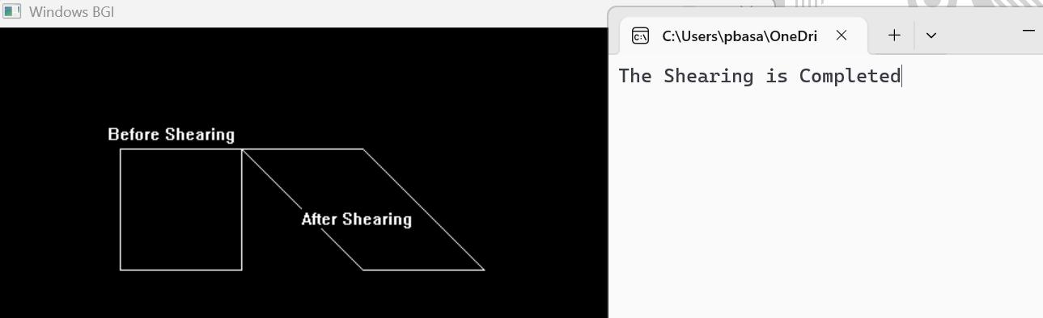
Output

Algorithm for 2D Transformation (2D Reflection)
- Start the program.
- Input the coordinates of the object points (x, y).
- Choose the reflection axis:
•About X-axis
•About Y-axis
•About Origin
- Apply reflection formula:
Reflection about X-axis
x′=x, y′=−y
Reflection about Y-axis
x′=−x,y′=y
Reflection about Origin
x′=−x,y′=−y

- Calculate reflected coordinates (x', y').
- Draw the original object.
- Draw the reflected object.
- Stop the program.
Code for 2D Transformation (2D Reflection)
#include <graphics.h>
#include <iostream>
#include <conio.h>
#include <stdio.h>
using namespace std;
int main(){
int gd = DETECT, gm;
initgraph(&gd, &gm, "C:\\Turboc3\\BGI");
int x[] = {200, 250, 300, 275, 225, 200};
int y[] = {150, 100, 150, 220, 220, 150};// Draw X-axis
line(0, 240, 640, 240);// Original pentagon
setcolor(WHITE);
int original[] = {
200,150,
250,100,
300,150,
275,220,
225,220,
200,150 };
drawpoly(6, original);
outtextxy(180, 80, "Before Reflection");// Reflection about X-axis (y = 240)
int ry[6];
for(int i = 0; i < 6; i++){
ry[i] = 480 - y[i];
}
int reflected[] = {
200, ry[0],
250, ry[1],
300, ry[2],
275, ry[3],
225, ry[4],
200, ry[5] };
drawpoly(6, reflected);
outtextxy(180, 370, "After Reflection");
printf("The Reflection is Completed");
getch();
Output

closegraph();
return 0;
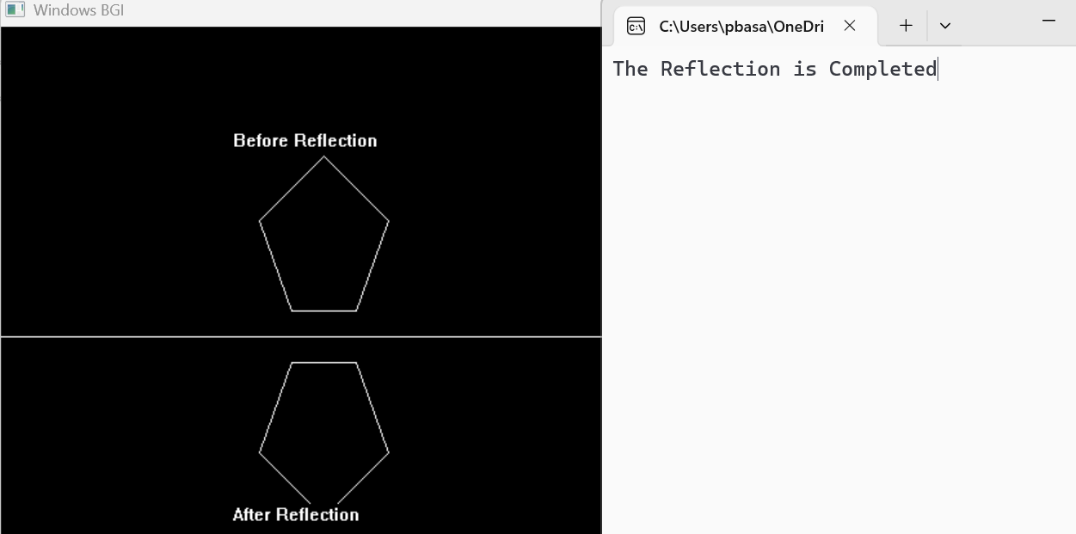
}

Algorithm for Window-View Port Mapping
- Start.
- Define window boundaries:
•Wxmin, Wymin, Wxmax, Wymax
- Define viewport boundaries:
•Vxmin, Vymin, Vxmax, Vymax
- Draw window and viewport rectangles.
- Select a point inside window: (x, y).
- Compute scaling factors:
•Sx = (Vxmax − Vxmin) / (Wxmax − Wxmin)
•Sy = (Vymax − Vymin) / (Wymax − Wymin)
- Apply mapping formula:
•Xv = Vxmin + (x − Wxmin) × Sx
•Yv = Vymin + (y − Wymin) × Sy
- Plot original point in window and mapped point in viewport.
- End.
Code for Window-View Port Mapping
#include <graphics.h>
#include <iostream>
#include <conio.h>
#include <stdio.h>
using namespace std;
int main(){
int gd = DETECT, gm;
initgraph(&gd, &gm, "C:\\Turboc3\\BGI"); // WINDOW boundaries
int Wxmin = 100, Wymin = 100;
int Wxmax = 300, Wymax = 300;// VIEWPORT boundaries
int Vxmin = 350, Vymin = 100;
int Vxmax = 600, Vymax = 300;// ?? Set text size
settextstyle(DEFAULT_FONT, HORIZ_DIR, 3);// Draw window
rectangle(Wxmin, Wymin, Wxmax, Wymax);
outtextxy(Wxmin, Wymin - 20, "WINDOW");// Draw viewport
rectangle(Vxmin, Vymin, Vxmax, Vymax);
outtextxy(Vxmin, Vymin - 20, "VIEWPORT");// Point inside window
int x = 200, y = 200;
putpixel(x, y, WHITE);
outtextxy(x + 5, y + 5, "P");// Scaling factors
float Sx = (float)(Vxmax - Vxmin) / (Wxmax - Wxmin);
float Sy = (float)(Vymax - Vymin) / (Wymax - Wymin);// Mapping formula
int Xv = Vxmin + (x - Wxmin) * Sx;
int Yv = Vymin + (y - Wymin) * Sy;// Draw mapped point
setcolor(RED);
putpixel(Xv, Yv, WHITE);
outtextxy(Xv + 5, Yv + 5, "P'");
printf("Window-Viewport Mapping is completed"); // fixed ;
getch();
closegraph();
return 0;

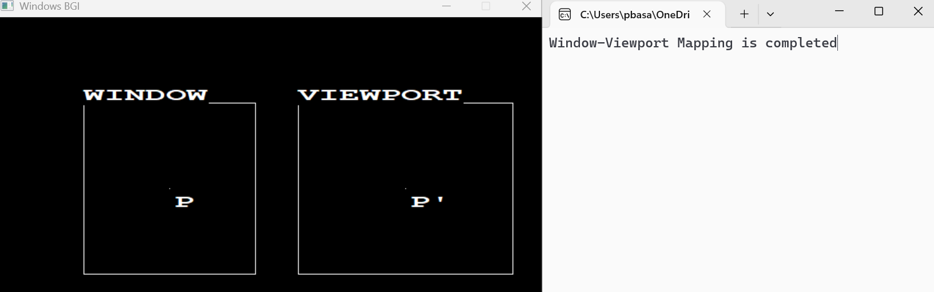
}
Algorithm for Cohen Sutherland Line Clipping
- Start.
- Define clipping window:
•Wxmin​,Wymin​,Wxmax​,Wymax​
- Assign region codes (4-bit) to both endpoints of the line.
- Check:
•If both codes are 0000 → Line is completely inside (accept).
•If logical AND of both codes ≠ 0 → Line is completely outside (reject).
•Else → Line is partially inside → proceed to clipping.
- Select an endpoint outside the window.
- Find intersection point with window boundary.
- Replace outside point with intersection point.
- Repeat steps 3–7 until line is accepted or rejected.
- Draw the final clipped line.
- End.

Code for Cohen Sutherland Line Clipping
#include <graphics.h>
#include <iostream>
#include <conio.h>
using namespace std;
const int INSIDE = 0;
const int LEFT = 1;
const int RIGHT = 2;
const int BOTTOM = 4;
const int TOP = 8;
int Wxmin = 75, Wymin = 75, Wxmax = 200, Wymax = 200;// Compute region code
int computeCode(int x, int y) {
int code = INSIDE;
if (x < Wxmin) code |= LEFT;
else if (x > Wxmax) code |= RIGHT;
if (y < Wymin) code |= TOP;
else if (y > Wymax) code |= BOTTOM;
return code;
}
int main() {
int gd = DETECT, gm;
initgraph(&gd, &gm, "C:\\Turboc3\\BGI");
int x1 = 50, y1 = 150;
int x2 = 350, y2 = 250;// == BEFORE CLIPPING
setcolor(WHITE);// Window (Before)
rectangle(Wxmin, Wymin, Wxmax, Wymax);
outtextxy(Wxmin, Wymin - 20, "BEFORE");// Original line
line(x1, y1, x2, y2);// Copy original values for clipping
int ox1 = x1, oy1 = y1, ox2 = x2, oy2 = y2; // = CLIPPING PROCESS =
int code1 = computeCode(x1, y1);
int code2 = computeCode(x2, y2);
bool accept = false;
while (true) {
if ((code1 == 0) && (code2 == 0)) {
accept = true;
break;
}
else if (code1 & code2) {
break;
}
else {
int codeOut;
int x, y;
if (code1 != 0)
codeOut = code1;
else
codeOut = code2;
if (codeOut & TOP) {
x = x1 + (x2 - x1) * (Wymin - y1) / (y2 - y1);
y = Wymin;
}
else if (codeOut & BOTTOM) {
x = x1 + (x2 - x1) * (Wymax - y1) / (y2 - y1);
y = Wymax;
}
else if (codeOut & RIGHT) {
y = y1 + (y2 - y1) * (Wxmax - x1) / (x2 - x1);
x = Wxmax;
}
else if (codeOut & LEFT) {
y = y1 + (y2 - y1) * (Wxmin - x1) / (x2 - x1);
x = Wxmin;
}
if (codeOut == code1) {
x1 = x;
y1 = y;
code1 = computeCode(x1, y1);
}
else {
x2 = x;
y2 = y;
code2 = computeCode(x2, y2);
}
}
}// ================= AFTER CLIPPING =================
setcolor(WHITE);
int shiftX = 350; // move to right side
// Draw new window (After)
rectangle(Wxmin + shiftX, Wymin, Wxmax + shiftX, Wymax);
outtextxy(Wxmin + shiftX, Wymin - 20, "AFTER");
if (accept) {
// Draw clipped line in right window
line(x1 + shiftX, y1, x2 + shiftX, y2);
}
printf("Cohen Sutherland Line Clipping Completed");
getch();
closegraph();
return 0;
Output

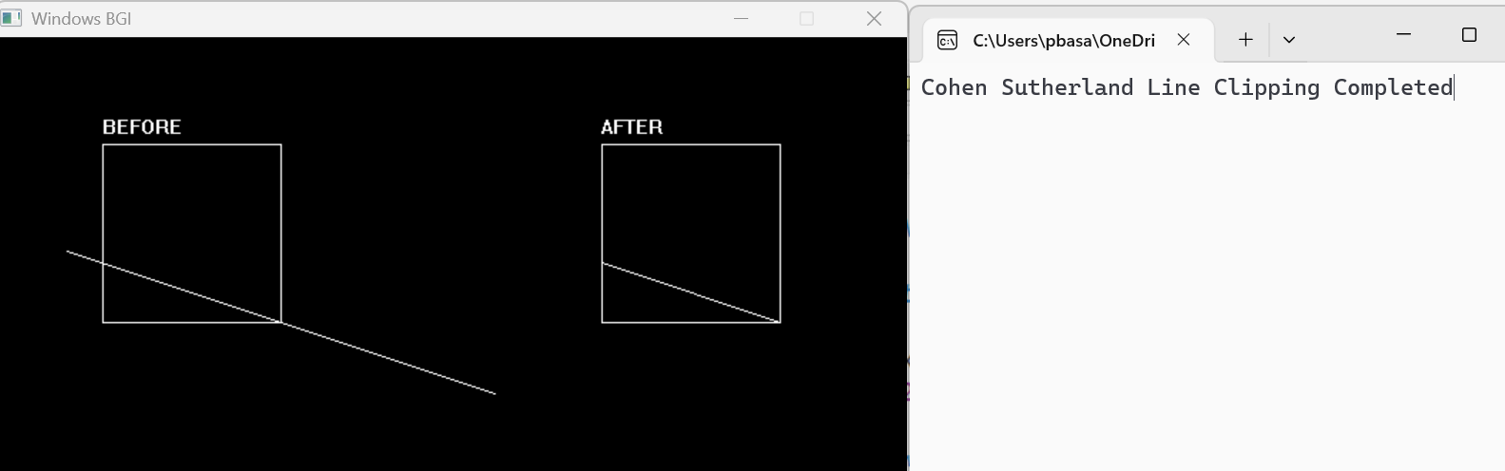
}

Algorithm for Sutherland-Hodgeman Polygon Clipping
- Start.
- Define clipping window:
•Wxmin, Wymin, Wxmax, Wymax
- Define polygon vertices.
- Draw original polygon (BEFORE clipping) inside window.
- Clip polygon against each boundary in sequence:
•Left boundary
•Right boundary
•Bottom boundary
•Top boundary
- For each edge of polygon:
•If both vertices are inside → add end vertex
•If one inside and one outside → compute intersection and add it
•If both outside → ignore
- Update polygon after each boundary clipping.
- After all 4 boundaries, obtain final clipped polygon.
- Draw clipped polygon (AFTER clipping) in shifted window.
- Display message: “Polygon clipping completed.”
- End.

Code for Sutherland-Hodgeman Polygon Clipping
#include <graphics.h>
#include <iostream>
#include <conio.h>
using namespace std;
struct Point {
int x, y;
};
int Wxmin = 75, Wymin = 75, Wxmax = 200, Wymax = 200;
int shiftX = 350;
int insideLeft(Point p) { return p.x >= Wxmin; }
int insideRight(Point p) { return p.x <= Wxmax; }
int insideBottom(Point p) { return p.y <= Wymax; }
int insideTop(Point p) { return p.y >= Wymin; }
Point intersect(Point p1, Point p2, int edge) {
Point p;
float m;
if (p2.x - p1.x != 0)
m = (float)(p2.y - p1.y) / (p2.x - p1.x);
else
m = 100000;
if (edge == 1) {
p.x = Wxmin;
p.y = p1.y + m * (Wxmin - p1.x);
}
else if (edge == 2) {
p.x = Wxmax;
p.y = p1.y + m * (Wxmax - p1.x);
}
else if (edge == 3) {
p.y = Wymax;
p.x = p1.x + (Wymax - p1.y) / m;
}
else {
p.y = Wymin;
p.x = p1.x + (Wymin - p1.y) / m;
}
return p;
}
int main() {
int gd = DETECT, gm;
initgraph(&gd, &gm, "C:\\Turboc3\\BGI");
setcolor(WHITE);
settextstyle(DEFAULT_FONT, HORIZ_DIR, 2);
Point poly[10] = {
{150, 150},
{250, 120},
{350, 200},
{280, 280},
{180, 250}
};
int n = 5;// = BEFORE CLIPPING =
rectangle(Wxmin, Wymin, Wxmax, Wymax);
outtextxy(Wxmin, Wymin - 20, "BEFORE");
for (int i = 0; i < n; i++) {
line(poly[i].x, poly[i].y,
poly[(i + 1) % n].x,
poly[(i + 1) % n].y);
}// Copy for clipping
Point temp1[20];
int tn;// LEFT
tn = 0;
for (int i = 0; i < n; i++) {
Point curr = poly[i];
Point prev = poly[(i + n - 1) % n];

int currIn = curr.x >= Wxmin;
int prevIn = prev.x >= Wxmin;

if (currIn) {
if (!prevIn)
temp1[tn++] = intersect(prev, curr, 1);
temp1[tn++] = curr;
}
else if (prevIn) {
temp1[tn++] = intersect(prev, curr, 1);
}
}
n = tn;
for (int i = 0; i < n; i++) poly[i] = temp1[i];// RIGHT
tn = 0;
for (int i = 0; i < n; i++) {
Point curr = poly[i];
Point prev = poly[(i + n - 1) % n];
int currIn = curr.x <= Wxmax;
int prevIn = prev.x <= Wxmax;
if (currIn) {
if (!prevIn)
temp1[tn++] = intersect(prev, curr, 2);
temp1[tn++] = curr;
}
else if (prevIn) {
temp1[tn++] = intersect(prev, curr, 2);
}
}
n = tn;
for (int i = 0; i < n; i++) poly[i] = temp1[i];// BOTTOM
tn = 0;
for (int i = 0; i < n; i++) {
Point curr = poly[i];
Point prev = poly[(i + n - 1) % n];
int currIn = curr.y <= Wymax;
int prevIn = prev.y <= Wymax;
if (currIn) {
if (!prevIn)
temp1[tn++] = intersect(prev, curr, 3);
temp1[tn++] = curr;
}
else if (prevIn) {
temp1[tn++] = intersect(prev, curr, 3);
}
}
n = tn;
for (int i = 0; i < n; i++) poly[i] = temp1[i];// TOP
tn = 0;
for (int i = 0; i < n; i++) {
Point curr = poly[i];
Point prev = poly[(i + n - 1) % n];

int currIn = curr.y >= Wymin;
int prevIn = prev.y >= Wymin;
if (currIn) {
if (!prevIn)
temp1[tn++] = intersect(prev, curr, 4);
temp1[tn++] = curr;
}
else if (prevIn) {
temp1[tn++] = intersect(prev, curr, 4);
}
}
n = tn;// =AFTER CLIPPING =
rectangle(Wxmin + shiftX, Wymin, Wxmax + shiftX, Wymax);
outtextxy(Wxmin + shiftX, Wymin - 20, "AFTER");
for (int i = 0; i < n; i++) {
line(poly[i].x + shiftX, poly[i].y,
poly[(i + 1) % n].x + shiftX,
poly[(i + 1) % n].y);
}
printf("The Sutherland Hodyeman-Hodgmen Polygon Clipping is completed");
getch();
closegraph();
return 0;
}
Output

