DDA Algorithm
Step 1: Start.
Step 2: Declare x₁, y₁, x₂, y₂, dx, dy, step, xinc, yinc, x, y.
Step 3: Input the values of x₁, y₁ and x₂, y₂.
Step 4: Calculate the following:
dx = x₂ − x₁
dy = y₂ − y₁
Step 5: Calculate the number of steps as follows:
step = abs ( max ( dx , dy ) )
Step 6: Calculate xinc and yinc as follows:
xinc = dx / step
yinc = dy / step
Step 7: Initialize
x = x₁
y = y₁
Step 8: Repeat the following steps until all points are plotted:
x = x + xinc
y = y + yinc
Step 9: Plot (round(x), round(y)) on the screen to get the required line between the given points.
Step 10: End.

Bresenham's Line Drawing Algorithm
Step 1: Start
Step 2: Declare x1, y1, x2, y2.
Step 3: Calculate the following,
dx = x2 − x1
dy = y2 − y
Step 4: Initialize decision parameter as follows,
p = 2dy − dx
Step 5: Initialize
x = x1
y = y1
Step 6: Plot the point (x, y).
Step 7: while ( x ≤ x2 )
If ( p < 0 )
x = x + 1
p = p + 2dy
Else
x = x + 1
y = y + 1
p = p + 2dy − 2dx
Step 8: Plot (x, y) on the graph, and hence we get our required line between the given points.
Step 9: End.

Mid Point Circle Drawing Algorithm
Step 1: Start.
Step 2: Declare xc, yc, r, x, y, p.
Step 3: Input the center coordinates (xc, yc) and radius r.
Step 4: Initialize
x = 0
y = r
Step 5: Calculate the initial decision parameter
p = 1 − r
Step 6: Plot the symmetric points of the circle as follows:
(xc + x, yc + y)
(xc − x, yc + y)
(xc + x, yc − y)
(xc − x, yc − y)
(xc + y, yc + x)
(xc − y, yc + x)
(xc + y, yc − x)
(xc − y, yc − x)
Step 7: Repeat while x ≤ y
If p < 0
x = x + 1
p = p + 2x + 1
Else
x = x + 1
y = y − 1
p = p + 2x − 2y + 1
Step 8: Plot the calculated symmetric points in each iteration.
Step 9: Stop when x > y.
Step 10: End.

Mid Point Ellipse Drawing Algorithm
Step 1: Start.
Step 2: Declare xc, yc, rx, ry, x, y, p1, p2.
Step 3: Input the center coordinates (xc, yc) and radii rx and ry.
Step 4: Initialize
x = 0
y = ry
Step 5: Calculate initial decision parameter for Region 1
p1 = ry² − rx²ry + 0.25rx²
Step 6: Repeat while 2ry²x ≤ 2rx²y
If p1 < 0
x = x + 1
p1 = p1 + 2ry²x + ry²
Else
x = x + 1
y = y − 1
p1 = p1 + 2ry²x − 2rx²y + ry²
Plot symmetric points:
(xc + x, yc + y)
(xc − x, yc + y)
(xc + x, yc − y)
(xc − x, yc − y)
Step 7: Calculate decision parameter for Region 2
p2 = ry²(x + 0.5)² + rx²(y − 1)² − rx²ry²
Step 8: Repeat while y ≥ 0
If p2 > 0
y = y − 1
p2 = p2 − 2rx²y + rx²
Else
x = x + 1
y = y − 1
p2 = p2 + 2ry²x − 2rx²y + rx²
Plot symmetric points in all quadrants.
Step 9: Stop when y < 0.
Step 10: End.

CODE OF DDA
#include <graphics.h>
#include <stdio.h>
#include <math.h>
#include <conio.h> // for getch()
int main()
{
float x, y, x1, y1, x2, y2, dx, dy, step;
int i, gd = DETECT, gm;
initgraph(&gd, &gm, "..\\bgi");
printf("DDA Line Drawing Algorithm\n");
printf("This Program is coded by Bashanta Pokharel\n");
printf("Enter the value of x1 and y1 : ");
scanf("%f%f", &x1, &y1);
printf("Enter the value of x2 and y2 : ");
scanf("%f%f", &x2, &y2);
dx = x2 - x1;
dy = y2 - y1;
if (fabs(dx) >= fabs(dy))
step = fabs(dx);
else
step = fabs(dy);
dx = dx / step;
dy = dy / step;
x = x1;
y = y1;
for (i = 0; i <= step; i++) {
putpixel(round(x), round(y), WHITE);
x += dx;
y += dy;
delay(50);
}
getch();
closegraph();
return 0;
}
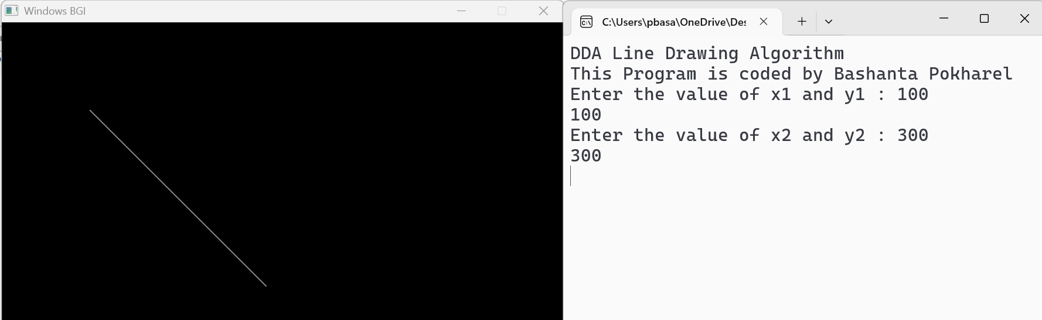

CODE OF Bresenham's Line Drawing Algorithm
#include <graphics.h>
#include <iostream>
#include <conio.h>
using namespace std;
void bresenham(int x1, int y1, int x2, int y2){
int dx = x2 - x1;
int dy = y2 - y1;
int x = x1;
int y = y1;
int p = 2 * dy - dx;
while (x <= x2){
putpixel(x, y, WHITE);
x++;
if (p < 0){
p = p + 2 * dy;
}
else{
y++;
p = p + 2 * (dy - dx);
}
delay(50);
}
}

int main(){
int gd = DETECT, gm;
initgraph(&gd, &gm, "..\\bgi");
int x1, y1, x2, y2;
printf("This Program is coded by Bashanta Pokharel\n");
cout << "Bresenham's Line Drawing Algorithm" << endl;
cout << "Enter x1 and y1: ";
cin >> x1 >> y1;
cout << "Enter x2 and y2: ";
cin >> x2 >> y2;
bresenham(x1, y1, x2, y2);
getch();
closegraph();
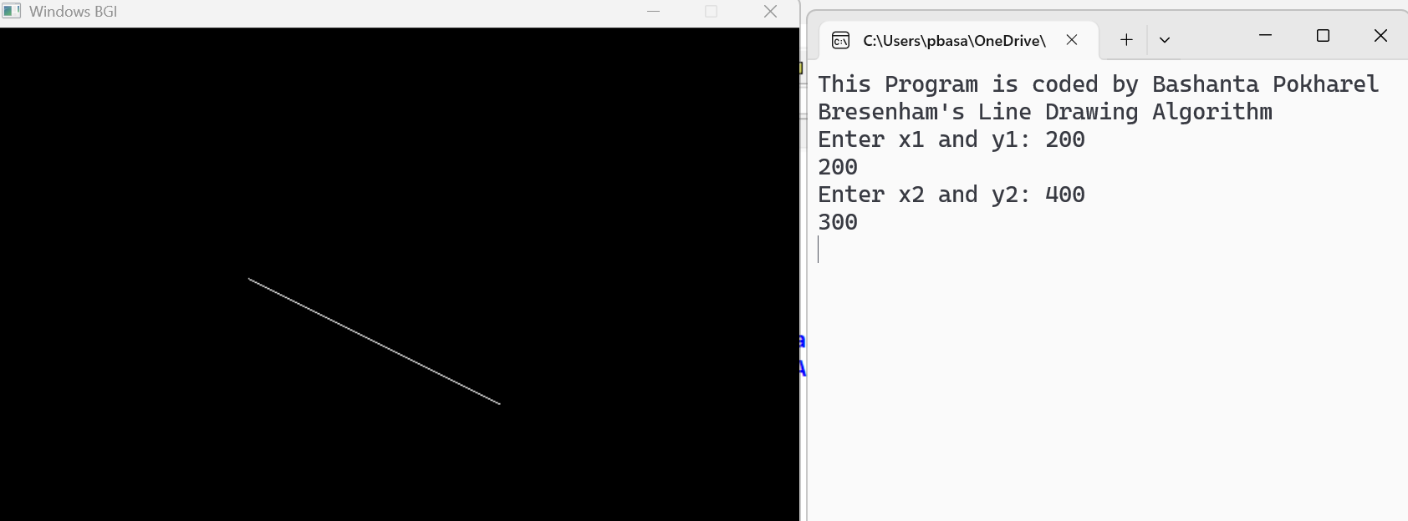
return 0;
}

CODE OF Mid-Point Circle Drawing Algorithm
#include <graphics.h>
#include <iostream>
#include <conio.h>
using namespace std;
void midPointCircleDraw(int x_centre, int y_centre, int r)
{
int x = r;
int y = 0;
putpixel(x + x_centre, y + y_centre, WHITE);
if (r > 0)
{
putpixel(x + x_centre, -y + y_centre, WHITE);
putpixel(y + x_centre, x + y_centre, WHITE);
putpixel(-y + x_centre, x + y_centre, WHITE);
}
int P = 1 - r;
while (x > y)
{
y++;
if (P <= 0)
P = P + 2 * y + 1;
else
{
x--;
P = P + 2 * y - 2 * x + 1;
}

if (x < y)
break;
putpixel(x + x_centre, y + y_centre, WHITE);
putpixel(-x + x_centre, y + y_centre, WHITE);
putpixel(x + x_centre, -y + y_centre, WHITE);
putpixel(-x + x_centre, -y + y_centre, WHITE);
if (x != y)
{
putpixel(y + x_centre, x + y_centre, WHITE);
putpixel(-y + x_centre, x + y_centre, WHITE);
putpixel(y + x_centre, -x + y_centre, WHITE);
putpixel(-y + x_centre, -x + y_centre, WHITE);
}

delay(50);
}
}
int main(){
int gd = DETECT, gm;
initgraph(&gd, &gm, "..\\bgi");
int x_centre, y_centre, r;
printf("This Program is coded by Bashanta Pokharel\n")
cout << "Mid-Point Circle Drawing Algorithm" << endl;

cout << "Enter circle centre (x y): "
cin >> x_centre >> y_centre;
cout << "Enter radius: ";
cin >> r;
midPointCircleDraw(x_centre, y_centre, r);
getch();
closegraph();
return 0;
}

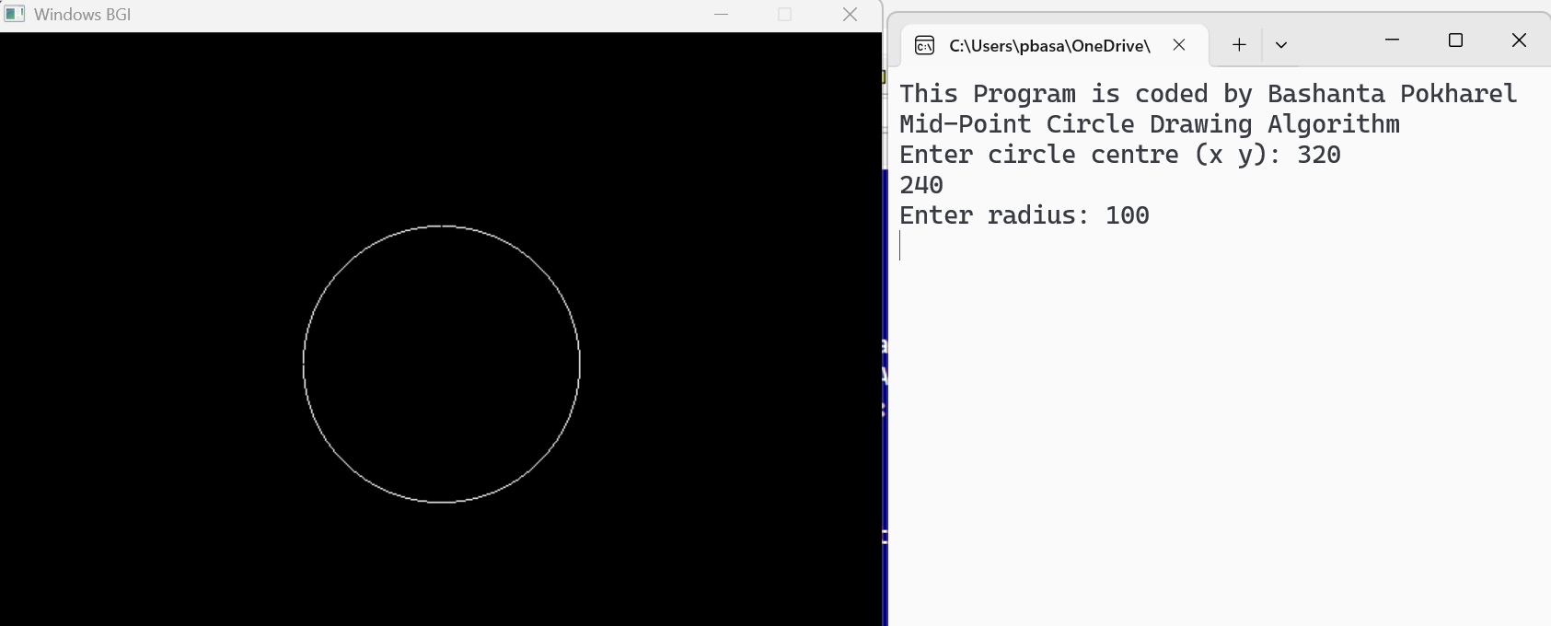
CODE OF Mid-Point Ellipse Drawing Algorithm
#include <graphics.h>
#include <iostream>
#include <conio.h>
using namespace std;
void midptellipse(int rx, int ry, int xc, int yc)
{
int x = 0;
int y = ry;
float d1 = (ry * ry) - (rx * rx * ry) + (0.25 * rx * rx);
int dx = 2 * ry * ry * x;
int dy = 2 * rx * rx * y;
while (dx < dy)
{
putpixel(x + xc, y + yc, WHITE);
putpixel(-x + xc, y + yc, WHITE);
putpixel(x + xc, -y + yc, WHITE);
putpixel(-x + xc, -y + yc, WHITE);
if (d1 < 0)
{
x++;
dx = dx + (2 * ry * ry);
d1 = d1 + dx + (ry * ry);
}
else
{
x++;
y--;
dx = dx + (2 * ry * ry);
dy = dy - (2 * rx * rx);
d1 = d1 + dx - dy + (ry * ry);
}
delay(30);
}
float d2 = ((ry * ry) * ((x + 0.5) * (x + 0.5))) +
((rx * rx) * ((y - 1) * (y - 1))) -
(rx * rx * ry * ry);
while (y >= 0)
{
putpixel(x + xc, y + yc, WHITE);
putpixel(-x + xc, y + yc, WHITE);
putpixel(x + xc, -y + yc, WHITE);
putpixel(-x + xc, -y + yc, WHITE);

if (d2 > 0)
{
y--;
dy = dy - (2 * rx * rx);
d2 = d2 + (rx * rx) - dy;
}

else
{
y--;
x++;
dx = dx + (2 * ry * ry);
dy = dy - (2 * rx * rx);
d2 = d2 + dx - dy + (rx * rx);
}
delay(30);
}
}
int main()
{
int gd = DETECT, gm;
initgraph(&gd, &gm, "..\\bgi");
int rx, ry, xc, yc;
printf("This Program is coded by Bashanta Pokharel\n");
cout << "Mid-Point Ellipse Drawing Algorithm" << endl;
cout << "Enter radius along x-axis (rx): ";
cin >> rx;
cout << "Enter radius along y-axis (ry): ";
cin >> ry;
cout << "Enter centre coordinates (xc yc): ";
cin >> xc >> yc;
midptellipse(rx, ry, xc, yc);
getch();
closegraph();
return 0;



