
Mawlana Bhashani Science and Technology University
Santosh, Tangail-1902.

Lab Report

Department of Information and Communication Technology
Report No: 04
Course Code : ICT-3208
Course Title: Network Planning and Designing Lab
Submitted By | Submitted To
Name: Md. Abul Basar  ID: IT-17026  Session: 2016-17  3rd Year 2nd Semester  Dept. of Information & Communication Technology, MBSTU. | Nazrul Islam  Assistant Professor  Dept. of Information & Communication Technology, MBSTU.

Python is an easy to learn, powerful programming language. It has efficient high-level data structures and a simple but effective approach to object-oriented programming. Python's elegant syntax and dynamic typing, together with its interpreted nature, make it an ideal language for scripting and rapid application development in many areas on most platforms.

Setup of Python Environment

STEP 1: Open Eclipse and setup a correct access to Internet (This is required only in RMIT network). In order to set up Manual Proxy follow the instructions (see also figure 1): a. Go to Windows > Preferences > General > Network Connections.

b. Change Active Provider to Manual.

c. Input proxy details, including username/password if required.
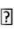

Host: proxy.rmit.edu.au

Port: 8080

Username/password: No required

d. Clear SOCKS proxy.

e. Restart Eclipse.
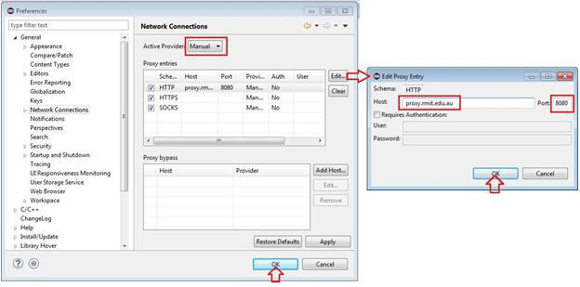
STEP 2: Installing python environment using Eclipse Graphical Interface1.

a. To install PyDev and PyDev Extensions using the Eclipse Update Manager, you need to use the Help > Install New Software... menu (note that in older versions, this would be the 'Find and Install' menu) as shown in the following figure:
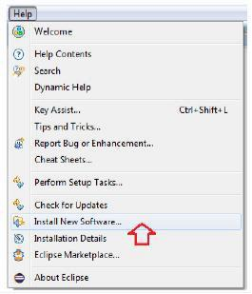

In the next screen, add the update site(s) you want to work with (see the figure below). The available update sites are :
http://pydev.org/updates
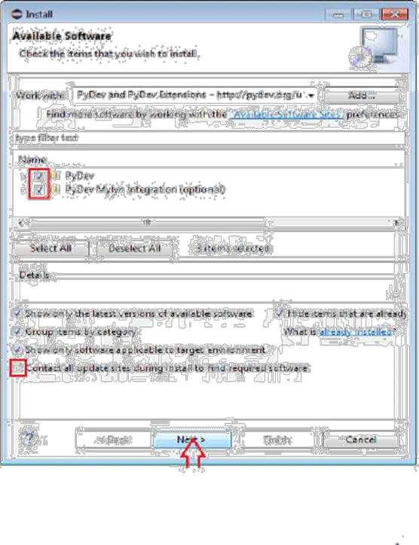

And finally, read the license agreement and if you accept, select the accept radio button and click 'Finish'
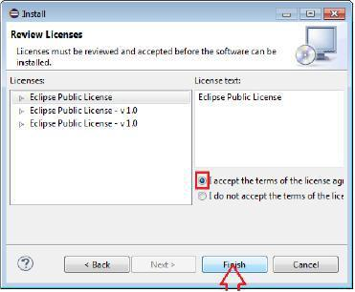

STEP 2: Checking the installation: You can verify if it is correctly installed going to the menu 'window> preferences' and checking if there is a PyDev item under that (see Figure 7). After that eclipse will display the graphical interface for python perspective, the main components are (see Figure 8)
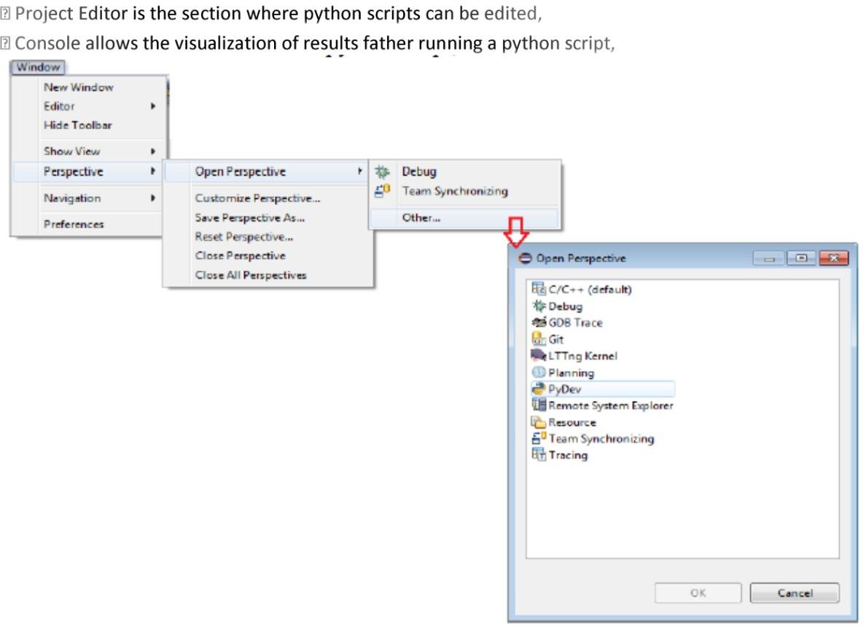

Exercises
Section 4.1: Basics of python and programing
Exercise 4.1.1: Create a python project.

Answer:
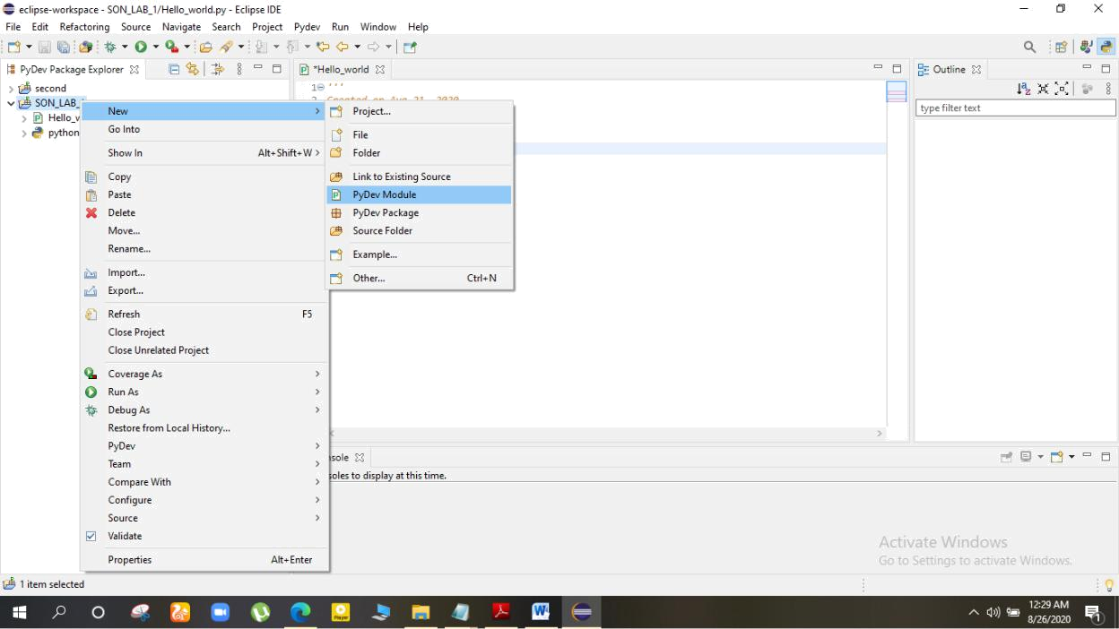

Project created successfully.
Exercise 4
1.PrintHelloworld
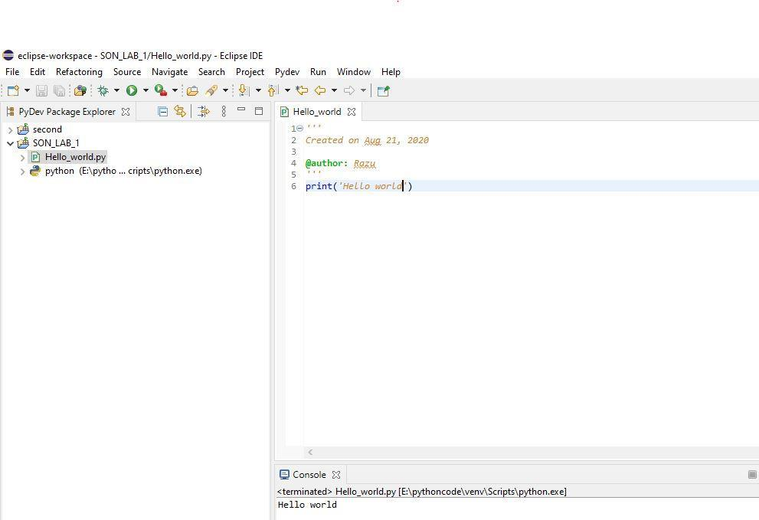

2.Compute 1+1
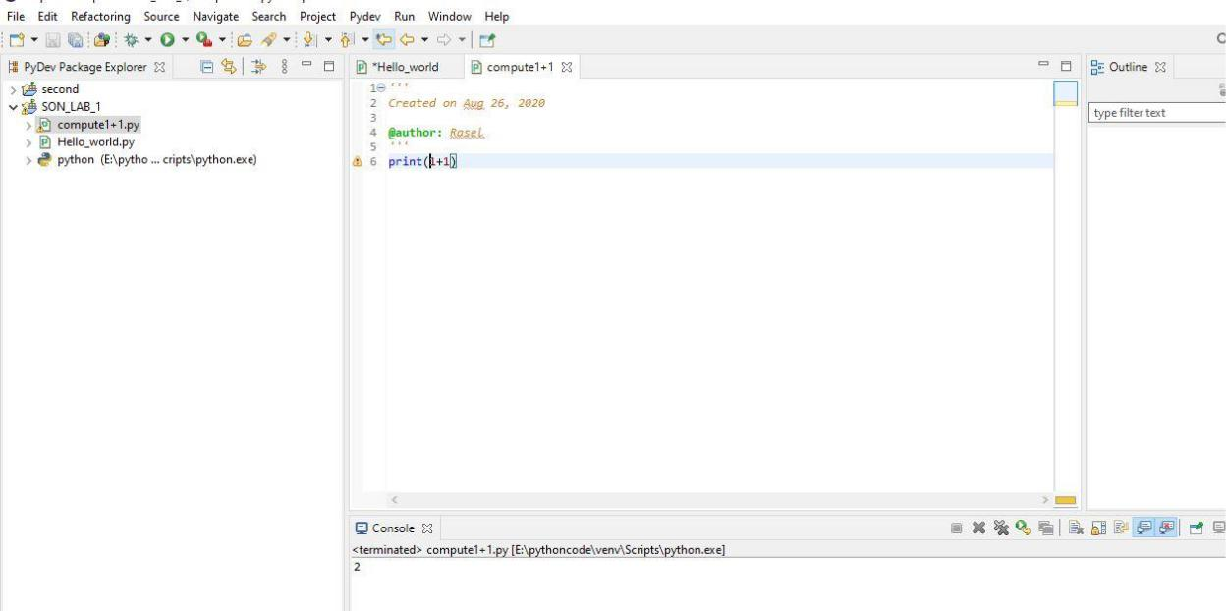
3.Expression
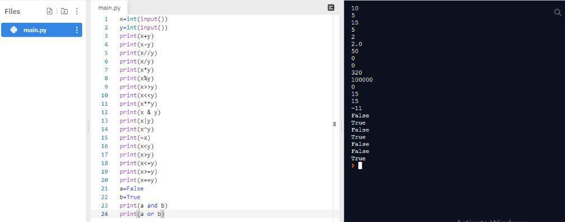

4.for loop
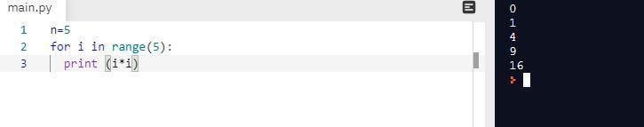

5.While loop program
