
Mawlana Bhashani Science and Technology University
Santosh, Tangail-1902.

Lab Report

Department of Information and Communication Technology
Report No: 06
Course Code : ICT-3208
Course Title: Network Planning and Designing Lab
Submitted By | Submitted To
Name: Md. Abul Basar  ID: IT-17026  Session: 2016-17  3rd Year 2nd Semester  Dept. of Information & Communication Technology, MBSTU. | Nazrul Islam  Assistant Professor  Dept. of Information & Communication Technology, MBSTU.

Theory: Python is a very simple programming language so even if you are new to programming, you can learn python without facing any issues. Python is free to download and use. This means you can download it for free and use it in your application.

Python is a general-purpose language sometimes referred to as utilitarian which is designed to be simple to read and write. The point that it’s not a complex language is important. The designers placed less of an emphasis on conventional syntax, which makes it easier to work with, even for non-programmers or developers.

Furthermore, because it’s considered truly universal and used to meet various development needs, it’s a language that offers a lot of options to programmers in general. If they begin working with Python for one job or career, they can easily jump to another, even if it’s in an unrelated industry. The language is used for system operations, web development, server and administrative tools, deployment, scientific modeling and much more.

But, surprisingly, many developers don’t pick up Python as their primary language. Because it’s so easy to use and learn, they choose it as a second or third language. This may be another reason why it’s so popular among developers.
Some Code in python language :

1. First code:
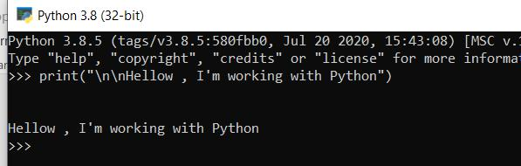

2. Addition :
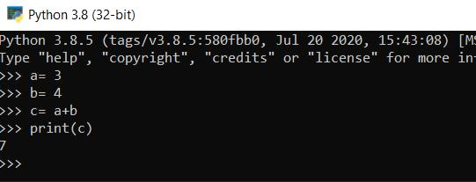

3. Subtraction :
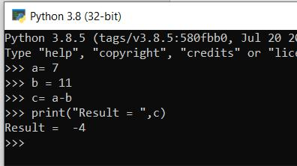
4. Multiplication:
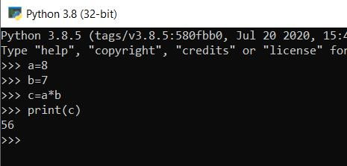

5. Division:
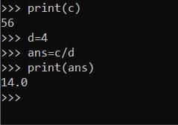

6. Input & print:
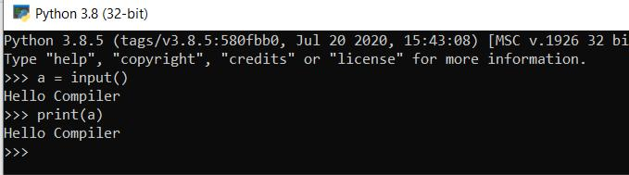
7. Loop:
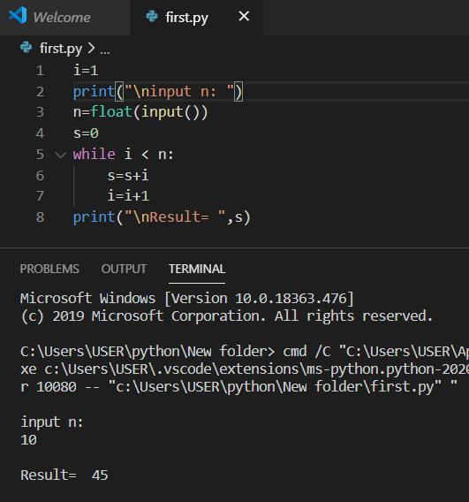

Conclusion: There are many benefits of learning Python, especially as your first language, which we will discuss. It is a language that is remarkably easy to learn, and it can be used as a stepping stone into other programming languages and frameworks. If you’re an absolute beginner and this is your first time working with any type of coding language, that’s something you definitely want. Python is widely used, including by a number of big companies like Google, Pinterest, Instagram, Disney, Yahoo!, Nokia, IBM, and many others. The Raspberry Pi which is a mini computer and DIY lover’s dream relies on Python as it’s main programming language too.

