Lab No : 01
Lab Name : Introduction to linux in computer network
1)Introduction

If I have a network that ranges from 192.168.1.0 to 192.168.1.255 Individual devices in the network can only be assigned IP addresses in the range of 192.168.1.1 to 192.168.1.254 because we can not use the first address is called network address and last address is called broadcast address but if we write a command before this ip

address named “ip-subnet zero” then we can use those subnet So

that’s why the first usable address is 192.168.1.1 and the last is 192.168.1.254.

2) Find IP & MAC

The MAC address and IP address are listed under the appropriate adapter as Physical Address and IPv4 Address.

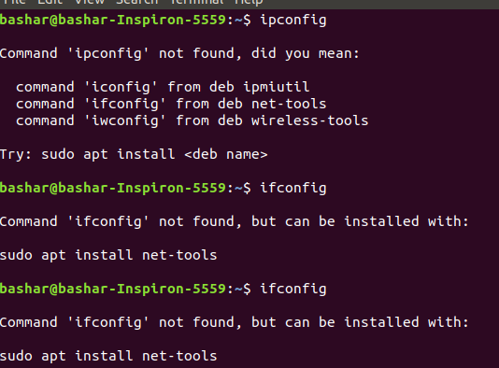

- Routing Table Basics:

Enter the command: "$ netstat -r" to print your computers routing table.

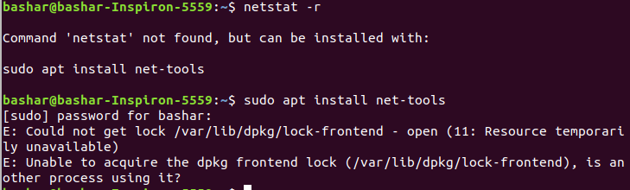

Enter the command: "$ netstat -nr" to print your computers routing table.

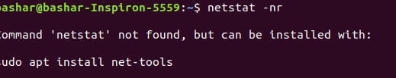

The –n option makes netstat print addresses as dotted quad IP numbers rather than the symbolic host and network names. This option is especially useful when you want to avoid address lookups over the network (e.g., to a DNS or NIS server).

The second column of netstat 's output shows the gateway to which the routing entry points. If no gateway is used, an asterisk is printed instead. The third column shows the “generality” of the route.

4. Virtual Interfaces:

- Create a new virtual interface with following IP address, 192.168.2.32 and netmask 255.255.255.0 then check to see if the interface was created successfully?

b)Now, you need to set up a route for this interface so that your computer can see it. Otherwise, everyone else on the network will be able to reach the new interface except you. Issue the needed command, then issue the "$ netstat -‐r" command and check if the route to your added interface is visible.

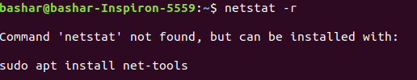

5. Add a New Network:

- Enter the command needed to add another network with the same values as your primary network meaning:

- Assign the default gateway for your newly added network(tip the same default gateway as your primary network), (Your default gateway address).

- Look for your newly added network in your routing table by issuing the “$ netstar -r” command. You should now have a double setup of your primary network in the table.

- Now, remove your changes meaning the double routing table setup for your primary network. First issue the command needed to delete your newly added route then issue the command to delete your newly added default gateway.

6. Multi network scenario Configuration:

Provide the necessary commands to route on the firewall/router system:

a)

b)

c)

d)

