DAFFODIL INTERNATIONAL UNIVERSITY



A Report on
Web Programming Project

EXAM (online exam system)

A PROJECT SUBMITTED TO THE DEPARTMENT OF SOFTWARE ENGINEERING DAFFODIL INTERNATIONAL UNIVERSITY, SOBAHANBAG, DHAKA, BANGLADESH.

SUPERVISED BY
Afsana Begum

Assistant Professor
DEPT OF Software Engineering

Faculty of Science and Information Technology

DAFFODIL INTERNATIONAL UNIVERSITY.

SUBMITTED BY

Muhammod Abul Bashar
ID: 171-35-2002
27th May, 2021
[Document version: 2.0]
Copyright © 2021 by Daffodil International University.

Letter of Transmittal

APPROVAL

This Project/Thesis titled “Exam” , submitted by Muhammod Abul Bashar ID:171-35-2002,
In the Department of Software Engineering (SWE) Daffodil International University, Dhaka, Bangladesh has been accepted as satisfactory for the partial fulfillment of the requirements for the degree of B.Sc. in Software Engineering and approved as to its style and contents.

Signature of Supervisor

Afsana Begum
Assistant Professor
Department of Software Engineering
Daffodil International University
Sobahanbag, Dhaka.

PROJECT DECLARATION

The project entitled “Muhammod Abul Bashar” is done under the supervision Afsana Begum
Assistant Professor, Department of Software Engineering, Daffodil International
University. I declare that this project is my original work for the degree of B. Sc. In Software Engineering and that neither the whole work nor any part has been submitted for another degree in this or any other university.
Submitted by
--------------------------------
Muhammod Abul Bashar
Id: 171-35-2002
Batch: 22 th
Department of Software Engineering
Daffodil International University

Certified by:
------------------------------
Afsana Begum
Assistant Professor
Department of Software Engineering
Daffodil International University

PREFACE

Special Thanks

Special thanks to dear mam Afsana Begum . Her insights, expertise, and energy contributed greatly to the success to this project. She has helped on several on my project and, as always, her efforts are appreciated. I also wish to express my gratitude to the mam, especially for invaluable suggestions and critical review of this project.
Finally, I thank Allah for his kindness, granting the patience and knowledge.

Acknowledgment

The authors feel proud to have the opportunity to express their heart-felt and most sincere gratitude to a number of peoples who have them in courses of this project.
This project was performed under the supervision of Afsana Begum Assistant Professor, Department of Software Engineering(SWE), Daffodil International University, Sobahanbag, Dhaka. First and foremost, the authors wish to concede their profound indebtedness to him for guidance, valuable suggestions, encouragement and cordial cooperation.
I also grateful to the rest of the teachers of our respective Department, Department of Software Engineering (SWE) for helping us in many ways.
Heartiest thanks to my Department of the University, SOFTWARE ENGINEERING for providing me such an opportunity for the accomplishment of our project smoothly.
Lot of thanks to those who were the respondents of our project work & soulfully helped us a lot for the collection of data for our project.
Finally, I would like to express our gratitude to the development staff and friends, who have inspired us in this project.
I am thankful to Allah for this life and afterlife.

Md. Abul Bashar
MAY, 2021.

Abstract

In our daily life we do a lots of thing.
Online Examination System is a technology-driven way to simplify examination activities like defining exam patterns with question banks, defining exam timer, objective/ subjective question sections, conducting exams using the computer or mobile devices in a paperless manner.

This application, actually reduce the pain of the teacher and students.

Using an Online Examination System has many benefits.
EXAM (online exam system) is a web-based application which connecting teacher and student for taking and giving exams form anywhere.
Teacher can create Course and assign students and Upload questions and Create exam_slot with machine generated exam question_paper.
Student can check there exam schedules and enroll courses and check there results and attend exams and view the announcements
This application can be used in any education institutes or any organization or education purpose where people want to evaluate students or any-kind of occupant.

This application is to made the daily, exams in a easy way in a simple way.

TABLE OF CONTENT

Approval .............................................................................................................… iii
PROJECT DECLARATION .......................................................................................… iv
Acknowledgment ...............................................................................................….. vi
Abstract ...............................................................................................................… vii
TABLE OF CONTENT ..........................................................................................….. viii
LIST OF FIGURES ......................................................................................................ix
LIST OF TABLES ....................................................................................................... x
Chapter 1 : Introduction ........................................................................................ 11
1.1 Project Overview ............................................................................................ 11
1.2 Project Purpose .............................................................................................. 11
1.2.1 Background ................................................................................................. 11
1.2.2 Benefits & Beneficiaries ............................................................................... 11
1.2.3 Goals ........................................................................................................... 12
1.3Organization of Document............................................................................... 12
1.4 Proposed System Model ( Block Diagram ) ..................................................... 13
1.5 Project Schedule ............................................................................................. 16
1.5.1 Gant Chart ................................................................................................... 16
1.5.2 Release Plan / Milestone ............................................................................. 16
Chapter 2 : Software Requirement Specification ...................................................... 17
2.1 Functional Requirements................................................................................ 17
2.2 Non-Functional Requirements ........................................................................ 18
2.3 Data Requirements ......................................................................................... 19
2.4 Performance Requirements ............................................................................ 19
2.4.1 Speed and Latency Requirements .......................................................... 19
2.4.2 Precision or Accuracy Requirements ...................................................... 19
2.4.3 Capacity Requirements .......................................................................... 19
2.5 Dependability Requirements .......................................................................... 19
2.5.1 Reliability Requirements ........................................................................ 19
2.5.2 Availability Requirements ...................................................................... 19
2.5.3 Robustness or Fault-Tolerance Requirements ........................................ 19
2.5.4 Safety-Critical Requirements .................................................................. 20
2.6 Maintainability and Supportability Requirements ........................................... 20
2.6.1 Maintenance Requirements ................................................................... 20
2.6.2 Supportability Requirements ................................................................. 20
2.6.3 Adaptability Requirements..................................................................... 20
2.6.4 Scalability or Extensibility Requirements ................................................ 20
2.7 Security Requirements ................................................................................... 20
2.7.1 Access Requirements ............................................................................. 20
2.7.2 Integrity Requirements .......................................................................... 20
2.7.3 Privacy Requirements ............................................................................ 20
2.8 Usability and Human-Interaction Requirements ............................................. 20
2.8.1 Ease of Use Requirements ..................................................................... 20
2.8.2 Personalization and Internationalization Requirements ......................... 21
2.8.3 Understandability and Politeness Requirements .................................... 21
2.8.4 Accessibility Requirements .................................................................... 21
2.8.5 User Documentation Requirements ....................................................... 21
2.8.6 Training Requirements ........................................................................... 21
2.9 Look and Feel Requirements .......................................................................... 21
2.9.1 Appearance Requirements ..................................................................... 21
2.9.2 Style Requirements ................................................................................ 21
2.10 Operational and Environmental Requirements ............................................. 21
2.10.1 Expected Physical Environment ............................................................. 21
2.10.2 Requirements for Interfacing with Adjacent Systems ............................. 21
2.10.3 Projectization Requirements .................................................................. 22
2.10.4 Release Requirements ........................................................................... 22
2.11 Functional Requirement Mapping ................................................................ 23
Chapter 3 : System Analysis ..................................................................................... 24
Copyright © 2020 by Daffodil International University.vii | P a g e
3.1 Use Case Diagram ........................................................................................... 24
3.2 Identifying Use Cases ...................................................................................... 25
3.3 Identifying Use Cases Description ................................................................... 26
3.4 Further Analysis ( MVC Architecture ) ............................................................. 47
3.5 Activity Diagram ............................................................................................. 48
3.6
MVC Analysis ............................................................................................. 60
3.7 OOP Analysis .................................................................................................. 61
3.8 Class Responsibility Collaboration Cards ( for each analysis ) .......................... 62
3.9 System Sequence Diagram ( for each use case ) .............................................. 68
Chapter 4: SYSTEM DESIGN SPECIFICATION ............................................................. 80
4.1
Entity Relationship Diagram ...................................................................... 80
4.2 Class Diagram ................................................................................................ 80
4.2.1The detailed design of classes....................................................................... 81
4.3 Development of tools And Technology ........................................................... 87
4.3.1 User Interface Technology ........................................................................... 87
4.3.2. Implementation Tools & Platforms ............................................................. 87
Chapter 5: System Testing ....................................................................................... 88
5.1 Testing Features ............................................................................................. 88
5.1.1 Features to be tested................................................................................... 88
5.1.2 Features to be tested................................................................................... 88
5.2 Testing Strategies ........................................................................................... 88
5.2.1 Testing Approach ......................................................................................... 88
5.2.2. Pass/Fail Criteria ......................................................................................... 88
5.2.3. Suspension and Resumption ....................................................................... 89
5.2.4. Testing Schedule ......................................................................................... 89
5.3 Test case ........................................................................................................ 90
5.3.1 Test case 1 ................................................................................................... 90
5.3.2. Test Case: 02 .............................................................................................. 90
5.3.3. Test Case: 03 .............................................................................................. 92
5.3.3. Test Case: 04 .............................................................................................. 93
Copyright © 2020 by Daffodil International University.viii | P a g e
CHAPTER 6: USER MANUAL ..................................................................................... 94
6.1. User Manual ( user ) ...................................................................................... 94
6.1.1 UC-1: Registration help ................................................................................ 94
6.1.2 UC-2: Registration ....................................................................................... 95
6.1.3 UC-3: Login .................................................................................................. 95
6.1.4 UC-6: View Profile........................................................................................ 96
6.1.5 UC-8: Search Available Counselling by sector ............................................... 97
6.2 User Manual ( Only Counselor ) ...................................................................... 98
6.2.1 UC-7: Manage Schedule ............................................................................... 98
6.2.2 UC-13: Manage Appointment by accepting Appointment. ........................... 99
6.2.3 UC-14: Manage Appointment by rejecting Appointment. .......................... 100
6.3 User Manual ( Only Client ) ........................................................................... 100
6.3.1 UC-10: Request for an Appointment .......................................................... 100
6.3.2 UC-11: Manage Appointment by canceling Appointment .......................... 103
6.3.3 UC-11: Manage Appointment by add another Appointment ...................... 103
6.4 User Manual ( Client and Counselor both ) ................................................... 104
6.4.1 UC-4: Retrieve Password ........................................................................... 104
6.4.2 UC-5: Add Profile ....................................................................................... 106
6.4.4 UC-17: Check Appointment Schedule ........................................................ 107
6.5 User Manual (Only Admin) ........................................................................... 107
6.5.1 UC-15: Manage Users by making them active. .......................................... 107
6.5.2 UC-16: Manage Users by making them inactive. ........................................ 108
CHAPTER 7: PROJECT SUMMARY ........................................................................... 109
7.1. GitHub Link: https://github.com/AlaminGECwin/AppoINT_DIU ................... 109
7.2. Limitations: ................................................................................................. 109
7.3. Obstacles & Achievements: ......................................................................... 109
7.4. Future Scope ............................................................................................... 109
REFERENCES ................................................................................................. 110
Plagiarism Result ................................................................................................ 112

Letter of Transmittal iii
Acknowledgment v
Abstract vi
Chapter 1: Introduction 4
1.1 Problem Statement 4
1.2 Scope 4
1.3 Organization of Document 5
Chapter 2: Software Requirement Specification 5
2.1 Functional and Non Functional Requirements 7
2.1.1 Functional requirement: Employee 7
2.1.2 Functional requirement: Manager 8
2.2 User Profile 10
2.2.1 User Profile -1 10
2.2.2 User Profile -2 10
2.2.3 User Profile -3 11
2.3 Use Case Diagram 11
2.3.1 Use case diagram: Employee 12
12
2.3.2 Use case diagram: Manager 13
13
2.4 File Structure 14
Chapter 3: Implementation and Testing 15
4.1 Tools and Technology(software and hardware) 24
Chapter 5: Conclution 24
References 24

List of FIGURES:

List of Table:
Table – 3.1: List of Header Files
Table - 3.2: Built In Functions Of conio.h
Table - 3.3: Built In Functions Of stdio.h
Table - 3.4: Built In Functions Of windows.h
Table - 3.5: Built In Functions Of stdlib.h
Table - 3.7: Built In Functions Of string.h

Chapter 1: Introduction

Project Overview

“EXAM” is a web application system.
Teachers and Students can use this application.
Where Teachers can Create Course,View courses,Upload Questions,Generate Exams.
Students can attend Exams,view performance,Education Board news,Enroll courses.

“Special feature”
Teacher don’t have to create question paper. Machine will generate a Question for teacher.

.1 Background

- EXAM is basically a Web application which will be use for official Education institute sector.
- This project is developed as a course project of “Project/Thesis: SWE431”.
- EXAM can Automatically create questions and evaluate answer paper for each students.
- Teachers’ point of view, teacher will create Course and assign students by himself or herself. Its more secure.

1.2.2 Benefits & Beneficiaries

Benefits:
- Easy to create an account for both ( Teachers or Students ).
- Easy to attend exams (Students)
- Easy to Generate exams (Teachers)

Beneficiaries:
- General people (Students)
- Expert people (Teachers)

1.2.3 Goals

The Goals of “Exams”(online exam, system) is very simple. This project Goals are:
✓ To reduce the gap between teacher with other general people.
✓ To provide them examination hall in any situation.
✓ To make it easy to check the activity of every student.

Stakeholders

- Teachers
- Students

Organization of Document (contribution)

- Chapter 2 describes both primary and secondary user profile
- Chapter 3 shows the list of functional and non-functional requirement including mind-map and requirement prioritization.
- In chapter 4, use case diagram was provided
- Chapter 5 displays the storyboard
- Chapter 6 labels the database of the system
- Chapter 7 contains requirement traceability matrix.

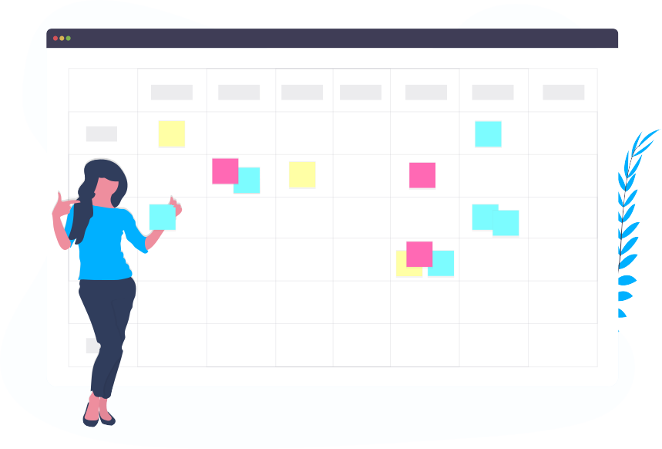
Project Schedule

Started at 10 January, 2021

1.5.2 Project Release Plan

1 July, 2021 (estimated Time)
1 Jun, 2021 (Finished)

Chapter 2: Software Requirement Specification

EXAM(online exam system)
Version 3.0

 |  | Reason for change
SRS_Exam_1.0 | 20-January-2021 | User profile, Functional requirement, non-functional requirement, Use case
SRS_Exam_1.1 | 21-January-2021 | Storyboard,  Database design,  requirement traceability
SRS_Exam_1.2 | 22-January-2021 | Admin part
SRS_Exam_1.3 | 23-January-2021 | Registration
SRS_Exam_1.4 | 24-January-2021 | Login
SRS_Exam_1.5 | 25-January-2021 | Flask (virtual environment)
SRS_Exam_1.6 | 26-January-2021 | Storyboard
SRS_Exam_1.7 | 29-January-2021 | NOSQL setup
SRS_Exam_1.8 | 30-January-2021 | Reg(username check)
SRS_Exam_1.9 | 31-January-2021 | Reg(pin add)
SRS_Exam_2.0 | 31-January-2021 | Login(check the username and password)
SRS_Exam_2.1 | 01-February-2021 | Log(User Teacher)
SRS_Exam_2.2 | 05-February-2021 | Log(User teacher Homepage)
SRS_Exam_2.3 | 09-February-2021 | Log(Session)

2.1 Functional and Non Functional Requirements

2.1.1 Functional requirement: Teacher

Requirement ID | FR.T.1
Requirement Name | Register
Description | AS Teacher

Requirement ID | FR.T.2
Requirement Name | Login
Description | AS Teacher

Requirement ID | FR.T.3
Requirement Name | Password recover
Description | Teacher can recover password

Requirement ID | FR.T.4
Requirement Name | Create Course
Description | Teacher put the course live for Students

Requirement ID | FR.T.5
Requirement Name | MCQ Upload
Description | Teacher can add a question in the Question Bank

Requirement ID | FR.T.6
Requirement Name | Generate Question-paper
Description | Teacher can generate a question for exam

Requirement ID | FR.T.7
Requirement Name | Enroll
Description | Teacher add the students created course.

Requirement ID | FR.T.8
Requirement Name | Evaluate a question
Description | Teacher add the question paper for Machine learning database by evaluating the difficulty.

Requirement ID | FR.T.9
Requirement Name | Active Students
Description | Teacher can monitor active students

2.1.2 Functional requirement: Students

Requirement ID | FR.S.1
Requirement Name | Register
Description | As Student

Requirement ID | FR.S.2
Requirement Name | Login
Description | AS Student

Requirement ID | FR.S.3
Requirement Name | Enroll
Description | Selected Course with a secret key

Requirement ID | FR.S.4
Requirement Name | Exam Schedule
Description | As students, they can view exams Schedules

Requirement ID | FR.S.5
Requirement Name | Exam entry
Description | Secret Exam key is the entry for the exam

Requirement ID | FR.S.6
Requirement Name | Answer Session
Description | Attend the exam as Students

Requirement ID | FR.S.7
Requirement Name | Course Detail
Description | Check the Course Outcomes or course info

2.2 Non-Functional Requirements

▪ User should be authenticated by the System for specific features: Request for
User As Teacher or Student or Teacher, Manage Request for Schedule, Add new Profile, Manage
Schedule, Review all Appointments, Requested Appointments, Clients, Manage
Users, Sign out.
▪ It should have password recover option
▪ This system should have supporting system where user can get support.
▪ This system Should have Session for Counselor, Client & Admin from Sign in
to Sign out.
▪ This system should have the process to create session for verified Users
▪ Users and Admin will have password retrieve option by
providing their per-registered email.
▪ To make this Web Application user friendly and reduce the page number it
should some modals (popup).
▪ User password must be encrypted before storing it in Database.

2.2 User Profile

2.2.1 User Profile -1

User Class: Employee | Characteristics | Requirement Implied
User type | Primary | Must give input
Age range | 18-65 | Minimal Design
Number of users | Unlimited | Bandwidth with nother computer in office
Education | N/A | Simple interface
Language Skill | English | Simple English
Computer Knowledge | Yes | Type option
Training | required | required
Goal | As a Teacher | Activity of teacher

2.2.2 User Profile -2

User Class: Manager | Characteristics | Requirement Implied
User type | Secondary | Must see output
Age range | 13-40 | Minimal Design
Number of users | Unlimited | Bandwidth with nother computer in office
Education | Higher education | Simple interface
Language Skill | English | Simple English
Computer Knowledge | Yes | Only type or click option
Training | Required | 2 days training will be provided
Goal | AS a Student | Attend the Course And Exam

2.2.3 User Profile -3

User Class:  Personal user (Total Spends) | Characteristics | Requirement Implied
User type | primary | Must see input,output
Age range | 45-65 | Minimal Design
Number of users | 2 | Not required
Education | Normal | Simple interface
Language Skill | English | Simple English
Computer Knowledge | Yes | Only type or click option
Training | Required | Not required
Goal | AS a admin | Provide Notice...

Chapter 3 : System Analysis

3.1 Use case diagram:

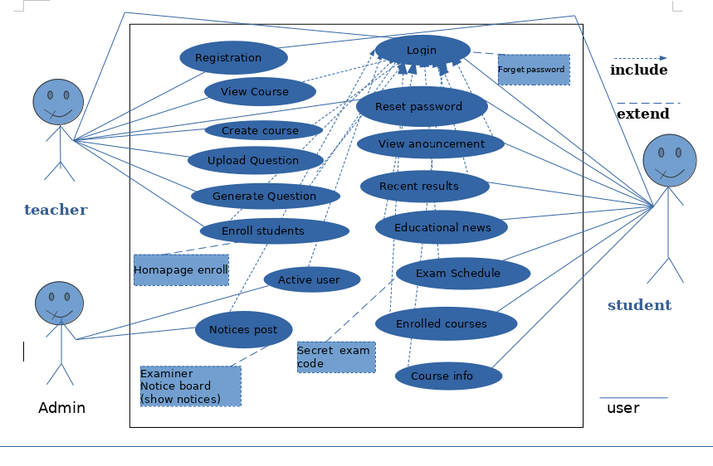
3.2 Identifying Use Cases

UC-1: Registration
UC-2: Login
UC-3: Reset Password
UC-4: Create Course(for Teacher)
UC-5: View Courses(for Teacher)
UC-6: Upload Question(for Teacher)
UC-7: Generate Question(for Teacher)
UC-8: Enroll Students(for Teacher)
UC-9: View announcement(for Students)
UC-10: Recent Result(for Students)
UC-11: Educational news(for Students)
UC-12: Exam Schedule(for Students)
UC-13: Enrolled Courses(for Students)
UC-14: Course info(for Students)
UC-15: Active users
UC-16: Notices post
UC-17: Secret exam code

3.3 Identifying Use Cases Description

Use Case Id | UC-1
Use Case name | Registration
Scenario | User can do Registration to create a new account
Triggering event | If any user want to create a new account and clicked Sign up button.
Brief description | User can create an account, Where it should be provided some basic information about user : User Name, Email, Password and user type:Teacher, Student, Admin.
Actors | Teacher, Student, Admin.
Extending use case | None
Included use case | None
Stakeholders | Teacher, Students.
Pre-Condition | User must have a new email address to create a new  account.
Basic path | 1. Click on “Sign up” link on Home page  2. Get Registration page  3. Enter the User Name  4. Enter the Email  5. Enter the Password  6. Re-Enter the Password  7. Select user type ( Teacher or Students )  8. Click on Submit button
Alternative path | None
Exceptional path | None
Post-Condition | All the input values must be validate.
Table: 3.3.1 use case description Registration
Use Case Id | UC-2
Use Case name | Login
Scenario | User can Log in to the system if they have account.
Triggering event | If any user want to Log in to the System and clicked Sign in button. Or want to use any feature that required Authentication then this page will be appear.
Brief description | User can click on Sign in button to log in to the system. Then Log in page will be appear. It will ask for Email and Password, click on Log in button. It will also have some extending features: Don’t have account? , Forgotten Account? .
Actors | Teacher, Student, Admin
Extending use case | UC-3: Reset Password ( Forgotten Password? )
Included use case | None
Stakeholders | Teacher, Student, Admin
Pre-Condition | User must have an account and remember the password for Log in to the System.
Basic path | 1. Click on “Log in” button  2. Get Login in page  3. Enter the Email  4. Enter the Password  5. Click on Log in button
Alternative path | None
Exceptional path | None
Post-Condition | All the inputs must be matched with the account details.
Table: 3.3.2 use case description Login

Use Case Id | UC-3
Use Case name | Reset Password
Scenario | If the user forget his / her account then they can Retrieve Password or account.
Triggering event | If any user forget his or her account and clicked “Forgotten Account?” link.
Brief description | User may forget his / her password then they will have a  option by what they will provide their email and send the  code that code will be one time code that will be use to verify  their account and after verified the account user can enter a  new password and re-enter the same password and confirm  it. That new password will be saved in to the system.
Actors | Teacher, Student, Admin
Extending use case | None
Included use case | None
Stakeholders | Teacher, Student
Pre-Condition | User must have pre-registered email address remembered.
Basic path | 1. Click on “Forgotten Password” link on Sign in page  Basic path  2. Get Forgotten Account Email page  3. Enter pre-registered email address  4. Click the button “Send reset-password request” to get the code  5. Get the verification link on email  6. Enter that link to verify the account  7. Click the button “Verify”  8. Get Forgotten Account New Password page  9. Enter the New Password  10. Re-enter same password  11. Click the button “Confirm”  12. Get the Sign in page
Alternative path | None
Exceptional path | None
Post-Condition | New password must be matched
Table: 3.3.4 use case description Reset Password

Use Case Id | UC-4
Use Case name | Create Course
Scenario | Teacher can create a Course with a course title,expire date and with a specific course code.
Triggering event | If Teacher want to create a new course and clicked Create Course nav-link button.
Brief description | Teacher must have to register himself or herself, for create a course, monitor.
Actors | Teacher
Extending use case | None
Included use case | None
Stakeholders | Teacher
Pre-Condition | User must have pre-registered email address remembered.
Basic path | 1. Click on “Create Course” button on navbar-link.  2. Get Create Course Page.  3. Checked any all form and fill them  4. Click the button “Create course button”.  5.If successful, get the home page.
Alternative path | none
Exceptional path | none
Post-Condition | Teacher must have to logged in.
Table: 3.3.4 use case description Create Course

Use Case Id | UC-5
Use Case name | View Courses
Scenario | Teacher can view the Courses he/she created. Teacher can view courses Title,Course code,Course caption,Course expire date.
Triggering event | If teacher click on any Course card.
Brief description | User can view created courses of current semester. if click on Course card  question view page will be appear with all the links, then user can choose any of them and another tab will be appear on browser.
Actors | Teacher
Extending use case | None
Included use case | UC-2 : Login
Stakeholders | Teacher
Pre-Condition | None
Basic path | 1. Click on “View courses” button.  2. Get the “View Courses Page”.
Alternative path | None
Exceptional path | None
Post-Condition | none
Table: 3.3.5 use case description View Courses

Use Case Id | UC-6
Use Case name | Upload Question
Scenario | Teacher can upload new Question for the stored question bank.
Triggering event | Upload new Question.
Brief description | Teacher have to upload question for automated generation question paper.  Question Bank have to be full with Course code’s questions.
Actors | Teacher
Extending use case | none
Included use case | UC-2 : Login
Stakeholders | Teachers,Students.
Pre-Condition | User must have to be logged in.
Basic path | 1. Click on “Upload new Question”.  2. Get Upload Question page.  3. Select a lesson.  4. Select question complexity level.  5. Select a course learning outcome.  6.Enter a question which will be uploaded.  7.Enter options.  8.Enter correct Answer.  9.Click on “Upload questions” for completion of the Upload.
Alternative path | 1.Click on “Add another Question” for adding a another question.  2.Enter a question which will be uploaded.  3.Enter options.  4.Enter correct Answer.
Exceptional path | None
Post-Condition | None
Table: 3.3.6 use case description Upload Question.

Use Case Id | UC-7
Use Case name | Generate Question
Scenario | Teacher can generate question slot.
Triggering event | If teacher click on “Generate Question” button.
Brief description | Teacher don’t have to fixed the exam paper for every students. Teacher will fill the needs in the generate question page.
Actors | Teacher
Extending use case | none
Included use case | UC-2 : Login
Stakeholders | Teacher
Pre-Condition | Must have selected course questions in question bank.
Basic path | 1. Click on “Upload new Question”.  2. Get Upload Question page.  3. Select Exam title.  4. Select Exam start time.  5. Select Exam End time.  6. Select Date field Calendar Date  7. Enter question paper caption  8. Enter a secret Code for confirmation.  9. Select question type.  10. Click ‘Add more button’ for multiple options  11.Select multiple Course Outcome.  12.Select multiple topic.  13.Select multiple Complexity Level.  14.Select multiple marks for each lesson  15. Click on “Generate” for Generate Question paper.
Alternative path | none
Exceptional path | none
Post-Condition | Have to fill all form info’s.
Table: 3.3.7 use case description Generate Question

Use Case Id | UC-8
Use Case name | Enroll Students
Scenario | Teacher can select which students can enroll, from the created course.
Triggering event | If any Teacher Click on “Students” button from question view page.
Brief description | If Teacher want to search available students by selecting sector they can do. If they don’t want to search they can just select them and Send mail with a enroll key.
Actors | Teacher
Extending use case | Homepage enroll form
Included use case | UC-2 : Login
Stakeholders | Teacher,students
Pre-Condition | none
Basic path | 1. Click on “Students” in Question view page.  2. Get the page Students_list for enrollment  3. Select checkbox for send the mail to selected address.  4. Click on “Search” button.
Alternative path | none
Exceptional path | none
Post-Condition | none
Table: 3.3.8 use case description Enroll Students

Use Case Id | UC-9
Use Case name | View announcement
Scenario | Student can view the announcement of the teacher.
Triggering event | No action needed. Automatically load in the homepage
Brief description | Students can monitor the latest announce.
Actors | student
Extending use case | none
Included use case | UC-2 : Login
Stakeholders | Teacher, Students
Pre-Condition | none
Basic path | No action needed.
Alternative path | none
Exceptional path | none
Post-Condition | none
Table: 3.3.9 use case description View announcement
Use Case Id | UC-10
Use Case name | Recent Results
Scenario | Students can view there exam results.
Triggering event | No action needed. Automatically load in the homepage.
Brief description | Students can monitor the latest exam results.
Actors | students
Extending use case | None
Included use case | UC-2 : Login
Stakeholders | Teacher, Students
Pre-Condition | None
Basic path | No action needed.
Alternative path | None
Exceptional path | None
Post-Condition | Have to logged in first.
Table: 3.3.10 use case description Recent Results

Use Case Id | UC-11
Use Case name | Educational news(for Students)
Scenario | Students can see latest Education board news.
Triggering event | No action needed. Automatically load in the homepage.
Brief description | Students can monitor the latest education board news.
Actors | students
Extending use case | none
Included use case | UC-2 : Login
Stakeholders | Students
Pre-Condition | none
Basic path | No action needed.
Alternative path | None
Exceptional path | none
Post-Condition | none
Table: 3.3.11 use case description Educational news

Use Case Id | UC-12
Use Case name | Exam Schedule (for Students)
Scenario | Students can see recent date exams created by course teacher.
Triggering event | If student click on “Exam-Schedule” nav-button.
Brief description | Student can view there recent exam schedules for Attending the exam
Actors | students
Extending use case | UC-17: Secret exam code
Included use case | UC-2 : Login
Stakeholders | Teacher, students
Pre-Condition | None
Basic path | 1. click on nav-button “Exam-Schedule”.  2. get the of viewing exam schedules.
Alternative path | none
Exceptional path | none
Post-Condition | none
Table: 3.3.12 use case description Exam Schedule

Use Case Id | UC-13
Use Case name | Enrolled Courses(for Students)
Scenario | Students can view their own enrolled course.
Triggering event | Students click on “Enrolled-courses” nav-button.
Brief description | If any students want to see the courses he/she enrolled, By clicking the button he/she can see and by clicking on course card they can see all the details of that course.
Actors | Student
Extending use case | none
Included use case | UC-2 : Login
Stakeholders | students
Pre-Condition | none
Basic path | 1. click on “Enrolled-courses” nav-button  2.Go to the Enrolled-course page.  3. find the desire course.  4.Click on course card for further details.
Alternative path | none
Exceptional path | none
Post-Condition | none
Table: 3.3.13 use case description Enrolled courses

Use Case Id | UC-14
Use Case name | Course info
Scenario | Students can see Course info
Triggering event | Click on Course Card.
Brief description | 1. click on Course card  2.Go to course page for all detail for about course.
Actors | Students
Extending use case
Included use case | UC-2 : Login
Stakeholders | Students
Pre-Condition | none
Basic path | 1.click on Course Card  2. go to the view detail page.
Alternative path | none
Exceptional path | none
Post-Condition | none
Table: 3.3.14 use case description Enrolled courses

Use Case Id | UC-15
Use Case name | Active user
Scenario | Admin can monitor how many user are active registered.
Triggering event | After logged in as admin.
Brief description | Admin after logged in he can see the active users.
Actors | Admin
Extending use case | none
Included use case | UC-2 : Login
Stakeholders | Admin,Students,teacher
Pre-Condition | none
Basic path | 1.login as admin
Alternative path | none
Exceptional path | none
Post-Condition | none
Table: 3.3.15 use case description active user

Use Case Id | UC-16
Use Case name | Notices post
Scenario | Admin can post Notices for Teachers.
Triggering event | If admin click on “Notices” nav-button.
Brief description | If admin want to post Notices for teachers they can do.
Actors | admin
Extending use case | none
Included use case | UC-2 : Login
Stakeholders | teacher
Pre-Condition | none
Basic path | 1. click on “notices” button.  2. fill form and post the notices.
Alternative path | none
Exceptional path | none
Post-Condition | none
Table: 3.3.16 use case description Notices post

Use Case Id | UC-17
Use Case name | Secret exam code
Scenario | If any student want to attend the exam.
Triggering event | If student Exam_Schedule card clicked
Brief description | Before attend the exam student need to confirm the exam code.
Actors | Students
Extending use case | none
Included use case | UC-2 : Login
Stakeholders | Students,Teachers
Pre-Condition | none
Basic path | 1. click on Exam-Schedule card  2.Enter the exam code.
Alternative path | none
Exceptional path | none
Post-Condition | none
Table: 3.3.17 use case description Notices post

3.4 System Sequence Diagram.

Teacher
Create Course
View Courses
Upload Question
Generate Question

Chapter 4: SYSTEM DESIGN SPECIFICATION

4 File Structure

admin ();
Regtistration ();
login ();
billcounter ();
billentry ();
calculator ();
Search ();
toallist ();
management();
hotel();
pharmacy();
Supeermarket();

Chapter 3: Implementation and Testing

Welcome page
There Are 7 option you have to input the frist letter of the option,
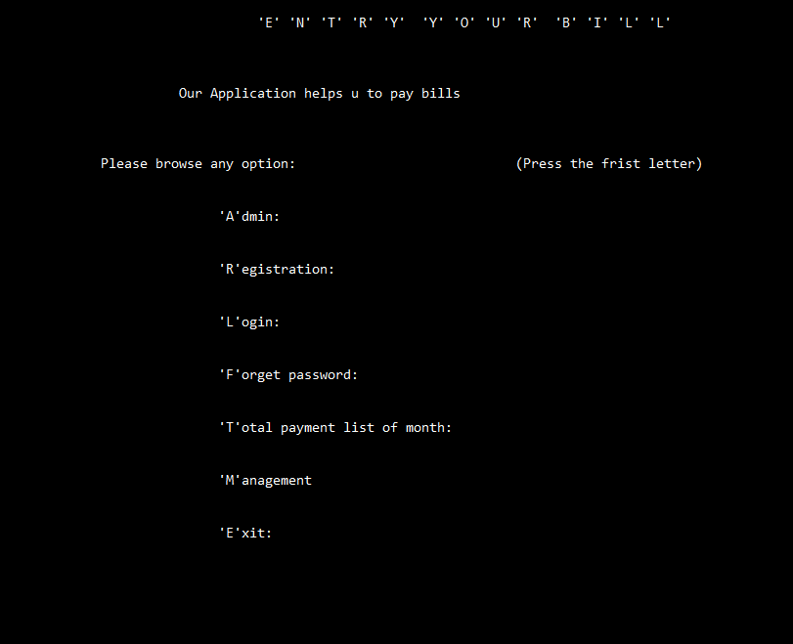

Admin
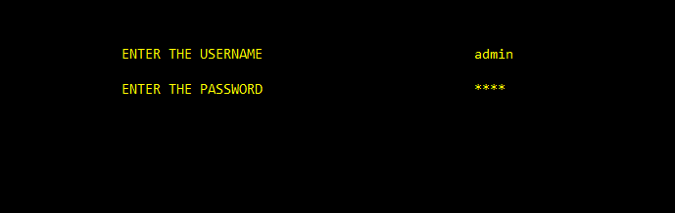
IF u give wrong username password
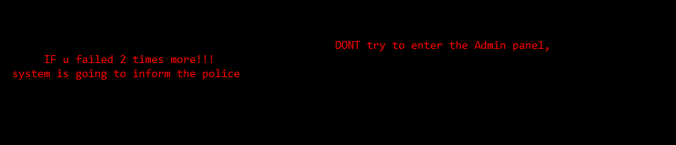
If admin search some user (must give username)
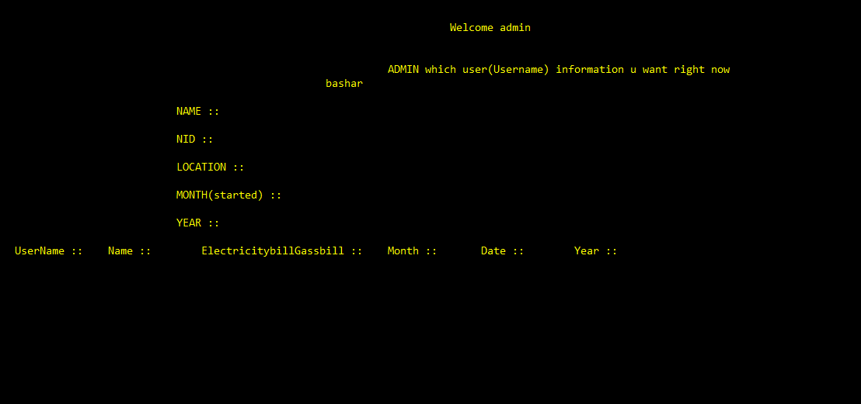
Registration

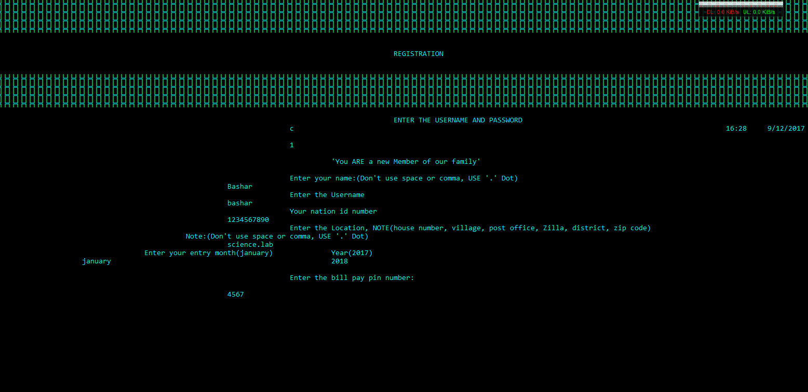
If u fill the information correctly
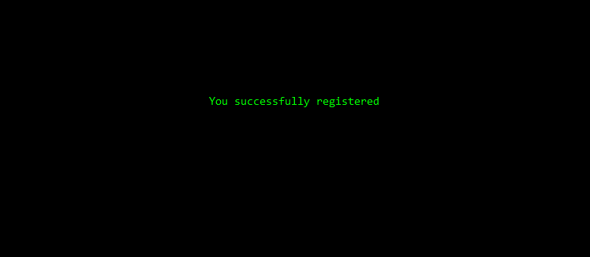

Login

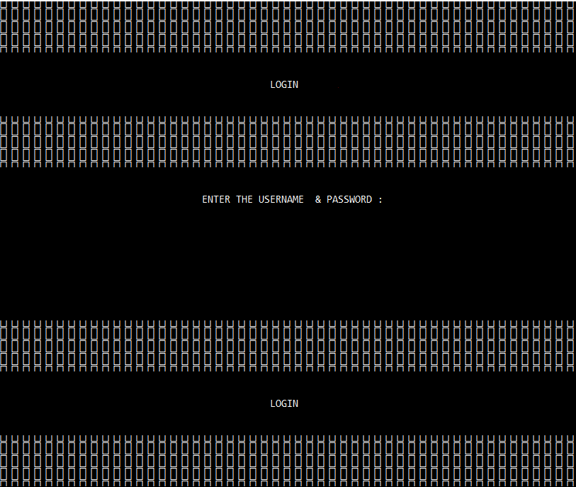
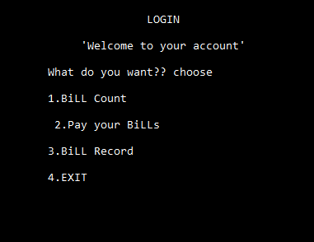
Choose one option to browse
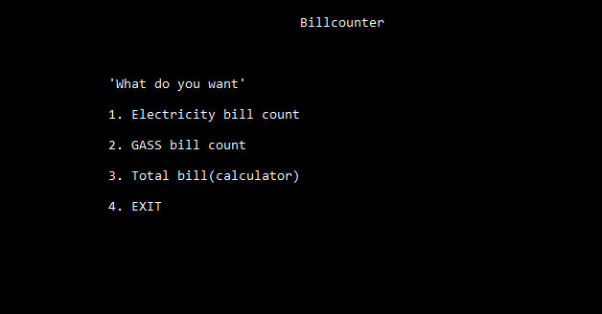
Choose what type user
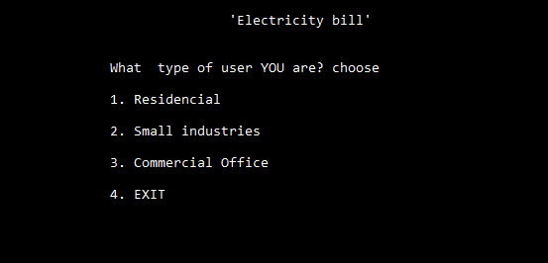
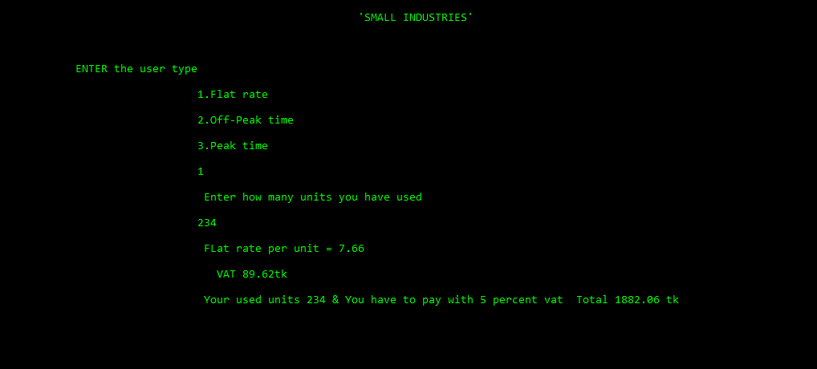
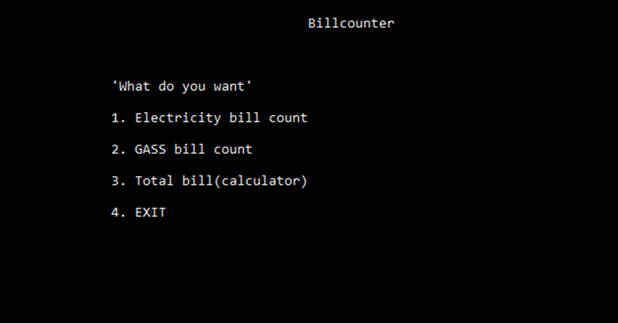
If you enter the gassbill counter
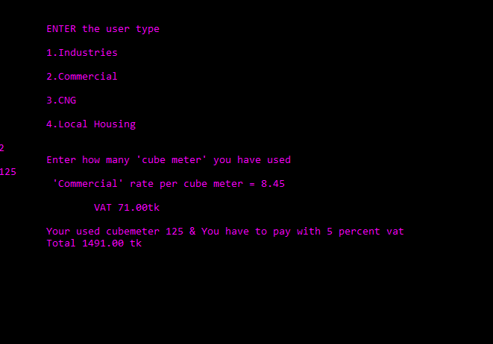
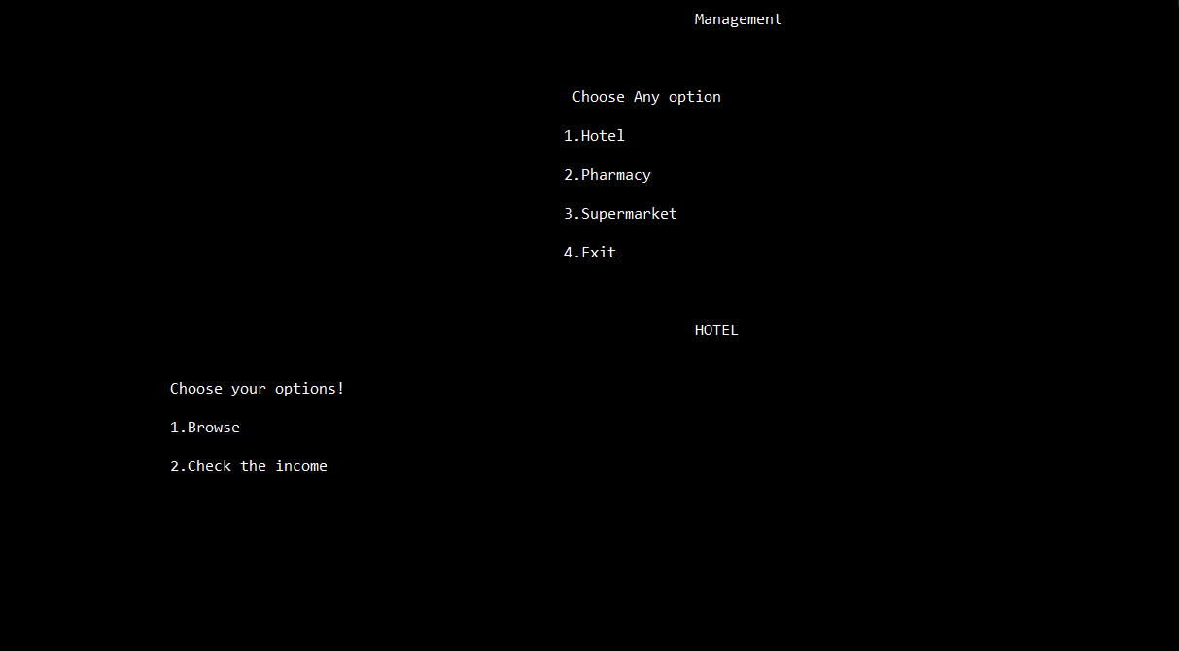
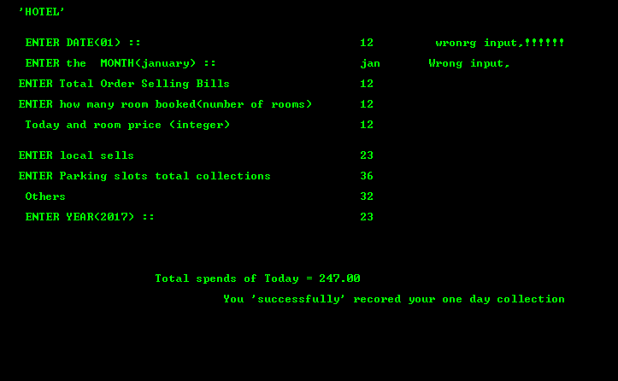
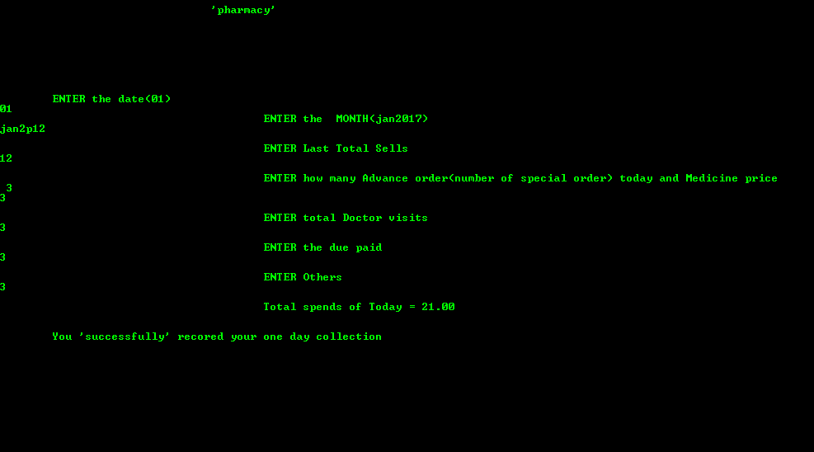

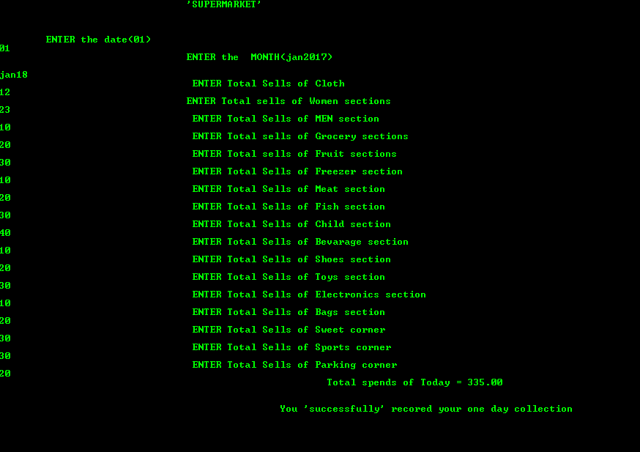

4.1 Tools and Technology(software and hardware)

Software and application platform
- CodeBlocks
- Dev++
Hardware
Unfortunately there is no hardware used in my project.

Chapter 5: Conclution

References

- Bangladesh electricity pay bill slip.
- My mother monthly spends pad.
- My friend pharmacy record book.
- My Uncle supermarket.

Appendix

- Header Files
S. NO | Header Files | Description
1. | #include<conio.h> | This is console input/output header file
2. | #include<stdio.h> | This is standard input/output header file in which Input/outputfunctions are declared
3. | #include<windows.h> | Creates the color window on the screen.  Set the curser.
4. | #include<stdlib.h> | This header file contains general functions used in C programs
6. | #include<string.h> | All string related functions are defined in this header file
Table – 3.1: List of Header File
a)#include<conio.h>
conio.h is a C header file used mostly by MS-DOS compilers to provide console input/output. It is not part of the C standard library or ISO C, nor is it defined by POSIX. This header declares several useful library functions for performing "console input and output" from a program.

Some of its inbuilt functions are:

S.NO | Inbuilt Functions | Description
1. | clrscr() | -It is used to clear the screen
2. | cgets() | -Reads a string from the keyboard
3. | getch() | - Reads a character from keyboard
4. | getche() | - Reads a character from keyboard and echoes it to the screen
5. | kbhit() | - Determines if a keyboard key was pressed
6. | putch() | - Determines if a keyboard key was pressed
7. | cputs() | - Writes a string to the screen
Table - 3.2:Built In Functions Of conio.h

b) #include<stdio.h>
The C standard library is the standard library for the C programming language, as specified in the ANSI C standard.^{[1]} It was developed at the same time as the C library POSIX specification, which is a superset of it.[2][3] Since ANSI C was adopted by the International,^{[4]} the C standard library is also called the ISO C library.
Some of its inbuilt functions are:

S.NO | Inbuilt Functions | Description
1. | printf() | This function is used to print the character, string, float, integer, octal and hexadecimal values onto the output screen
2. | scanf() | This function is used to read a character, string, and numeric data from keyboard.
3. | getc() | It reads character from file
4. | gets() | It reads line from keyboard
5. | getchar() | It reads character from keyboard
6. | puts() | It writes line to o/p screen
7. | putchar() | It writes a character to screen
Table - 3.3:Built In Functions Of stdio.h
c)#include<windows.h>
There are many header files present in a C Programming language.
Dos.h is one among the header files. It contains functions for handling interrupts, producing sound, date and time functions etc. It is a Borland specific and works in turbo c compiler.
Some of its inbuilt functions are:

S.NO | Inbuilt Functions | Description
1. | - delay | -Abort Program.
4. | - nosound | -Get Environment String.
5. | - SYATEMTIME | -Perform Operating System Command
6. | - Sleep | -Generate Pseudo-Random Number
Table - 3.4:Built In Functions Of windows.
d)#include<stdlib.h>
stdlib.h is the header of the general purpose standard library of C programming language which includes functions involving memory allocation, process control, conversions and others. The name "stdlib" stands for "standard library".

Some of its inbuilt functions are:
S.NO | Inbuilt Functions | Description
1. | abort | -Abort Program.
2. | atexit | -Register Function to be Called at Program Exit.
3. | exit | -Exit from Program.
4. | getenv | -Get Environment String.
5. | system | -Perform Operating System Command
6. | rand | -Generate Pseudo-Random Number
7. | srand | -Seed Pseudo-Random Number Generator
Table - 3.5:Built In Functions Of stdlib.h
e)#include<string.h>
A set of simple string manipulation functions are implemented in <string.h>, or on some systems in <strings.h>. The string library (string.h or strings.h) has some useful functions for working with strings, like strcpy, strcat, strcmp, strlen, strcoll, etc.
Some of its inbuilt functions are:

S.NO | Inbuilt Functions | Description
1. | memcmp | -Compare Memory Blocks
2. | strcmp | -String Compare
3. | strcoll | -String Compare Using Locale-Specific Collating Sequence
4. | strncmp | -Bounded String Compare
5. | strxfrm | -Transform Locale-Specific String
6. | strcat | -String Concatenation
7. | memmove | -Copy Memory Block.
Table - 3.6:Built In Functions Of string.h

- Source code

http://codepad.org/wsxcpW7M

