Freight Rate Prediction: Validation Approach
Candidate report for the Spotter Machine Learning Engineer assessment.

1. Data and split strategy
The labeled development data (train_test.csv, 48,000 loads) covers 2025-01-01 to 2025-10-31. The 12,000 loads to predict (validation.csv) cover 2025-11-01 to 2025-12-31, so the task is forecasting the next two months. A random train/test split would mix Nov-Dec-like market conditions into training and overstate accuracy. I therefore validated in time order:
- Rolling-origin folds: train on all data before the cut-off, test on the following two months. Folds: test May-Jun, test Jul-Aug, test Sep-Oct (train Jan-Aug).
- The Sep-Oct fold is the best proxy for the real test (same 2-month horizon, most recent regime).
- The final model is refit on all 48,000 labeled rows; the fold results are used only to choose between designs.
Two facts shaped the design: 736 validation routes never appear in training (so no route-level target encoding), and the December chart inputs have no market_index or quote_signal (see section 4).

2. Data-quality issues and handling
Issue | Evidence | Handling
Negative weights | 292 train / 145 validation rows with sign flipped | Use absolute value
Weight capped at 47,500 | 1,191 train / 297 validation rows at the cap | Keep value, add cap flag
Missing weight / market_index | 300 / 374 train rows (165 / 249 validation) | Weight: native NaN in LightGBM. market_index: same-day mean
Corrupted rates | About 1.1% of rows have rate per mile <0.8 or >6 (up to $14/mile) | Dropped from training; Huber loss for robustness
Noisy listed distance | Route std about 19 mi; 214 rows >1.5x the straight-line distance | Route-median distance and distance/haversine features

3. Model and results
LightGBM regressor on log(rate) with Huber loss, averaged over 3 seeds. Features: distance, straight-line distance, distance ratio, route-median distance, weight, cap flag, equipment, pickup/delivery coordinates, market_index, quote_signal. Rate per mile falls with distance and differs by equipment, which trees capture without hand-tuning. Date-level residuals correlate strongly with market_index (0.71) and also show a slow upward drift (about +0.02% per day at equal market index), so a linear time trend is added as an offset instead of letting the trees extrapolate a flat level.
Variant (mean of 3 folds) | MAE | MAE (clean labels) | Sep-Oct MAE (clean)
A. Baseline, all labels | 118.1 | 73.9 | 90.6
B. + drop corrupted labels | 117.8 | 73.6 | 90.4
C. + route-median distance | 117.8 | 73.6 | 90.5
D. + linear time trend (final) | 116.4 | 72.2 | 48.6

Held-out Sep-Oct with the final design: MAE $93.9 overall, $48.6 on rows with plausible labels, median absolute percentage error 1.3%. Overall RMSE (about $630) is dominated by the corrupted labels that no model can predict. Caveat: the trend term hurt the Jul-Aug fold, where the market index was falling and the trend was estimated from a shorter history; with the full 10 months the estimate is more stable, but the size of the Nov-Dec drift remains an assumption.

4. Fixed December prediction chart
December inputs are fixed (Lexington to Fort Wayne, 360 miles, Dry Van, 32,000 lb) and contain no market_index or quote_signal. For each December date I used the daily average market_index observed in validation.csv (features only, no labels) and the December average quote_signal, so the chart varies with the date only through the market index and the trend.
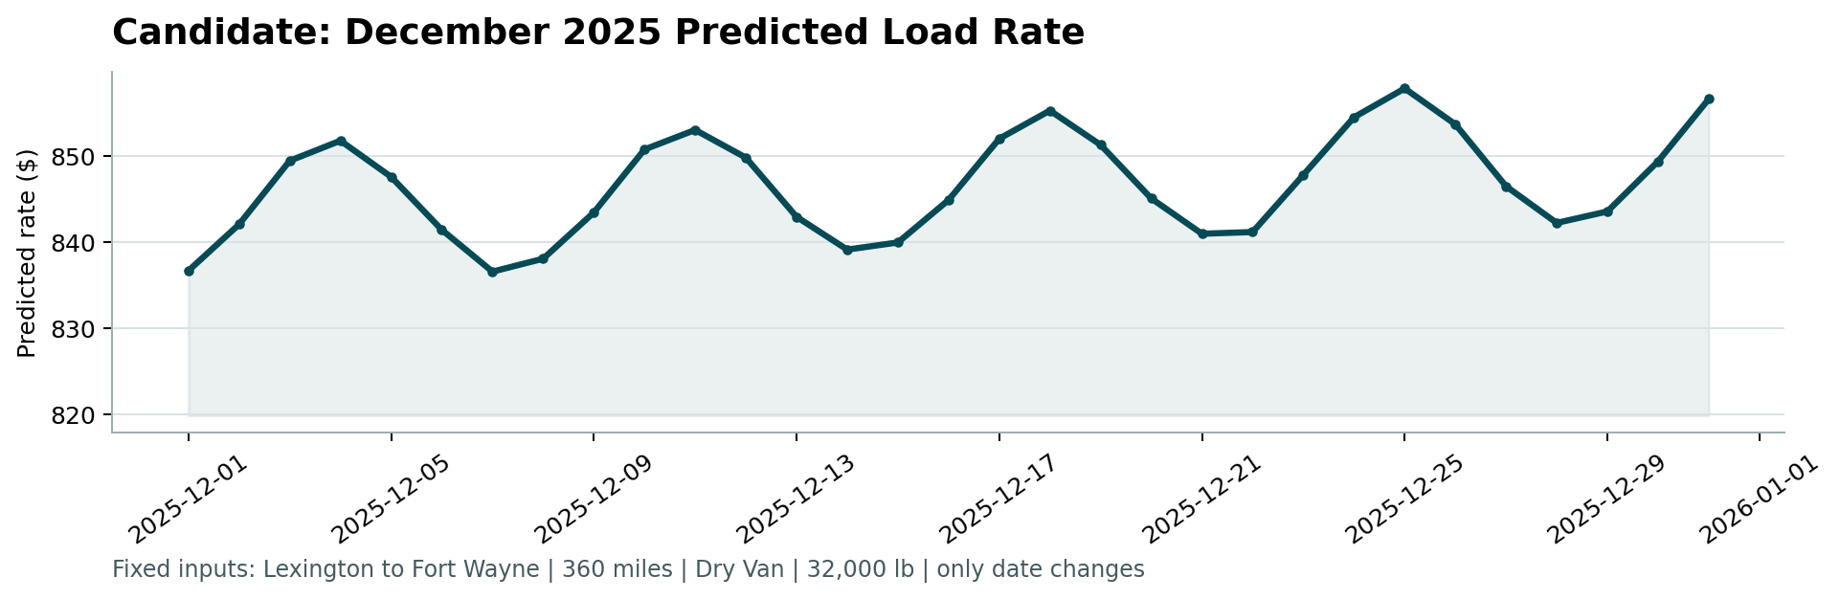
Predicted rates range from about $837 to $858 across the month. The model has no December-specific holiday information because training data ends in October, so holiday effects are not captured.

