Objective:

To find the value of gravitational acceleration “g”.

Apparatus Required:

Compound Pendulum, G clamp, V shape knife edge, meter rod, and a stop watch.

Theory:

A compound pendulum or physical pendulum is a rigid body which is suspended from one end and the other is free to rotate. In Simple Pendulum, the whole mass is concentrated at the bob of the pendulum, while here in compound pendulum the whole mass is distributed over the entire body. Simple pendulum is a special case of compound pendulum where all the mass is concentrated in bob and the string is massless. Bar pendulum is an example of compound pendulum which is composed of rod of length one meter and has 19equally spaced holes. The distance between the two holes is 5 centi-meter.The following figure shows a bar pivoted so that it can turn without friction about an axis through point “O”. In equilibrium position the centre of gravity is directly below the pivot. The bar is displaced from equilibrium position by an angle “ $θ$”, which we use as a coordinate for the system. The distance from point “O” to the centre of gravity is “r”, the moment of inertia of the bar about the axis of rotation through “O” is “I, and the mass of the bar is “m”.

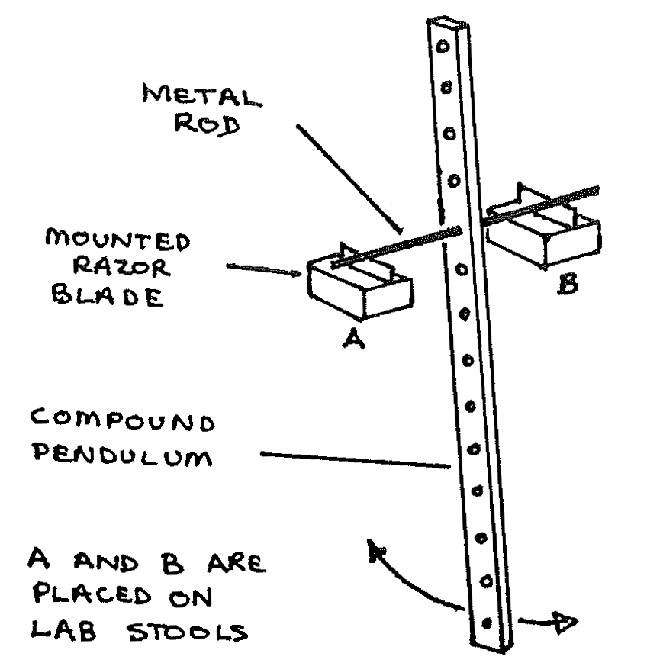

When the bar is displaced as shown, the weight “mg” causes a restoring torque which is given by

$T_{z}=-mgrsinθ$------------------------(1)

The negative sign shows that the restoring torque produced is in clockwise direction.

When the bar is released at its extreme position, it oscillates but about its equilibrium position. The motion is not simple harmonic because the torque ${"T}_{z}"$ is proportional to “sinθ” rather than to “θ” itself. However, for small “θ”, we can approximate “sinθ” by “θ” in radians, just as we did in analyzing simple pendulum. Then the motion is simple harmonic so eq(1) becomes

$T_{z}=-mgrθ$---------------------(2)

Also we know that

$T_{z}=Iα$----------------------(3)

Compairing (2) and (3), we get

$Iα=$ $-mgrθ$-----------------(4)

$I\frac{d^{2}θ}{{dt}^{2}}=-mgrθ$

* $\frac{d^{2}θ}{{dt}^{2}}=-\frac{mgrθ}{I}$---------------------------(5)

Which is comparable with simple harmonic equation, a=- $ω^{2}x$

Means that ω = $\sqrt{\frac{mgr}{I}}$, so the angular frequency is

$$f=\frac{1}{2π}\sqrt{\frac{mgr}{I}}$$

So $T=2π\sqrt{\frac{I}{mgr}}$----------------------------------------(6)

Where “I” is moment of inertia through the point of suspension.

Eq(6) can be used to find the period of the bar pendulum when we are familiar with moment of inertia of the bar. Similarly we can find the moment of inertia of irregular shaped objects by measuring time period for it experimently.

Using parallel axis theorem, we have

$$I= I_{CM}+ mr^{2}$$

* $I=m{(k)}^{2}+ mr^{2}$----------------------(7)

Putting (7) in (6), we get

$T=2π\sqrt{\frac{k^{2}+ r^{2}}{gr}}$------------------------------------(8) where k= radius of gyration.

Where L = $\frac{k^{2}+ r^{2}}{r}$

So T= $2π\sqrt{\frac{L}{g}}$-------------------------(9)

L = $\frac{l_{1}+ l_{2}}{2}$ (can be figured out from graph drawn)

$L= \frac{AB+CD}{2}$ (can be figured out from graph) Experimental Procedure:

1. We balanced the bar on a sharp wedge and marked the position of its C.G.
2. We fixed the knife edges in the outermost holes at either end of the bar pendulum. The knife edges were horizontal and lied symmetrically with respect to centre of gravity of the bar.
3. We suspended the pendulum vertically by resting the knife edge at end A of the bar.
4. We adjusted the lower end of the bar and put a reference mark on the wall behind the bar to denote its equilibrium position.
5. We displaced the bar slightly to one side of the equilibrium position and let it oscillate with the amplitude not exceeding 5 degrees.
6. We used the stop watch to measure the time for 10 oscillations.
7. We measured the distance “r” from C.G. to the knife edge.
8. We recorded the results in Table. Repeating the measurement of the time for 10 oscillations.
9. We suspended the pendulum on the knife edge of side B and repeated the measurements in steps 5 to 9 as mentioned above.
10. We fixed the knife edges successively in various holes on each side of C.G. and in each case, measuring the time for 10 oscillations and the distance of the knife edges from C.G.
11. TABLE FOR HOLES ABOVE CG

|  |  |  |  |  |  |  |
| --- | --- | --- | --- | --- | --- | --- |
| S.NO. | Hole Number | distance from CG (cm) |  | No. Of oscillations | Time period for 10 vibrations(t) | Time period(T=t/n) |
| 1 | 1 | 45 |  | 10 | 16.505 | 1.8 |
| 2 | 2 | 40 |  | 10 | 15.945 | 1.5 |
| 3 | 3 | 35 |  | 10 | 15.48 | 1.4 |
| 4 | 4 | 30 |  | 10 | 15.215 | 1.35 |
| 5 | 5 | 25 |  | 10 | 15.48 | 1.35 |
| 6 | 6 | 20 |  | 10 | 15.45 | 1.4 |
| 7 | 7 | 15 |  | 10 | 17.18 | 1.49 |
| 8 | 8 | 10 |  | 10 | 19.96 | 1.8 |
| 9 | 9 | 5 |  | 10 | 26.295 | 2.29 |

TABLE FOR HOLES BELOW CG

|  |  |  |  |  |  |
| --- | --- | --- | --- | --- | --- |
| S.NO. | Hole Number | distance from CG (cm) | No. Of oscillations | Time period for 10 vibrations(t) | Time period(T=t/n) |
| 11 | 1 | 5 | 10 | 26.2 | 2.29 |
| 12 | 2 | 10 | 10 | 19.9 | 1.8 |
| 13 | 3 | 15 | 10 | 17 | 1.49 |
| 14 | 4 | 20 | 10 | 16 | 1.4 |
| 15 | 5 | 25 | 10 | 15.4 | 1.35 |
| 16 | 6 | 30 | 10 | 15.2 | 1.35 |
| 17 | 7 | 35 | 10 | 15.4 | 1.4 |
| 18 | 8 | 40 | 10 | 16 | 1.5 |
| 19 | 9 | 45 | 10 | 16.5 | 1.8 |

Graph from plotted table:

X axis = distance of suspension point from CG

Y axis = Time period

Calculations from graph

|  |  |  |  |  |  |  |
| --- | --- | --- | --- | --- | --- | --- |
| serial no | AC(cm) | BD(cm) | L=(AC+BD)/2 | T² | L/T² |  |
| 1 | 55 | 50 | 52.5 | 2.22 | 23.45 |  |
| 2 | 55 | 55 | 55 | 2.102 | 26.1 |  |
|  |  |  |  |  |  |  |
|  |  |  |  |  |  |  |

g=g1+g2/2

g1=4π²23.45cm/sec²

g1=9.24m/sec²

g2=4π²26.1cm/sec²

g2=10.1m/sec²

g=9.24+10.1/2

g=9.76m/sec²

The value of g is 9.76m/sec²

%Error:

**%Error = $\frac{9.8-9.76}{9.8}*100$**

**%g difference=0.7%**

Precautions:

1. Make sure that there is no rotational motion associated with the pendulum.

2. The jerk should be very small and of very small amplitude up to 5°.

3. Stopwatch should be precise and maximum effort shall be made to make time reading

accurate.

4. The air resistance shall be negligible in the experimental area.

References:

University physics 13th edition

https://www.youtube.com/watch?v=beKbi_sUQ9Q&t=26s