C:\Program Files (x86)\Microsoft Office\MEDIA\CAGCAT10\j0300840.wmf C:\Program Files (x86)\Microsoft Office\MEDIA\CAGCAT10\j0300840.wmf

***VIP CULTURE:***

|  |
| --- |
| images (8).jpg |
| images (5).jpg |

2017

***Basharat Hussain Ammad Amir***

***P17-6102 p17-6119***

***10/23/2017***

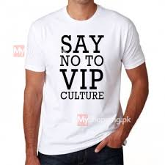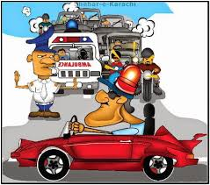

***PROJECTS OUTLINES:***

* ***Definition :***

* ***VIP Culture a Problem :***
* ***VIP Culture in Pakistan:***
* ***Causes & Effects :***
* ***Personal Experience :***
* ***Campaign Name:***
* ***Awareness :***
* ***Capital (Money):***
* ***How to finish VIP culture in Pakistan:***
* ***Problem Solved / unsolved:***
* ***Future Vision :***

***VIP- CULTURE***

***Definition:***

***“A very important person (VIP) is a person who is accorded special***[***privileges***](https://en.wikipedia.org/wiki/Privilege_(legal_ethics))***due to their***[***status***](https://en.wikipedia.org/wiki/Social_status)***or importance.”***

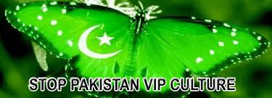

***VIP Culture a Problem?***

***It is an amalgamated result of several factors common to Pakistani society — factors whose existence we do not question or realize that they play a vital part in our behavior.***

***There is no denying the fact that Pakistani society is structured on the basis of class differences. We have the elite,***

* ***The upper class,***
* ***The middle-class and***
* ***The lower class,***

***All playing their roles on a daily basis. To remove a weed, one must find its root and pull it out. The question is whether VIP culture itself is the problem.***

***They created VIP culture which is existing till today in the shape***

* ***Capitalist,***
* ***Military and***
* ***Mullah (Islamic Religious Leaders) Alliance.***

***They are united to mentain VIP culture in Pakistan.*  
*The people relating to oppressed nations (Sindhis, Balochs, Pathan, Gilgiti,Kashmiri and Seraikis) want and need rid of VIP culture. All ruling and waiting for rule political parties, religious parties and ethnic groups are supporting VIP culture in Pakistan. They are safe guards for status quo and present political system based on VIP culture.***

***VIP Culture in pakistan:***

***VIP culture is very common in our country. Even we are full of examples where vip culture took precious lives of people, like the death of Bismah, chairperson pakistan people’s party Banazir bhutto once visted a public hospital in karachi, because of her protocol, the patient Bismah unable to approach the doctors and she lost her life. In return CM punjab grant her father with a government job and gave him some money to shut his mouth up. This culture really ruin our society. VIP culture is one of the basic factor, because of which the name of our country is not included in the list of most developed countries people not reach on their jobs , students not reach to their schools and universities on time because all the roads around offices, schools and universities get blocked when an official person passes.***

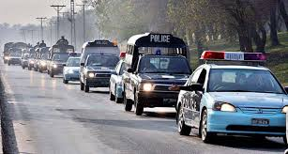

***So I think it is impossible to include oueselves in the list of developed countries untill we will remove class difference from our society.***

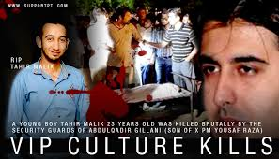

***Effects and Causes of VIP Culture:***

***VIP culture is on the rise and it is becoming very undemocratic, and a new form of racism in our society for its culture is against the idea of equality as it makes some citizen inferior than others. There can be no argument that some people deserve special treatment. However, it’s conventionally forgotten that the treatment is reserved only for the special office they hold, not for the individual per se. The president or PM of the country, for example, is protected across the world. It’s because the office they represent and the symbolic importance they carry. the common man who pays the bills for the VIP security while he himself remain exposed to crimes, unsafe at street and even unsafe in its own home***

*** Personal Experience:***

***VIP is abbreviated as very important person, so VIP culture is defined as if a high ranking offical or important guest is accorded with a special treatment,then that is called VIP culture. This is a simple one line definition of VIP culture, but the topic is not that much limited, we can observe vip culture all round us. would like to elaborate my topic with a real incident that happend to me when I was 6. I got an oppurtunity to travel from islamabad to gilgit by plane, till that time I was unaware of a fact that the plane is divided into two parts, business class for vips and economic class for non-vips . unfortunatily I was also with the people of economic class. My father was with me at that time, when I expressed my wish infront of him that I also want to be part of that business class, he explained something to me, which really minimized my self respect, for few moments I felt that I’m an unimportant person on this planet, I really felt shame on myself and what he explained to me was vip culture. After few moment I managed to getout of that stress with a hope that I will work in future to vanish this culture from my society. There are millions of people who feel themselves unimportant , who feel shame o theirselves and who haven’t any selfrespect infront of themselves because of vip culture. Although this is not true they are equally important as vip people, they have their own selfrespect, but vip culture forced them to do so.***

***CAMPAIGN NAME:***

***“GET UNITE TO ERADICATE VIP CALTURE”***

***AWARENESS :***

***People of pakistan are well aware of vip culture, but are not taking action about***

***It. We have to make Pakistani people ready to take action against this culture.***

***Now the question is how we can prepare the public to raise their voice***

***Against this? Counselling is one way to create awareness about this culture, like***

***Some well educated people should arrange seminars, where they should explain***

***The demerits of vip culture and they should guide public in legal and proper way***

***To take action against it. Another way to create awareness is like, people of***

***Different classes should gather in one place where they can share their problems***

***With eachother, this will help in vanishing of class difference from people’s mind.***

Demonstrators distributed bumper and windscreen stickers against VIP culture. PHOTO: ATHAR KHAN/EXPRESS


***CAPITAL (MONEY):***

***Of course at this level money is a big deal for us, but it is not impossible to collect that much money on which we can initiate our project. We have few ways to collect money, like we will run a compaign in our respective universitiy where we will request students to donate money for this compaign.***

***HOW TO FINISH VIP CULTURE IN PAKISTAN:***

* ***The real solution is to kill the root of VIP CULTURE***

***And systematically change the attitude of those people’s who are involve in VIP culture.***

* ***Law and inforcement agencies should take action against Vip culture.***
* ***Education, Pour Politics, Justics can stop VIP CULTURE.***
* ***Once people understand things properly and self organize and self regulate themselves Pakistan will become the very first country that will become a true people friendly state in the name of Allah***

***. Problem solved or un-solved:***

***At this stage it is very difficult to solve the whole problem at once, but because of our campaign at least people will get aware of negative impacts of this of this culture, due to which 20-25% of our problem get solved.***

***OUR FUTURE VISION ABOUT VIP CULTURE:***

***As I have explained already, vip culture is very dangrous for society, it will not let us to develop our nation, so in future it is very important that this vip culture should be removed from our society. What we want to do in future to eridicate vip culture is like, we want to visit different schools in country where we will explain the negative impacts of this culture on our society, if the school children will understand the demerits of this culture, I think in up coming few years we will get succeed to vanish this culture from our society, because we know responsibility of our country is on the shoulders of these children.***

***THE END***